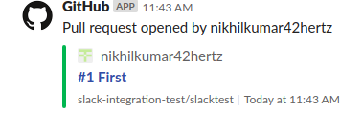

**When a Pull request is opened**

**Things that are shown:**

* 1. **Request number**
  2. **Title**
  3. **Repository Name**
  4. **Date and Time**

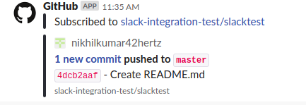

**When a new commit is pushed**

**Things that are shown:**

* 1. **Pushed to <branch name>**
  2. **Commit ID – File Name**
  3. **Repository Name**

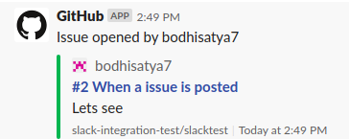

**When an issue is posted**

**Things that are shown:**

* 1. **Request number**
  2. **Title**
  3. **Comment**
  4. **Repository Name**
  5. **Date and Time**

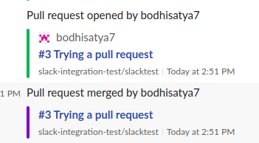

**When a pull request is tried and when a pull request is merged**

**Things that are shown:**

* 1. **Request number**
  2. **Title**
  3. **Repository Name**
  4. **Date and Time**