Assignment 2

ReadMe Doc

**URLS**

BuyOnline.htm

<https://mercury.swin.edu.au/cos80021/s102019464/Assignment2/buyonline.htm>

Register.htm

<https://mercury.swin.edu.au/cos80021/s102019464/Assignment2/register.htm>

Mlogin.htm

<https://mercury.swin.edu.au/cos80021/s102019464/Assignment2/mlogin.htm>

Listing.htm

<https://mercury.swin.edu.au/cos80021/s102019464/Assignment2/listing.htm>

processing.htm

<https://mercury.swin.edu.au/cos80021/s102019464/Assignment2/processing.htm>

logout.htm

<https://mercury.swin.edu.au/cos80021/s102019464/Assignment2/logout.htm>

login.htm

<https://mercury.swin.edu.au/cos80021/s102019464/Assignment2/login.htm>

buying.htm

<https://mercury.swin.edu.au/cos80021/s102019464/Assignment2/buying.htm>

System Instructions-

The system can be used to purchase items from website. The home page starts from buyonline page. The system can be used by manger as well as customers. Customer can buy all the item which will be shown into the shopping cart. After confirming purchase final amount will be displayed. Managers can use the system to list new items and process old ones.

**File list-**

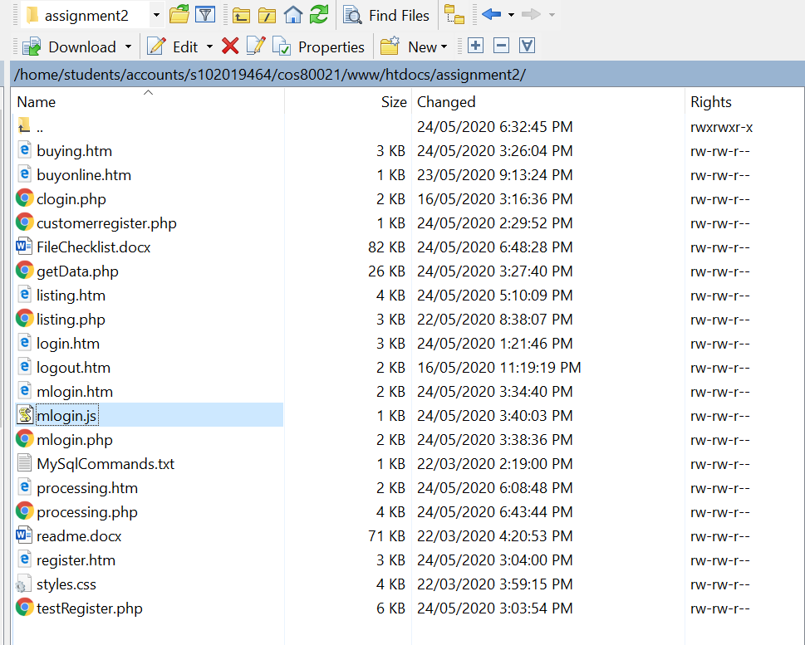

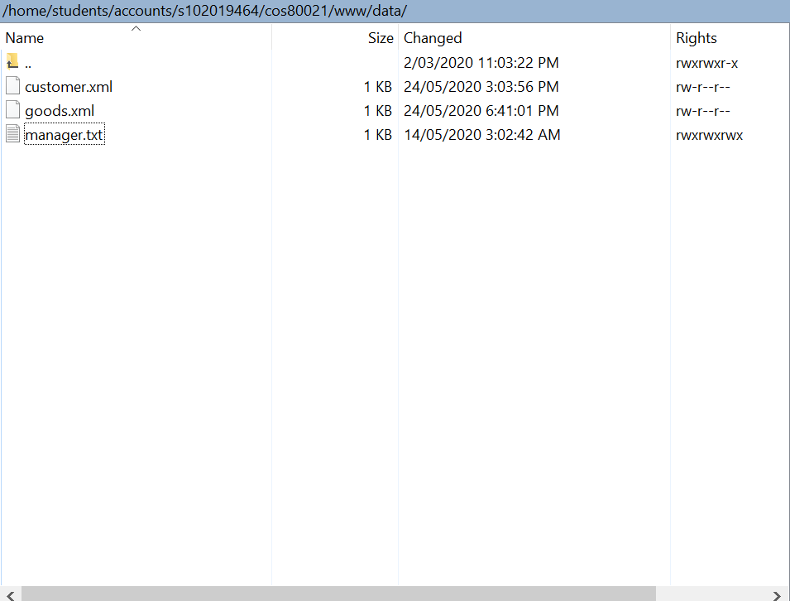

**Customer login**- email: t password:t

**Manager login-** name-:john password:100

