Demo

Contents

Task 1 - Business Narrative 2

Current Business Process 2

Data Involved 2

Why database solution? 5

Business Rule 6

Useful outcomes 7

Task 2 - ERD 7

Relational schema 10

Task 3 - Database Solution 12

Task 4 - Test Data 14

Task 5 - Queries and Visualisations 21

# Task 1 - Business Narrative

Yum-Yum Kitchen Hand Services

YYKHS is located in Melbourne Hawthorn. It provides casual kitchen hand services to customers. The business was started to help customers who are in urgent need for help in kitchen for short duration. The business started with owner Peter and a multi-purpose staff Harry. But now the business has grown, and they are daily getting many calls. On weekend it’s even more. Seeing the work volume Peter has hired few full time and part time staffs to manage customers.

## Current Business Process

The current business process is not online and mostly done through phone or face to face. First the customer contact Peter or Harry and give detail (work duration, cuisine skill, cooking related information, Thai, Continental, French, and Curry etc.) about the work. Harry then act as a talent consultant and search for the required match in company database. The company database is maintained in an excel sheet. Sometimes it’s difficult to find the exact match and sometimes Harry has accidently changed the data. The excel sheet contain applicant list who have worked before with the agency and their speciality Thai, American, Mexican etc. When Harry is very busy he send this list to other staff to the same duty. If any new applicant is engaged his or her details are added to the list. This creates problem as some times employees are having an old list and this causes coordinating problems. Employee A refer to the old list and Employee B to the other list. Sometimes applicant update their hourly rate in one list but are assigned with some other rate because the assigner was having an old list. Once the worker is found, one of the employees call them to inform about the job and take consent. After this customer is informed. Worker/Tradies are billed based on their rate. On the day of the work Harry call the applicant to give final reminder. Harry calls customer during the work time to ensure applicant has arrived and everything is well. Once the work is done customer pays to the agency and give feedback. The agency then pay the worker and take their feedback. Sometimes customer may request extra cooking equipment like a big party size griller. Agency also provides this and send it with the worker.

## Data Involved

The company has provided **some part** of sample data for modelling.

Customer-

|  |  |  |  |  |  |  |  |
| --- | --- | --- | --- | --- | --- | --- | --- |
| **suburb** | **fname** | **lname** | ***Customercontactnumber*** | **gender** | **mailid** | **loactionaddress** | **dob** |
| Hawthorn | Tim | Symonds | *406535158* | male | [tim@swin.com](mailto:tim@swin.com) | 34, beach street | 21/02/1885 |
| SouthYarra | Benjamin | Hopkins | *406235158* | female | [hopksi@yahoo.com](mailto:hopksi@yahoo.com) | 14, beach street | 31/12/1984 |
| Docklands | Alyssa | Jamieson | *406531158* | male | [ajamson@yahoo.com](mailto:ajamson@yahoo.com) | 54, beach street | 23/06/1990 |

Common attributes of customer.

Tradie/Worker/Cook

|  |  |  |  |  |  |  |  |  |
| --- | --- | --- | --- | --- | --- | --- | --- | --- |
| **addresslocation** | **fname** | **lname** | ***contactnumber*** | **mail** | **hurrateDollar** | **gender** | **suburb** | **dob** |
| 35 dock Pave | Abby | Annand | *406535222* | [akop@yum.com](mailto:akop@yum.com) | 50 | male | Hawthorn | 1/11/1985 |
| 42 Reuters Road | Michael | East | *406235333* | [atyukop@yum.com](mailto:atyukop@yum.com) | 61 | female | SouthYarra | 31/08/1980 |

Common attributes of tradies.

Equipment Agency

|  |  |  |  |
| --- | --- | --- | --- |
| **suburb** | **addresslocaton** | **name** | ***contactnumber*** |
| Hawthorn | 38 Devil Road | TastyTools | *406535000* |
| SouthYarra | 20 Queen Avenue | BigCook | *805535158* |

Task Rating

|  |  |
| --- | --- |
| ***Task_Rating*** | **Rating_description** |
| *1* | not ok |
| *2* | ok |

Equipment

|  |  |  |  |  |
| --- | --- | --- | --- | --- |
| ***equipmentname*** | **descrption** | **horlycharge** | ***agencycontact*** | Type |
| *Oven* | Big Oven | 20 | *406535000* | A |
| *BBQ* | Medium BBQ | 20 | *806535158* | B |

Invoice

|  |  |  |  |
| --- | --- | --- | --- |
| ***Invoiceid*** | **paymentamount** | **taskid** | **paymentstatus** |
| *I125* | 560 | 125 | Completed |
| *I126* | 810 | 126 | Completed |
| *I127* | 624 | 127 | Completed |

Payment

|  |  |  |  |  |
| --- | --- | --- | --- | --- |
| ***datetime*** | **status** | **tupe** | **carddetals** | ***invoceid*** |
| *21/02/2010* | Success | cash |  | *I125* |
| *31/12/2010* | Success | cash |  | *I126* |
| *1/01/2010* | Success | cash |  | *I127* |

Payment date and time must be recorded.

Cuisine list

|  |  |  |
| --- | --- | --- |
| ***cusineid*** | **cusine_Descripton** | **skill_level** |
| *111ASIAN* | noodle, dimsums | 5 |
| *211THAI* | nasi lamark | 3 |

Each cuisine has unique id.

Task

|  |  |  |  |  |  |  |
| --- | --- | --- | --- | --- | --- | --- |
| ***taskid*** | **CUSTOMER_CONTACT_NUMBER** | **DATE_CREATED** | **START_DATE** | **SUBURB** | **DURATIONINHOUR** | **TASK_RATING** |
| ***125*** | 406535158 | 20/02/2010 | 21/02/2010 | Hawthorn | 8 | 5 |
| ***126*** | 406235158 | 3/12/2010 | 31/12/2010 | SouthYarra | 10 | 4 |
| ***127*** | 406531158 | 1/01/2010 | 1/01/2010 | Docklands | 12 | 2 |

Each task is given a unique id.

Type of equipment

|  |  |
| --- | --- |
| Type | Description |
| A | Indoor |
| B | Outdoor |

## Why database solution?

Peter/owner is now looking for effective IT solutions for his business. He wants to store all detail in a central location through which everyone can access the same data. He also want the process to be streamline and effectively, manage the data. He want to see some analysis on his business such as which area brings highest revenue, customer age group who engages frequently, Gender gap and ensure there are no Gender pay gap. He also wants to store detail about all worker so that he can use it in time of urgency.

In the current business process YYKHS is using spreadsheets to manage data and there are lot of redundancy and mismatches. Many of the cuisine skills are similar e.g. ThaiCurry specialist, IndoThai baker etc. This makes it hard to track the data for the YYKHS organisation. Same kind of report are created multiple time with duplication of efforts. This causes loss of time and money.

After implementing database solution below benefits will be realized for YYKHS -

* Reduce data redundancy
* Sorting, Matching, Aggregating functions
* Referential Integrity(parent-child) in data(consistency)
* Sharing of data with multiple user but maintain consistency at same time
* Tracking of transaction processing
* Backup and data prevention

## Business Rule

*The business has already given sample data for analysis, apart from it some of the main business rules are –*

Each job is called a task in YYKHS. A customer can have **many tasks** with the agency. But one task must belong to only one customer. A customer can have **only one** contact number.

**More than one** tradie can be assigned for a task. And one task can require many equipment for rent.

Service rating must be maintained on a scale of 1 to 5.

Tradies can have **more than** one cuisine skill. But their skill level may vary and must be recorded.

YYKHS wants to offer flexibility in payment, in future **multiple invoice** can be generated for same task based on customer choice of instalment amount.

Customer payment might fail sometime, and they had to retry. However, **payment time and date must** be recorded. If customer pays by card the details of card must be recorded.

Billing of a task is done based on the duration of task multiplied by the hour rate of tradie and equipment on rent.

## Useful outcomes

After implementing database solution, we will be able to analyse business data. We will be able to see -

* tradies performance/ average rating
* suburb with highest revenue
* age group distribution
* equipment in demand, equipment having lot of demand can be purchased by agency to create revenue
* year wise revenue of company
* gender distribution
* cuisines in high demand for which more tradies can be hired etc.

These **insights** can bring radical changes in YYKHS business.

# Task 2 - ERD

No surrogate keys have been used either in modelling or in database design. Entities are being identified using simple data such as customer contact number, agency contact number etc.

Model 1 is created based on business description and **later simplified** to handle many to many relationships.

Model 1-

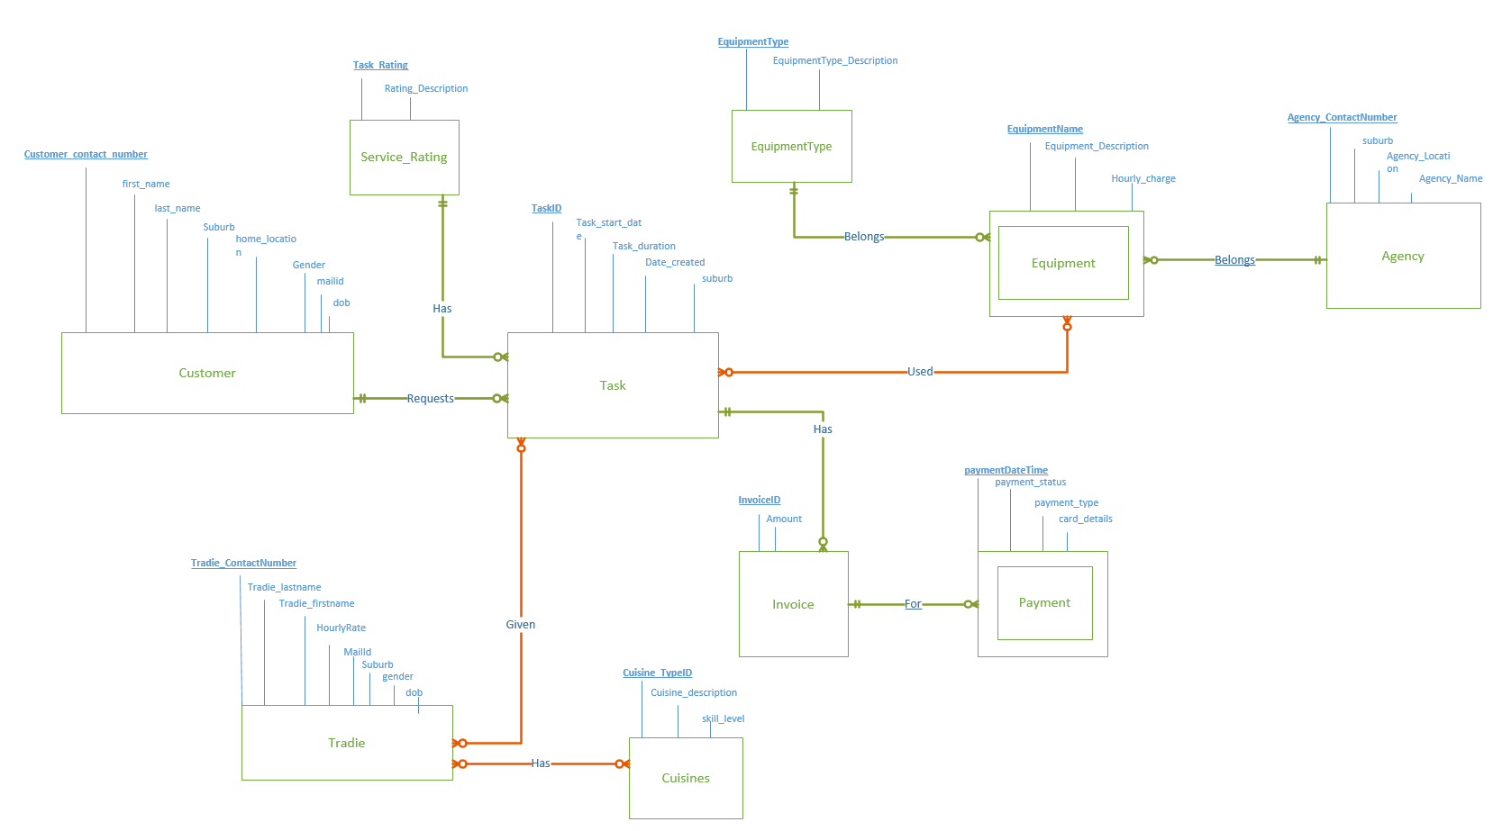

After **resolving the many to many** relationships, we get Model 2-

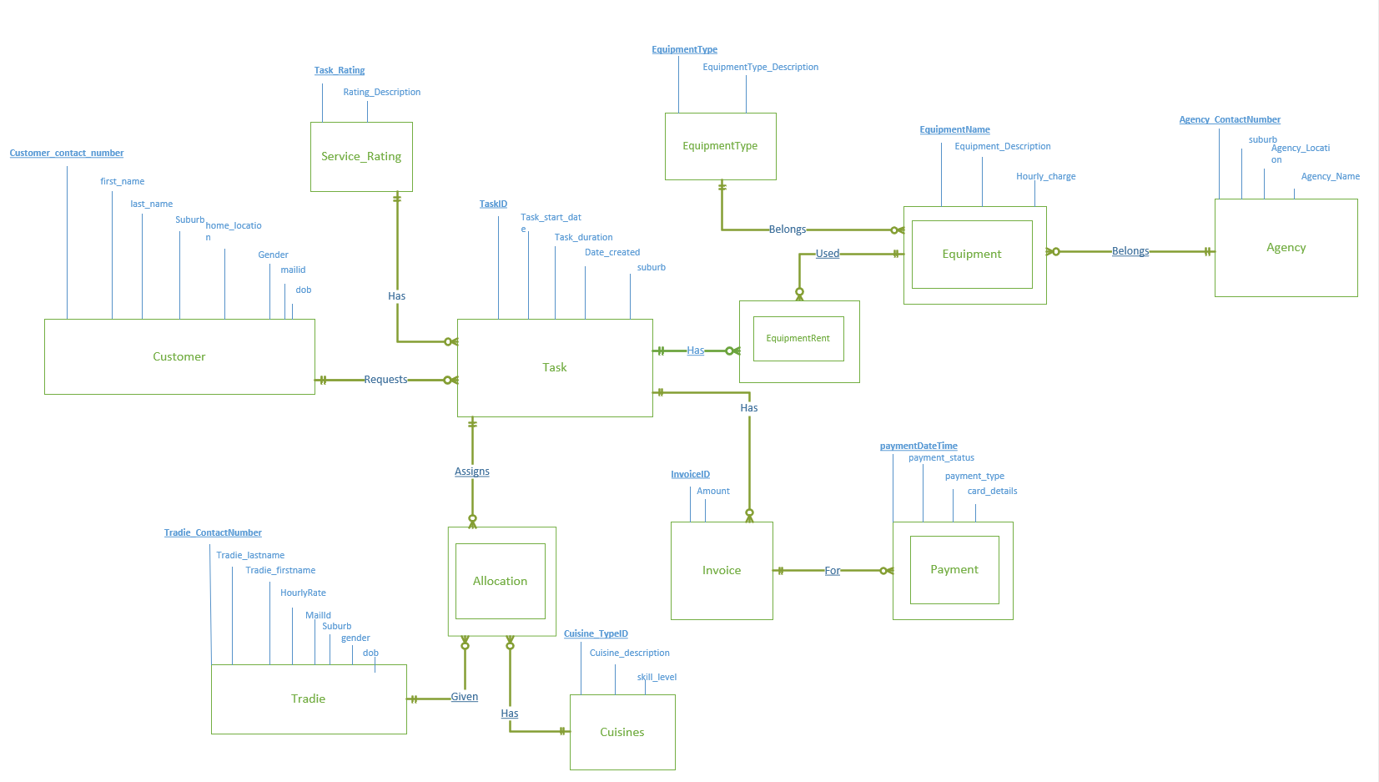

**Final *ERD* Model**

## Relational schema

**YUMCUSTOMER9464**(CUSTOMER_CONTACT_NUMBER, FIRST_NAME, LAST_NAME, SUBURB, HOME_LOCATION_GENDER, MAILID,DOB)

PK(CUSTOMER_CONTACT_NUMBER)

**YUMAGENCY9464**(SUBURB,ADDRESS_LOCATION,NAME, AGENCY_CONTACT_NUMBER)

PK(AGENCY_CONTACT_NUMBER)

**YUMALLOCATION9464** (TRADIE_CONTACT_NUMBER, CUISINEID, TASKID)

PK(TRADIE_CONTACT_NUMBER, CUISINEID, TASKID)

FK(TRADIE_CONTACT_NUMBER) REFERENCES TRADIE

FK(CUISINEID) REFERENCES CUISINE

FK(TASKID) REFERENCES TASK

**YUMCUISINE9464** (CUISINEID, CUISINE_DESCRIPTION)

PK (CUISINEID)

**YUMEQUIPMENT9464**(EQUIPMENT_NAME,AGENCY_CONATCT_NUMBER, EQUIPMENT_DESCRIPTION, HOURLY_CHARGE, EQUIPMENT_TYPE)

PK(EQUIPMENT_NAME,AGENCY_CONATCT_NUMBER)

FK(AGENCY_CONATCT_NUMBER) REFERENCES AGENCY

FK (EQUIPMENT_TYPE) REFERENCES EQUIPMENTTYPE

**YUMEQUIPMENTRENT9464**(EQUIPMENT_NAME,AGENCY_CONATCT_NUMBER, TASKID)

PK (EQUIPMENT_NAME, AGENCY_CONATCT_NUMBER, TASKID)

FK(EQUIPMENT_NAME ,AGENCY_CONATCT_NUMBER) REFERENCES EQUIPMENT

FK(TASKID) ) REFERENCES TASK

**YUMEQUIPMENTTYPE9464** (EQUIPMENT_TYPE, EQUIPMENT DESCRIPTION)

PK(EQUIPMENT_TYPE)

**YUMINVOICE9464**(INVOICEID, PAYMENT_AMOUNT, TASKID, PAYMENT_STATUS)

PK(INVOICEID)

FK(TASKID) REFERENCES TASK

**YUMPAYMENT9464**(PAYMENT_DATEANDTIME, INVOICEID,STATUS, TYPE, CARD_DETAIL)

PK(PAYMENT_DATEANDTIME, INVOICEID)

FK(INVOICEID) REFERENCES INVOICE

**YUMRATING9464** (TASK_RATING, RATING_DESCRIPTION)

PK(TASK_RATING)

**YUMTASK9464**(TASKID, CUSTOMER_CONTACT_NUMBER, DATE_CREATED, START_DATE, SUBURB, DURATIONINHOUR, TASK_RATING)

PK(TASKID)

FK (CUSTOMER_CONTACT_NUMBER) REFERENCES CUSTOMER

FK (TASK_RATING) REFERENCES RATING

**YUMTRADIE9464**(ADDRESS_LOCATION,FIRST_NAME,LAST_NAME, TRADIE_CONTACT_NUMBER, MAILID,RATE_PER_HOUR, GENDER,SUBURB, DOB)

PK(TRADIE_CONTACT_NUMBER)

# Task 3 - Database Solution

We have not used any surrogate keys in database as well. All the primary keys are indexed to support faster operations. We have tried our best to maintain database consistency. Any dependency of data is resolved through normalisation and no duplicate data set are saved in entities. Designing is done in such a way that it can be scaled in future within the constraint of current business rule. Some of the highlights of model are –

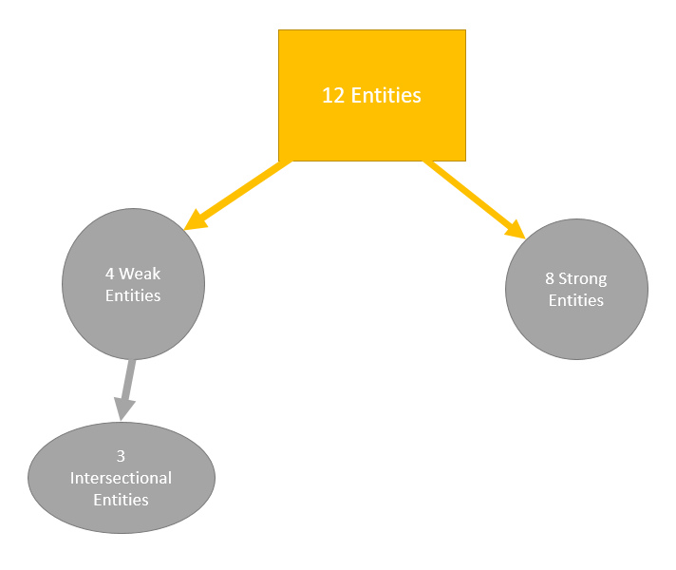

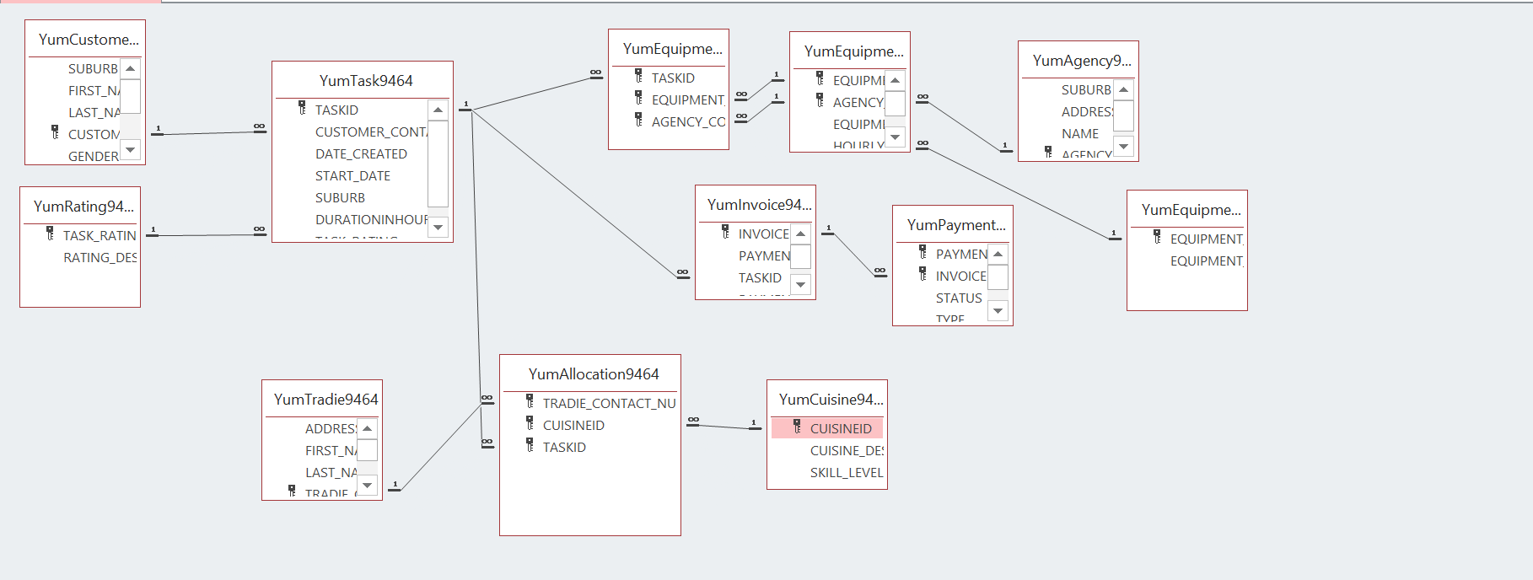

# Task 4 - Test Data

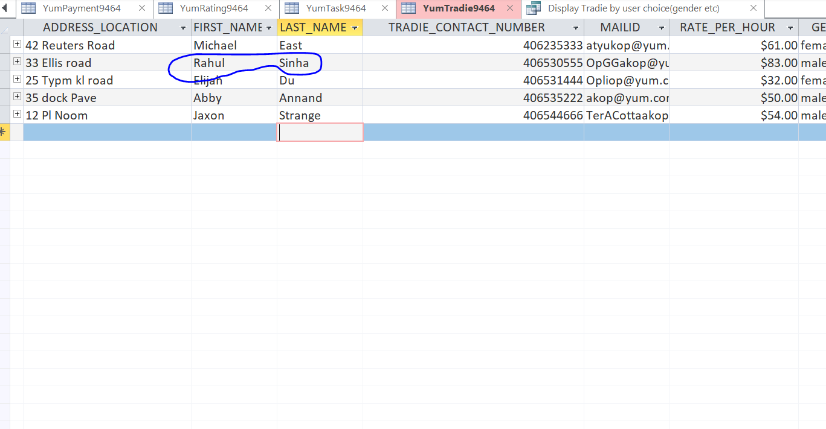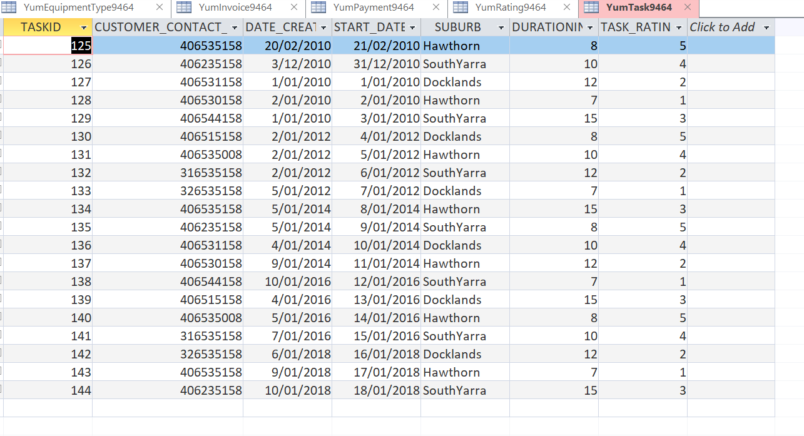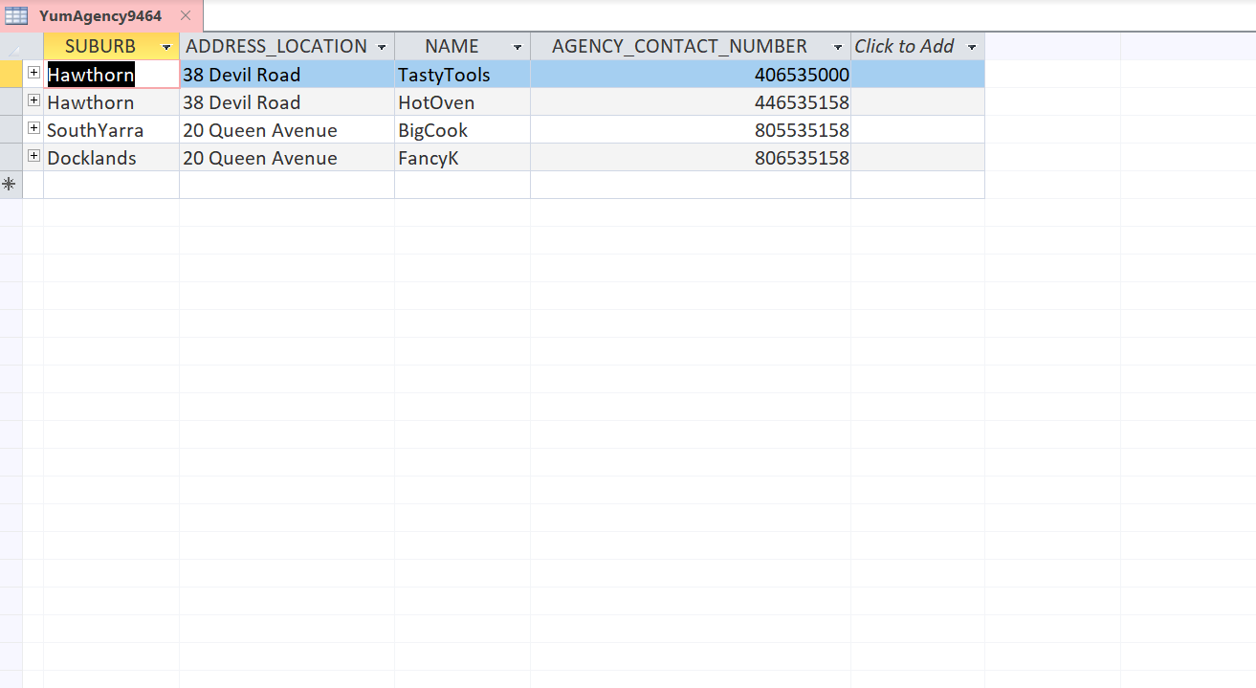

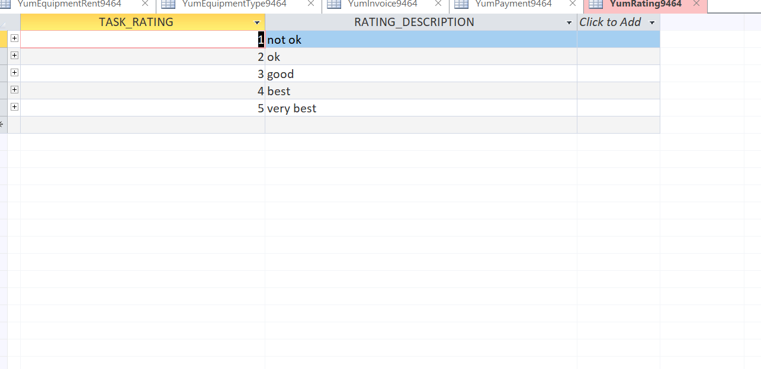

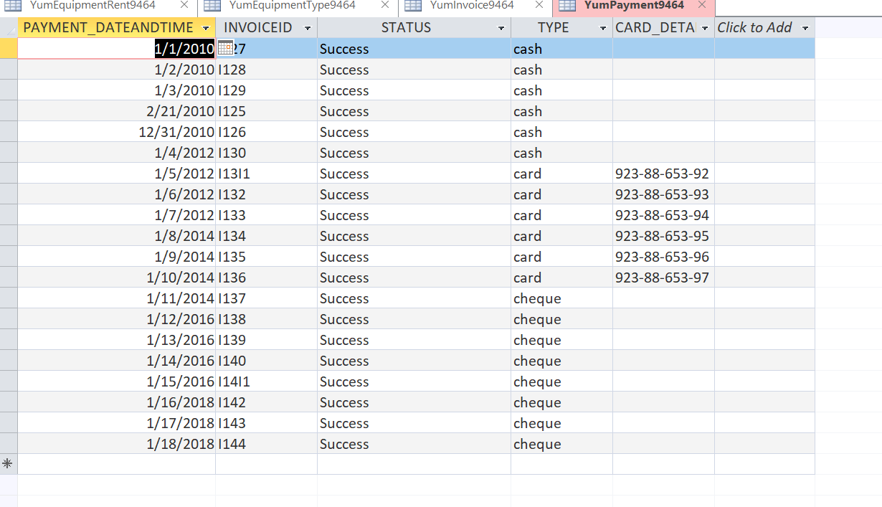

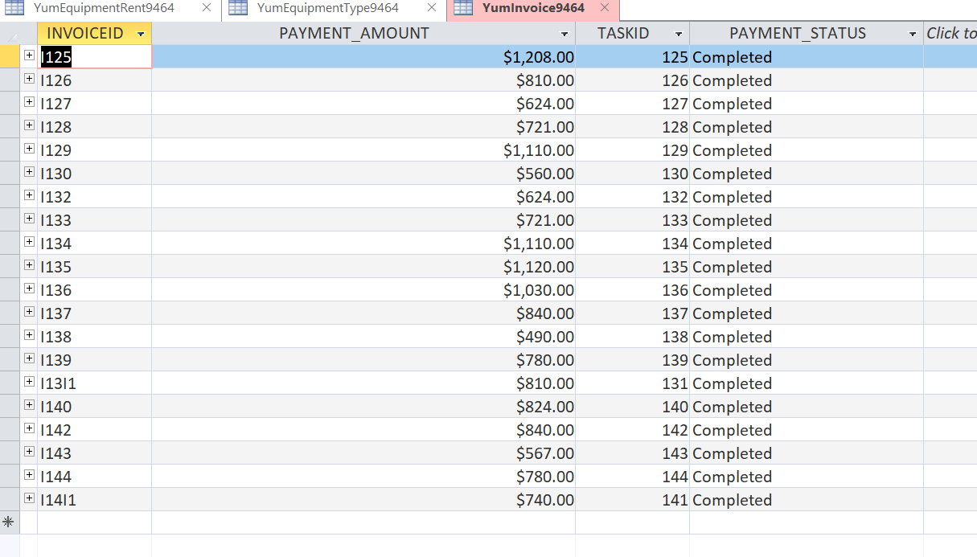

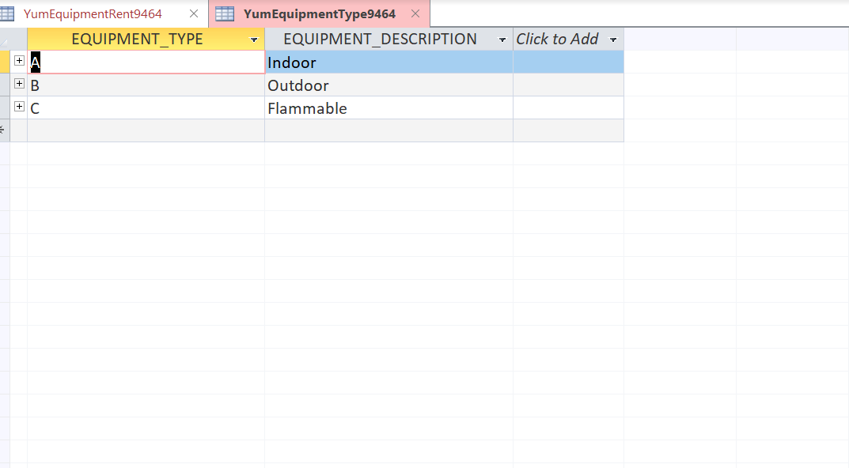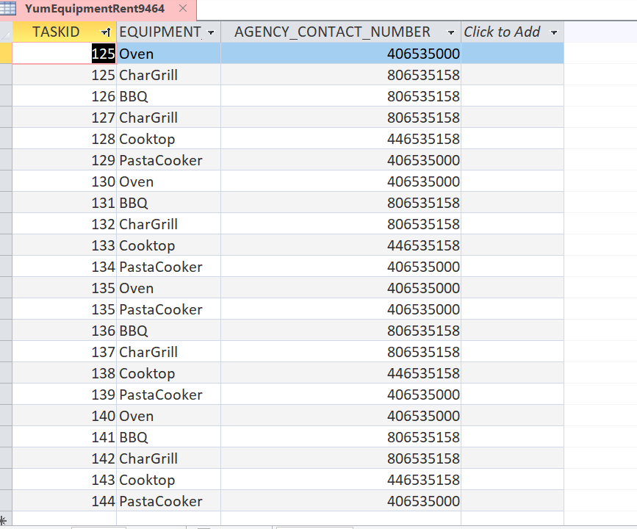

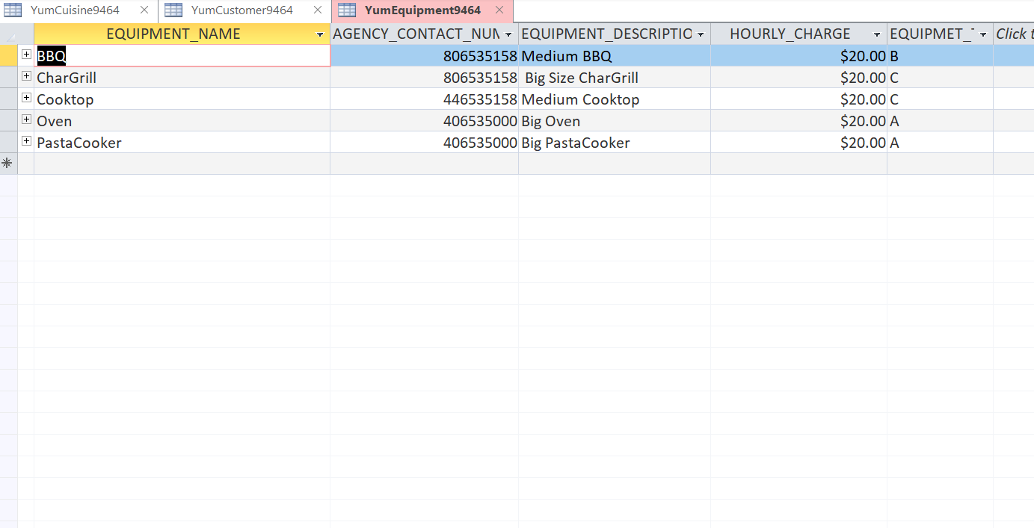

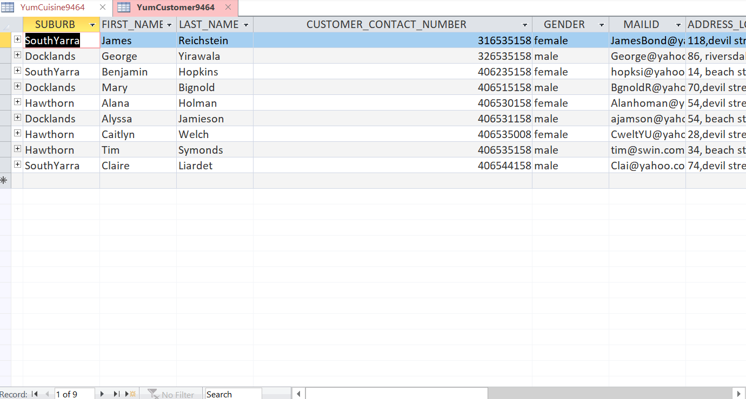

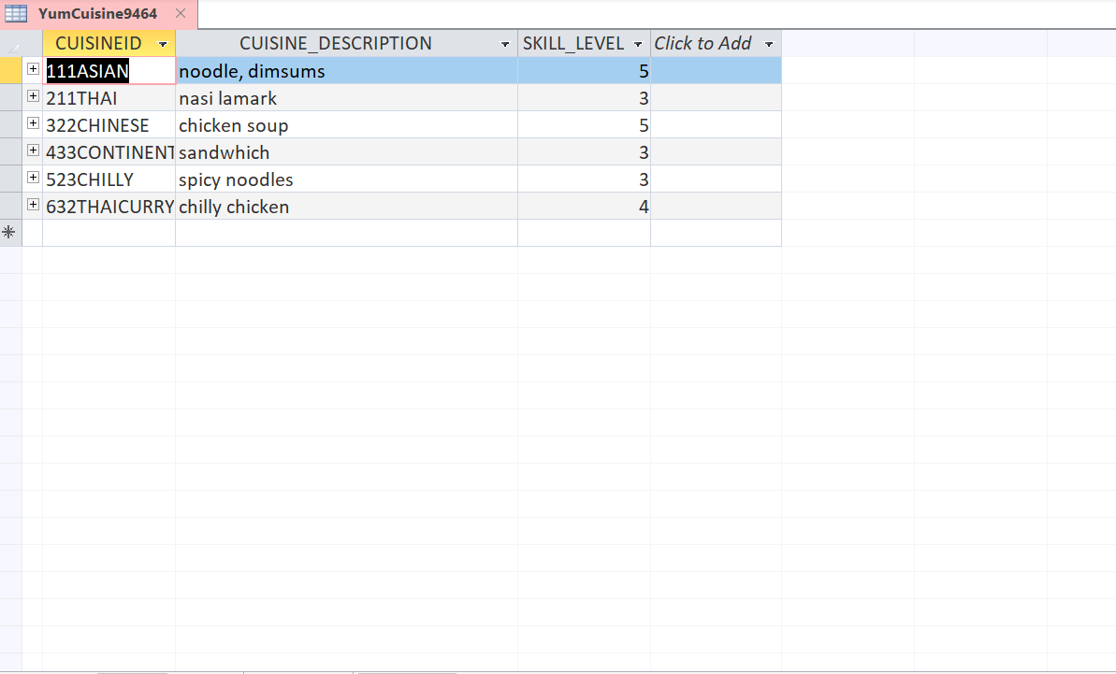

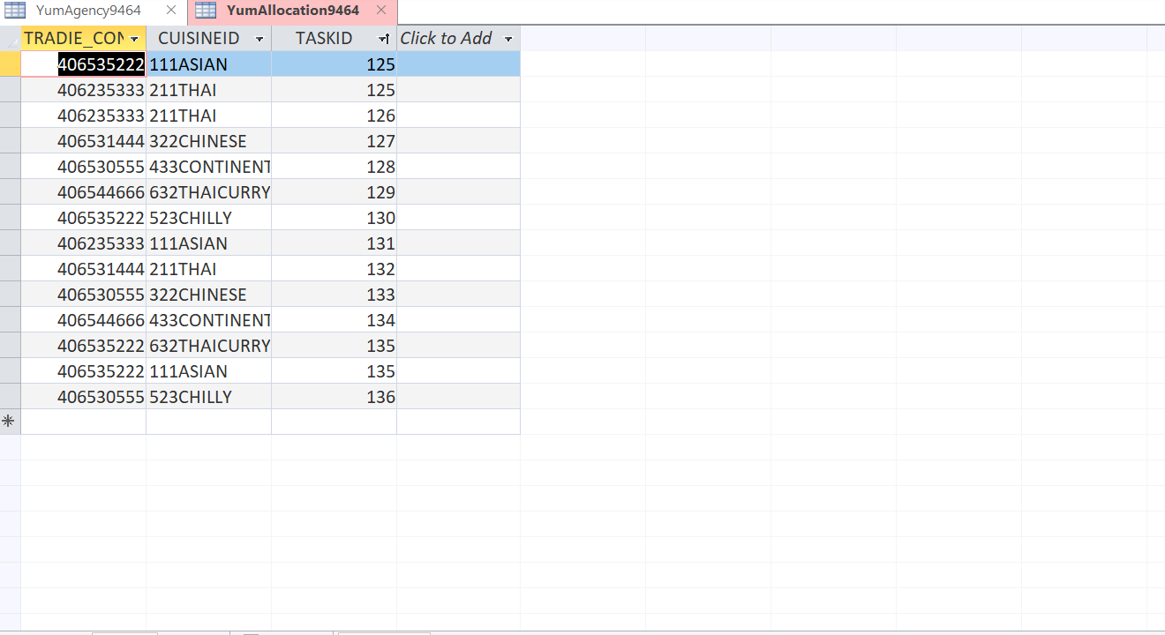

# Task 5 - Queries and Visualisations

1. Report- Jobs by Suburb

SELECT COUNT(TASKID) AS TOTAL_JOBS, SUBURB FROM YUMTASK9464 GROUP BY SUBURB ORDER BY COUNT(TASKID) DESC;

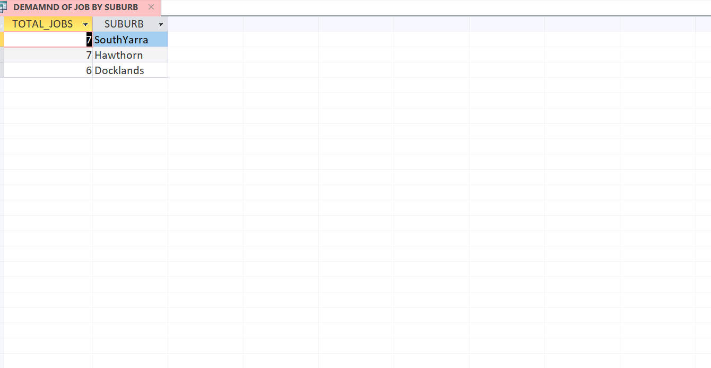

1. Report- Demand of equipment

SELECT COUNT(R.TASKID) AS NUMBER_OF_USE, E.EQUIPMENT_NAME, E.EQUIPMENT_DESCRIPTION

FROM YUMEQUIPMENTRENT9464 AS R **RIGHT OUTER JOIN** YUMEQUIPMENT9464 AS E ON (R.EQUIPMENT_NAME= E.EQUIPMENT_NAME) AND (R.AGENCY_CONTACT_NUMBER=E.AGENCY_CONTACT_NUMBER)

GROUP BY E.EQUIPMENT_NAME, E.EQUIPMENT_DESCRIPTION

ORDER BY COUNT(R.TASKID) DESC;

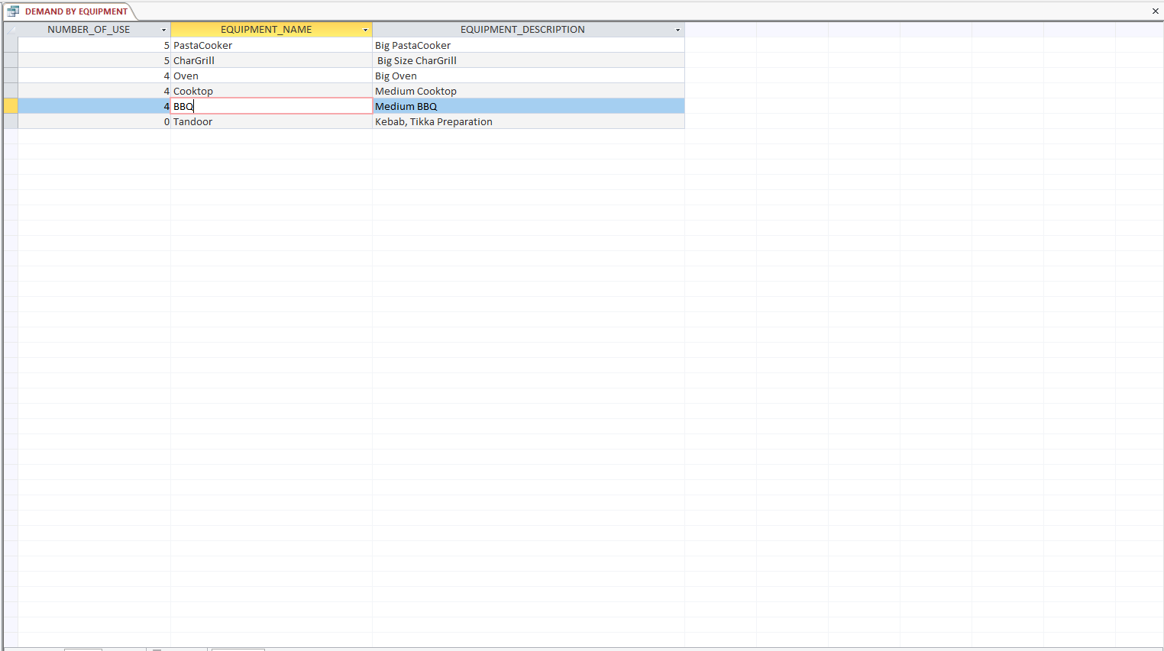

1. Report- Demand of cuisine

SELECT COUNT(A.TASKID) AS COUNT_OF_TASKS, A.CUISINEID, C.CUISINE_DESCRIPTION

FROM YUMALLOCATION9464 AS A INNER JOIN YUMCUISINE9464 AS C ON A.CUISINEID=C.CUISINEID

GROUP BY A.CUISINEID, C.CUISINE_DESCRIPTION

ORDER BY COUNT(A.TASKID) DESC;

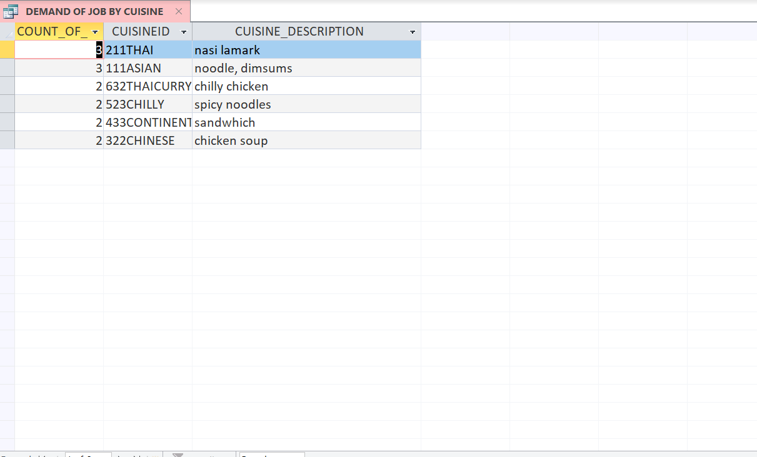

1. Report- Expenditure on equipment

SELECT SUM(T.DURATIONINHOUR*E.HOURLY_CHARGE) AS EXPENDITURE, E.EQUIPMENT_NAME, A.NAME AS SUPPLYING_AGENCY

FROM ((YUMTASK9464 AS T INNER JOIN YUMEQUIPMENTRENT9464 AS R ON T.TASKID=R.TASKID) INNER JOIN YUMEQUIPMENT9464 AS E ON (R.EQUIPMENT_NAME= E.EQUIPMENT_NAME) AND (R.AGENCY_CONTACT_NUMBER=E.AGENCY_CONTACT_NUMBER)) INNER JOIN YUMAGENCY9464 AS A ON A.AGENCY_CONTACT_NUMBER= E.AGENCY_CONTACT_NUMBER

GROUP BY E.EQUIPMENT_NAME, A.NAME

ORDER BY SUM(T.DURATIONINHOUR*E.HOURLY_CHARGE);

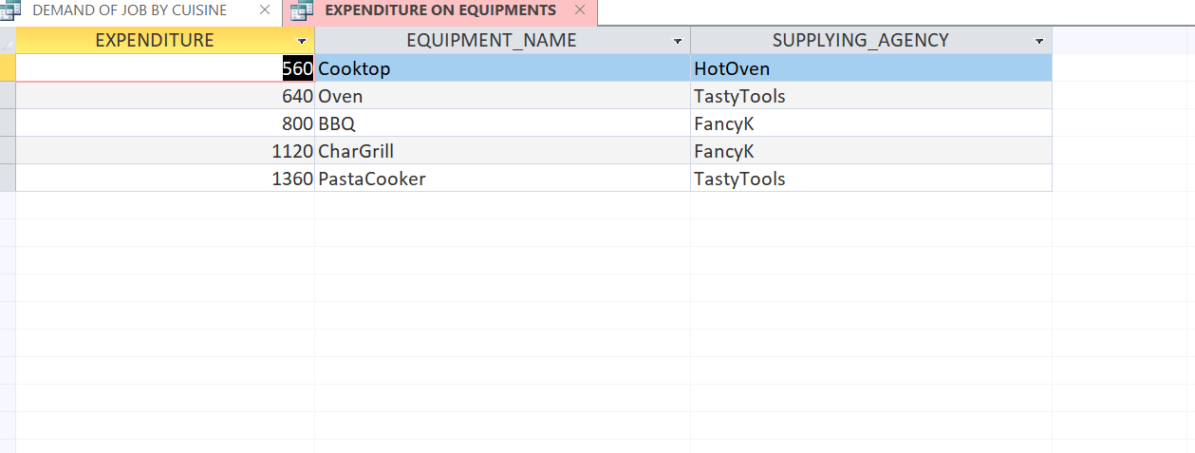

1. Report on Job count per tradie

SELECT COUNT(T.TASKID) AS TOTAL_JOBS, W.TRADIE_CONTACT_NUMBER, W.FIRST_NAME, W.LAST_NAME, W.MAILID

FROM (YUMTASK9464 AS T **RIGHT OUTER** JOIN YUMALLOCATION9464 AS A ON A.TASKID = T.TASKID) **RIGHT OUTER** JOIN YUMTRADIE9464 AS W ON W.TRADIE_CONTACT_NUMBER = A.TRADIE_CONTACT_NUMBER

GROUP BY W.TRADIE_CONTACT_NUMBER, W.FIRST_NAME, W.LAST_NAME, W.MAILID

ORDER BY COUNT(T.TASKID) DESC;

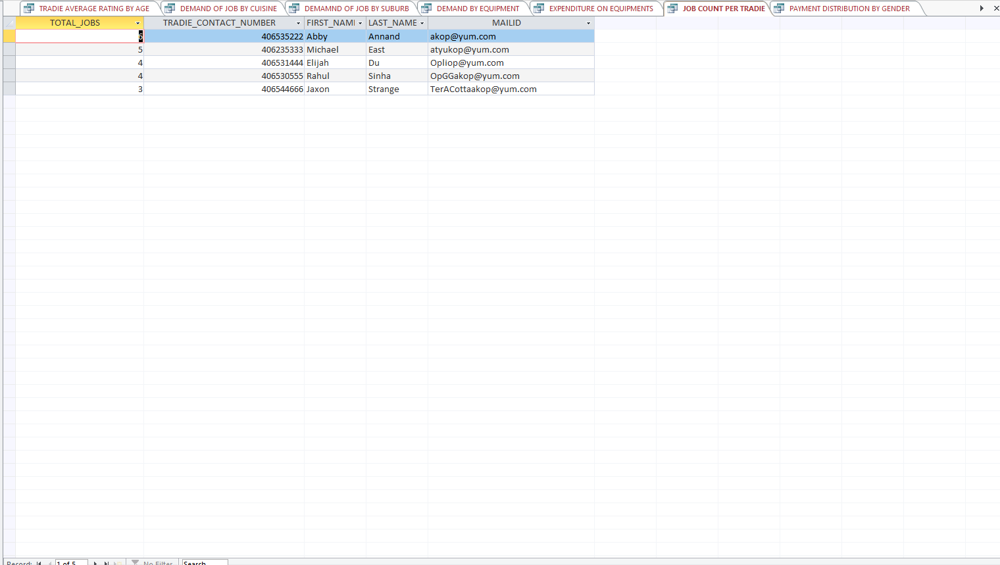

1. Payment distribution by tradie gender

SELECT SUM(W.RATE_PER_HOUR * T.DURATIONINHOUR) AS TOTAL_PAYMENT, W.GENDER

FROM (YUMTASK9464 AS T INNER JOIN YUMALLOCATION9464 AS A ON A.TASKID=T.TASKID) INNER JOIN YUMTRADIE9464 AS W ON W.TRADIE_CONTACT_NUMBER = A.TRADIE_CONTACT_NUMBER

GROUP BY W.GENDER;

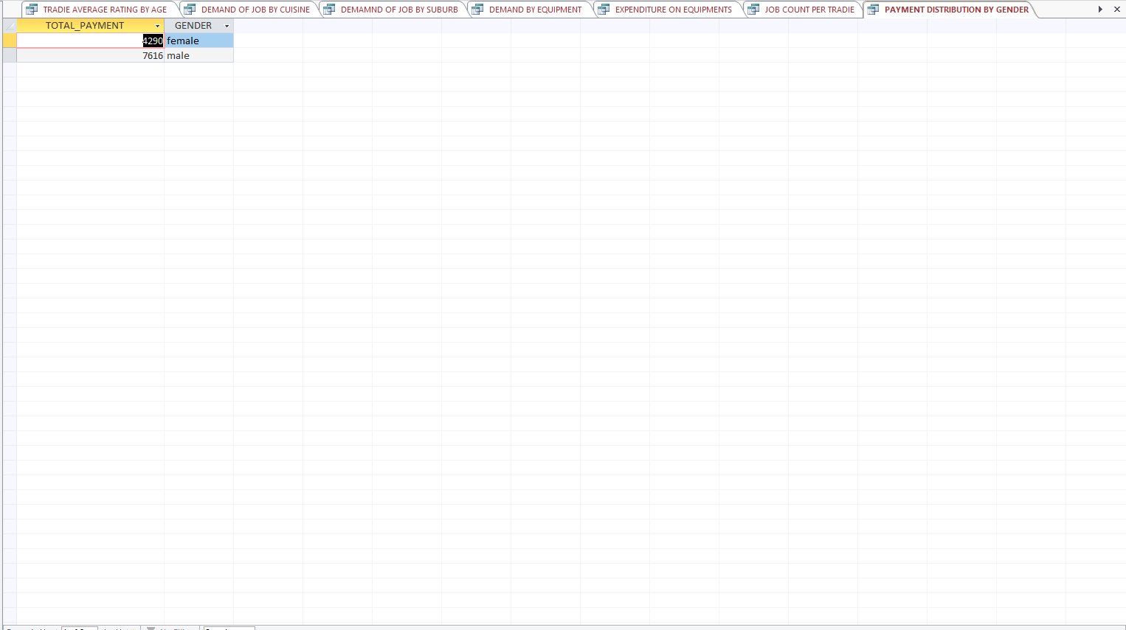

1. Report of Average task rating per customer

SELECT COUNT(T.TASKID) AS TOTAL_JOBS, AVG(R.TASK_RATING) AS AVERAGE_TASK_RATING, C.FIRST_NAME, C.LAST_NAME, C.GENDER, C.ADDRESS_LOCATION

FROM (YUMTASK9464 AS T INNER JOIN YUMCUSTOMER9464 AS C ON T.CUSTOMER_CONTACT_NUMBER=C.CUSTOMER_CONTACT_NUMBER) INNER JOIN YUMRATING9464 AS R ON R.TASK_RATING = T.TASK_RATING

GROUP BY C.FIRST_NAME, C.LAST_NAME, C.GENDER, C.ADDRESS_LOCATION

ORDER BY COUNT(T.TASKID) DESC;

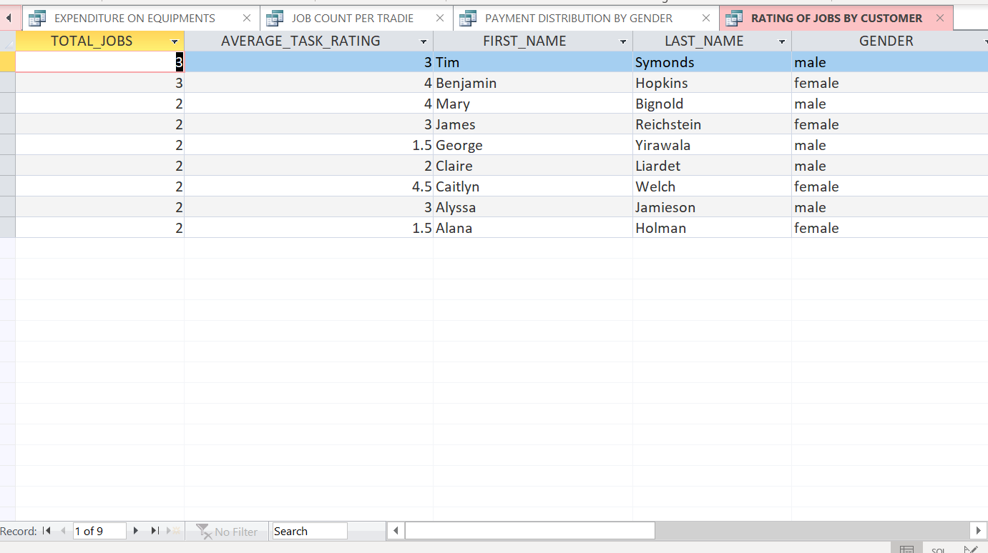

1. Revenue by suburb

SELECT SUM(P.PAYMENT_AMOUNT) AS REVENUE, T.SUBURB

FROM YumInvoice9464 AS P INNER JOIN YumTask9464 AS T ON P.TASKID= T.TASKID

GROUP BY T.SUBURB

ORDER BY SUM(P.PAYMENT_AMOUNT);

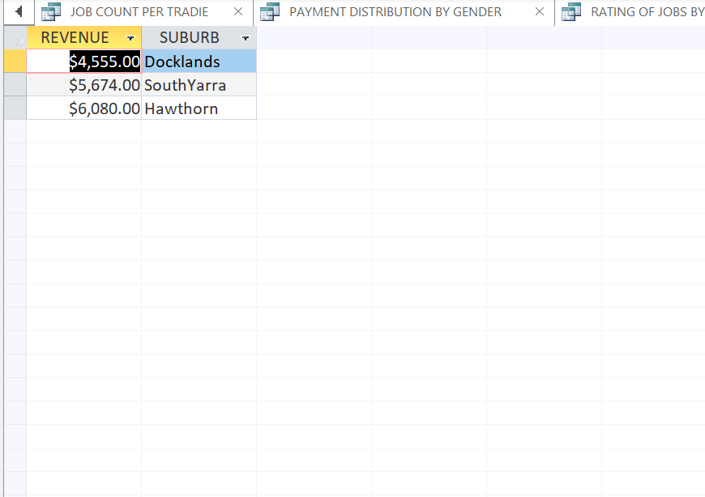

1. Revenue by year

SELECT SUM(P.PAYMENT_AMOUNT) AS REVENUE, YEAR( T.DATE_CREATED) AS BUISNESS_YEAR

FROM YumInvoice9464 AS P INNER JOIN YumTask9464 AS T ON P.TASKID= T.TASKID

GROUP BY YEAR( T.DATE_CREATED)

ORDER BY SUM(P.PAYMENT_AMOUNT);

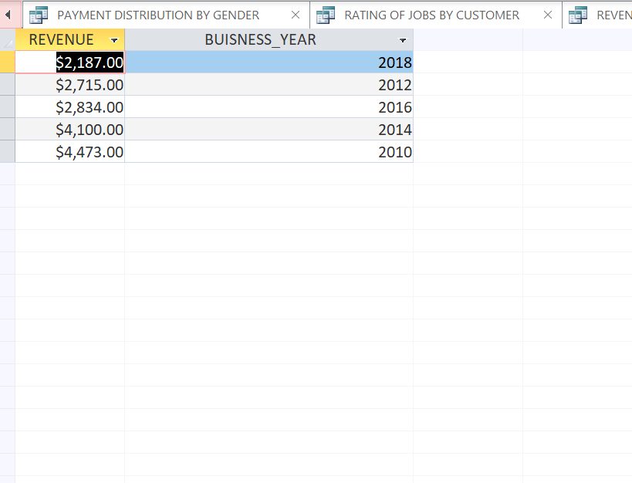

1. Average rating of each tradie vs age

SELECT YEAR(NOW())-YEAR(W.DOB) AS TRADIE_AGE, ROUND(AVG(T.TASK_RATING),2) AS AVERAGE_RATING, W.FIRST_NAME, W.LAST_NAME, W.MAILID

FROM ((YUMTRADIE9464 AS W INNER JOIN YUMALLOCATION9464 AS A ON A.TRADIE_CONTACT_NUMBER= W.TRADIE_CONTACT_NUMBER) INNER JOIN YUMTASK9464 AS T ON A.TASKID=T.TASKID) INNER JOIN YUMRATING9464 AS R ON R.TASK_RATING=T.TASK_RATING

GROUP BY YEAR(NOW())-YEAR(W.DOB), W.FIRST_NAME, W.LAST_NAME, W.MAILID

ORDER BY YEAR(NOW())-YEAR(W.DOB) DESC;

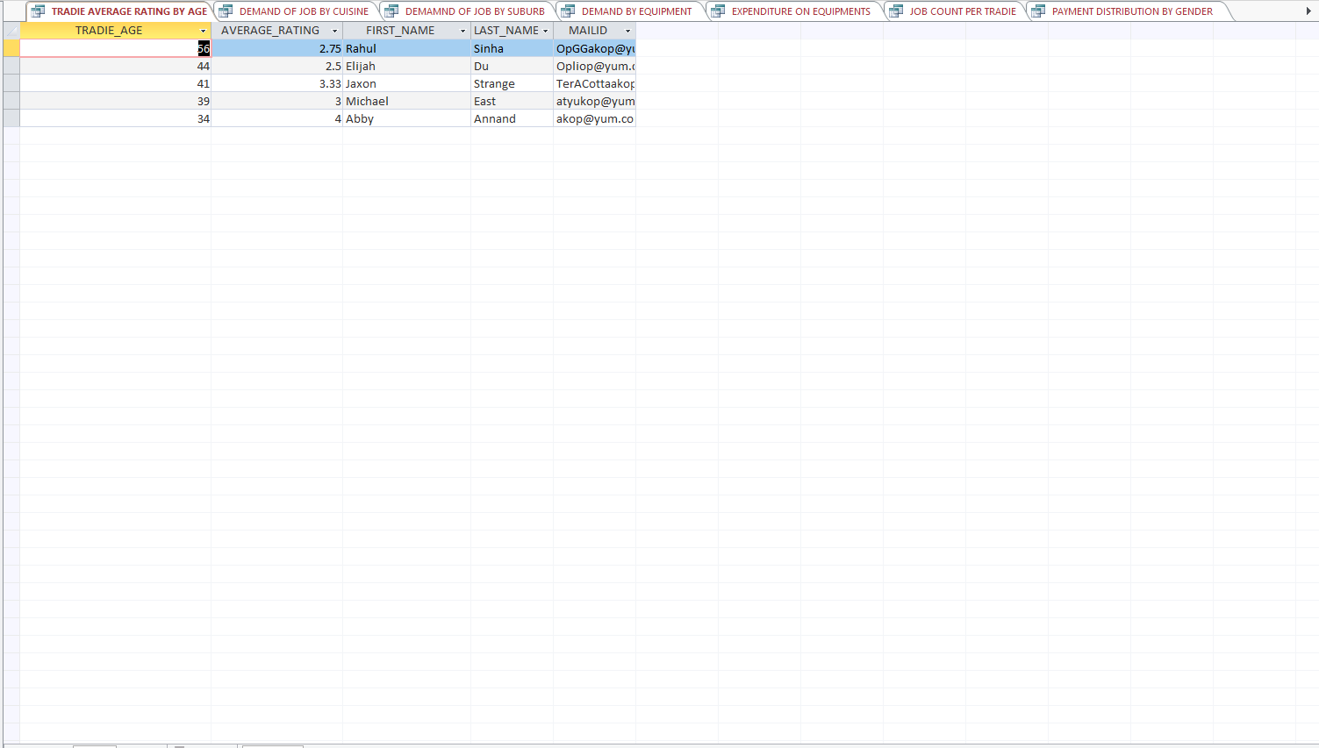

## Power BI

Extra columns and calculation were added whenever necessary to analyse innovative aspects of business. We have also included some new type of charts. To cover a complete overview of business we didn’t restrict ourselves to the minimum number of visualisation requirement. We have tried to aggregate and present the overall business insight.

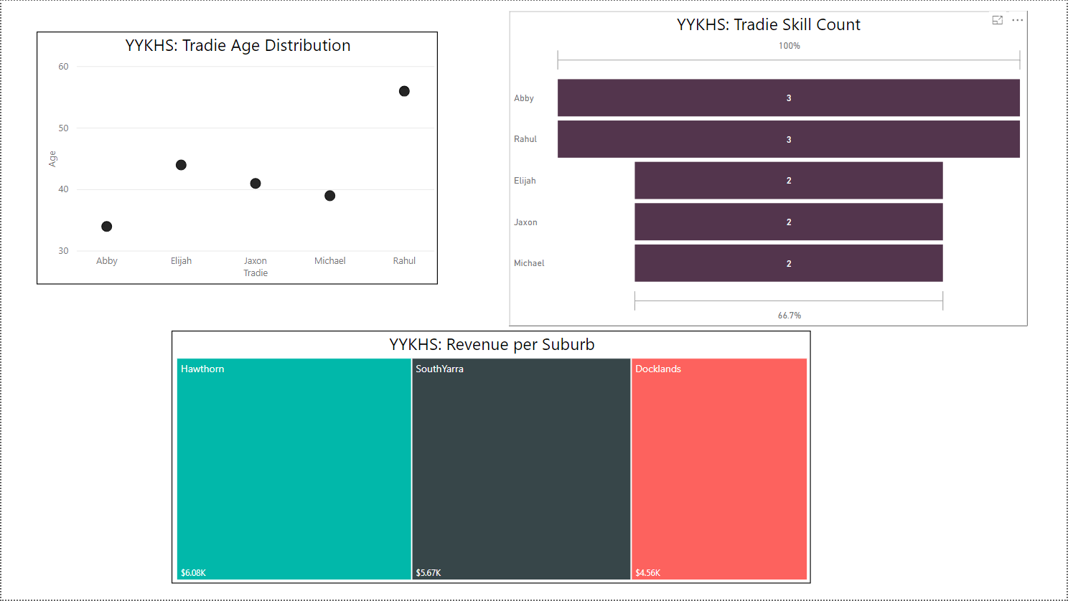

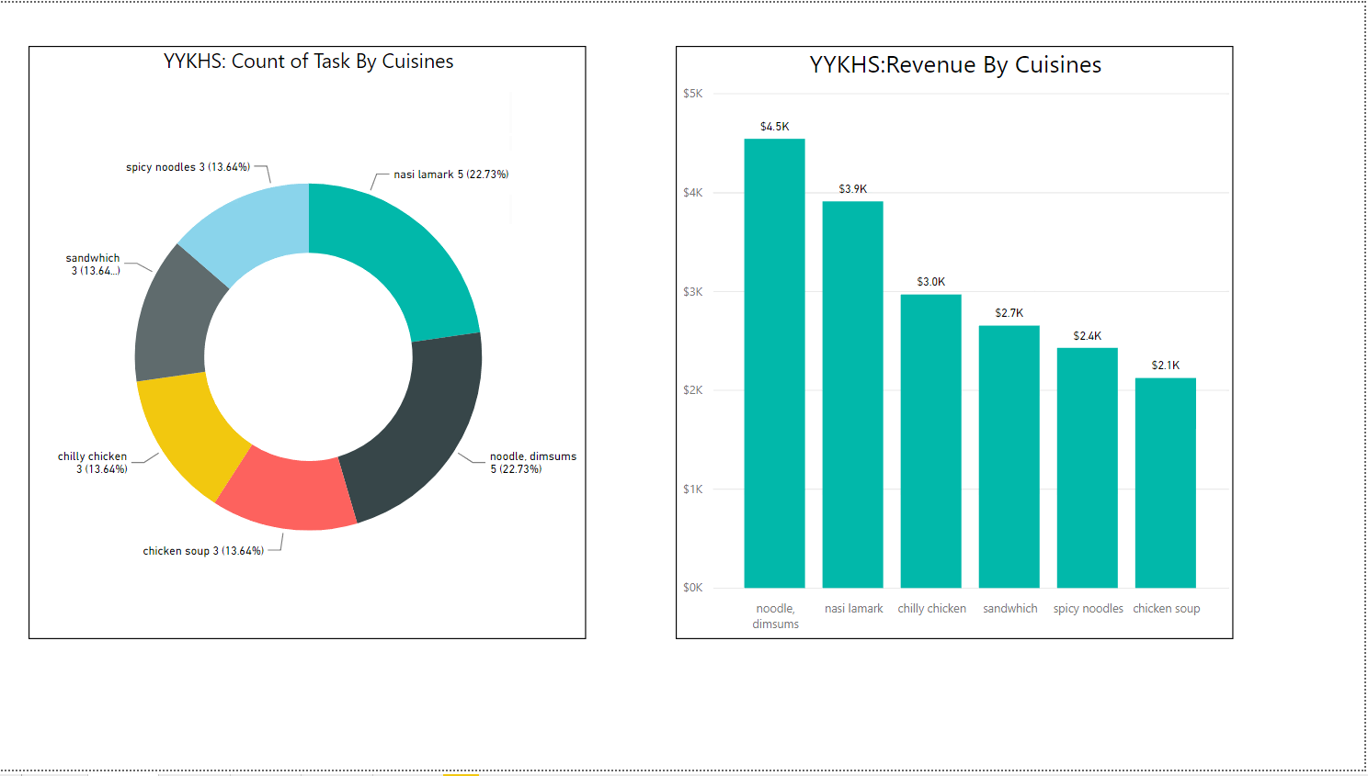

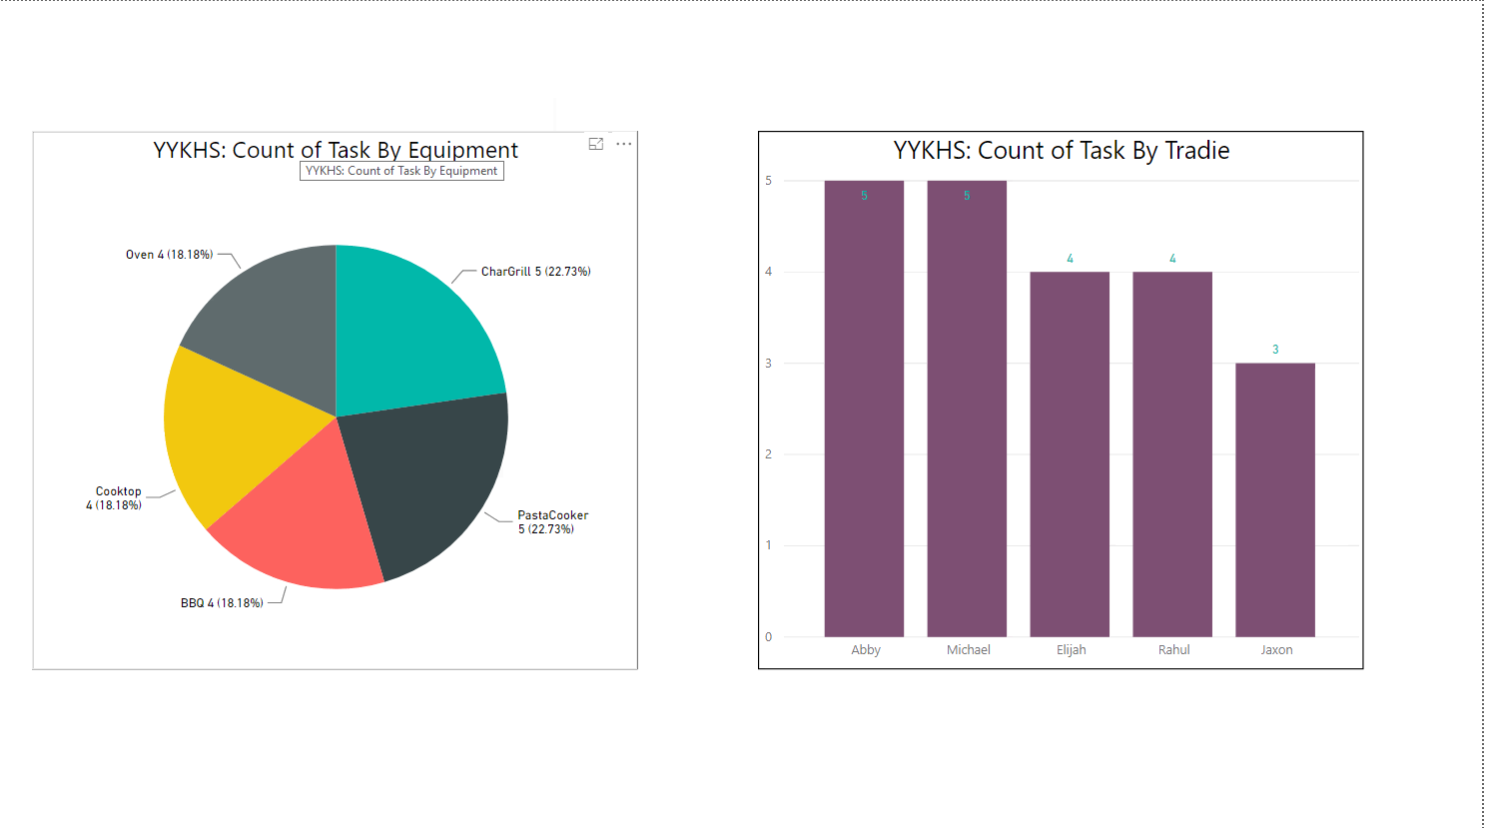

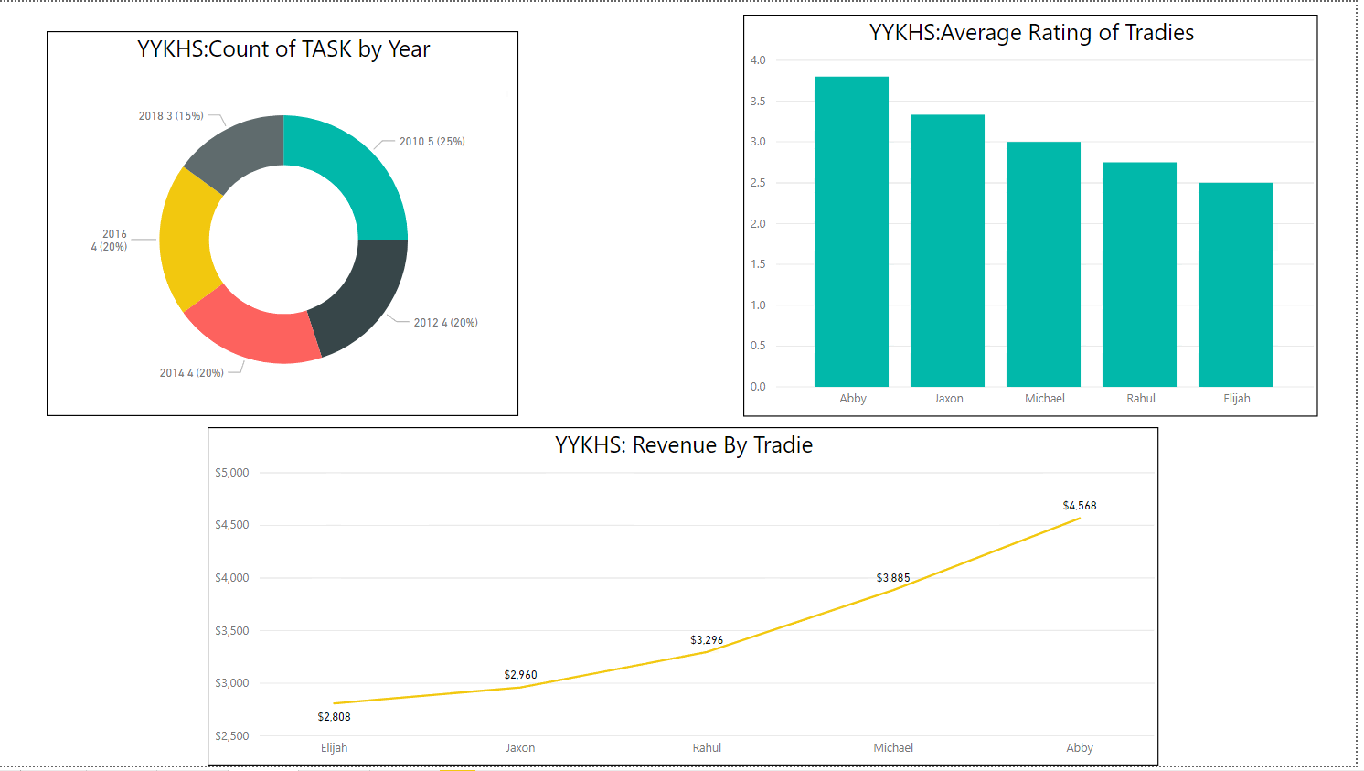

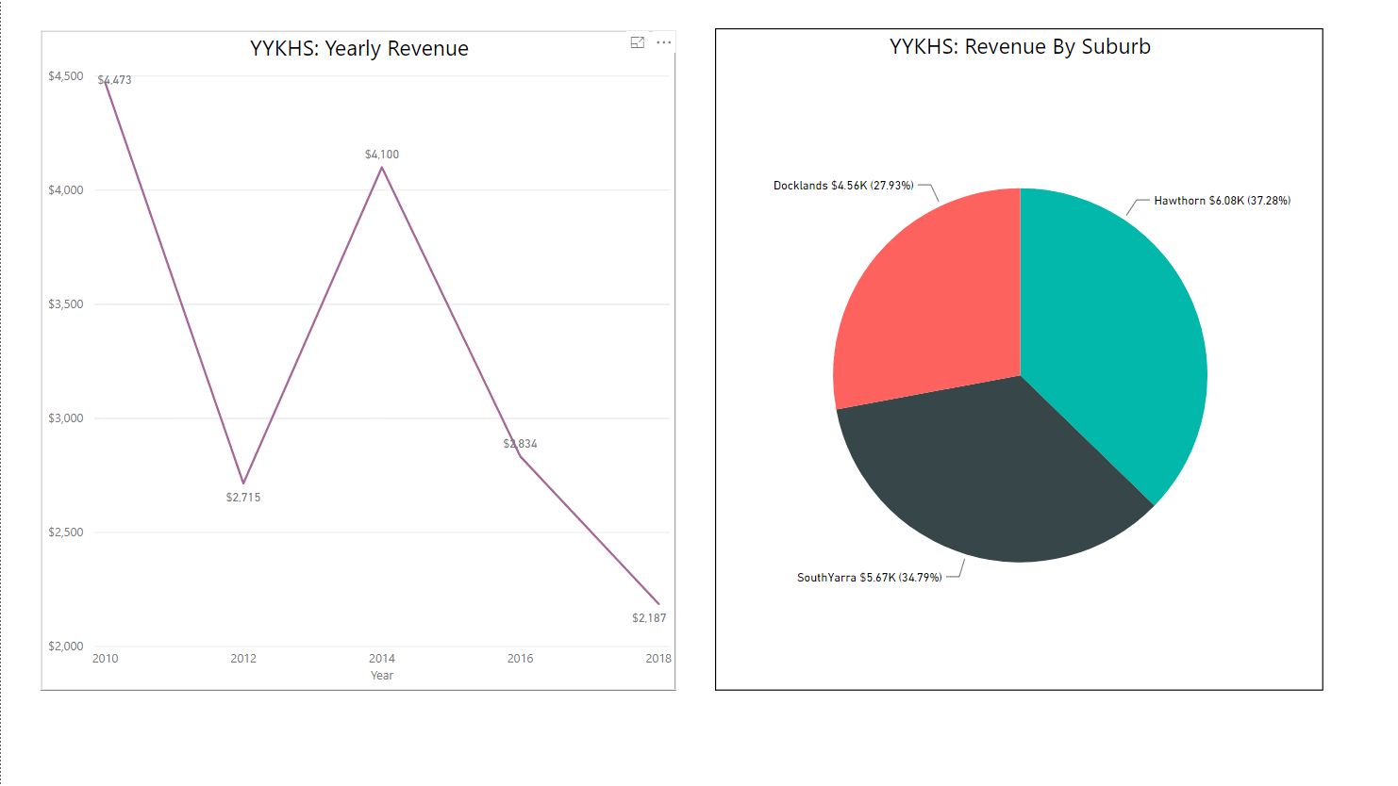

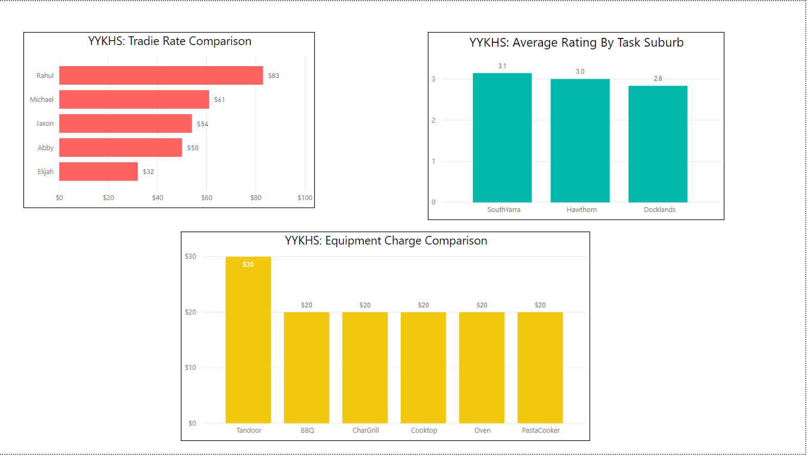

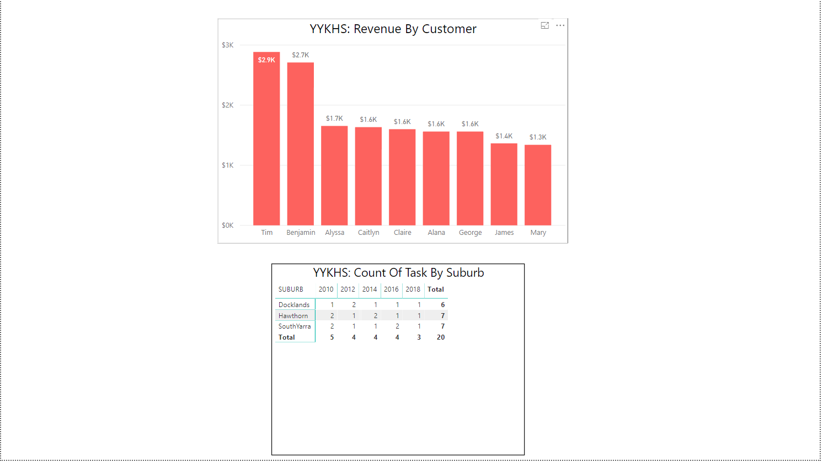

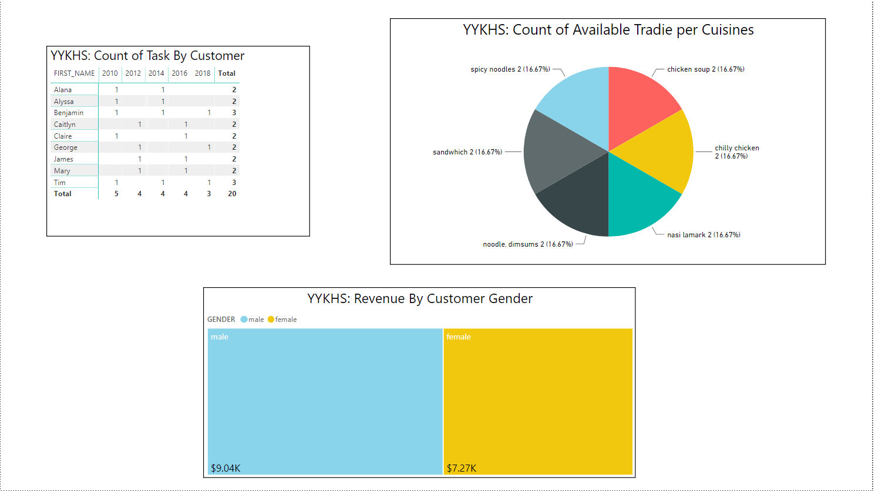

Thank You