COMP4908

Industry Project

Convergent Manufacturing Technologies

Design documentation

Chris Sim A00691404

Mike Zobac A00000000

Tyler Allison A00000000

Project Schedule

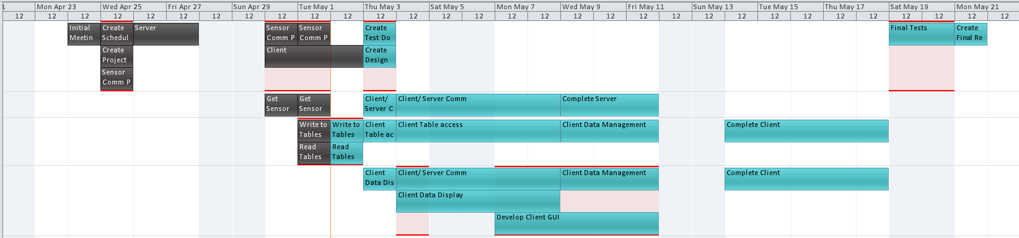

|  |  |  |  |  |  |
| --- | --- | --- | --- | --- | --- |
| Task Name | Duration | Start | Finish | Predecessors | Resource Names |
| **Convergent Practicum** | **22 days** | **Mon 4/23/12** | **Tue 5/22/12** |  |  |
| Initial Meeting | 1 day | Tue 4/24/12 | Tue 4/24/12 |  | All |
| Create Schedule | 1 day | Wed 4/25/12 | Wed 4/25/12 | 2 | All |
| Create Project Proposal | 1 day | Wed 4/25/12 | Wed 4/25/12 | 2 | All |
| **Design** | **8 days** | **Wed 4/25/12** | **Fri 5/4/12** | **2** |  |
| Sensor Comm Protocol | 1 day | Wed 4/25/12 | Wed 4/25/12 |  | All |
| Server | 2 days | Thu 4/26/12 | Fri 4/27/12 |  | All |
| Client | 3 days | Mon 4/30/12 | Wed 5/2/12 |  | All |
| Create Design Doc | 1 day | Thu 5/3/12 | Thu 5/3/12 |  | All |
| Present Desig Document | 0 days | Fri 5/4/12 | Fri 5/4/12 |  |  |
| Present Schedule and Proposal | 0 days | Mon 4/30/12 | Mon 4/30/12 |  |  |
| Project Proposal Sign-Off | 0 days | Wed 5/2/12 | Wed 5/2/12 |  |  |
| **Create Unit Tests** | **5 days** | **Mon 4/30/12** | **Fri 5/4/12** |  |  |
| Sensor Comm Protocol | 1 day | Mon 4/30/12 | Mon 4/30/12 |  | All |
| Get Sensor Data | 1 day | Mon 4/30/12 | Mon 4/30/12 |  | Tyler |
| Write to Tables | 1 day | Tue 5/1/12 | Tue 5/1/12 |  | Chris |
| Read Tables | 1 day | Tue 5/1/12 | Tue 5/1/12 |  | Chris |
| Client/ Server Comm | 1 day | Thu 5/3/12 | Thu 5/3/12 |  | Tyler |
| Client Table access | 1 day | Thu 5/3/12 | Thu 5/3/12 |  | Chris |
| Client Data Display | 1 day | Thu 5/3/12 | Thu 5/3/12 |  | Mike |
| Create Test Doc | 1 day | Thu 5/3/12 | Thu 5/3/12 |  | All |
| **Develop Product** | **16 days** | **Mon 4/30/12** | **Sun 5/20/12** | **13SS** |  |
| Sensor Comm Protocol | 1 day | Tue 5/1/12 | Tue 5/1/12 | 14 | All |
| Get Sensor Data | 1 day | Tue 5/1/12 | Tue 5/1/12 | 15 | Tyler |
| Write to Tables | 1 day | Wed 5/2/12 | Wed 5/2/12 | 16 | Chris |
| Read Tables | 1 day | Wed 5/2/12 | Wed 5/2/12 | 17 | Chris |
| Client/ Server Comm | 3 days | Fri 5/4/12 | Tue 5/8/12 | 18 | Mike,Tyler |
| Complete Server | 3 days | Wed 5/9/12 | Fri 5/11/12 | 27 | Tyler |
| Server Complete | 0 days | Sat 5/12/12 | Sat 5/12/12 |  |  |
| Client Table access | 3 days | Fri 5/4/12 | Tue 5/8/12 | 19 | Chris |
| Client Data Display | 3 days | Fri 5/4/12 | Tue 5/8/12 | 20 | Mike |
| Client Data Management | 3 days | Wed 5/9/12 | Fri 5/11/12 |  | Chris,Mike |
| Develop Client GUI | 5 days | Mon 5/7/12 | Fri 5/11/12 |  | Mike |
| GUI Complete | 0 days | Sat 5/12/12 | Sat 5/12/12 |  |  |
| Complete Client | 5 days | Mon 5/14/12 | Fri 5/18/12 | 32,33 | Chris,Mike |
| Client Complete | 0 days | Sat 5/19/12 | Sat 5/19/12 |  |  |
| Final Tests | 2 days | Sat 5/19/12 | Sun 5/20/12 |  | All |
| Create Final Report | 1 day | Mon 5/21/12 | Mon 5/21/12 |  | All |
| Final Report | 0 days | Tue 5/22/12 | Tue 5/22/12 |  |  |
| Presentation | 0 days | Tue 5/22/12 | Tue 5/22/12 |  |  |

# 

# State Transition Diagram - Server (overview)



# State Transition Diagram - Server (Select)

# 

# Pseudo Code - Server

### Create Select Thread

* Myahhh

### Select Thread

* Myahhh

### Open UDP Socket

* Creates an UDP socket that will be used for listening for sensor connections
* Binds the socket to broadcasting IP and default port
* Non-blocking socket for efficiency

### Listen for Broadcasts

* Using select call for handling multiple sensors
* Instead of polling, when it receives a datagram from a sensor, will get the CPU time back
* When the datagram is received from a sensor, it saves packet data

### Save Packet Data

* Stores data received which contains serial number of the sensor and port to be used for transmission
* Also stores sensor’s IP
* Serial number and port number need to be extracted from the bytes

### Check Serial Number

* If the list is not empty, go through the list and see if the sensor is already in the list

### Create TCP Socket

* Create a TCP socket for this particular sensor to be used for transmission of data
* When the sensor gets added to the list, socket is associated with the serial number and added to the list together

### Add to the List

* Since we start with empty list, check to see if the list is empty and if so, add the sensor
* After checking serial number, if it exists in the list, ignore
* If it does not exist, add to the list of sensors being used
* Display which sensor is registered

### Connect

* Connect to the sensor via TCP using sensor’s IP and port received

### Send START message

* Send a control message to the sensor which enables collecting data

### Register FD

* Hmm?