COMP4908

Industry Project

Data collection server/client for Convergent Manufacturing

User Manual

Chris Sim A00691404

Mike Zobac A00721357

Tyler Allison A00779685

How to use Server

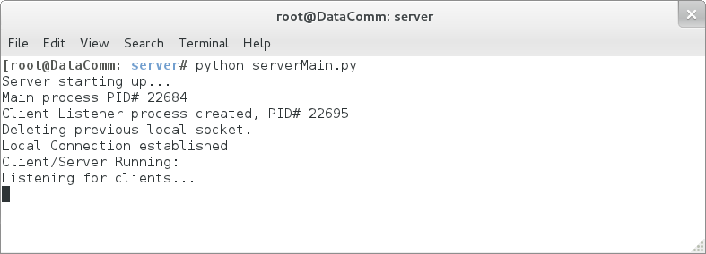

* Server can be started by running serverMain.py file
* Once the server is started, it listens to the socket for any sensor to connect as well as any client
* When sensors are detected, it will print out sensor number and start connection to it
* Please see next screen shot for reference

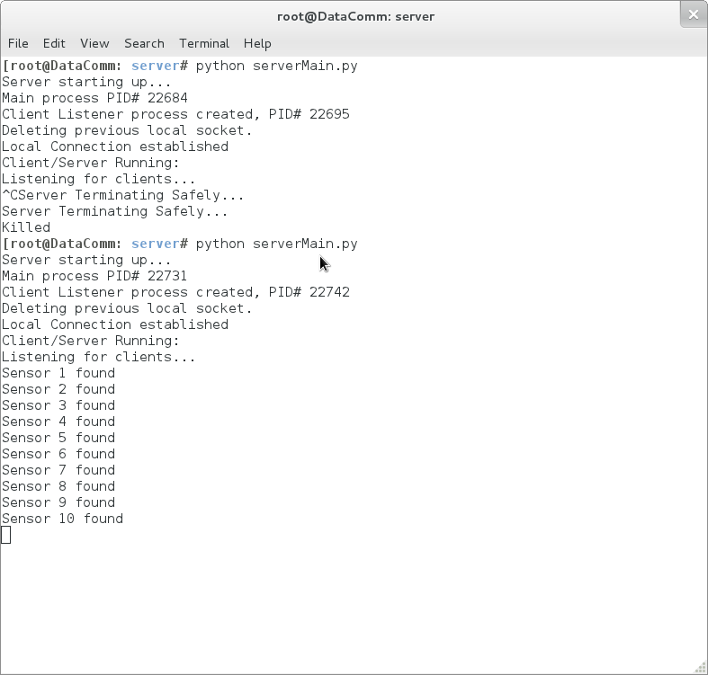

How to use virtual sensors

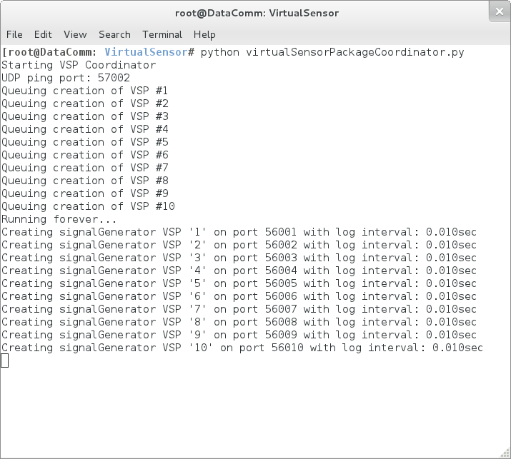

* Virtual sensor can be run by executing virtualSensorPackageCoordinator.py file
* It will display sensor creation status on screen, with port number for each sensor
* At this stage, sensors broadcast it’s serial number and port number on the network

How to use Client

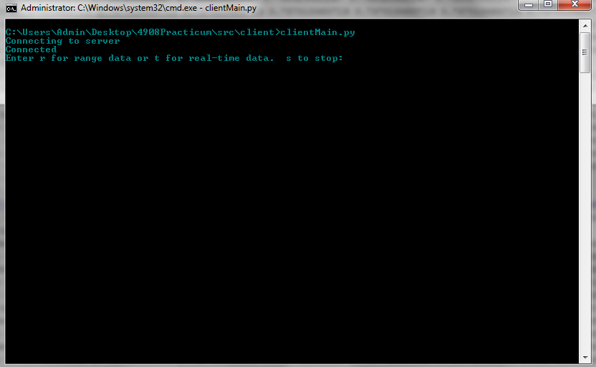

* Client can be started by running clientMain.py file
* Server’s IP needs to be passed in as argument (ie. clientMain.py 192.168.0.15)
* Once started, it will connect to the server and prompt for a command
* There are 3 commands: r for range data, t for real-time data, or s for stop
* When r is received, it will prompt for specific time value in second as range
* Once commands are received, it receives the data from the server and saves it as a file