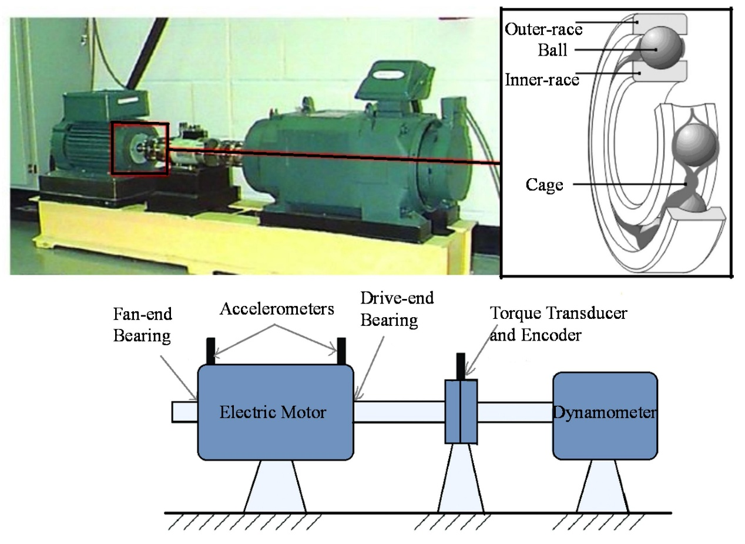

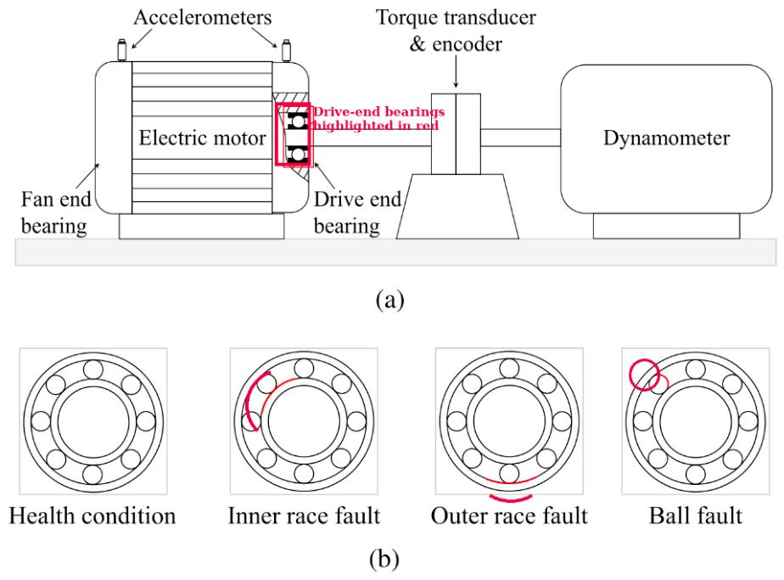
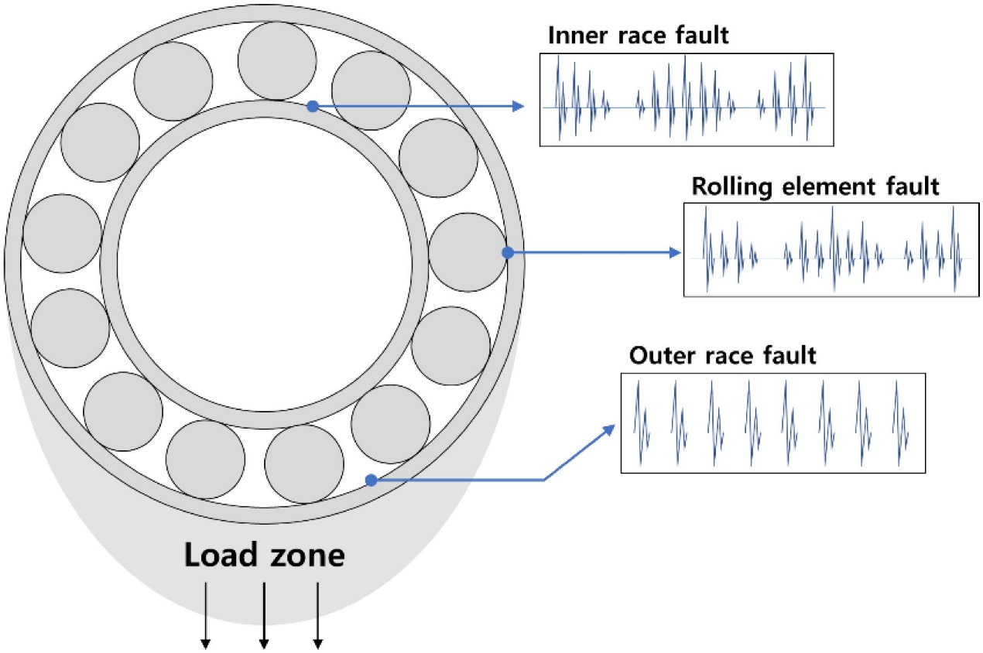
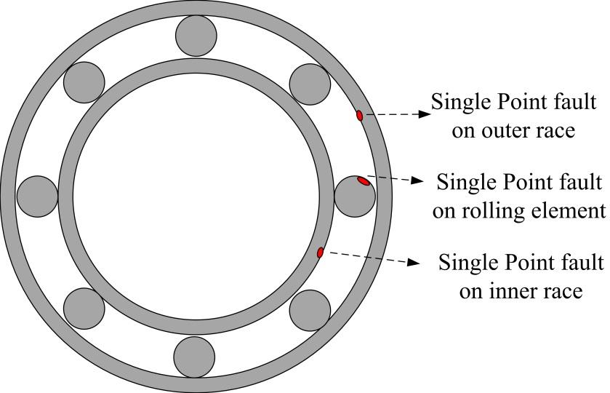

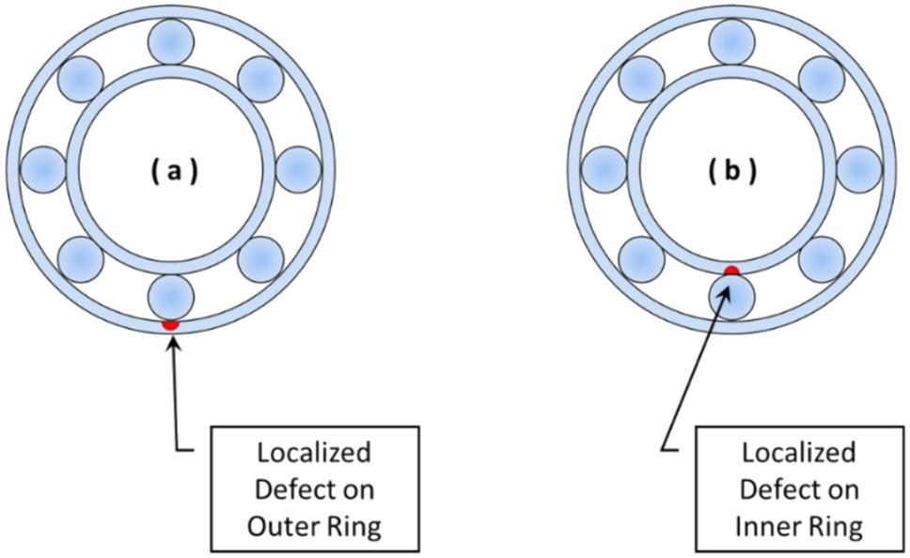
https://github.com/srigas/CWRU_Bearing_NumPy/tree/main

https://engineering.case.edu/bearingdatacenter/download-data-file

HP：Horse power
HP Reliance Electric moto

