{{enReceiveDate}}

To Whom It May Concern:

This is to certify that {{enSexPrefix}} {{enName}} ({{chName}}) has duly passed the qualification examination as {{enSubject}} and has been granted a certificate, No. {{enDocNo}} dated {{enReceiveDate}} to this effect by the Public Construction Commission, Executive Yuan.

Particulars of the certificate are as follows:

Name: {{enName}}

Sex: {{enSex}}

Date of Birth: {{enBirthDate}}

Classification: {{enSubject}}

Public Construction Commission

picture

Technical Department

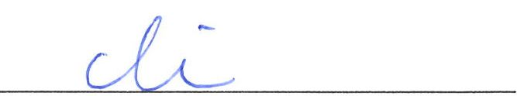

Lin, Chieh

Director

For Wu, Tse-Cheng

Chairperson of Public Construction Commission, Executive Yuan