Road Incidents, Car Wreck Fatalities & Covid in the United States 2019-2020

Katie Chen & Heather Lemon

2022/05/23

Introduction:

The COVID-19 pandemic first reached the United States in January of 2020, and rapidly spread throughout the country until it reached its first peak in March of 2020. In this project, we aim to find out if the number of national road incidents and car wreck fatalities changed between 2019 and 2020 when the pandemic began. Additionally, we want to know if the COVID-19 pandemic was a factor in affecting the number of driving incidents in 2020.

Authors:

Heather Lemon - Part 1 Comparing FARS 2019 with FARS 2020 Data Katie Chen - Part 2 Comparing FARS 2020 Data with the Covid Tracking Project

Data Sets:

<https://www.nhtsa.gov/file-downloads?p=nhtsa/downloads/FARS/> <https://covidtracking.com/data/national>

Loading in all the necessary libraries:

knitr::opts_chunk$set(echo = TRUE)  
library(tidyverse)

## -- Attaching packages --------------------------------------- tidyverse 1.3.1 --

## v ggplot2 3.3.5 v purrr 0.3.4  
## v tibble 3.1.6 v dplyr 1.0.8  
## v tidyr 1.2.0 v stringr 1.4.0  
## v readr 2.1.2 v forcats 0.5.1

## -- Conflicts ------------------------------------------ tidyverse_conflicts() --  
## x dplyr::filter() masks stats::filter()  
## x dplyr::lag() masks stats::lag()

library(dplyr)  
library(ggplot2)  
library(reshape2)

##   
## Attaching package: 'reshape2'

## The following object is masked from 'package:tidyr':  
##   
## smiths

library(lubridate)

##   
## Attaching package: 'lubridate'

## The following objects are masked from 'package:base':  
##   
## date, intersect, setdiff, union

library(glmnet)

## Loading required package: Matrix

##   
## Attaching package: 'Matrix'

## The following objects are masked from 'package:tidyr':  
##   
## expand, pack, unpack

## Loaded glmnet 4.1-4

# The questions we would like to answer:

Do you think the car wreck fatality rate went up or down from 2019-2020? Did Covid have an impact on car wreck fatalities?

# Part 1: FARS (Fatality Analysis Reporting System) 2019-2020 Comparisons

Reading in the data:

# Load people dataset:

person2020 = read.csv("./person2020.csv")  
dat20=data.frame(person2020)  
  
  
person2019 = read.csv("./person2019.csv")  
dat19=data.frame(person2019)

# Total Car Wreck Deaths in 2020&2019:

table_death_count2020=table(dat20$DOA)  
  
total2020=table_death_count2020[2]+table_death_count2020[3]  
  
table_death_count2019=table(dat19$DOA)  
total2019=table_death_count2019[2]+table_death_count2019[3]  
  
df2019=data.frame(total2019)  
df2020=data.frame(total2020)  
  
counts= c(df2019$total2019, df2020$total2020)  
years = c('2019', '2020')  
  
df=data.frame(years, counts)  
  
ggplot(data=df, aes(x=years, y=counts))+geom_bar(stat = "identity", width = .3,   
alpha=0.7, color="black")+ggtitle("Fatality Count per Year")

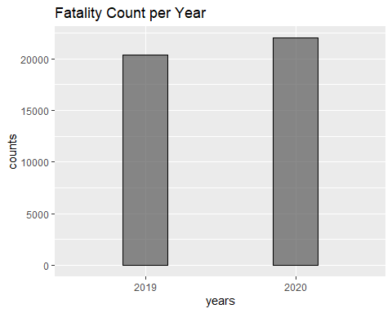

percent_increase = ((counts[2]-counts[1])/counts[1]) * 100  
percent_increase

## [1] 8.10333

# Breaking down deaths per Month:

n19=table(dat19$MONTHNAME)  
df19=data.frame(n19)  
  
n20=table(dat20$MONTHNAME)  
df20=data.frame(n20)  
  
sort_by_month<-factor(df19, levels = month.name)  
  
df_month_19=data.frame(sort_by_month)  
df_month_20=data.frame(sort_by_month)  
  
ggplot(data = df19, aes(x=Var1, y=Freq))+  
 geom_point(stat = "identity")+geom_line()+  
 ggtitle("DEATH COUNT PER MONTH 2019")+  
 scale_x_discrete(limits=month.name)

## geom_path: Each group consists of only one observation. Do you need to adjust  
## the group aesthetic?

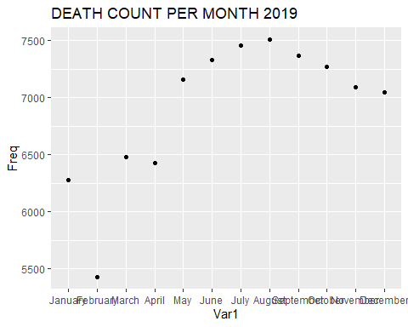

ggplot(data = df20, aes(x=Var1, y=Freq))+geom_point(stat = "identity")+  
 geom_line()+ggtitle("DEATH COUNT PER MONTH 2020")+  
 scale_x_discrete(limits=month.name)

## geom_path: Each group consists of only one observation. Do you need to adjust  
## the group aesthetic?

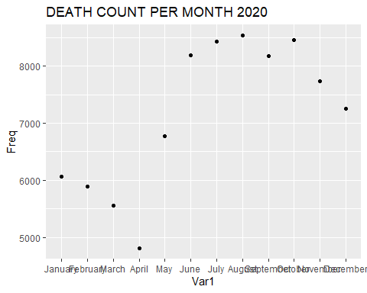

combined_df=rbind(df19, df20)  
  
ggplot(data = combined_df, aes(x=Var1, y=Freq))+  
 geom_point(data = df19, stat="identity")+  
 geom_line()+geom_point(data = df20, stat="identity")+  
 ggtitle("DEATH COUNT COMBINED")+  
 scale_x_discrete(limits=month.name)

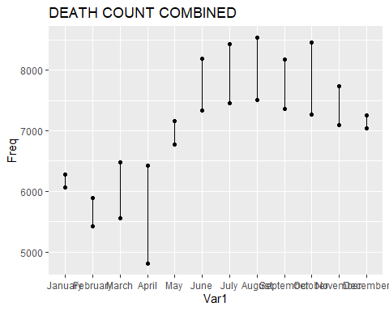

Apply filters for unknown data:

Age was inferred to be a factor in determining the differences between 2019 and 2020 car fatalities and road accidents. The graphs show the ages of drivers between the two years. # Age

age_19<-data.frame(AGE=dat19$AGE[dat19$AGE<115])  
ggplot(data=age_19, aes(x=AGE))+geom_bar(width=.5)+ggtitle("AGE 2019")

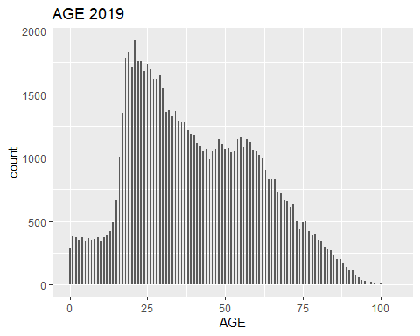

age_f<-data.frame(AGE=dat20$AGE[dat20$AGE<115])  
ggplot(data=age_f, aes(x=AGE))+geom_bar(width=.5)+ggtitle("AGE 2020")

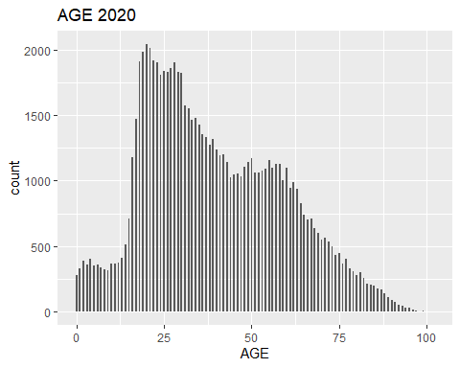

# Speeding Violations:

Speeding violations were inferred to be another factor that could impact the number of road accidents and fatalities. The graph below shows the total number of speeding violations per year and the percentage change between 2019 and 2020.

v2020=read.csv("./violatn2019.CSV")  
v2019=read.csv("./violatn2020.CSV")  
  
  
#speeding codes  
viol_df2019=data.frame(table(v2019$VIOLATION))  
speeding2019=viol_df2019$Freq[20]+viol_df2019$Freq[21]+viol_df2019$Freq[22]  
+viol_df2019$Freq[23]+viol_df2019$Freq[24]+viol_df2019$Freq[25]

## [1] 158

viol_df2020=data.frame(table(v2020$MVIOLATN))  
speeding2020=viol_df2020$Freq[20]+viol_df2020$Freq[21]+viol_df2020$Freq[22]  
+viol_df2020$Freq[23]+viol_df2020$Freq[24]+viol_df2020$Freq[25]

## [1] 142

speeding_counts= c(speeding2019, speeding2020)  
years = c('2019', '2020')  
  
df=data.frame(years, speeding_counts)  
  
ggplot(data=df, aes(x=years, y=speeding_counts))+geom_bar(stat = "identity",   
width = .3)+ggtitle("Speeding Count per Year")

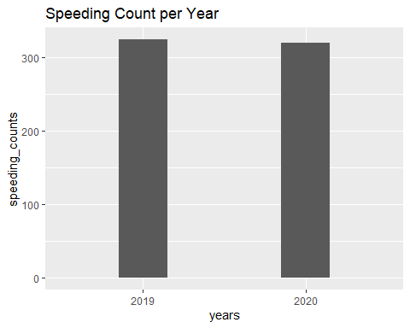

percent_speeding =   
 ((speeding_counts[2]-speeding_counts[1])/speeding_counts[1]) * 100  
percent_speeding

## [1] -1.234568

From the observation above, we would be hesitant to say that speeding was a major factor of why the increase in fatalities, despite having personal connections say that there has been a noticeable increase of people speeding.

For example, here is an article relating speeding as a reason for more deaths: <https://www.thelongofirm.com/posts/colorado-car-accident-fatalities-increase-2020>

# Accidents related to Alcohol:

Alcohol-related incidents would have been another contributing factor towards road incidents and fatalities. The graph below shows the total number of alcohol-related deaths between 2019 and 2020.

alc_df2019=data.frame(table(dat19$DRINKING))  
alc_df2020=data.frame(table(dat20$DRINKING))  
  
counts= c(alc_df2019$Freq[2], alc_df2020$Freq[2])  
years = c('2019', '2020')  
  
df_alc=data.frame(years, counts)  
  
ggplot(data = df_alc, aes(x=years, y=counts))+geom_bar(stat = "identity",   
width = .3)+ggtitle("Alcohol Related Death Count")

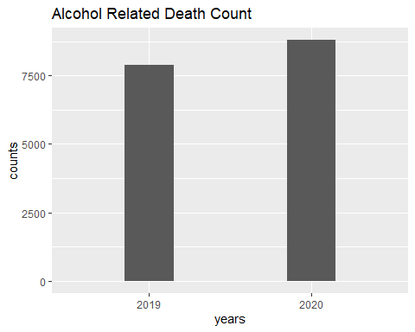

percent_alcohol = ((counts[2]-counts[1])/counts[1]) * 100  
percent_alcohol

## [1] 11.62142

# Ridge Regression Method (Math):

Ridge Regression is used to fit a model that has multicollinearity while trying to minimize the (RSS) sum of square residuals. Col-linearity in regression is the event of two or more variables being highly linearly related.

In terms of relationships between variables, our use case refers to the target or dependent variable as the number of car wrecks. The independent variable or predictor variable could be any of these; speeding, weather, age, covid cases, alcohol, drugs, etc.

*least squares regression tries to find coefficient estimates that minimize the sum of squared residuals (RSS) (<https://www.statology.org/ridge-regression-in-r/>)

As the tuning parameter gets larger the value of the coefficients shrink towards 0.

# The Ridge Regession Esimator:

$$∑\left[yi−{\hat{y}}_{i}^{2}\right]+λ\sum_{k=1}^{k}{y_{i}^{2}}$$

Another form in linear algebra.

$$\hat{β}\left(λ\right)={\left(X^{T}X+λI_{p×p}\right)}^{−1}X^{T}Y$$

Linear algebra plays a significant role in understanding the lambda value as well as the rank and matrix operations. Selecting a valid lambda value is crucial to getting the best fit for the model.

$$y= f\left(x_{1}, x_{2}, x_{3}... x_{n}\right)$$

To put it simply we want to know which predictor

$$\left(x_{i}\right)$$

had the greatest affect on the dependent variable y.

# Part 2: FARS 2020 Comparison with COVID-19

# Cleaning and Reformatting Data:

The Covid-19 dataset taken from the Covid Tracking Project was reformatted to include the final positive case counts from each month between January and December 2020. Given that the original data set tracked cumulative daily counts, this was calculated by taking the total case counts on the last day of each month.

#This section gets the total count of covid-19 cases from January-December 2020  
dat <- read.csv('national-history.csv')  
  
#convert date to datetime  
dat<-dat %>%  
 mutate(date=as.Date(date))  
  
#cut to all entries between January 2020 - December 2020  
y_2020 <- filter(dat, dat$date <= '2020-12-31' )  
  
#take the final case counts from each month  
# creates an identifier with which to group  
y_2020$mon_yr <- format(as.Date(y_2020$date), '%Y-%m')  
#groups by created month identifier and then keeps only those rows with last(max) date  
cases <- y_2020 %>% group_by(mon_yr) %>% filter(date == max(date))  
cases

## # A tibble: 12 x 18  
## # Groups: mon_yr [12]  
## date death deathIncrease inIcuCumulative inIcuCurrently  
## <date> <int> <int> <int> <int>  
## 1 2020-12-31 336802 3297 37066 23097  
## 2 2020-11-30 259690 1037 30469 18807  
## 3 2020-10-31 222625 958 24375 9613  
## 4 2020-09-30 199080 1064 20390 6241  
## 5 2020-08-31 175751 380 17537 7054  
## 6 2020-07-31 145507 1324 14044 10471  
## 7 2020-06-30 120258 583 10669 7419  
## 8 2020-05-31 100783 654 8446 8373  
## 9 2020-04-30 59646 2153 4192 13982  
## 10 2020-03-31 4331 909 230 3487  
## 11 2020-02-29 5 1 NA NA  
## 12 2020-01-31 NA 0 NA NA  
## # ... with 13 more variables: hospitalizedIncrease <int>,  
## # hospitalizedCurrently <int>, hospitalizedCumulative <int>, negative <int>,  
## # negativeIncrease <int>, onVentilatorCumulative <int>,  
## # onVentilatorCurrently <int>, positive <int>, positiveIncrease <int>,  
## # states <int>, totalTestResults <int>, totalTestResultsIncrease <int>,  
## # mon_yr <chr>

# Graphing and Displaying Reformatted Data:

In graphing the number of positive covid-19 cases, a log scale was added to better show the overall number of cases nationwide.

#graph the positive cases  
  
cases$logpositive = log(cases$positive)  
cases$monthnames <- months(as.Date(cases$date))  
cases$month<-factor(cases$monthnames, levels = month.name)  
  
ggplot(data = cases, aes(x = month, y = logpositive)) +  
 geom_point() +  
 labs(x = "Month",  
 y = "Postive Cases (Log)",  
 title = "Positive Covid Cases in 2020 (Log form)") +   
 theme(axis.text.x=element_text(angle=45,hjust=1))

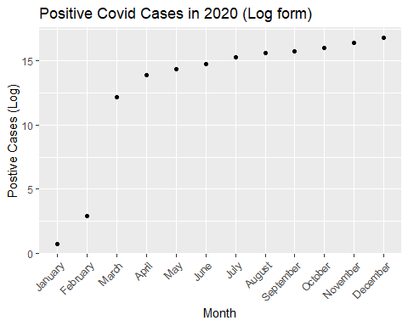

ggplot(data = cases, aes(x = month, y = positive)) +  
 geom_point() +  
 labs(x = "Month",  
 y = "Postive Cases",  
 title = "Positive Covid Cases in 2020") +   
 theme(axis.text.x=element_text(angle=45,hjust=1))

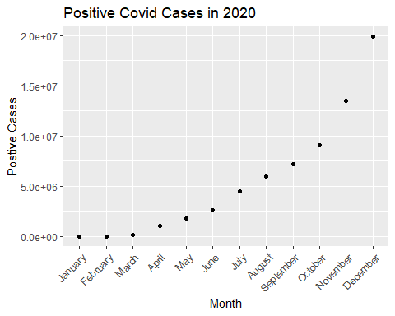

For additional comparison, a bar chart was added to reflect the total covid-19 case counts in both the normal and log scales.

#as a bar chart  
  
cases$logpositive = log(cases$positive)  
cases$monthnames <- months(as.Date(cases$date))  
cases$month<-factor(cases$monthnames, levels = month.name)  
  
ggplot(cases, aes(month)) + geom_bar(aes(weight=positive), position="dodge", fill= 'lightblue') + theme(axis.text.x=element_text(angle=45,hjust=1)) + labs(x = "Month",  
 y = "Postive Cases",  
 title = "Positive Covid Cases in 2020")

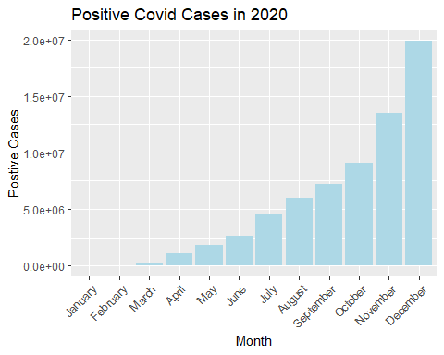

ggplot(cases, aes(month)) + geom_bar(aes(weight=logpositive), position="dodge", fill= 'lightblue') + theme(axis.text.x=element_text(angle=45,hjust=1)) + labs(x = "Month",  
 y = "Postive Cases (log)",  
 title = "Positive Covid Cases in 2020 in Log Format")

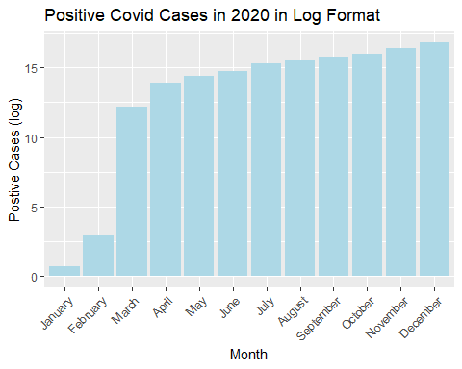

# Cleaning and Reformatting Road Incident Data:

Road accident data taken from FARS (Fatality Analysis Reporting System) 2020 was cleaned and reformatted to reflect aggregated data by month. The reformatted data was then merged with covid-19 data to show the following:

* month of the year
* total number of road incidents reported by FARS
* total positive covid-19 case counts
* the average age of individuals involved in FARS incidents
* total number of drinking violations
* total number of speeding violations

The following rmd blocks show the complete process of reformatting and merging the two data sets:

# 1. Read in FARS 2020 data set:

# total car wrecks in 2020  
car_wrecks <- read.csv('person2020.csv')

# 2. Aggregate the total number of entries per month:

#counts of car wrecks by month  
df <- data.frame(aggregate(car_wrecks, by=list(car_wrecks$MONTHNAME), FUN=length))  
names(df) <- c('Month','Crashes')  
  
#stick it in a new data frame  
columns <- c('Month','Crashes')  
data2020 <- df[,columns]  
  
data2020

## Month Crashes  
## 1 April 4811  
## 2 August 8535  
## 3 December 7255  
## 4 February 5891  
## 5 January 6071  
## 6 July 8425  
## 7 June 8185  
## 8 March 5562  
## 9 May 6778  
## 10 November 7736  
## 11 October 8459  
## 12 September 8177

# 3. Merge (inner join) reformatted covid-19 data with FARS entry counts on month

Log scales were added for both covid-19 cases and crash data for scalable comparison.

#combine covid 2020 with car crashes 2020  
covid <- data.frame(cases$monthnames, cases$positive)  
names(covid) <- c("Month", "Cases")  
  
total <- merge(data2020, covid, by.x = "Month", by.y="Month")  
names(total) <- c("Month", "Crashes", "Cases") #naming them so we don't throw an error  
  
total$logCases <- log(total$Cases)  
total$logCrashes<-log(total$Crashes)  
total

## Month Crashes Cases logCases logCrashes  
## 1 April 4811 1073244 13.8861964 8.478660  
## 2 August 8535 5980439 15.6040045 9.051931  
## 3 December 7255 19864374 16.8044384 8.889446  
## 4 February 5891 18 2.8903718 8.681181  
## 5 January 6071 2 0.6931472 8.711279  
## 6 July 8425 4523226 15.3247360 9.038959  
## 7 June 8185 2623046 14.7798468 9.010058  
## 8 March 5562 196965 12.1907813 8.623713  
## 9 May 6778 1791449 14.3985353 8.821437  
## 10 November 7736 13541108 16.4212407 8.953640  
## 11 October 8459 9065117 16.0199443 9.042986  
## 12 September 8177 7173102 15.7858488 9.009081

# 4. Age was taken from the original FARS 2020 data set and aggregated by calculating the average age per month of individuals involved in each FARS incident. Entries reflecting unknown ages ‘999’ were dropped.

#Since our data set is split by month, we can get  
#average age each month  
  
car_wrecks.age<-filter(car_wrecks, AGE != 999)  
#car_wrecks.age$AGE  
  
car_wrecks.age <- car_wrecks.age %>%  
 group_by(MONTHNAME) %>%  
 summarise(result = mean(AGE) )  
  
names(car_wrecks.age) <- c("Month", "Avg_Age")  
  
car_wrecks.age

## # A tibble: 12 x 2  
## Month Avg_Age  
## <chr> <dbl>  
## 1 April 53.7  
## 2 August 50.6  
## 3 December 54.6  
## 4 February 48.0  
## 5 January 51.9  
## 6 July 52.5  
## 7 June 45.9  
## 8 March 52.4  
## 9 May 49.2  
## 10 November 58.5  
## 11 October 53.4  
## 12 September 52.8

# 5. Cleaned and reformatted age data was merged.

#join the age table on total  
total.a <- merge(total, car_wrecks.age, by.x = "Month", by.y="Month")  
total.a

## Month Crashes Cases logCases logCrashes Avg_Age  
## 1 April 4811 1073244 13.8861964 8.478660 53.74868  
## 2 August 8535 5980439 15.6040045 9.051931 50.62693  
## 3 December 7255 19864374 16.8044384 8.889446 54.57355  
## 4 February 5891 18 2.8903718 8.681181 48.01624  
## 5 January 6071 2 0.6931472 8.711279 51.89990  
## 6 July 8425 4523226 15.3247360 9.038959 52.47881  
## 7 June 8185 2623046 14.7798468 9.010058 45.86492  
## 8 March 5562 196965 12.1907813 8.623713 52.42142  
## 9 May 6778 1791449 14.3985353 8.821437 49.21146  
## 10 November 7736 13541108 16.4212407 8.953640 58.49599  
## 11 October 8459 9065117 16.0199443 9.042986 53.40945  
## 12 September 8177 7173102 15.7858488 9.009081 52.79774

#6. Drinking reports were calculated based on known reported drinking incidents, where the DRINKING column in the original FARS data set = 1. A sum for each month was calculated and inserted into a dataframe.

#here we aggregate Drinking reports  
car_wrecks.drink<-filter(car_wrecks, DRINKING==1)  
#car_wrecks.drink  
  
car_wrecks.drink <- car_wrecks.drink %>%  
 group_by(MONTHNAME) %>%  
 summarise(result = sum(DRINKING) )  
  
names(car_wrecks.drink) <- c("Month", "drink_counts")  
  
car_wrecks.drink

## # A tibble: 12 x 2  
## Month drink_counts  
## <chr> <int>  
## 1 April 468  
## 2 August 962  
## 3 December 689  
## 4 February 606  
## 5 January 615  
## 6 July 837  
## 7 June 897  
## 8 March 581  
## 9 May 729  
## 10 November 782  
## 11 October 798  
## 12 September 834

# 7. Drinking counts were merged into the data frame.

#merge drinking with total  
  
total.b <- merge(total.a, car_wrecks.drink, by.x = "Month", by.y="Month")  
total.b

## Month Crashes Cases logCases logCrashes Avg_Age drink_counts  
## 1 April 4811 1073244 13.8861964 8.478660 53.74868 468  
## 2 August 8535 5980439 15.6040045 9.051931 50.62693 962  
## 3 December 7255 19864374 16.8044384 8.889446 54.57355 689  
## 4 February 5891 18 2.8903718 8.681181 48.01624 606  
## 5 January 6071 2 0.6931472 8.711279 51.89990 615  
## 6 July 8425 4523226 15.3247360 9.038959 52.47881 837  
## 7 June 8185 2623046 14.7798468 9.010058 45.86492 897  
## 8 March 5562 196965 12.1907813 8.623713 52.42142 581  
## 9 May 6778 1791449 14.3985353 8.821437 49.21146 729  
## 10 November 7736 13541108 16.4212407 8.953640 58.49599 782  
## 11 October 8459 9065117 16.0199443 9.042986 53.40945 798  
## 12 September 8177 7173102 15.7858488 9.009081 52.79774 834

#8. Speeding related incidents were manually taken from the FARS annual report. The following vector reflects the total speeding violation counts per month in 2020. A month vector was added and speeding related incidents transformed into a data frame. Dataframe total.c reflects the final data frame transformation with all our predictor variables.

#add speeding-related incidents  
#manually taken from page 19  
#Table 4. Monthly Traffic Fatalities, by Speeding Involvement,   
#Alcohol-Impaired Driving, and Passenger Vehicle Occupant Restraint Use, 2019 and 2020  
  
speeding <- c(733, 718, 735, 761, 1007, 1189, 1151, 1089, 1079, 999, 883, 914)  
month<-month.name  
  
car_wrecks.speeding <- data.frame(month, speeding)  
names(car_wrecks.speeding)<-c("Month", "Speeding")  
  
#merge into the main df  
  
total.c <- merge(total.b, car_wrecks.speeding, by.x = "Month", by.y="Month")  
total.c

## Month Crashes Cases logCases logCrashes Avg_Age drink_counts  
## 1 April 4811 1073244 13.8861964 8.478660 53.74868 468  
## 2 August 8535 5980439 15.6040045 9.051931 50.62693 962  
## 3 December 7255 19864374 16.8044384 8.889446 54.57355 689  
## 4 February 5891 18 2.8903718 8.681181 48.01624 606  
## 5 January 6071 2 0.6931472 8.711279 51.89990 615  
## 6 July 8425 4523226 15.3247360 9.038959 52.47881 837  
## 7 June 8185 2623046 14.7798468 9.010058 45.86492 897  
## 8 March 5562 196965 12.1907813 8.623713 52.42142 581  
## 9 May 6778 1791449 14.3985353 8.821437 49.21146 729  
## 10 November 7736 13541108 16.4212407 8.953640 58.49599 782  
## 11 October 8459 9065117 16.0199443 9.042986 53.40945 798  
## 12 September 8177 7173102 15.7858488 9.009081 52.79774 834  
## Speeding  
## 1 761  
## 2 1089  
## 3 914  
## 4 718  
## 5 733  
## 6 1151  
## 7 1189  
## 8 735  
## 9 1007  
## 10 883  
## 11 999  
## 12 1079

The following graph shows the final monthly aggregates for each predictor in our data set.

#graph the totals  
total.c$logAge <- log(total.c$Avg_Age)  
total.c$logDrinks <- log(total.c$drink_counts)  
total.c$logSpeed <- log(total.c$Speeding)  
  
# Reshape data frame  
df_reshaped <- data.frame(x = total.c$Month,  
 y = c(total.c$logCases, total.c$logCrashes,   
 total.c$logAge, total.c$logDrinks, total.c$logSpeed),  
 group = c(rep("Covid Cases", nrow(df)),  
 rep("Crashes", nrow(df)),  
 rep("Average Age", nrow(df)),  
 rep("Drinking Violations", nrow(df)),  
 rep("Speeding Violations", nrow(df))  
 ))  
  
df_reshaped$x <- factor(df_reshaped$x, levels = month.name)  
  
ggplot(df_reshaped, aes(x, y, col = group)) + geom_line(aes(group = group)) +   
 geom_point(aes(group = group)) +   
 theme(axis.text.x=element_text(angle=45,hjust=1)) + labs(x = "Month",  
 y = "Predictors",  
 title = "Counts of Predictor Variables on Car Accidents by Month in 2020 (Log Scale)")

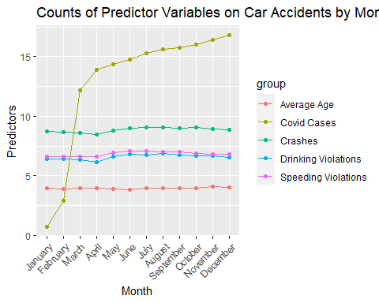

# Ridge Regression Analysis:

The ridge regression was performed using the final transformed data frame “total.c”. In this analysis, the response variable is defined as the total number of incidents per month reported by FARS. Columns ‘Cases’, ‘Avg_Age’, ‘drink_counts’, and ‘Speeding’ were formatted into an ‘x’ matrix. Using the glmnet package, a ridge regression model was fitted onto the x and y variables, and an optimal lambda value minimizing the mean squared error was chosen.

#begin ridge regression  
  
#define response variable and predictors  
y <- total.c$Crashes  
x<-data.matrix(total.c[,c('Cases','Avg_Age','drink_counts', 'Speeding')])  
  
#fit ridge regression model  
model <- glmnet(x, y, alpha = 0)  
#summary(model)  
  
#perform k-fold cross-validation to find optimal lambda value  
cv_model <- cv.glmnet(x, y, alpha = 0)

## Warning: Option grouped=FALSE enforced in cv.glmnet, since < 3 observations per  
## fold

#find optimal lambda value that minimizes test MSE  
best_lambda <- cv_model$lambda.min  
best_lambda

## [1] 479.2966

#produce plot of test MSE by lambda value  
plot(cv_model)

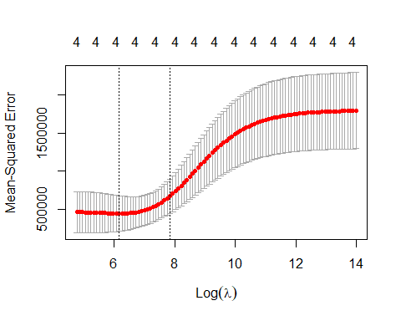

Based on the values of the coefficients of the best model, we can conclude that the number of positive covod-19 cases had very little to no effect on the overall number of FARS driving incidents in 2020. In fact it appears that the average age of drivers had the largest impact, followed by overall alcohol consumption and speeding incidents.

#coefficients of the best model  
best_model <- glmnet(x, y, alpha = 0, lambda = best_lambda)  
coef(best_model)

## 5 x 1 sparse Matrix of class "dgCMatrix"  
## s0  
## (Intercept) 7.758772e+02  
## Cases 3.563755e-05  
## Avg_Age 1.858331e+01  
## drink_counts 4.065878e+00  
## Speeding 2.386681e+00

The model below shows the Ridge trace plot for each of the coefficients as the log lambda increases. As lambda increases, the coefficients trend towards 0.

#produce Ridge trace plot  
plot(model, xvar = "lambda")

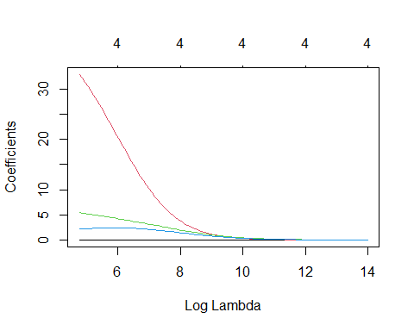

# Verifying our Model

To verify the accuracy of our model, we predicted some y-values using our best model and used these values to calculate the total sum of squares (sst) and the sum of squared errors (sse). From these values, we know that the R^2 value of our model is about 0.94. Thus, our model explains about 94% of the variation in our data.

#use fitted best model to make predictions  
y_predicted <- predict(model, s = best_lambda, newx = x)  
  
#find SST and SSE  
sst <- sum((y - mean(y))^2)  
sse <- sum((y_predicted - y)^2)  
  
#find R-Squared  
rsq <- 1 - sse/sst  
rsq

## [1] 0.9177653

Because the original data sets had to be aggregated in order to run the model, there may have been some loss in the data when translating into the model. Many entries in the FARS data set had unknown values. Thus there may have been insufficient data for the Drinking, Age, and Speeding columns, and the coefficients for the best-fit Ridge regression model may not be representative of the true population values.

Finally, there may have been many other predictors not considered within this report that could have affected our conclusion. Nevertheless, the empirical evidence of the study seems to suggest that there were differences in the number of vehicle accidents and fatalities between 2019 and 2020, and that the COVID-19 pandemic did not appear to have a significant impact on the number of road incidents in 2020. The number of overall car wreck incidents went down from 2019-2020 however, the total number of car wreck fatalities increased.[2]

# Citations

*[0] Ridge Regression in R (Step-by-Step)* [*https://www.statology.org/ridge-regression-in-r/*](https://www.statology.org/ridge-regression-in-r/)[1] Elements of Statistical Learning Data Mining, Inference, and Prediction *[2]* [*https://www.nhtsa.gov/press-releases/2020-traffic-crash-data-fatalities*](https://www.nhtsa.gov/press-releases/2020-traffic-crash-data-fatalities)[3] COVID dataset <https://covidtracking.com/data/national> *[4] FARS <https://www.nhtsa.gov/file-downloads?p=nhtsa/downloads/FARS/>