**Spotify understand which features make a song popular**

Heather Lemon

Department of Computer Science, University of Denver

COMP 4449 Capstone Midterm

Dr. Claudio Delrieux

April 3, 2023

**Spotify understand which features make a song popular by Heather Lemon**

Spotify is a popular music and media steaming service. Founded in 2006, it has grown to over 450 million active users and is one of the most successful and largest music streaming platforms available today.[2] Spotify has a developer API access to gather detailed information about a song, but that data is already provided for us in a CSV format.

The goal of this project is to predict which features about a song’s attributes make it “popular”.

This data contains audio features like Tempo, BPM, Liveness, Valence(Positivity) and many more.

**Description of the Dataset**

The dataset comes from five files. The ranking_spotify.csv files contains more than 2 million rows, which comprises 6629 artists, 18598 songs for a total count of one hundred five billion streams count. This csv contains the daily ranking of the 200 most listened songs every day, in 53 countries from 2017 and 2018 in Spotify.

For the purpose of narrowing the scope of the dataset, we will choose only songs from the year 2017 and country. The second dataset comes from featuresdf.csv. It contains popular song attributes such as (tempo, energy, song name etc.) There are 13 numerical columns about a song's attributes and 3 categorical columns (song name, artist, key symbol (C#))[1]. By scoping the issue down to only songs from region USA and year 2017, we have 72,400 rows from the daily popular song list.

**Data Preprocessing**

The first step was cleaning and feature engineering. Where we chose to covert the time in milliseconds to minutes/seconds, a much more human readable format. The other feature engineering task was converting the key signature from 0-11 to the symbol used such as C#.

Null checks and data type checks were implemented on both dataframes; ranking_spotify_1 and features_df.

**Exploratory Data Analysis**

Seventeen features is a lot to show for a pairplot, so I went with a histplot of the features df.

**Figure 1**

*HistPlot of all numerical features df*

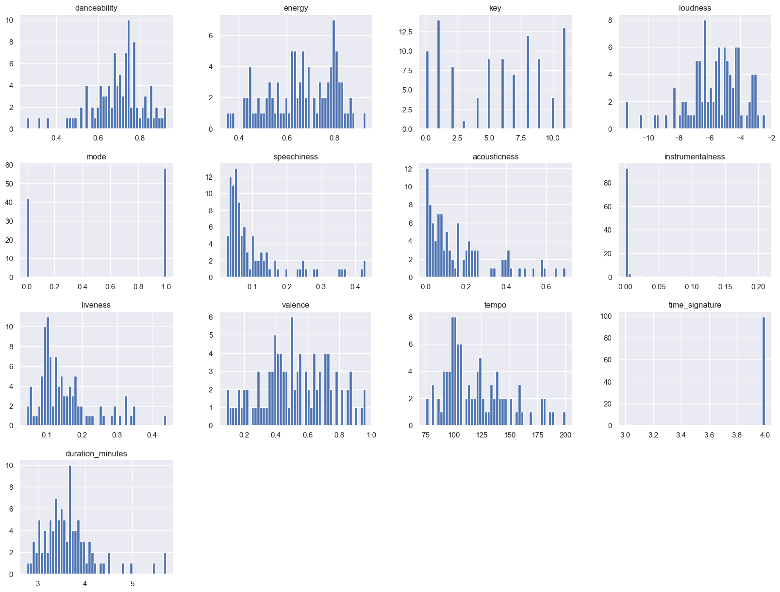

*\*Note:* *There is a mix of normal and non-normal distributions, some have a normal distribution while other features only have one to two values.*

**Figure 2**

*Statistical Output of Song Details*

*\*Note: Most features between mean and median are similar but a few of the features are skewed and the standard deviation is low except for tempo (BPM).*

**Figure 3**

*Correlation Plot*

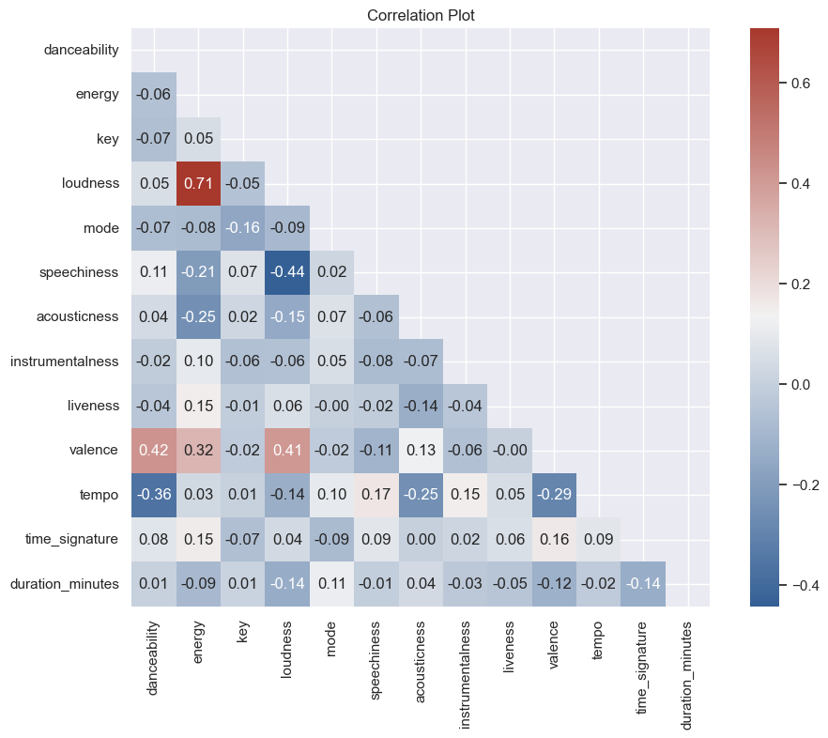

*\*Note: Energy and loudness have a strong positive correlation.*

*Valance and danceability, energy and loudness all have a positive correlation.*

*Loudness and speechiness have a negative correlation, which makes sense if a song is very loud you likely cannot hear the person singing in the background unless you're talking about death metal :) Surprising note - I expected danceability to have a stronger correlation with loudness, but there can be songs to be used to dance formally like a waltz or tango.*

**Figure 4**

*KDE Plot of positively correlated features*

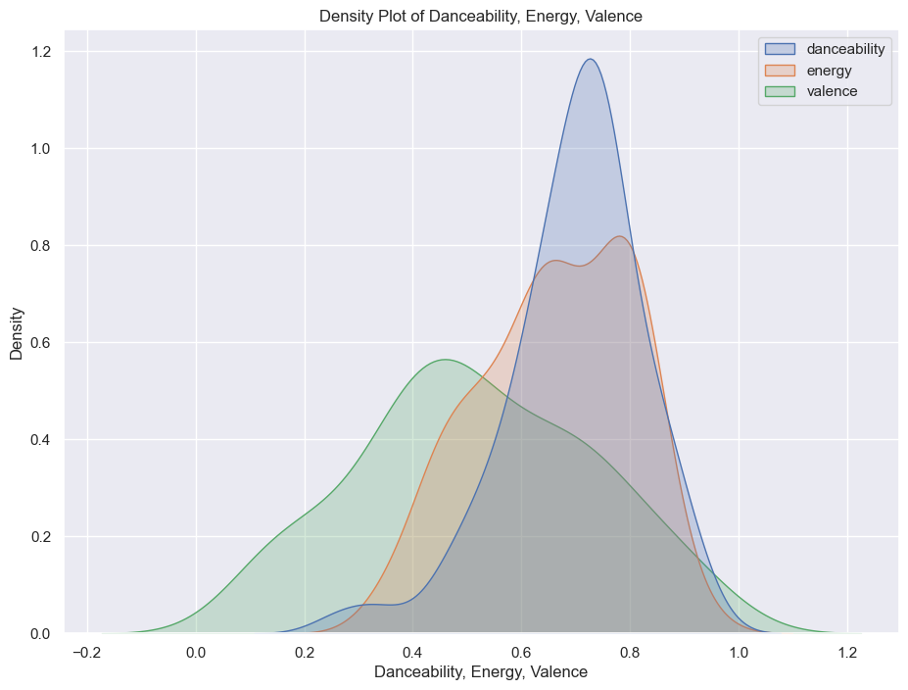

*\*Note: the shapes are similar*

**Figure 5**

*Top 100 Rankings vs Number of Streams*

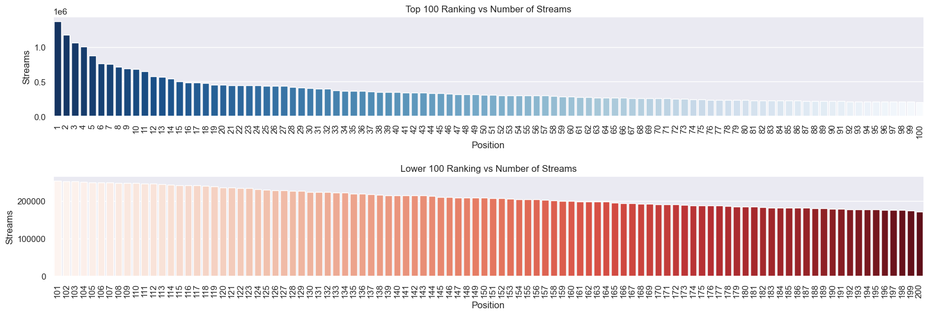

*\*Note: The top 100 most stream songs with the highest 5 having over a million streams per song with the lower 25% still around 500k streams. While the lower 100 rankings have values around 200k.*

**Figure 6**

*Stream Count per Season*

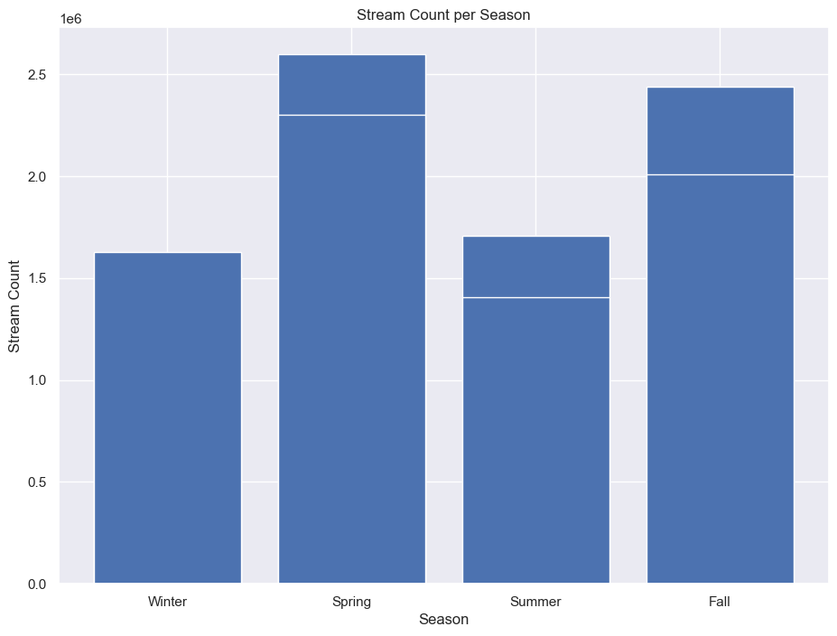

*\*Note: Spring had the highest average streamer count*

**Figure 7**

*Top 10 Spotify Reoccurring Artists*

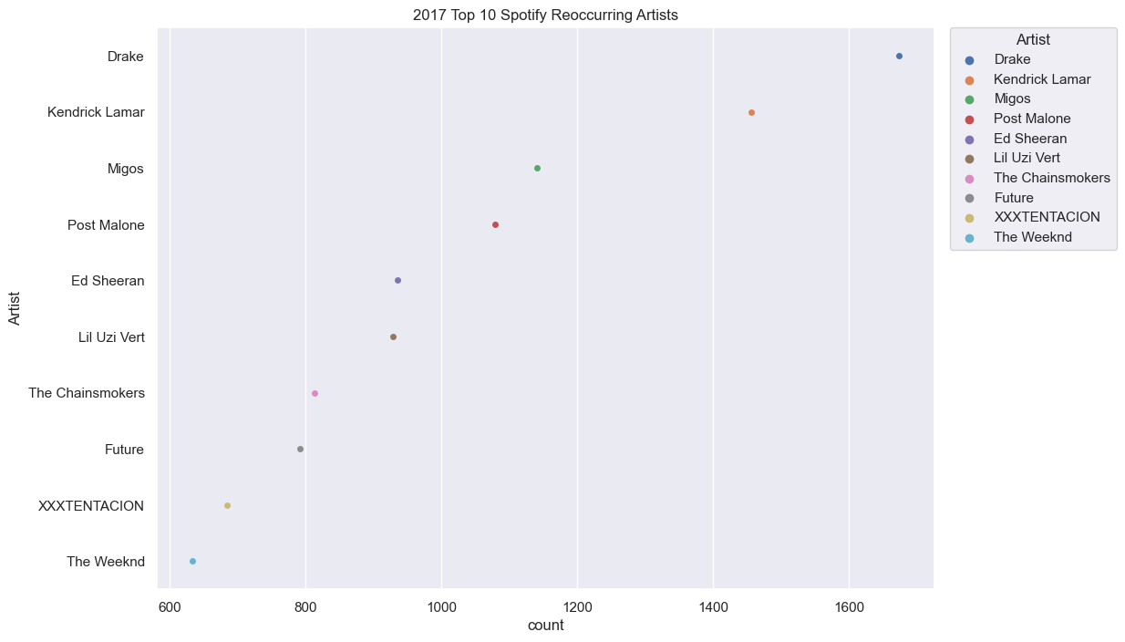

*\*Note: This was just for fun, but it seems Drake is pretty popular*

**Pre Model Data Prep**

A key feature to this project is using features_df as a lookup table for popular song details.

We merge the two dataframes together to include popular song details via song and artist name.

We drop the categorical features before the modeling phase including anything that was not part of the original dataset, i.e. We don’t want to include the month in song attributes list.

Data scaling with the StandardScaler method because the features all have different relational values i.e. energy is not on the same scale as minutes.

Data Split with an 80/20 split of the data leaving us with (16184, 13) training examples and (4047,) test examples.

The target value is the position of ranking out of our 200 songs listed every day.

**Model Building and Evaluation**

Every model is rank sorted from highest to lowest.

Linear regression’s most important feature is energy with a low accuracy score of 0.05%.

Decision Tree Regressor’s most important attribute was acousticness with an accuracy score of 0.35%. Random Forest Regressor most important attribute was acousticness with an accuracy score of 0.35%. SVM-R most important attribute was tempo with a low accuracy score of 0.28%.

Bagging Regressor most important attribute was acousticness with a low accuracy score of 0.34%. Ridge Regressor most important attribute was energy with a low accuracy score of 0.05%.

**Figure 8**

*Table of model, accuracy score, most important feature, and feature’s score*

Next, we chose the top three models by accuracy score and ran a cross validation score to see a closer look at the performance of the models.

**Figure 9**

*Cross Validation Mean Accuracy Score*

The cross validation score the same for all three models.

**Hyper Parameter Tuning**

The Random Forest and Decision Tree Regressor models were closer in value score.

Tuning the models and running the grid search function for both resulted in an accuracy score of 35% for random forest and $R^{2}$ of 0.35 for both models. Both models performance was the same. It doesn't really matter which of the two models we choose, because we are most likely underfitting the data where we cannot capture the relationship properly between the inputs and outputs accurately.

**Final Model Selection**

The model selected was the random forest regressor model because the accuracy score was poorer on the decision tree regression. Running the final predictions on the test set concludes with an R2 score of 0.35 an MSE of 0.65 and an RMSE of 0.80. Here are the final coefficient values for each of the feature variables.

**Figure 10**

*Final Model Feature Importance*

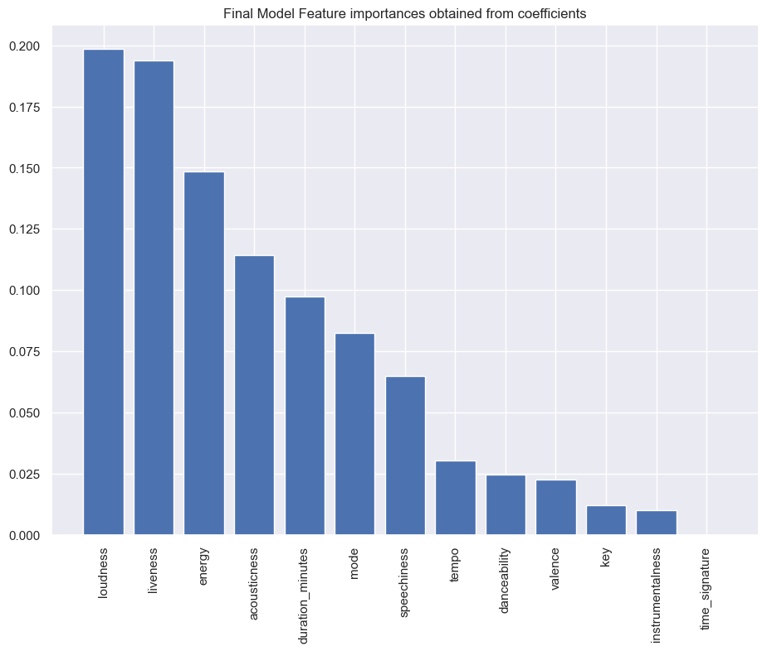

The final model predicted loudness as the most contributing factor to a song’s popularity.

We have a different output than the expected from our training set which is why we are most likely underfitting our data such that the inputs do not give a good representation of the outputs.

Loudness being a big indicator, which is a bit surprising, and is potentially more indicative of the decibel level in which most "popular" songs are mixed at.

**SHAP and Explainable AI**

For machine learning models this means that SHAP values of all the input features will always sum up to the difference between baseline (expected) model output and the current model output for the prediction being explained.

**Figure 11**

*Beeswarm plot*

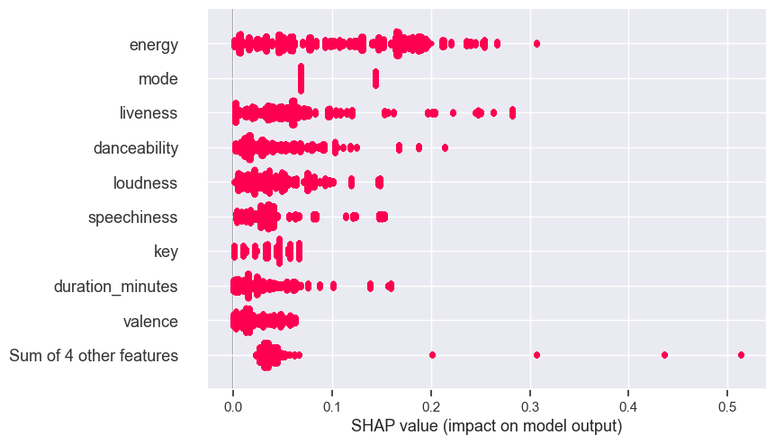

*\*Note: Beeswarm plot shows the same explainable output for the linear regression model output of feature importance*

**Conclusion**

In answering the research question, predicting which attributes make a song popular? We saw different regression models give different answers as to what it thought made the most contributions to a song’s popularity. I don’t believe we have done a good enough job capturing the relationship between a song’s attributes and its popularity ranking. Genre and the popularity score were excluded from this project, adding those attributes back, would help clarify some of the relations between the inputs and outputs. With such low accuracy scores across all models, it would be difficult to choose one for production. With poor performance on both the training and test sets, it’s likely we are underfitting the data and addressing that concern should be a priority. Gathering more information or reframing the question might make it simpler to execute and achieve better results. It was still very interesting to see the machine learning models identify which features about a song, the model thought were most important for popularity.

**Figure 12**

**Surprise! Explainable machine learning with explainerdashbord package**

The explainerdashboard package only need the machine learning model, the training or test set and to have an Explainer variable instantiated which we already did for the linear regression model and so we will use the linear regression model as an example here. Clicking the link will open a new browser tab to show you the dashboard the model built.

**Future Improvements**

Although we were unable to use any of the textual data, it would be interesting to see the lyrics to be included in the study and you can do analysis around that as well. Having a configurable threshold would also be an interesting feature to be added. Maybe you only want to look at the top 10 songs of the 200 recorded every day and see which song attributes are most important.

**References**

* [0] https://developer.spotify.com/documentation/web-api/reference/#/operations/get-several-audio-features

* [1] https://en.wikipedia.org/wiki/Pitch_class

* [2] https://en.wikipedia.org/wiki/Spotify

* [3] https://www.kaggle.com/datasets/edumucelli/spotifys-worldwide-daily-song-ranking

**Glossary Terms**

|  |  |
| --- | --- |
| Term | Description |
| id | id of song |
| name | Name of song |
| Artists | Song artist name |
| Danceability | Danceability describes how suitable a track is for dancing based on a combination of musical elements including tempo, rhythm stability, beat strength, and overall regularity. A value of 0.0 is least danceable and 1.0 is most danceable. |
| Energy | Energy is a measure from 0.0 to 1.0 and represents a perceptual measure of intensity and activity. Typically, energetic tracks feel fast, loud, and noisy. For example, death metal has high energy, while a Bach prelude scores low on the scale. Perceptual features contributing to this attribute include dynamic range, perceived loudness, timbre, onset rate, and general entropy. |
| key signature | The key the track is in. Integers map to pitches using standard Pitch Class notation.[1] E.g. 0 = C, 1 = C♯/D♭, 2 = D, and so on. If no key was detected, the value is -1. |
| loudness | The overall loudness of a track in decibels (dB). Loudness values are averaged across the entire track and are useful for comparing relative loudness of tracks. Loudness is the quality of a sound that is the primary psychological correlate of physical strength (amplitude). Values typically range between -60 and 0 db. |
| mode | Mode indicates the modality (major or minor) of a track, the type of scale from which its melodic content is derived. Major is represented by 1 and minor is 0. |
| speechiness | Speechiness detects the presence of spoken words in a track. The more exclusively speech-like the recording (e.g. talk show, audio book, poetry), the closer to 1.0 the attribute value. Values above 0.66 describe tracks that are probably made entirely of spoken words. Values between 0.33 and 0.66 describe tracks that may contain both music and speech, either in sections or layered, including such cases as rap music. Values below 0.33 most likely represent music and other non-speech-like tracks. |
| acousticness | A confidence measure from 0.0 to 1.0 of whether the track is acoustic. 1.0 represents high confidence the track is acoustic. |
| instrumentalness | Predicts whether a track contains no vocals. "Ooh" and "aah" sounds are treated as instrumental in this context. Rap or spoken word tracks are clearly "vocal". The closer the instrumentalness value is to 1.0, the greater likelihood the track contains no vocal content. Values above 0.5 are intended to represent instrumental tracks, but confidence is higher as the value approaches 1.0. |
| liveness | Detects the presence of an audience in the recording. Higher liveness values represent an increased probability that the track was performed live. A value above 0.8 provides strong likelihood that the track is live. |
| valence | A measure from 0.0 to 1.0 describing the musical positiveness conveyed by a track. Tracks with high valence sound more positive (e.g. happy, cheerful, euphoric), while tracks with low valence sound more negative (e.g. sad, depressed, angry). |
| tempo | The overall estimated tempo of a track in beats per minute (BPM). In musical terminology, tempo is the speed or pace of a given piece and derives directly from the average beat duration. |
| duration_ms | song length in milliseconds |
| time_signature | An estimated time signature. The time signature (meter) is a notational convention to specify how many beats are in each bar (or measure). The time signature ranges from 3 to 7 indicating time signatures of "3/4", to "7/4". |

* Mood: Danceability, Valence, Energy, Tempo

* Properties: Loudness, Speechiness, Instrumentalness

* Context: Liveness, Acousticness