1. E.

Deejay T. Pacio

ICT-11

Activity No. 3

1. Research 3 Tai Chi exercises and demonstrate those exercises by providing documentation.

Balance. **Tai chi** improves balance and, according to some studies, reduces falls. Proprioception — the ability to sense the position of one's **body** in space — declines with age. **Tai chi helps** train this sense, which is a function of sensory neurons in the inner ear and stretch receptors in the muscles and ligaments.

Punch ears:



Brush Knee Twist Step:

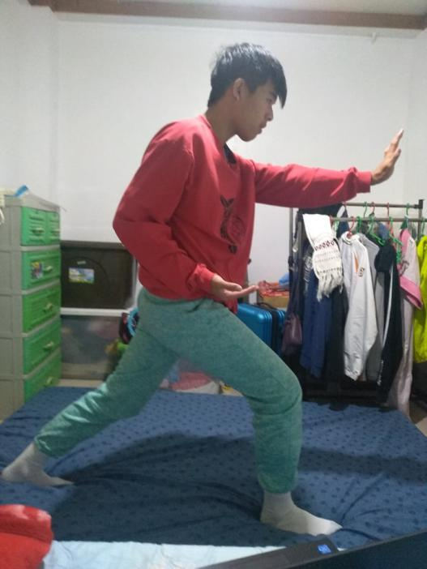

High Pat on Horse:

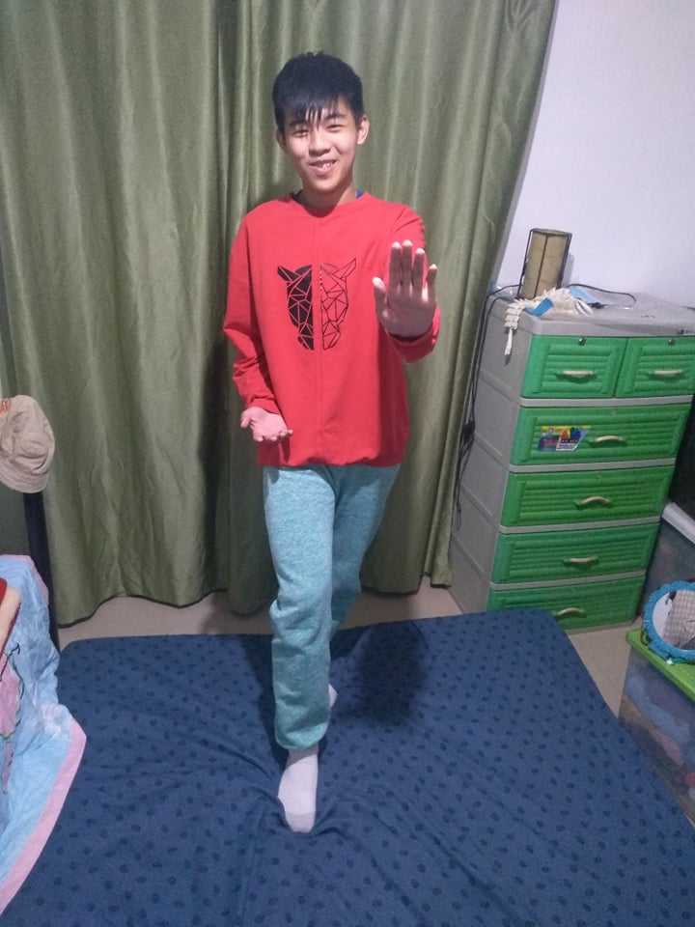

1. Research 3 Yoga that can relieve anxiety and demonstrate those exercises.

**Yoga** postures, known as asanas, help **ease** the physical discomfort that is caused by**anxiety**. Asanas work to stretch, lengthen, and balance the muscles. These postures**can** assist in releasing built-up muscle tension and stiffness throughout the body.

Cow pose:

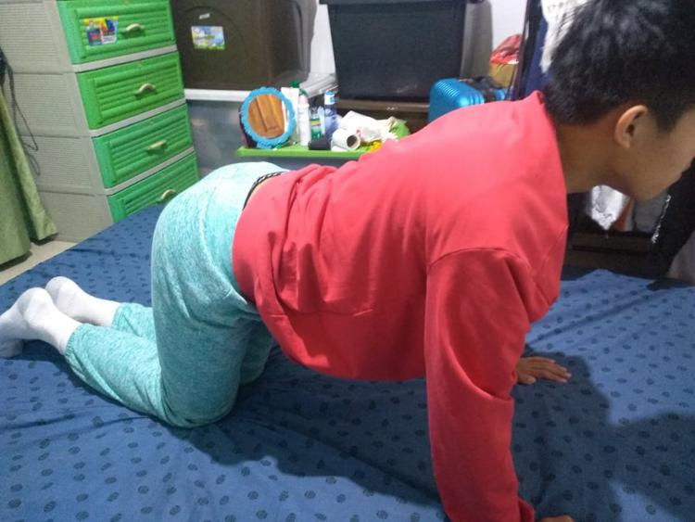

Cat Pose:

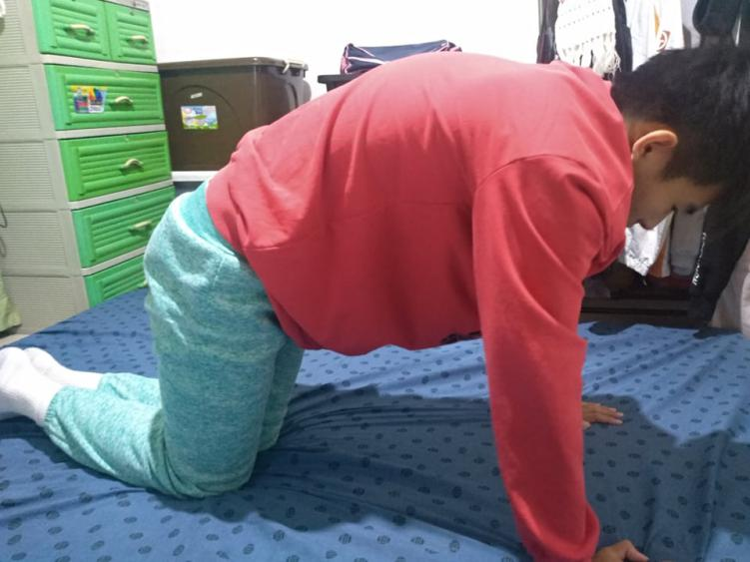

Channel Cleaning Breath :

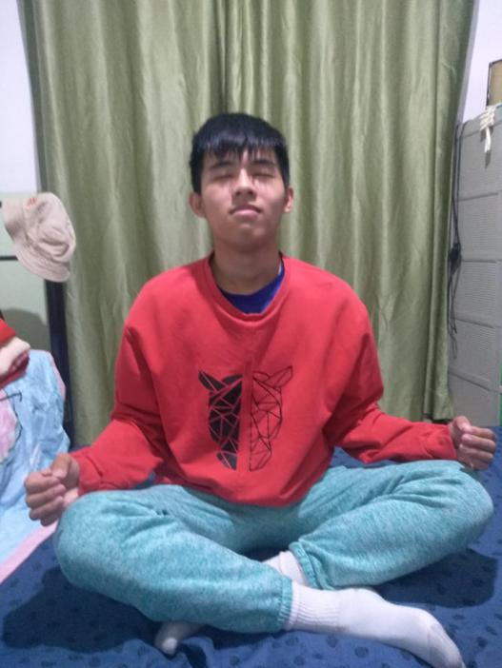

1. Research 3 Yoga exercises that can relieve depression and demonstrate those exercises by providing documentation.

**Yoga** increases body awareness, relieves stress, reduces muscle tension, strain, and inflammation, sharpens attention and concentration, and calms and centers the nervous system.

Up facing Dog pose:

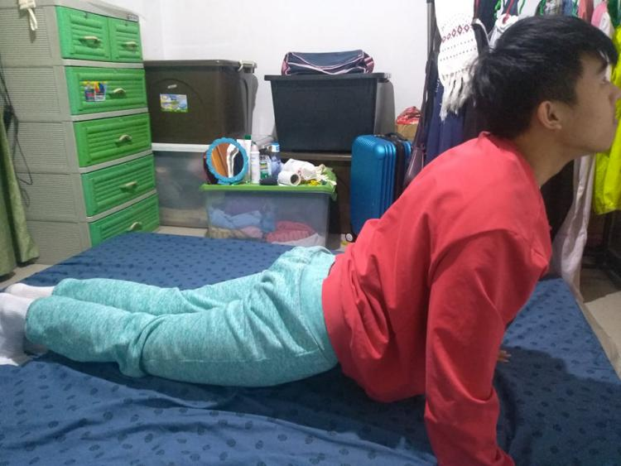

Child pose:

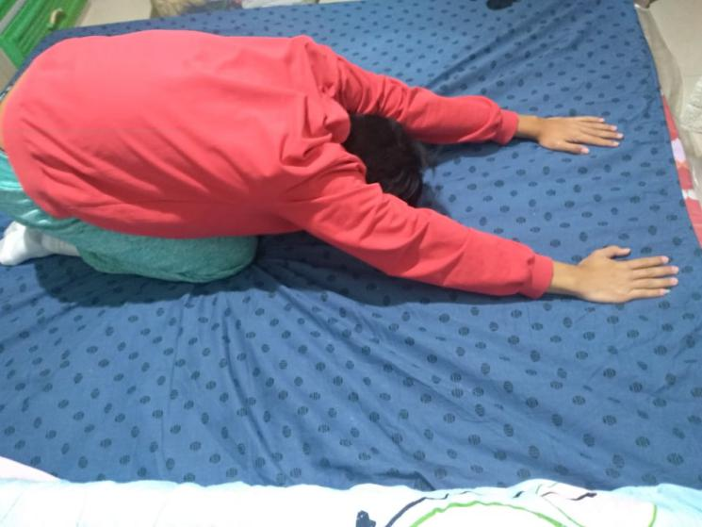

Corpes pose:

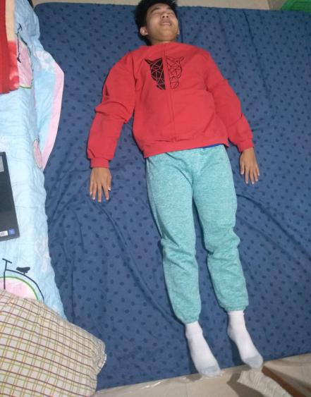

1. Enumerate 5 activities you usually do as family that serves as your bonding moments and provide documentation of those activities.

Eating Together



Walking together



Having a field trip



Swimming



Biking

