|  |
| --- |
| The american university in cairo |
| Project 2 Proposal |
| Embedded systems CSCE4301 |
|  |
|  |
| **Group 11:**  Samah Hussein 900172660  Mohamed Shehawy 900172173  Eman Darwish 900172070  **Presented to:**  **Dr. Mohamed Shalan**  **Spring 2021** |
|  |

|  |
| --- |
|  |

Project Idea

Our project aims at utilizing hand gestures for control. We will be controlling a car kit (Dagu 4WD) using a glove that has sensors and an embedded MCU. We use a mixture of flex sensors and an Inertial measurement unit (IMU) inside the glove to determine the hand movement. We use the STM32 Nucleo board to interact with the sensors. Moreover, it communitcates the desired car movements to another Nucleo-32 board in the Dagu kit using a bluetooth module via UART. The on-ground Nucleo-32 will signal the Pololu motor controller to move the Dagu in the correct direction.

We plan to implement 5 gestures:

- open palm for stopping/braking

- closed fist + downwards rotate (pitch angle) for forward

- closed fist + upwards rotate (pitch angle) for reverse

- closed fist + left rotate (roll angle) for left

- closed fist + right rotate (roll angle) for right

Components

Microcontroller

STM32 Nucleo-32: STM32L432KC x2

Car Kit

Dagu Wild Thumper 4WD

Pololu TReX Dual Motor Controller: DMC01

Communication

Bluetooth Moduel: HC-06 x2

Sensors

Flex sensor 56mm

Inertial measurement unit (IMU): BNO055

Software Components

Keil uVision 5

STM 32 Cube programmer

Proposed Architecture

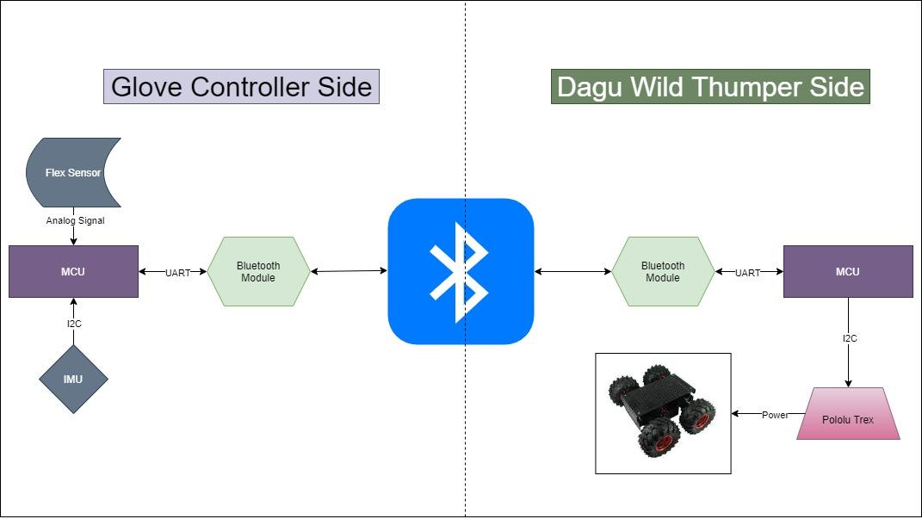

Potential enhancements

Automatic Replay/Repeat

Using another gesture/button in order to record a sequence of movements of the kit and then replay these movements automatically on gesturing.

Implementing a PID control loop

The proportional–integral–derivative (PID) control loop will provide angular feedback to the on-ground MCU in order to adjust the movement of the Dagu to specifically the desired angel. It will also revert the Dagu into its original stance in case any obstacles try to divert it.

This will enhance Dagu stability and response accuracy to the gestures. In addition, it will eliminate the effect of external obstacles and diversions.

Foreseen limitations

- Limited range of the Bluetooth communication modules, the kit has to be operated in close-range

- No encoders on the Dagu motors, this makes re-mapping or automation inaccurate

- Manufacturing a more stable glove with allocated space for the components

Planned milestones

* April 22nd: Acquired the components
* April 24th: implemented & tested communication
* April 26th: tested & tuned the sensors
* April 29th: Integrated system
* May 2nd: Tested and Tuned the whole system + debugging