1. Register a personal AWS account on [https://aws.amazon.com/](https://link.jianshu.com/?t=https://aws.amazon.com/).
2. Go to your dashboard and enter EC2, then start an EC2 Instance

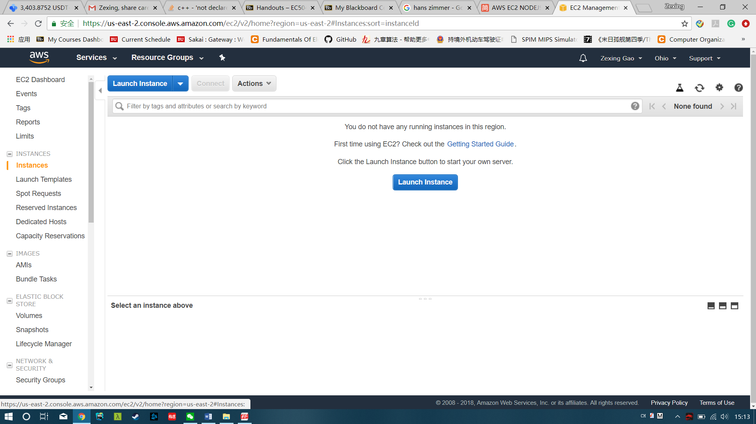

1. Start to setup your instance following steps. You can use default setup if you want to use it free.

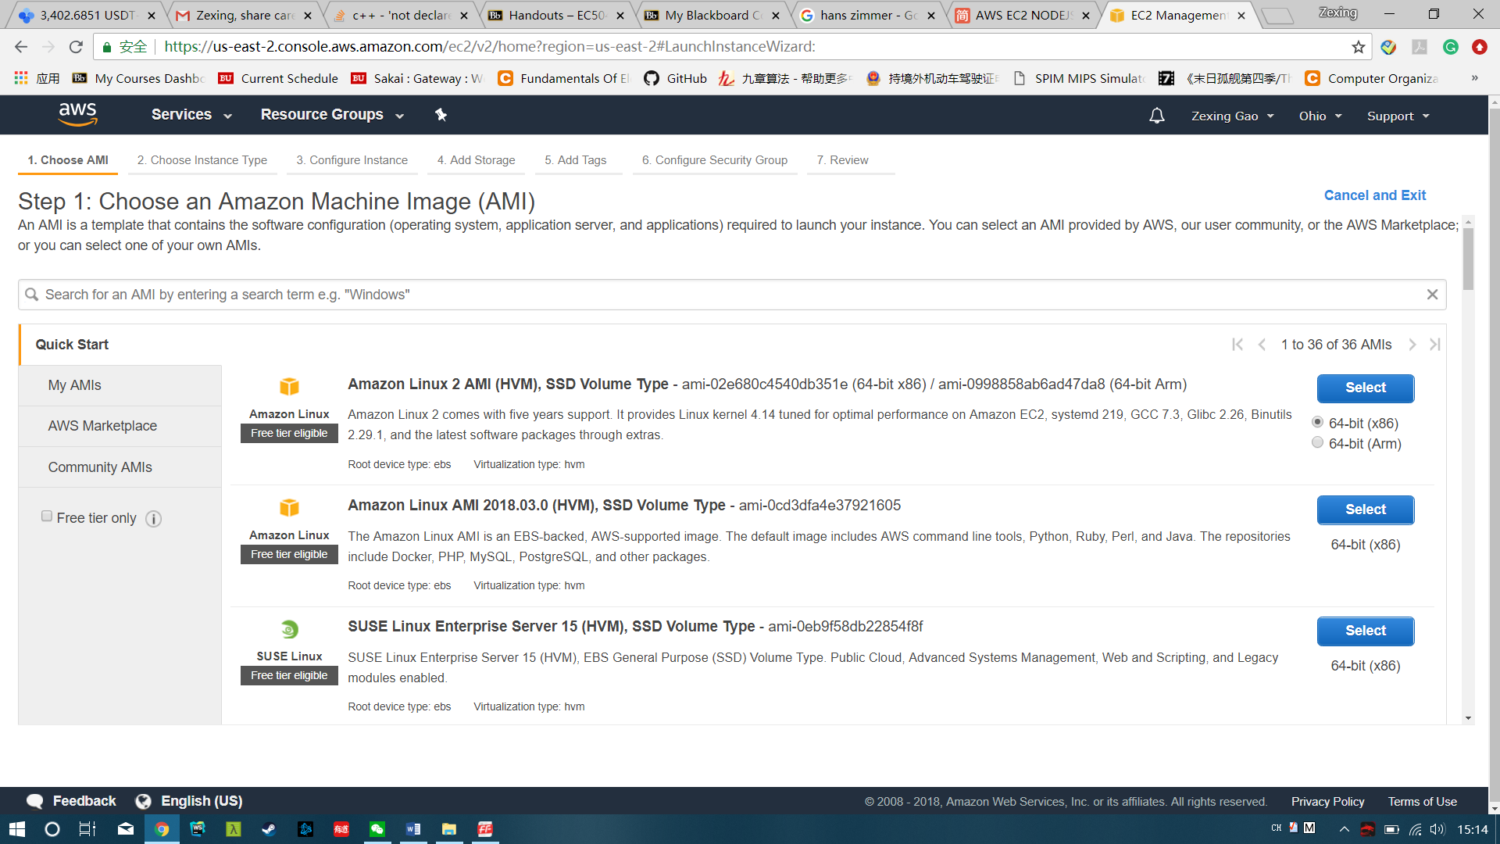

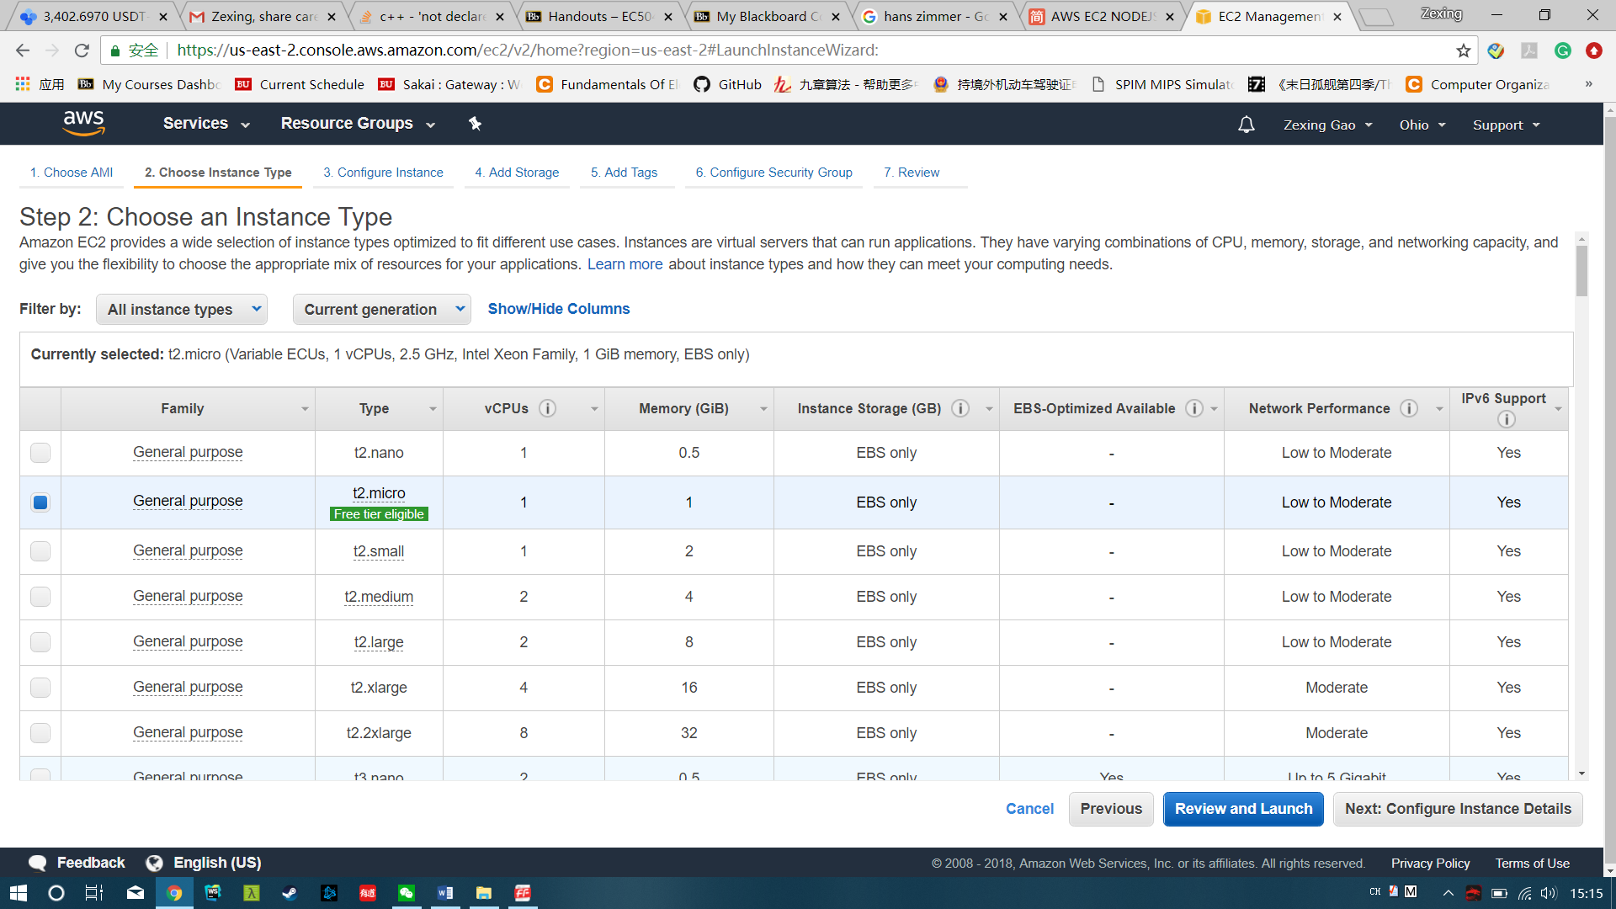

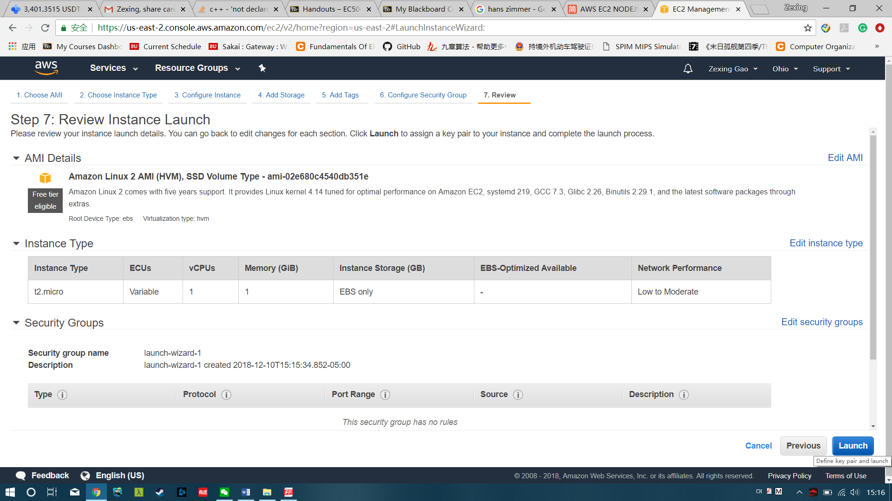

Download Key Pair. This is very important because for this instance you cannot download it again.

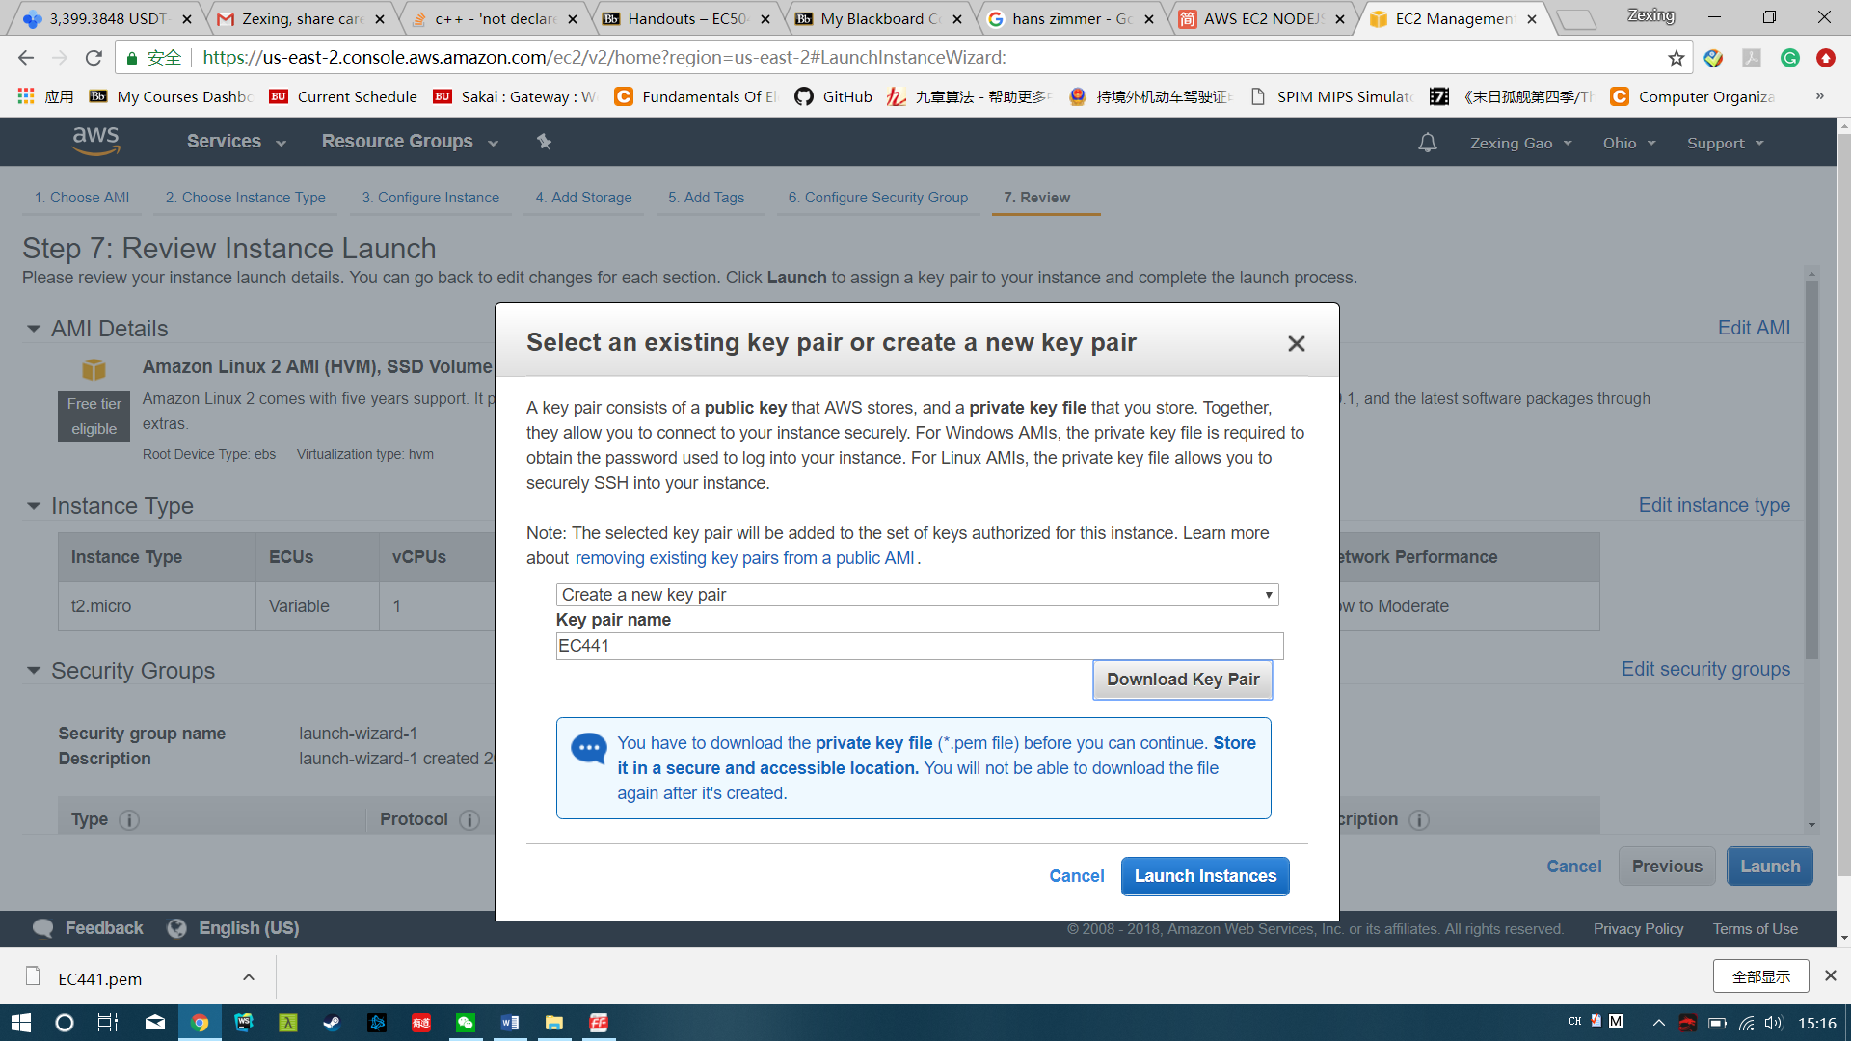

1. Download a virtual machine to deploy your project. Here I used MobaXterm as example.

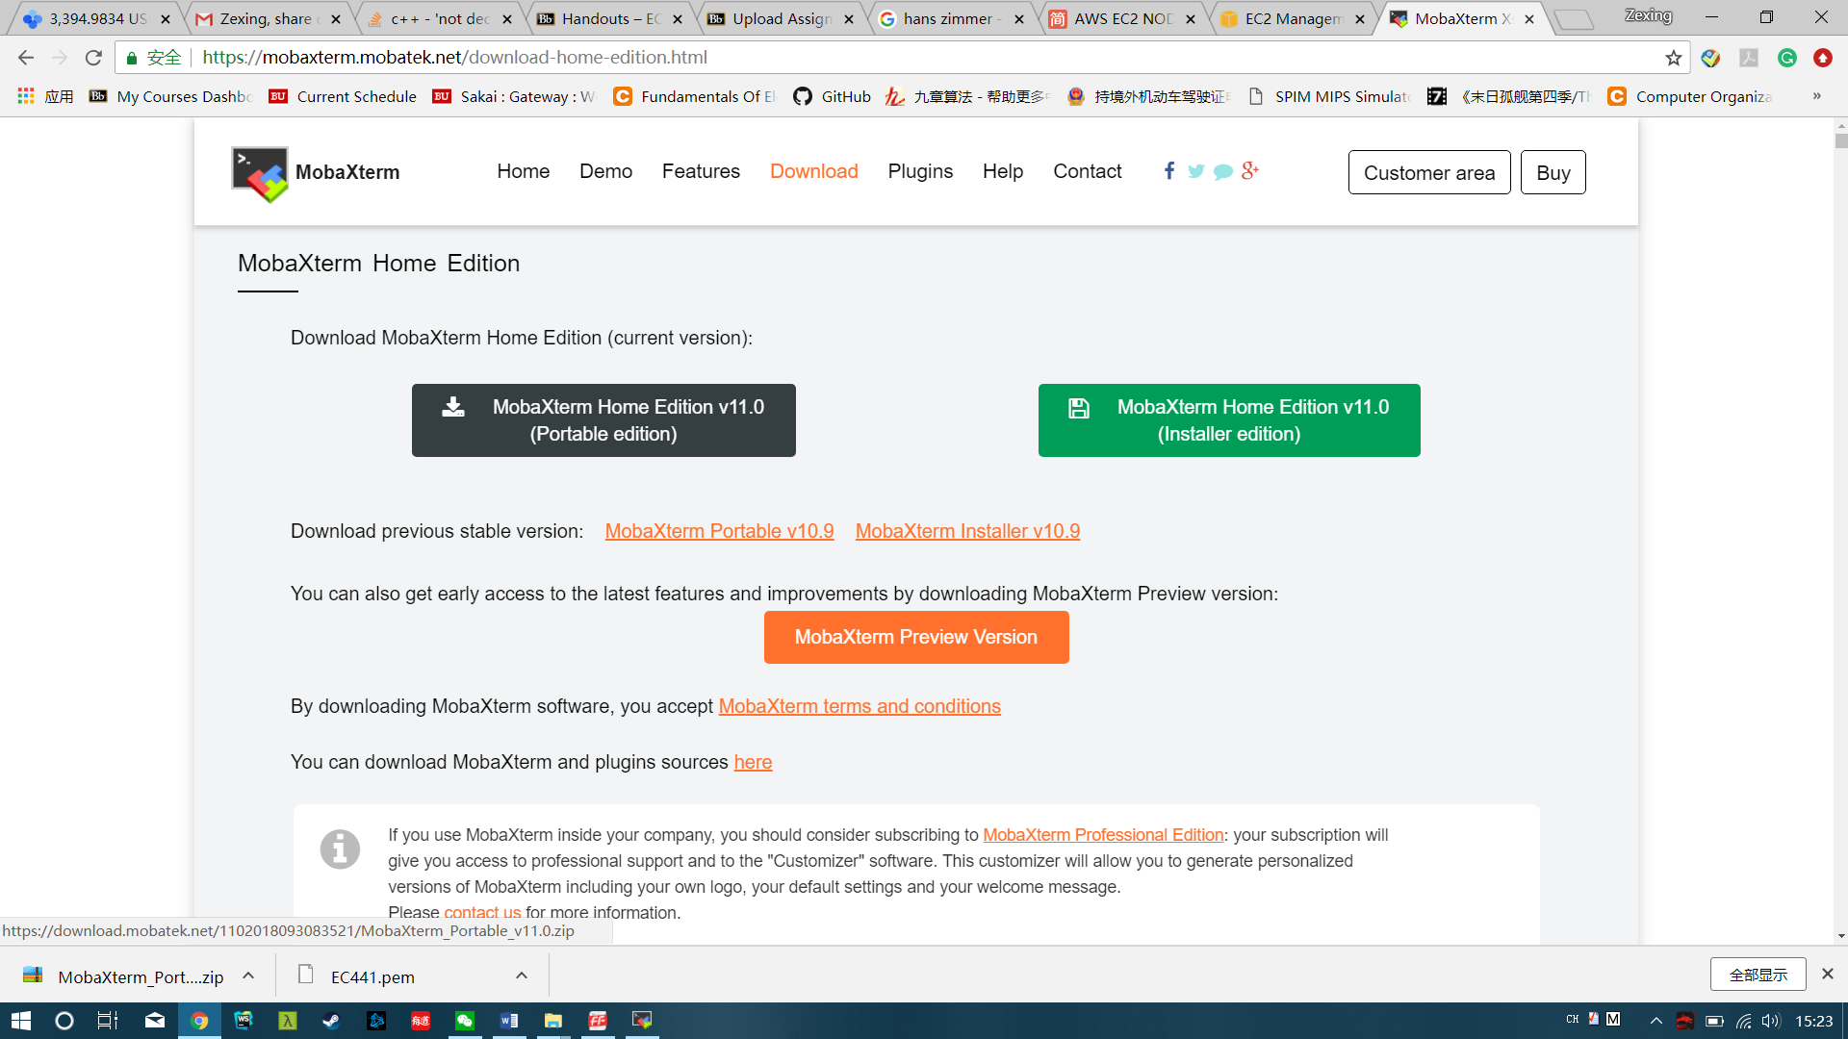

1. After you open the MobaXterm, click session, and then click SSH. Enter Remote host from your EC2 instance. Finally pair the private key that you download before. When you see the black page below, user have successfully connected to the EC2 instance with your local virtual machine.

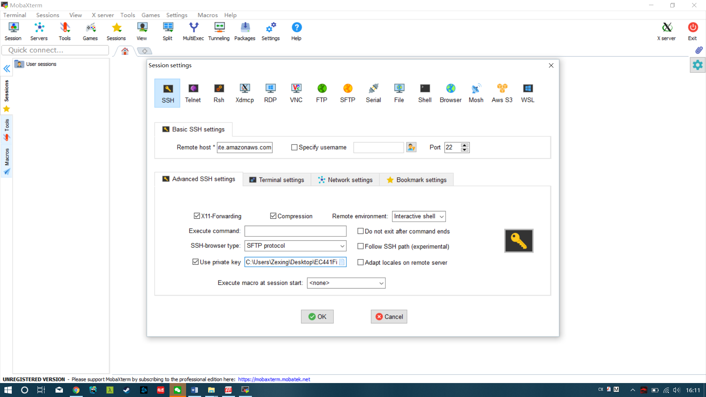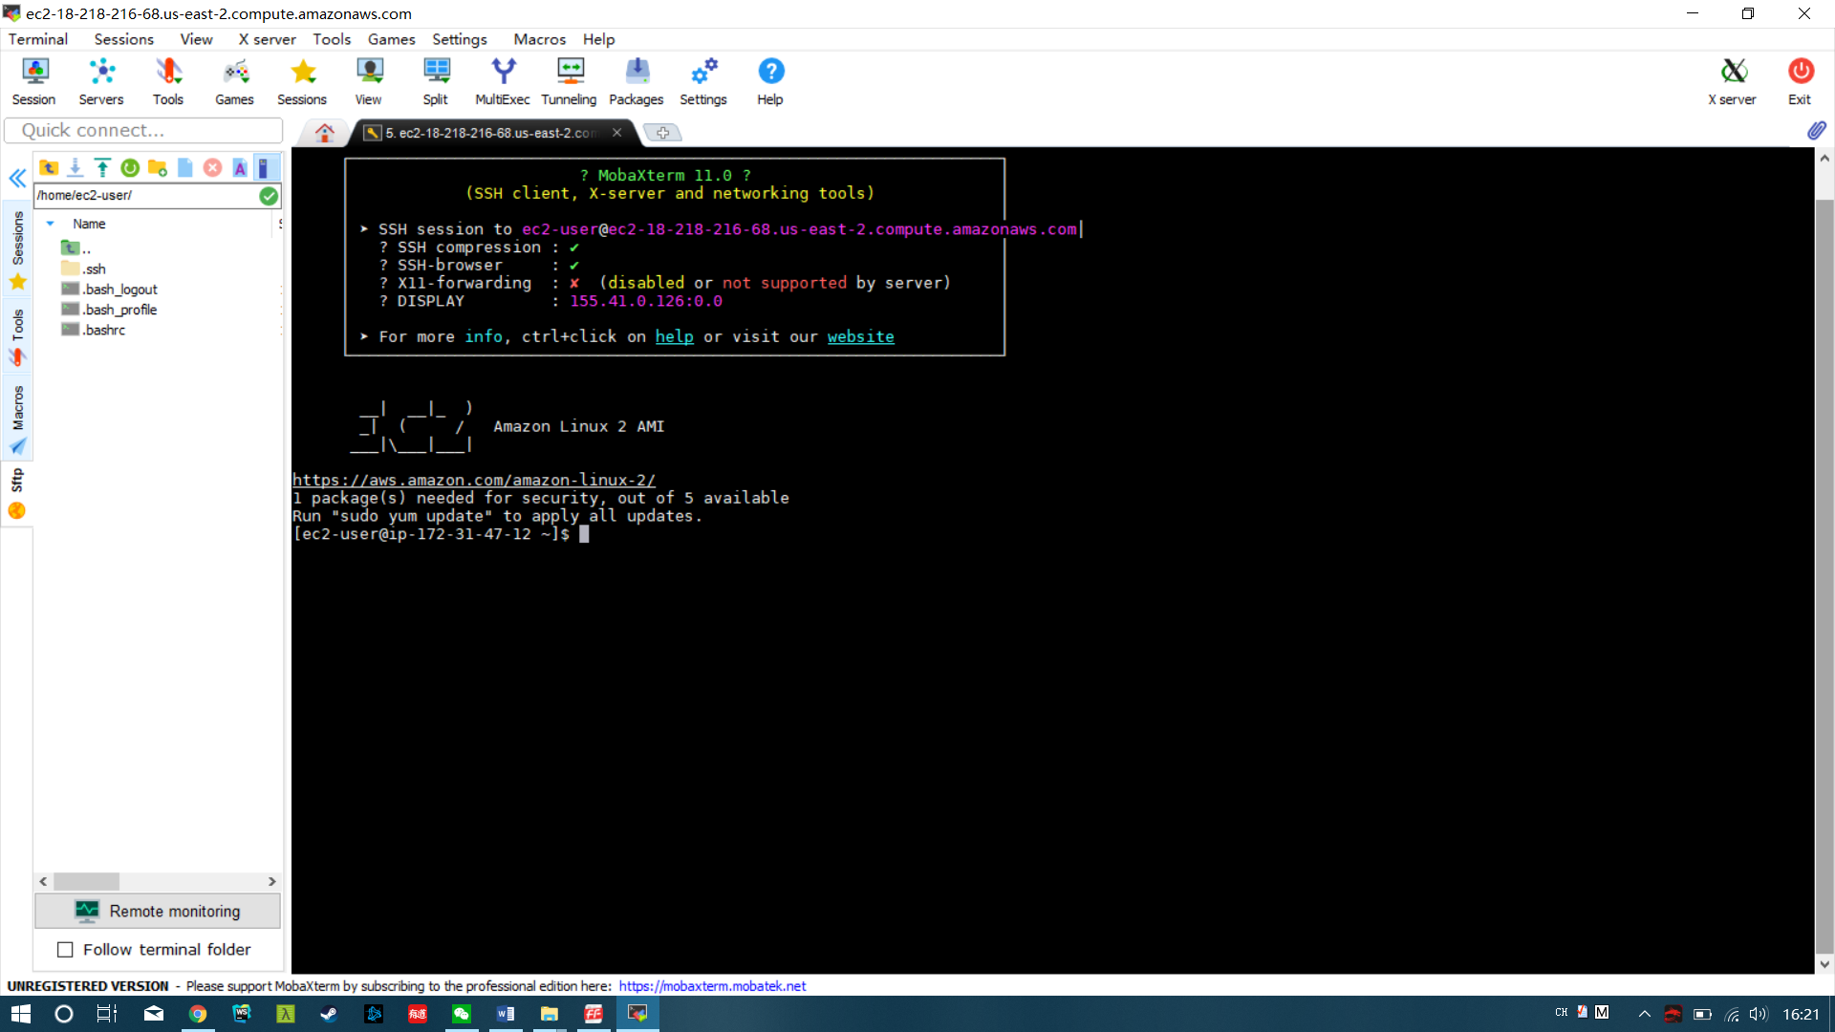

1. Install node.js in your virtual machine by following the instruction below:

$ sudo yum install wget

sudo cd /usr/share  
sudo wget [https://nodejs.org/dist/v6.11.2/node-v6.11.2-linux-x64.tar.xz](https://link.jianshu.com?t=https:/nodejs.org/dist/v6.11.2/node-v6.11.2-linux-x64.tar.xz)  
sudo xz -d node-v6.11.2-linux-x64.tar.xz  
sudo tar xvf node-v6.11.2-linux-x64.tar  
sudo ln -s /usr/share/node-v6.11.2-linux-x64/bin/node /usr/bin/node  
sudo ln -s /usr/share/node-v6.11.2-linux-x64/bin/npm /usr/bin/npm

npm install 'socket.io'

1. Drag your file into the page. You can now run any node.js application via the console in this virtual machine. If you are missing any package, just use -npm install Package_name.
2. Use socket io to implement bidirectional pipeline bewtween clients server. Chat Events can be emitted to all client when sent. Connection and disconnection will also be broadcasted.