library**(**ggplot2**)**

library**(**microbenchmark**)**

small_ite **<-** 25

large_ite **<-** 150

fibonacci_seq **<-** vector**(**mode**=**"numeric", length**=**small_ite**)**

log_factorial_seq **<-** vector**(**mode**=**"numeric", length**=**large_ite**)**

sum_log_factorial_seq **<-** vector**(**mode**=**"numeric", length**=**large_ite**)**

**for** **(**i **in** 1**:**large_ite**)** **{**

log_factorial_seq**[**i**]** **<-** mean**(**microbenchmark**::**microbenchmark**(**log_factorial**(**i**))$**time**)**

sum_log_factorial_seq**[**i**]** **<-** mean**(**microbenchmark**::**microbenchmark**(**sum_log_factorial**(**i**))$**time**)**

**}**

**for** **(**i **in** 1**:**small_ite**)** **{**

fibonacci_seq**[**i**]** **<-** mean**(**microbenchmark**::**microbenchmark**(**fibonacci**(**i**))$**time**)**

**}**

ggplot2**::**qplot**(**x**=**seq**(**large_ite**)**, y**=**log_factorial_seq, xlab**=**"n", ylab**=**"runtime(ns)"**)** **+** ggtitle**(**"log_factorial Runtime"**)**

ggplot2**::**qplot**(**x**=**seq**(**large_ite**)**, y**=**sum_log_factorial_seq, xlab**=**"n", ylab**=**"runtime(ns)"**)** **+** ggtitle**(**"sum_log_factorial Runtime"**)**

ggplot2**::**qplot**(**x**=**seq**(**small_ite**)**, y**=**fibonacci_seq, xlab**=**"n", ylab**=**"runtime(ns)"**)** **+** ggtitle**(**"fibonacci Runtime"**)**

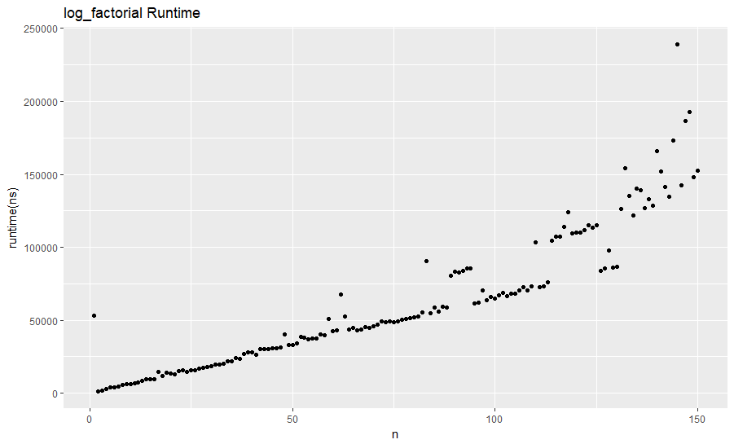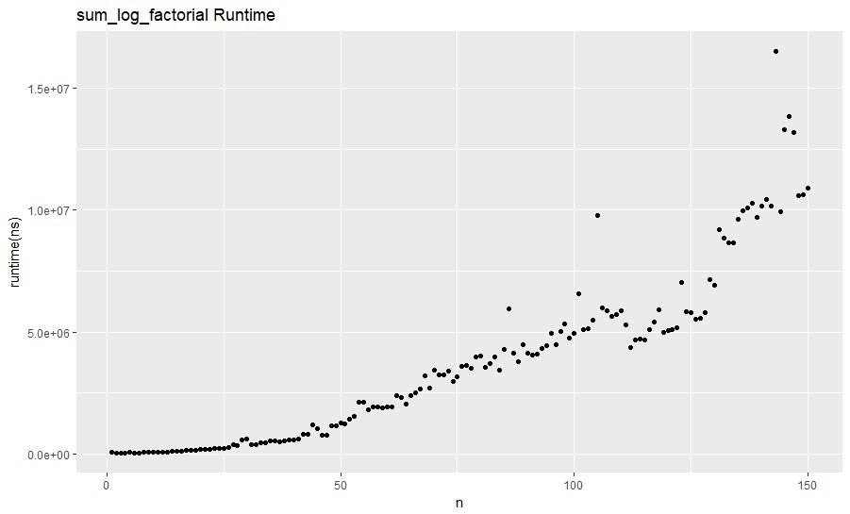

Runtime: $O(n^{2})$

Runtime: $O(n)$

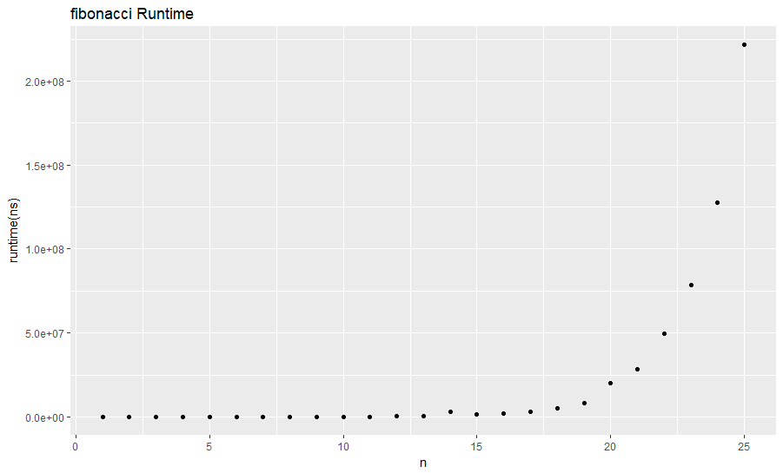

Runtime: $O(2^{n})$