Data Science: An Overview

What is data science, how is it used, and what are its main challenges?

# Introduction

Data science is the interdisciplinary field of using scientific methods, processes, algorithms, and systems to extract knowledge and insights from data. Data science can be applied to various domains, such as business, health, education, social sciences, engineering, and natural sciences. Data science involves collecting, cleaning, analyzing, visualizing, and communicating data, as well as developing and deploying data-driven solutions.

# Applications of Data Science

Data science has many applications in different sectors and industries. Some examples are:

* Recommendation systems: Data science can be used to analyze user behavior, preferences, and feedback, and provide personalized recommendations for products, services, or content. For instance, Netflix uses data science to suggest movies and shows to its users based on their viewing history and ratings.
* Fraud detection: Data science can be used to detect and prevent fraudulent transactions, activities, or behaviors. For example, credit card companies use data science to identify and flag suspicious transactions based on patterns, anomalies, or rules.
* Healthcare: Data science can be used to improve healthcare outcomes, diagnosis, treatment, and prevention. For example, data science can be used to analyze medical records, images, sensors, and genomics, and provide insights for doctors, patients, and researchers.
* Natural language processing: Data science can be used to process and understand natural language, such as speech, text, or audio. For example, data science can be used to build chatbots, voice assistants, translators, or sentiment analyzers.
* Computer vision: Data science can be used to process and understand images, videos, or other visual data. For example, data science can be used to build face recognition, object detection, or self-driving systems.

# Challenges of Data Science

Data science also faces many challenges and limitations, such as:

* Data quality: Data science relies on the quality and availability of data, which can be affected by factors such as noise, missing values, outliers, or biases. Data quality can impact the accuracy, reliability, and validity of data analysis and solutions.
* Data privacy: Data science involves collecting, storing, and sharing data, which can raise ethical and legal issues regarding data privacy and security. Data privacy can be compromised by unauthorized access, misuse, or leakage of data, which can harm the rights and interests of data owners, users, or subjects.
* Data complexity: Data science deals with large, diverse, and complex data, which can pose challenges for data processing, analysis, and interpretation. Data complexity can require advanced techniques, tools, and skills, as well as computational and storage resources.
* Data communication: Data science aims to communicate data and insights to various stakeholders, such as decision-makers, customers, or the public. Data communication can be challenging due to the gap between data and domain knowledge, the diversity of audiences and contexts, and the need for clear and effective visualization and storytelling.

Data Science MLOps

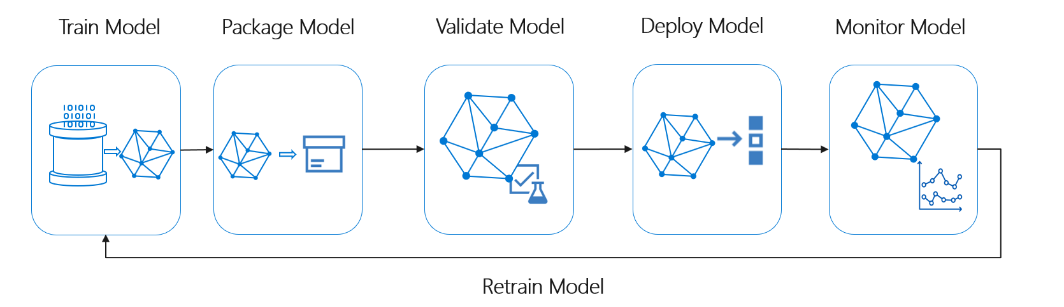

GPU machine price table

|  |  |  |  |  |  |
| --- | --- | --- | --- | --- | --- |
| CPU (Core) | CPU Gen | Memory | GPU Model | price | Perf./Cost |
| 9 | 11 | 32 | 3090 | $ 1,324.00 | $ 0.42 |
| 7 | 12 | 32 | 4090 | $ 2,000.00 | $ 0.48 |
| 9 | 12 | 32 | 3090 | $ 1,610.00 | $ 0.51 |
| 7 | 11 | 16 | 3090 | $ 1,812.00 | $ 0.58 |
| 9 | 12 | 64 | 4090 | $ 2,581.00 | $ 0.62 |
| 9 | 12 | 64 | 3090 | $ 1,956.00 | $ 0.62 |
| 9 | 13 | 32 | 4090 | $ 2,601.00 | $ 0.63 |
| 9 | 13 | 64 | 4090 | $ 2,870.00 | $ 0.69 |
| 9 | 13 | 64 | 4090 | $ 2,890.00 | $ 0.69 |
| 9 | 12 | 32 | 3090 | $ 2,699.00 | $ 0.86 |