Chapter 7
Autonomy Compliance with Doctrine and Ethics Ontological Frameworks
Chapter Subtitle: Precision and Understandability for Humans and Machines
Don Brutzman^{a,b}, Curtis Blaisª, Hsin-Fu Wu^{c}, Richard Markeloff^{d}, and Carl Andersen^{d}
ªNaval Postgraduate School, ^{c}Raytheon Corporation, ^{d}Raytheon BBN Technologies, ^{b}brutzman@nps.edu
ABSTRACT
Ensuring ethical robot behavior requires complex representations and methodologies designed to guarantee it. This chapter synopsizes a large body of work. Our approach extends frameworks already used by the U.S. military to ensure human ethical and doctrinal behavior by human beings. These have built in advantages of being able to express complex plans and constraints, yet remaining intelligible to humans, a requirement for ethical responsibility and liability. To extend the framework to machines, mission constructs are expressed using an Autonomous Vehicle Command Language (AVCL) expressing mission actions and outcomes that can readily be translated to runnable source code in several programming languages. Missions written in AVCL can be validated via translation to a formalized Mission Execution Ontology (MEO) supporting automated reasoning and queried proofs of ethical correctness. MEO ensures that missions are both semantically valid and compliant with ethical constraints. These technologies implement a simulation, testing, and certification regime that can serve as a foundation for human authority over and trust in robots capable of even lethal force when authorized.
KEYWORDS
unmanned systems; autonomous systems; ethical control; ontology; formal semantics; Mission Execution Ontology
7.1 INTRODUCTION AND MOTIVATION
Robotic agent capabilities are evolving rapidly, complicating the challenge of controlling them. In particular, the problem of maintaining human control of robots similar to that exercised over human armed forces members is complicated by robot inability to understand and execute natural language directives and constraints at the level of reliable human interpretation. A number of authors express skepticism that ethical robots can even be achieved. (Forbes.com 2019) However, the present authors offer evidence that recent development of action languages intelligible to both humans and robots makes it possible to achieve these control-oriented goals. Implementing such capabilities broadly in a variety of domains, with the ability to apply ethical control over robot behaviors, becomes a moral imperative.
7.2 BACKGROUND, DEFINITIONS AND NOTATIONS
Our work adapts frameworks for human ethical responsibility used successfully in collaborative military operations, even across varying human cultures and platforms. These frameworks are rooted in international humanitarian law (Wikipedia 2021a) and are frequently manifested in military training and operations as Rules of Engagement (ROE) (United States Marine Corps Post 2005; Wikipedia 2021b) that ”define the circumstances, conditions, degree, and manner in which the use of force, or actions which might be construed as provocative, may be applied.” U.S. armed forces are trained in ROE and associated ethics doctrines that emphasize ultimate human responsibility and liability for the actions of military organizations of human agents. This emphasis on human beings as controlling ethical actors is explicitly preserved in U.S. doctrine about robot autonomy (Department of Defense 2023). The requirements established in the Directive include the following:
“Autonomous and semi-autonomous weapon systems will be designed to allow commanders and operators to exercise appropriate levels of human judgment over the use of force.” (p 3)
“Persons who authorize the use of, direct the use of, or operate autonomous and semi- autonomous weapon systems will do so with appropriate care and in accordance with the law of war, applicable treaties, weapon system safety rules, and applicable rules of engagement.” (p 4)
The weapon system has demonstrated appropriate “performance, capability, reliability, effectiveness, and suitability under realistic conditions.” (p 16)
“The design, development, deployment, and use of systems incorporating artificial intelligence (AI) capabilities is consistent with the DoD AI Ethical Principles and the DoD Responsible AI (RAI) Strategy and Implementation Pathway.” (p 5)
The authors identify implicit requirements of these frameworks, transferred to a human-robot context:
• Predictability. Robot control methods and associated development methodologies must be sufficiently reliable to enable prediction of robot behavior in any situation.
• Authority. Robot control must support ultimate (direct and indirect) control by qualified, well-informed humans over robot outcomes.
• Responsibility. Because only human beings can adopt moral responsibility, any robotic failures must be traceable back to a specific human entity (e.g., programmers, manufacturers, operators, leadership).
• Liability. Liability assignment (whether legal or moral) requires that parties involved in robotic development and employment can reasonably foresee outcomes for which they are responsible.
7.3 LITERATURE REVIEW AND STATE OF THE ART
Other authors have identified and confronted the competing challenges identified in the above requirements; a useful survey of algorithmic solutions is available (Yu et al. 2018). A variety of approaches are represented in the literature, including Answer Set Programming logics (Berreby, Bourgne, and Ganascia 2015), deontic logics (Bringsjord, Arkoudas, and Bello 2020), and action logics (Wooldridge and Van Der Hoek 2005), analogical reasoning (Blass and Forbus 2015), Markov Decision Processes (MDPs) (Nashed, Svegliato, and Zilberstein 2021) and Reinforcement Learning (Wu and Lin 2018), among others. Here, we comment on several promising efforts.
Deontic and action logic approaches often confront philosophical problems and are not scalable or easily deployable. In contrast, Berreby’s Answer Set Programming work could be a tractable method of representing and reasoning over rich ethical constraints. Using an Event Calculus framework, this system can represent uncertain, conflicting actions and effects of multiple agents, enabling sophisticated proof reasoning about detailed consequences. This expressiveness also enables reasoning about competing ethical priorities, a focus of many authors, which the present work assumes are resolved by the mission plan. However, the representational detail in Berreby, even if fully correct, may preclude practical usefulness to human supervisors of robots in dull, dirty, or dangerous scenarios.
Work on Markov Decision Processes (MDPs) and Reinforcement Learning can be said to employ consequentialist (as opposed to deontic) ethics because their activities are based on numerical reward functions. A primary problem for these approaches is achieving the absolute guarantees of action or restraint that are built into the present work. Decision-making based on rewards runs the risk of prioritizing the reward of some mission goal above that of ethical behavior, especially when rewards and policies are machine-learned. Proving correct behavior is even more challenging. Nashed et. al’s work makes headway in this area, showing that MDPs can be constrained to obey intuitive ethical precepts such as the Golden Rule (the original one—“Do unto others as you would have others do unto you”—not the more recent “The one who has the gold makes the rules” which assigns undue authority to manufacturers and owners).
Analogical reasoning approaches face similar criticism of potential unreliability because it is difficult to guarantee that they will successfully retrieve any guiding ethical principle from their library via similarity search. However, these approaches at least face head-on the challenging problem of a robot interpreting its environment. The present work assumes built-in capabilities in this area; e.g., that a robot can interpret its situation in enough detail to recognize when a specified ethical constraint is in danger of being violated. In fact, with the presented approach, the mission itself is considered invalid if the assigned robot does not have this capability.
7.4 PROBLEM / SYSTEM / APPLICATION DEFINITION
The question of which autonomy approaches might satisfy the above requirements is a subject of active research. Research and operational experience by the authors over the past two decades has informed our own conceptualization of how the problem must be solved. Some top-level, recurring criteria include:
• Expressiveness. A robot control framework must be able to express real world missions at a useful level of detail, including actions and goals, decision criteria, sequencing, and constraints upon behavior. Actions and goals should be decomposable into smaller elements to mirror human cognitive methods of dealing with complexity.
• Relevance and Intelligibility. Ideally, the framework should smoothly integrate with existing military and civil frameworks for control and decision-making for human beings. This implies that all humans developing or using the robot system must understand the framework and how their own choices contribute to its behavior.
• Provability & Tractability. To ensure robot control and predictability, the framework should support proofs that robots will behave ethically, and particularly proofs of robot compliance with behavioral constraints. This criterion creates a tension with Expressiveness, as powerful, expressive mission representations may not be easily amenable to proof.
• Developmental Usability. To ensure wide applicability, the framework must be easily used by developers of real world robot control systems, across platforms and languages.
7.5 PROPOSED SOLUTION
Over years of practice, the authors developed a number of formalisms that meet the above criteria. As a conceptual framework, the authors developed a three-level control architecture, the Rational Behavior Model (RBM) (Byrnes et al. 1996), shown in Figure 1, that applies roles and tasks familiar to manned ships and aircraft to a robot context:
• Execution is the lowest control level, analogous to junior human crew members executing atomic commands (e.g. ”Left rudder 30 degrees”). For robots, execution involves control and management of hardware systems that directly interact with the vehicle’s physical environment (i.e., actuators, effectors).
• Tactical control directs execution-level functions to achieve more complex, but largely scripted tasks such as directing a vessel or conducting an area search or mapping.
• Strategic control, in turn, oversees tactical behaviors and corresponds to manned vessel command. Most ethical control issues are usefully represented and addressed at this level.
This division of roles is familiar to most military personnel and also supports widely used control theories in military operations such as the so-called observe-orient-decide-act (OODA) loop (Boyd 1995).
Figure 1. The RBM software architecture in relation to the hierarchical control paradigm employed in naval vessels.
These roles also help conceptualize how failures might occur and how responsibility for them might be traced back to specific human system developers or users. The authors’ work focuses on Strategic level decision making as the locus of familiar ethical reasoning patterns, but RBM highlights that Execution and Tactical-level tasks also must be represented and implemented for higher level reasoning to function correctly.
The authors’ ideas about mission representations, languages, and expressiveness have evolved steadily over many years of experimentation with robot control, including sea trials with the Phoenix (Brutzman 1994) and Aries (Brutzman et al. 2013) Autonomous Underwater Vehicles (AUVs). Their work has coalesced to using Finite State Machines (FSMs) with decomposable states as an expressive and intelligible framework that is still amenable to proof.
Mission Execution Automata (MEA) (McGhee, Brutzman, and Davis 2012) are FSMs with several important properties supporting control criteria. MEAs are process flow graphs in which each Goal state embodies a task or process extended in time. Goals may be decomposed into subgraphs to achieve greater modeling fidelity. Figure 2 shows an example of a mission expressed in MEA. The mission has five Goal states, labeled “Goal 1” (Search Area A), “Goal 2” (Sample Environment), “Goal 3” (Search Area B), “Goal 4” (Rendezvous with Vehicle 2), and “Goal 5” (Proceed to Recovery), with two terminal states, “Mission abort” and “Mission complete.” An important MEA innovation is the use of three distinct transition types between Goals: succeed, fail, and constraint. Succeed transitions typically lead to a next Goal in the larger process. Most real-world Goal failures (e.g., an engine failing to ignite) are modeled without any transition from the current Goal, which is still underway. The fail transition models only a final, irrecoverable failure, often prompting mission abort or recovery. The constraint transition models recognition by the agent that the current goal or perceived situation is incompatible with currently assigned ethical constraints. An insight of MEA is that constraint failures should be represented distinctly from general failures because they often transition to a different Goal to recover from the impending ethical constraint violation.
Figure 2. MEA mission-flow graph for a search and sample mission with ternary branching for success, failure, and imminent ethical constraint violations.
A recurring concern for the authors is support for proof of ethical behavior. Earlier work restricted the use of loops in MEAs because of difficulties deriving proofs; more recent work relaxes the restriction provided timeout conditions are added to ensure mission completion. By intention, lower-level Goal pre- and post- conditions are represented only implicitly in the model and must be described externally using text and diagrams for use by developers and commanders.
The MEA identifies a set of Constraints that can apply at the mission level (i.e., from start to end of the mission) or to individual Goal states. During execution of the mission, if the robotic system determines that an identified constraint applicable to that stage of the mission is about to be violated, the system transitions to the next state via the identified constraint transition.
A major advantage of MEAs is that they are amenable to formal proof, software development, and even machine understanding, yet also are easily expressed graphically in charts and graphical user interfaces for human understanding. For formal MEA representation, the authors adapted their own Autonomous Vehicle Command Language (AVCL), a schema-constrained XML data model supporting autonomous vehicle mission definition, execution, and management (Davis, Blais, and Brutzman 2006). The authors developed a simulation and graphical display environment, AUV Workbench (Weekley et al. 2004), for testing of AVCL missions. The authors have also implemented translators from AVCL to leading autonomy development languages (Java, Lisp, Prolog) as well as presentation languages (HTML5, KML, X3D). The former effort supports the Developmental Usability criterion by easing the process of developing actual autonomy applications that comply with the MEA framework.
MEA/AVCL Translation also supports the Provability criterion by creating formal models in languages amenable to validation, or proofs of coherent and ethical behavior. MEA is advantageous as a representation of missions whose behavior can be guaranteed given certain assumptions and where identified goals can be fulfilled, missions can be finite, and constraints can be adhered to.
7.6 QUALITATIVE AND QUANTITATIVE ANALYSIS
The authors’ work on validation has also evolved, from initial efforts using Prolog (eventually rejected as potentially undecidable) to judicious use of the Web Ontology Language (OWL). Using OWL (W3C 2009), the authors created the Mission Execution Ontology (MEO) (Brutzman et al. 2017, 2018; Brutzman, Blais, and Wu 2020), which defines classes for all relevant mission concepts. Figure 3 illustrates the principal classes of the ontology interrelated by object properties (relating a member of one class to a member of another, or the same, class). The solid arrows in the diagram depict relationships that are asserted explicitly in the ontology. The dashed arrows are relationships that are inferred from the given assertions and from the logical rules defined in the ontology. This is an example of the power of the formalized semantics, enabling new knowledge to be inferred from the given knowledge. OWL includes class and property restrictions, expressed as logical formulas, that enforce MEA behaviors. Figure 4 presents selected MEO semantics used to strengthen the data model.
Figure 3. MEO classes and role predicates expressing the MEA mission model structure.
Figure 4. Selected MEO semantics expressed as OWL assertions.

A crucial MEO feature is its use of a Vehicle class and associated Vehicle capabilities towards Goals and Constraints. Specifically, the Vehicle canExecute object property expresses that the Vehicle can complete a particular Goal, while the Vehicle canIdentify property expresses that a Vehicle can recognize an imminent potential violation of some ethical, doctrinal, or command Constraint. Consider, for example, the Vehicle Rule labeled “V4.” The formal expression asserts that “if a Vehicle has a VehicleFeature that canTest a Constraint, then that Vehicle canIdentify that Constraint.” In such a case, the Vehicle is qualified to perform any part of the mission to which that particular Constraint is assigned. These relationships allow the modeling of complex, multi-Vehicle missions with varying Vehicle capabilities as well as contingency plans for responding to looming constraint violations. MEO’s representations naturally support the integration of human oversight into a larger mission; for example, recognition of a potential constraint violation can force consultation with a human commander before engaging in lethal force.
With the above relationships, MEO supports a variety of logical validation proofs about defined Missions. As discussed, MEO can validate that proposed Vehicles are capable of completing mission Goals. Importantly, MEO can validate that no mission execution exists in which robot Vehicles fail to comply with Constraints and can verify that at least some potential executions might achieve the mission Goals. Such proofs can be performed through automated reasoning mechanisms, through structured queries (e.g., SPARQL) (W3C 2013) exploring the logical relationships in a mission specification, or through formalized language constraints (e.g., SHACL) (Pareti and Konstantinidis 2021).
An important feature of the combined AVCL/MEA/MEO framework is that it abstracts complex aspects of the autonomy problem. Goal pre- and post- conditions and conditions determining Goal success or failure are represented only implicitly in the model. For real world mission executions to mirror an abstracted MEO execution, these details would need to be described externally using text and diagrams for use by developers and commanders. Constraint semantics, including conditions indicating imminent violation, are similarly abstracted away, and could be developed independently of the model. Alternatively, future work could extend MEO with Tactical- and Execution- level primitives that model Goal and Constraint dynamics in more detail (i.e., formalized semantics for Constraint specifications).
Two central design decisions in OWL semantics complicate the use of MEO in mission modeling. First, OWL uses an open-world semantics that assumes some world facts may not be known. A reasoner cannot conclude that a mission is invalid due to missing information. Oftentimes, this is quite appropriate since a mission may become more fully specified as plans become more complete. What a reasoner can do is declare when a particular instance of a mission fully meets the specifications to be classified (i.e., inferred) as a member of the Mission class. Second, OWL’s lack of a unique-names assumption sometimes causes unexpected inference that two model entities are actually the same entity. The authors currently are exploring the use of SHACL shapes to achieve proof semantics similar to OWL without its peculiarities.
7.7 USE CASES AND APPLICATIONS
Of note is that the potential for lethal force is a sharp dividing line, whether for intentional defensive action or neglectful omission of lifesaving force. The authors have applied the combined AVCL/MEA/MEO framework to a number of practical problems involving preservation of human life. Missions expressed as MEAs can be understood readily by humans and machines. In order to pursue clear presentations showing intended relationships of missions, the authors have explored a variety of graphical views and annotations to create clear mission descriptions that are amenable to translation to machine-readable form. Figure 5 provides an example illustration of a Sailor Overboard mission to apply lifesaving action under close coordination to recover the sailor (Brutzman et al. 2020).
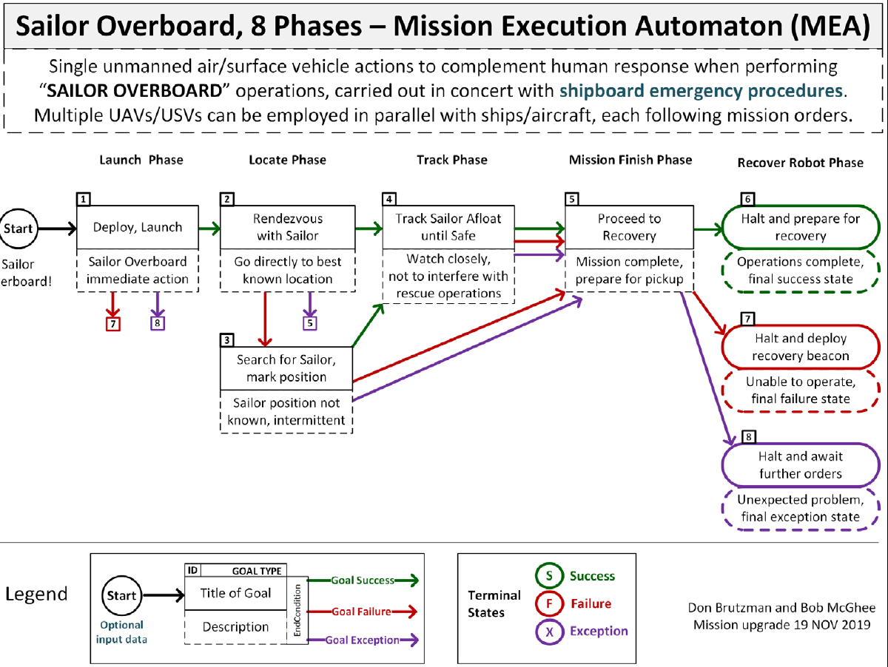
Figure 5. Sailor Overboard mission decision-flow diagram.
Annotations in the diagram provide explanatory information for clarity and precision. The diagram provides the fundamental elements of the MEA approach, identifying the goals and transitions. It would be straightforward to develop a graphical user interface to support the creation of such diagrams, with automatic extraction of information to render the mission in AVCL and MEO for computer-processing or even extraction of scenario elements as a foundation for simulation of the mission in a tool like the AUV Workbench, as shown in Figure 6. Implicit in this design is enabling effective human-machine cooperation without mutual interference during mission conduct.
The authors have explored other applications that can provide greater insights into robotic missions expressed in this framework. For example, Monterey Phoenix (NPS n.d.) is a systems engineering tool for describing and analyzing workflows. The authors have expressed MEAs as state machines using the tool, permitting examination of the many execution paths possible through a mission. In practice, such examination often reveals anomalies or unintended paths through the mission execution that can be corrected before the mission is assigned to one or more robots. Recall earlier the brief discussion about possible looping in the state transition graph describing the mission. If there are loops, they can be explored to whatever depth is desired by the user, allowing for more flexibility in the mission specification for cases where such behavior is precisely what is needed for mission success.
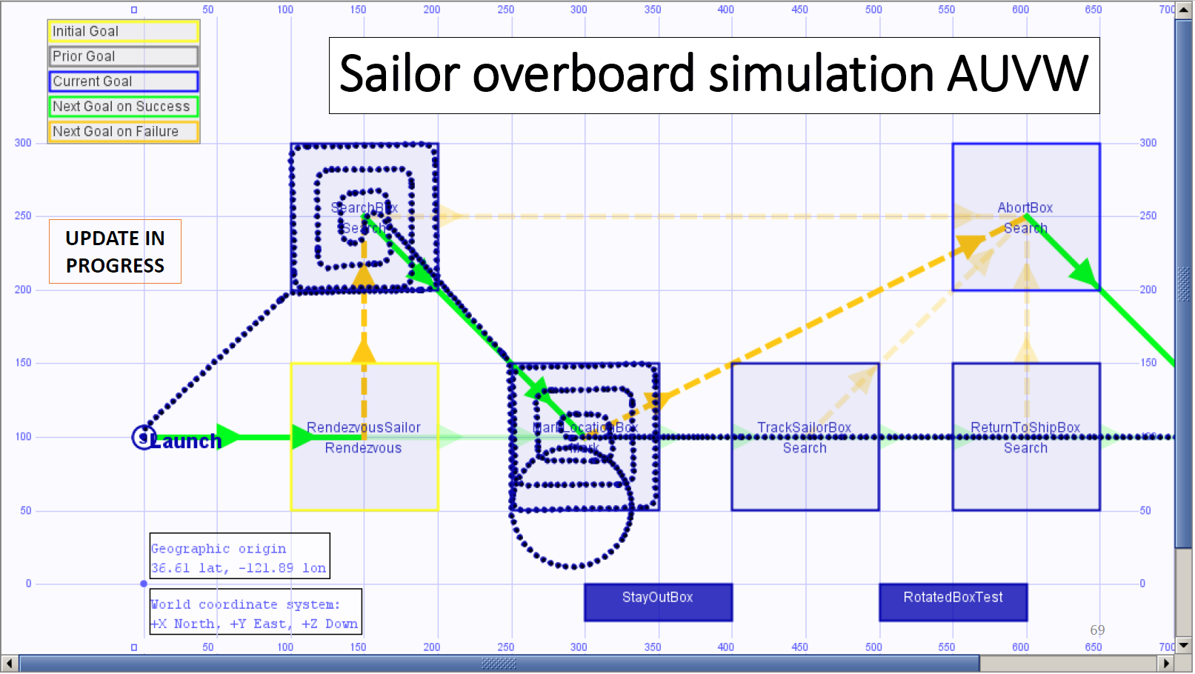
Figure 6. Sailor Overboard mission scenario as simulated using AUV Workbench.
Another powerful feature of ontologies is the ability to merge multiple ontologies into a single ontology, bringing together the conceptualizations to expand the application domain. At the time of this writing, there have been a number of major developments in the area of ethical control of robotic systems. Stumborg et al. (2021) identify categories of potential risk that should be considered before assigning decision-making responsibilities to autonomous systems. Termed “dimensions of autonomous decision-making” (DADM), these categories provide a basis for disciplined systems engineering practices. The authors have created an OWL representation of the identified categories in order to facilitate integration of these principles into mission specifications. Another key development is approval of the Ontological Standard for Ethically Driven Robotics and Automation Systems by the Institute for Electrical and Electronic Engineers (IEEE) in November, 2021 (IEEE 2021). The standard was created in recognition of the increasing complexity of robotic and autonomous systems requiring agreed-upon semantic specifications. Work has begun to translate the logical formalisms in this standard to OWL expressions that can be readily integrated with the MEO concepts and properties, further enriching mission specifications for unmanned systems.
7.8 DISCUSSION AND CONCLUSIONS
When compared to other leading approaches to ethical robot autonomy, the present work has several advantages when viewed in reference to the criteria introduced earlier. This work is often comparable or superior in Expressiveness, striking a good balance between mission fidelity and human Intelligibility. Such fidelity has been achieved without compromising the Provability & Tractability required to engender human trust, even for real world missions. Because our framework is an extension of human command hierarchies, it appears more Relevant to existing military practice. Finally, the present work also enjoys Usability advantages due to its tested operational maturity and the developed infrastructure supporting its use across platforms.
7.9 OUTLOOK AND FUTURE WORK
Military application of unmanned systems is too important to leave to the imprecise and unintelligible computations of artificial intelligence and machine learning. Rather, assignment of missions to unmanned systems must carry the same assurance and level of trust as giving orders to trained human performers, with the same understanding of shared responsibility and liability. Admittedly, this idea runs counter to the helter-skelter development and application of AI/ML processes today. Command and control remain critically important, requiring precision in command and diligence in control. Ethical control of robotic systems means humans make the decisions, retaining responsibility for ethical action. Continuing proliferation of robotic and autonomous systems demands strong management and oversight to avoid pending technological failures.

Bibliography
Berreby, F., Bourgne, G., and Ganascia, J.-G. 2015. Modelling moral reasoning and ethical responsibility with logic programming. In Logic for programming, artificial intelligence, and reasoning, 532–548. Springer.
Blass, J. A., and Forbus, K. D. 2015. Moral decision-making by analogy: Generalizations versus exemplars. In Twenty-Ninth AAAI conference on artificial intelligence.
Boyd, J. R. 1995. The Essence of Winning and Losing. https://web.archive.org/web/20110324054054/http://www.danford.net/boyd/essence.htm
Bringsjord, S., Arkoudas, K., and Bello, P. 2020. Toward a General Logicist Methodology for Engineering Ethically Correct Robots. In Machine Ethics and Robot Ethics, 291–297. Routledge.
Brutzman, D., Blais, C., McGhee, R., and Davis, D. 2017. Position Paper: Rational Behavior Model (RBM) and Human-Robot Ethical Constraints Using Mission Execution Ontology (MEO). In 2017 AAAI Fall Symposium Series.
Brutzman, D., Blais, C. L., Davis, D. T., and McGhee, R. B. 2018. Ethical mission definition and execution for maritime robots under human supervision. IEEE Journal of OceanicEngineering, 43(2): 427–443.
Brutzman, D., Davis, D., Lucas, G. R., and McGhee, R. 2013. Run-time ethics checking for autonomous unmanned vehicles: Developing a practical approach. In Proceedings of the 18th International Symposium on Unmanned Untethered Submersible Technology (UUST), Portsmouth, New Hampshire.
Brutzman, D. P. 1994. A virtual world for an autonomous underwater vehicle. Technical report, Naval Postgraduate School, Monterey, CA, U.S.
Brutzman, D. P., Blais, C. L., and Wu, H.-F. 2020. Ethical Control of Unmanned Systems: Lifesaving/Lethal Scenarios for Naval Operations. Technical report, Naval Postgraduate School, Monterey, CA, U.S.
Byrnes, R. B.; Healey, A. J.; McGhee, R. B.; Nelson, M. L.; Kwak, S.-H.; and Brutzman, D. P. 1996. The rational behavior software architecture for intelligent ships. Naval Engineers Journal, 108(2): 43–55.
Davis, D.; Blais, C.; and Brutzman, D. 2006. Autonomous vehicle command language for simulated and real robotic forces. In Fall Simulation Interoperability Workshop.
Department of Defense. 2023. Autonomy in Weapon Systems. DOD Directive 3000.09. January 2023.
Forbes.com. 2019. Can We Teach Machines A Code Of Ethics? https://www.forbes.com/sites/insights-intelai/2019/03/27/can-we-teach-machines-a-code-of-ethics/.
Institute for Electrical and Electronic Engineers (IEEE). 2021. Ontological Standard for Ethically Driven Robotics and Automation Systems. https://standards.ieee.org/ieee/7007/7070/.
McGhee, R., Brutzman, D., and Davis, D. 2012. Recursive Goal Refinement and Iterative Task Abstraction for Top-Level Control of Autonomous Mobile Robots by Mission Execution Automata-A UUV Example. Technical Report, Naval Postgraduate School.
Naval Postgraduate School. n.d. Monterey Phoenix Behavior Modeling. https://wiki.nps.edu/display/MP/Documentation/.
Nashed, S., Svegliato, J., and Zilberstein, S. 2021. Ethically compliant planning within moral communities. In Proceedings of the 2021 AAAI/ACM Conference on AI, Ethics, and Society, 188–198.
Stumborg, M. F., Roh, B., and Rosen, M. 2021. Dimensions of autonomous decision-making: A first step in transforming the policies and ethics principles regarding autonomous systems into practical systems engineering principles. DRM-2021-U-030642-1Rev. Center for Naval Analysis.
World Wide Web Consortium (W3C). 2009. OWL 2 web ontology language document overview. http://www. w3. org/TR/owl2-overview/.
World Wide Web Consortium (W3C). 2013. SPARQL 1.1 Query Language. https://www.w3.org/TR/sparql11-query/. W3C Recommendation. 21 March 2013.

