英语：
1、自我介绍：
中文自我介绍
各位教授，下午好！很高兴有机会参加这次面试和各位教授交流。首先我简单的介绍一下自己：我叫张颖颖，就读于中南民族大学计算机科学学院，所学专业是网络工程。
其次，我想谈一下我的大学生活。在学习方面，三年以来，我认真学习各门课程，绩点排名一直都是专业第一，先后获得励志国家奖学金、国家奖学金和专业一等奖等。在各种学科竞赛方面，多次参加比赛，先后获得数模美赛H奖、蓝桥杯省二等奖，多次参加校程序设计竞赛，分别获得优秀奖、三等奖；在项目经历方面，大一下加入实验室，参与“基于机器学习的书籍推荐系统”、“宿舍床位智能分配”等项目，极大地提高了自己的专业水平和技术能力。最后由于工作能力突出，被选为实验室负责人，思维活跃，协助老师管理实验室各项工作。大三时，由于对机器学习感兴趣，跟随任课老师正在做教育数据的分析与处理工作——”校园生活方式的行为分析“，主要是根据学生的行为轨迹预测其学业成绩。
最后，我想谈一下我感兴趣的研究方向：机器学习。在做项目中了解过机器学习里面的推荐算法，并且选修过《数据挖掘》这门课，所以对机器学习有初步的了解，想在研究生阶段进一步学习。如果有幸能够得到一个机会在这个学校学习，我会更加努力的，做出成绩，为未来的发展打下坚实的基础。
谢谢各位老师！

Self-introduction
Good afternoon, professors! It`s great honor to be here for the interview. First of all, I would like to take a brief introducation about myself. My name is zhang yingying, majoring in network engineering at the school of computer science, south-central university for nationalities.

Secondly, I want to talk about my college life. In terms of study, for the past three years, I have been studying very hard at all my courses, ranking the second in my major in terms of gpa. After ensuring having seldom problem on learning courses, I took part in several subject competitions and achieved a lot. In terms of project experience, I joined the lab and participated in "book recommendation system based on machine learning", "intelligent allocation of dormitory beds" and other projects, which greatly improved my professional level and technical ability. Finally, due to my outstanding working ability, I was selected as the person in charge of the lab and assisted the teacher to manage various work in the lab. In my junior year, interested in machine learning, I am doing the analysis and process of educational data with my teacher -- "behavior analysis of campus lifestyle".
Last but not least, I'd like to talk about the research direction I'm interested in: machine learning. During the project, I learned about the recommendation algorithm in machine learning, and took the course 《data mining 》as an elective course, so I have a preliminary understanding of machine learning, and I want to get further study in the postgraduate stage. If I am lucky enough to get an opportunity to study in this school, I will work harder and make achievements, laying a solid foundation for my future development.

Ok，that’s all,Thank you!

- 为什么选择这个学校？

I have been deeply impressed by the academic atmosphere here ,as one of the famous university in our country,ZhongNan university has many advanced research groups which have outstanding achievement ,what’s more,It provides people with enough study resource to make them get further enrichment .I like this beautiful university and I am willing to continue studying here.

- 研究方向

Firstly,maybe I will choose Machine Leaing ,especially in the the Recommendation Algorithm.Secondly,I will choose computer vision.
- 对研究方向的了解
Machine learning is a subset of artificial intelligence in the field of computer science that often uses statiscial techniques to give computers the ability to learn.
Computer vision tasks include methods for acquiring, processing, analyzing and understanding digital images, extraction of high-dimensional data from the real world in order to produce numerical
Or symbolic information.
- 研究计划
First, I will try my best to learn the theoretical knowledge and make a foundation for my further study. Second, if time permits, I will find some practice(实习) which is related to computer so that I can put the theory into practice. Third, I will participate in some competitions and activities to broaden knowledge.
- 优点
I feel that my strongest asset is my ability to stick to my best to do someing. I feel a real sense of accomplish when I finish a job and it turns out just as I’d planned . I’ve set some high goals for myself. For example ,I want to graduate with highest distinction .I have been studying very hard at all my courses.
- 缺点
There is not an easy question to answer. There are so many things really.Oh,I get one .I think the bigest weakness is that I feel very nervous when I interview.Especially,I find very difficult to answer teacher’s question. But now,I have aready made a change : just pretend smile.
- 介绍家乡
My hometown Suizhou . There are many beautiful rivers,high moutains ,great trees and high buildings.The most famous attractions is the white-water rafting.Then maybe you will ask me,”what is it ,exactly?” Oh,well,you know. It’s in Hongshan mountain .There have all these trips down the rapids ,the water gets really raft,but I think it’s very exciting.If you have a chance come to Suizhou ,I really recommend you to have a white-water rafting.
- 爱好
I have no special hobby .I usually like to read books 、 listen to music and accosionally go out to travel.
- 家人
There are five people in my family.my parents, my grandmother ,my brother and me.My family is very warm and happy.My brother is in high school,.he is good at sports ,especially in running and swimming.I study very hard，I like math and computer.my parents are farmers,they are very kind. my grandmother is seventy years old. she is very health.she likes watching TV.I live in this family, it is really my pleasure.
- 用英语介绍一下学校、专业
I come from south-central university for nationalities .The university is located on the south lake and covers an area of more than 1 million square meters .It is a comprehensive university,which has the highest university library in the country.It has beautiful scenery ,clean environment , and it’s very suitable for learning.
The major of network engineering mainly teaches basic theories of computer science, computer software and hardware systems and applied knowledge, professional knowledge and applied knowledge of network engineering. The network engineering major aims to cultivate a sense of innovation, the ability to analyze and solve problems in the professional field, and certain practical skills.

- 用英语介绍一下项目
基于机器学习的书籍推荐系统（Book recommendation system based on machine learning）：This project uses recommendation algorithm to recommend books that users like according to their information and behaviors. We are going to build a website, which mainly has 8 function modules: registration, login, retrieving password, displaying personal information and so on。
13、基于物品的协同过滤算法：该算法认为，物品A和物品B具有很大的相似度是因为喜欢物品A的用户大都也喜欢物品B。
基于物品的协同过滤算法主要分为两步：
一、计算物品之间的相似度；
二、根据物品的相似度和用户的历史行为给用户生成推荐列表；
- 用户打分（五个星星打分）分别给看过的书籍评分（0-4）或者用户行为（点击、搜索、收藏、购买链接）
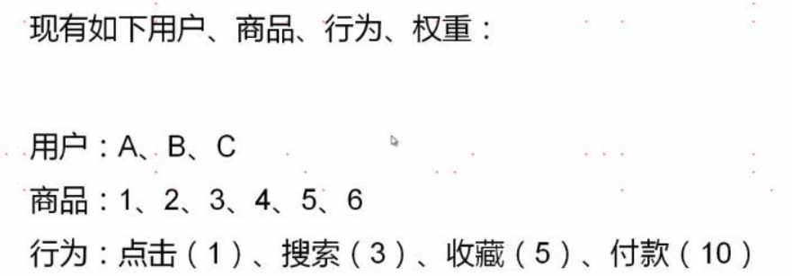
- 根据用户行为列表计算用户、物品的评分矩阵
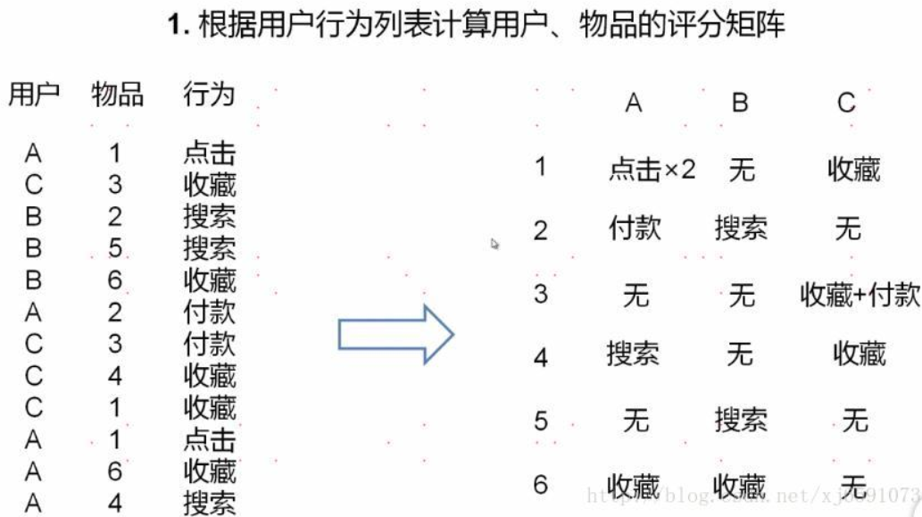
- 根据用户、物品的评分矩阵计算物品之间的相似度
利用余弦相似度计算相似度。
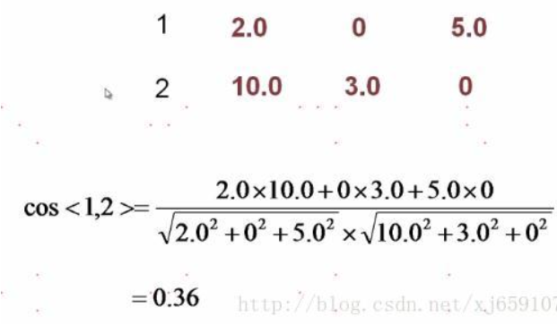
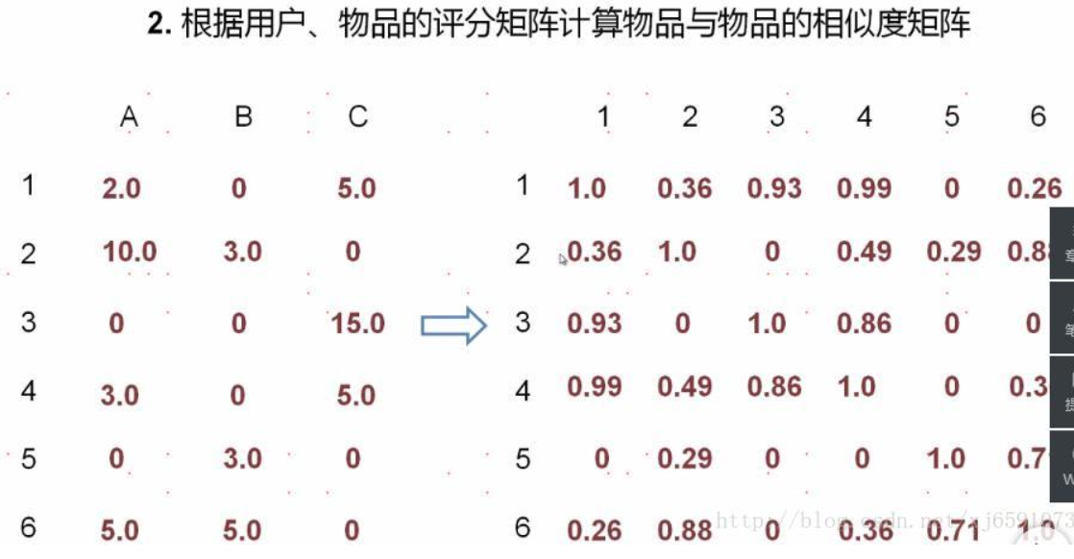

- 相似度矩阵*评分矩阵=推荐矩阵
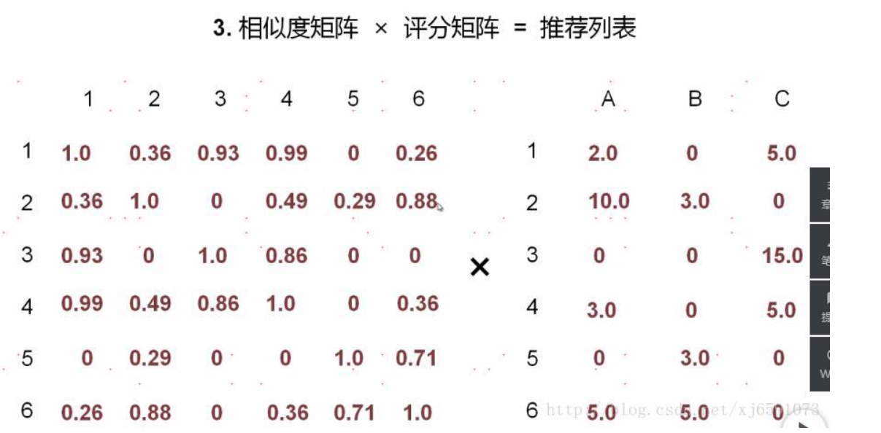
计算得出推荐矩阵
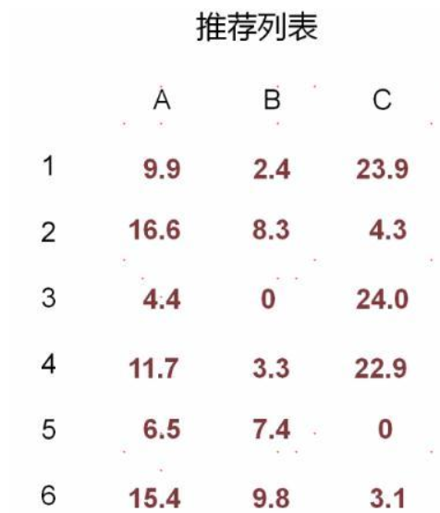
- 对比评分矩阵，对于已经推荐过的物品要去除推荐
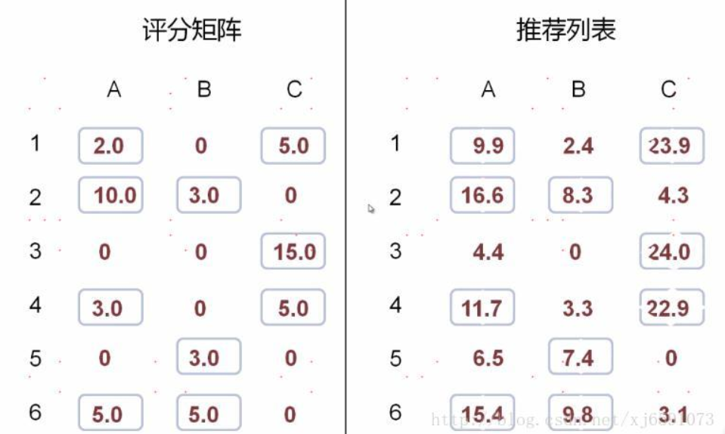

去除推荐就是置为0，并且选出评分最高的物品就是用户最应该推荐的一个物品了
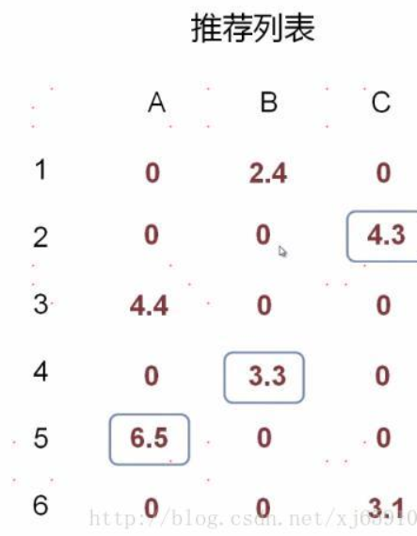
14、校园生活方式的行为分析
本项目通过校园智能卡收集了中国电子科技大学18960名本科生日常活动的数字记录。我们提取的一些高层次的行为特征记录,如生活规律性(根据淋浴记录和饮食记录来评估),衡量日常生活的规律性和努力程度(根据进出图书馆的记录和在教学楼取水的记录来评估)用来评估在学习上花了多少时间。我们证明了生活规律性和成绩之间的，以及努力程度和GPA之间的重要相关性,。特别是，据我们所知，生活规律性首次被认为是一种重要的行为特征，在很大程度上影响学生的学业成绩。进一步的分析表明,作为一个特征，生活规律性的引进，即使在努力程度存在的情况下，能够显著的提高学期GPA预测的精准性。

