Famox Requirements Analysis and Initial Design Report

Team T25

26372452 - Hui Yee Tan

24201596 - Sean Kozer

Table of Contents

**Overview of Famox Business** **3**

**Functional Requirements of The System** **4**

**Business Benefits** **4**

**Data Model** **5**

**Sitemap & Prototypes** **5**

**Sitemap** **5**

**Prototypes** **6**

**Work breakdown** **21**

# 

# 

# Overview of Famox Business

Famox is an Australian based charity which raises money for ethical causes through project donations and the sale of branded apparel.

Currently Famox has no online presence which is standing in the way of their goals of becoming a global charity and brand.

All of Famox’s data comes from paper based forms which are prone to data inaccuracy through lack of validation.

Manual data entry also presents hidden costs such as printing, postage, paper and transport. In addition to these costs, paper based forms require more time from staff to process, and more time from clients to fill out; likely resulting in a low conversion rate.

Famox has expressed interest in leveraging modern technology to enable the organisation to acquire clients across the globe.

It is expected the increase in donations revenue from a larger clientbase will enable Famox to implement more financially demanding initiatives to support their causes.  
In addition to this, Famox will be able to diversify their focus from wildlife causes to other ethical causes such as rural community development, women’s rights and sustainable farming.

Being an local, offline-only organisation, Famox is unable to leverage cost effective marketing tools such as social media, CPC advertising and cookie-based intelligent retargeting.

Famox wishes to expand into retailing their own branded apparel in order to raise brand awareness. This will also open up new marketing avenues such as social media influencer marketing and sponsorships.

# Functional Requirements of The System

The key requirements of the proposed system include:

**General**

* Clients are able to donate and purchase from anywhere.
* The website must have ‘About’ and ‘Contact’ pages.
* System must use modern web technologies.

**Clients**

* Client registration is promoted and encouraged throughout the site.
* Information about a client’s interests are collected during registration.
* Clients can save their billing and shipping details for faster checkout flow.

**Products**

* Products must be filterable by category.
* System must support international sales.
* Products can be purchased by guests.
* Multiple items can be purchased in 1 transaction.

**Donations**

* Donations must only be made directly to projects (i.e. no general donations).
* Projects can have expiry dates.
* Donations are restricted to registered clients only.
* System must support international donations.

**Admin**

* Staff can access a backend system to manage the website.
* Staff can view, create, edit and delete Projects and Products.
* Staff can view Purchases, Donations and Clients.
* Staff can see an overview of KPIs on their dashboard.

# 

# 

# Business Benefits

Through our web application Famox will be exposed to the global audience, expanding the reach of its charity business. This application will allow clients to access the products and projects anytime, anywhere as long as there is connection to the internet.

Clients are no longer limited by their location to donate to the charity since Famox will be able to accept donations and payment online using our web application.

By going digital, Famox will have its database of projects to showcase to potential clients, allowing Famox to exhibit professionalism and commitment to its cause. Also through this initiative all existing paperwork will be digitised, streamlining the entire administrative process and cutting down the time spent by its staff. It will provide administrators ease of management for the projects and products of the organisation.

In conclusion, adopting the web application will open up new avenues and revenue streams for Famox, improve business performance and widen its influence as a charity organisation.

# Data Model

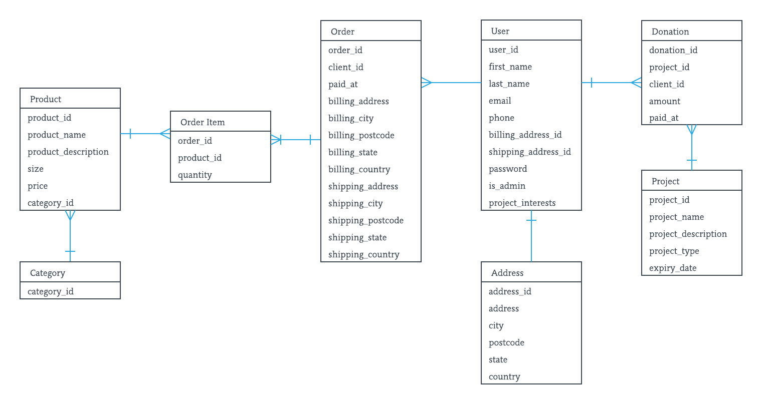

# Sitemap & Prototypes

## Sitemap

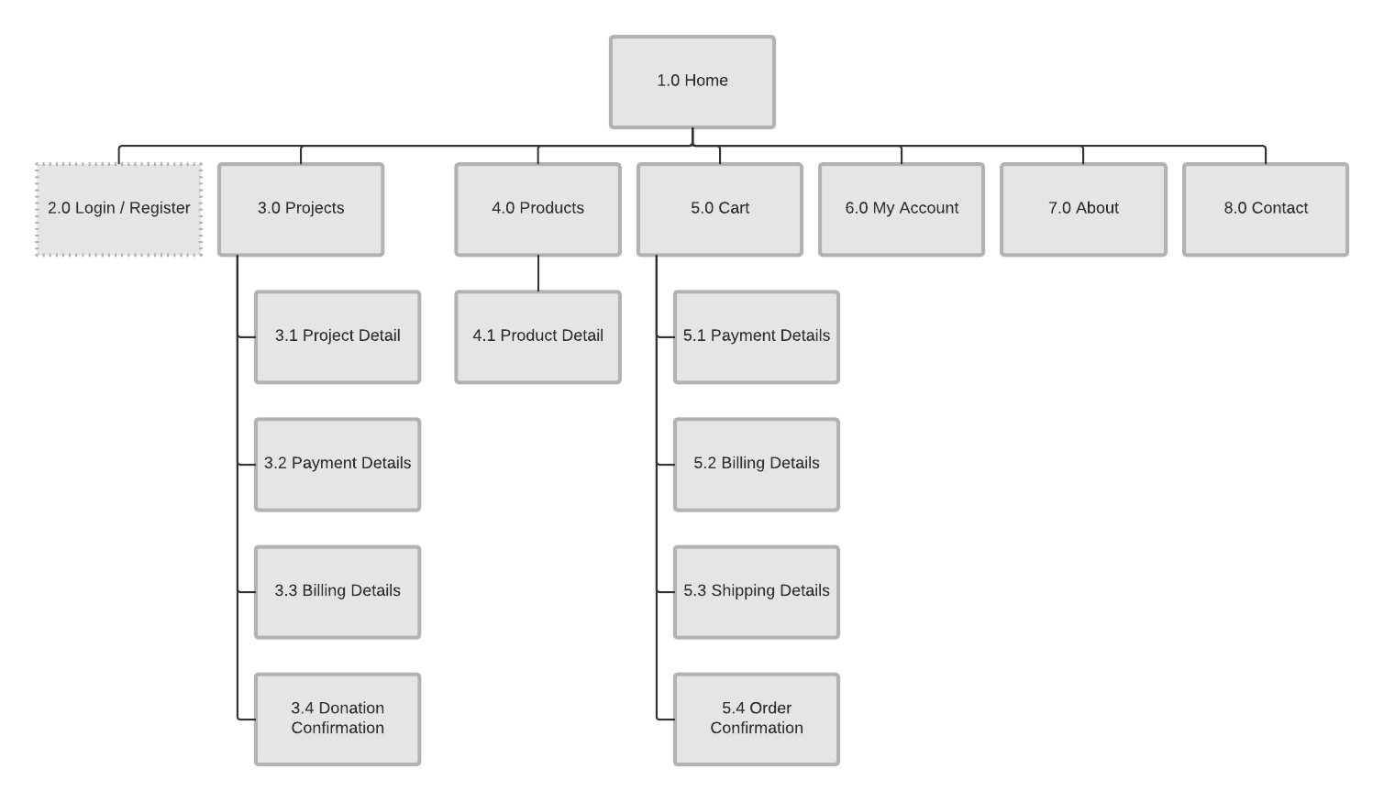

## Prototypes

Homepage

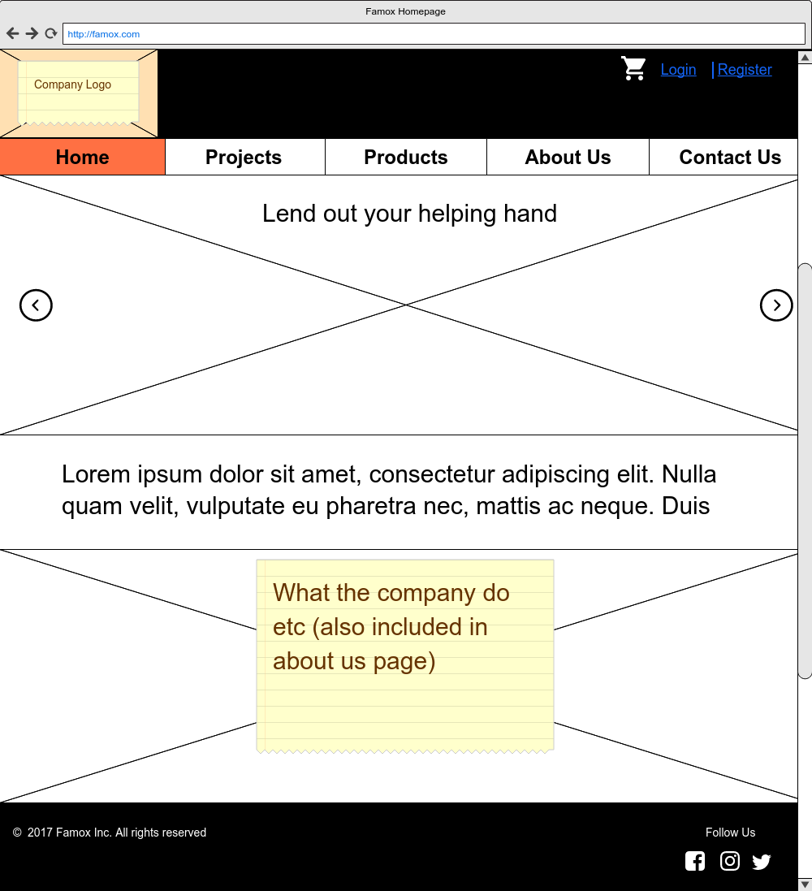

Login Page

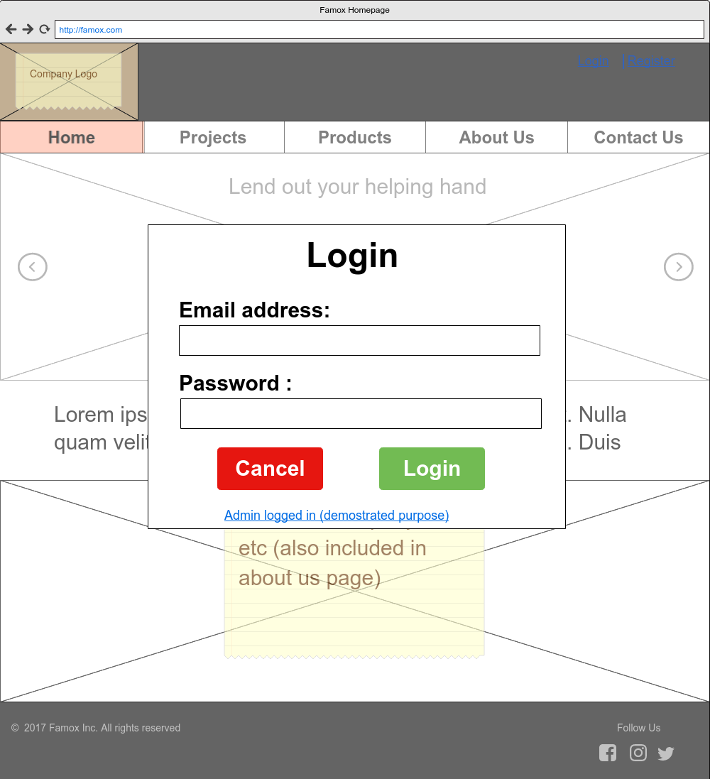

Register Page

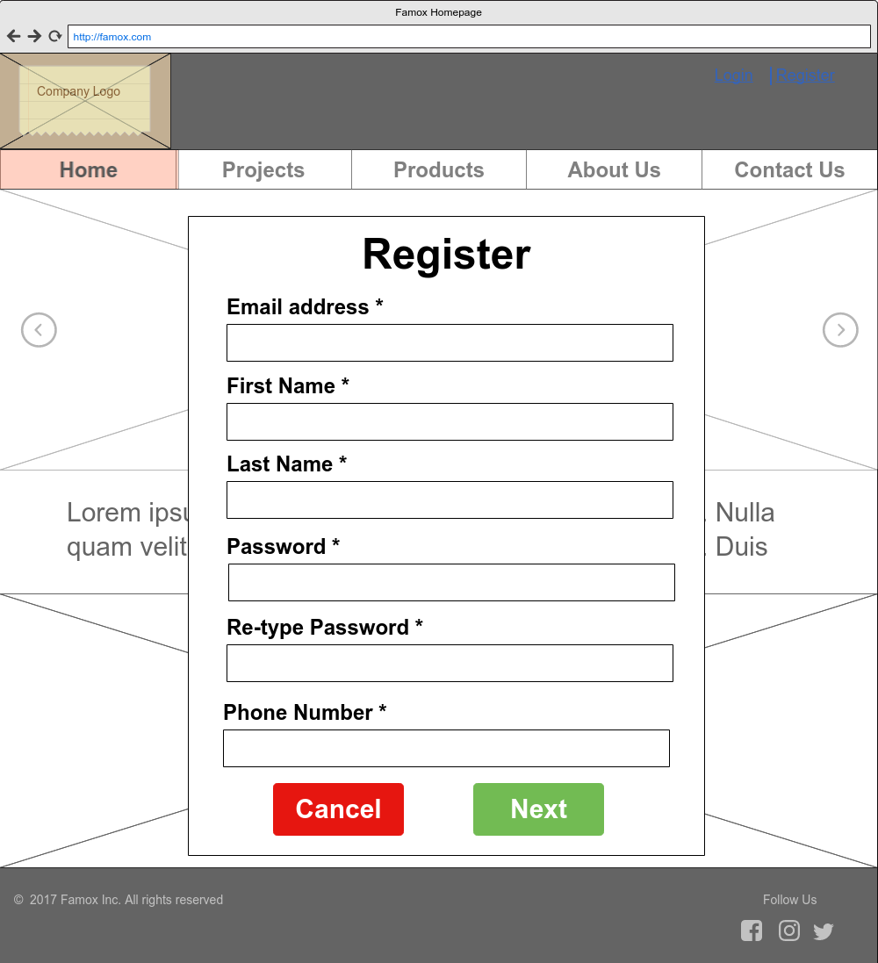

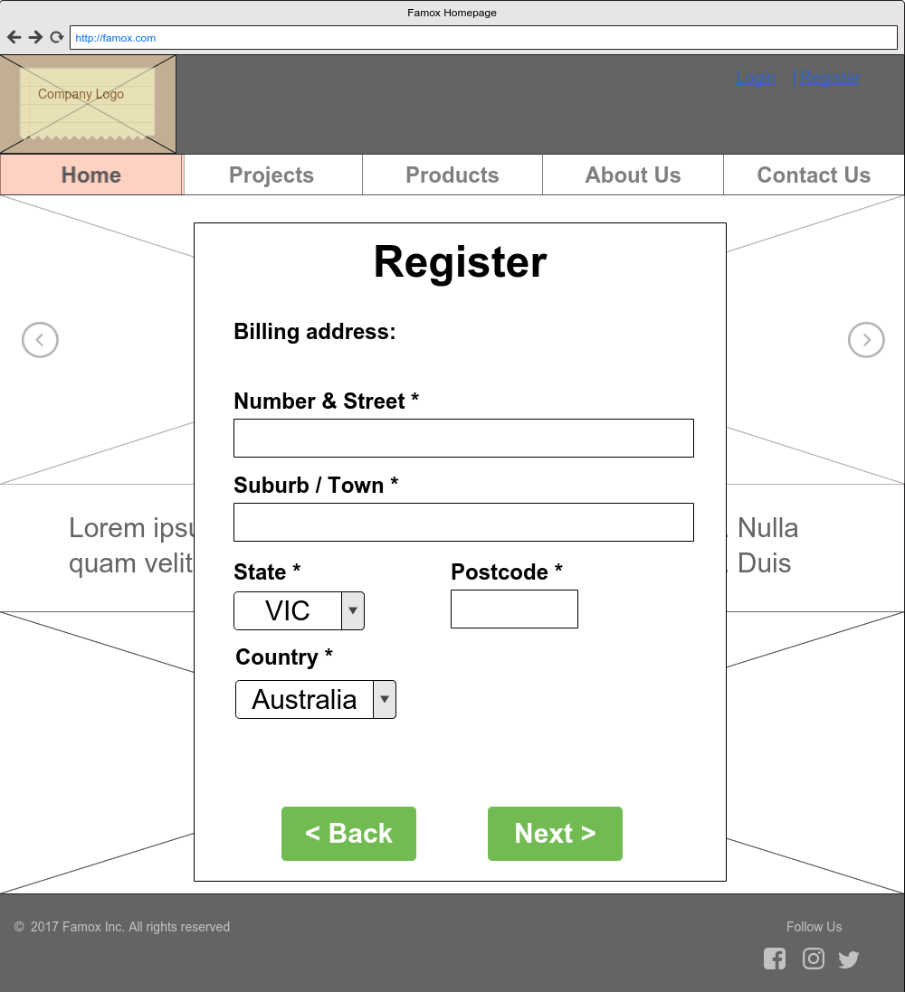

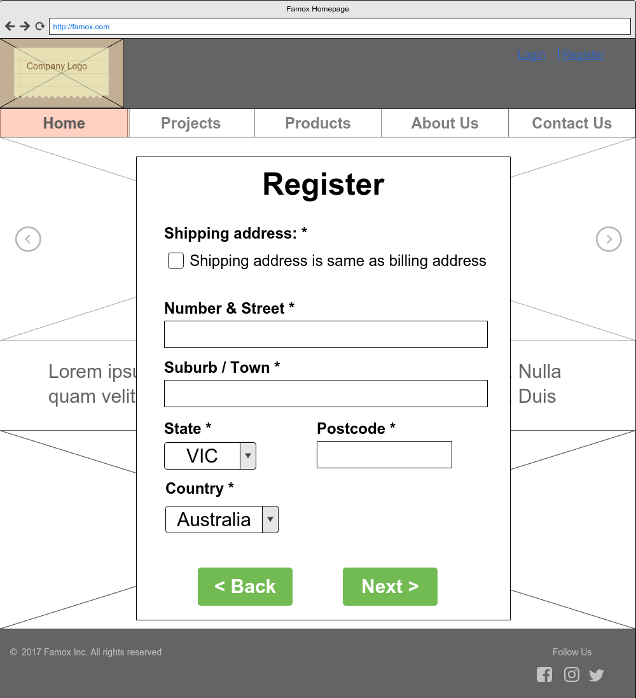

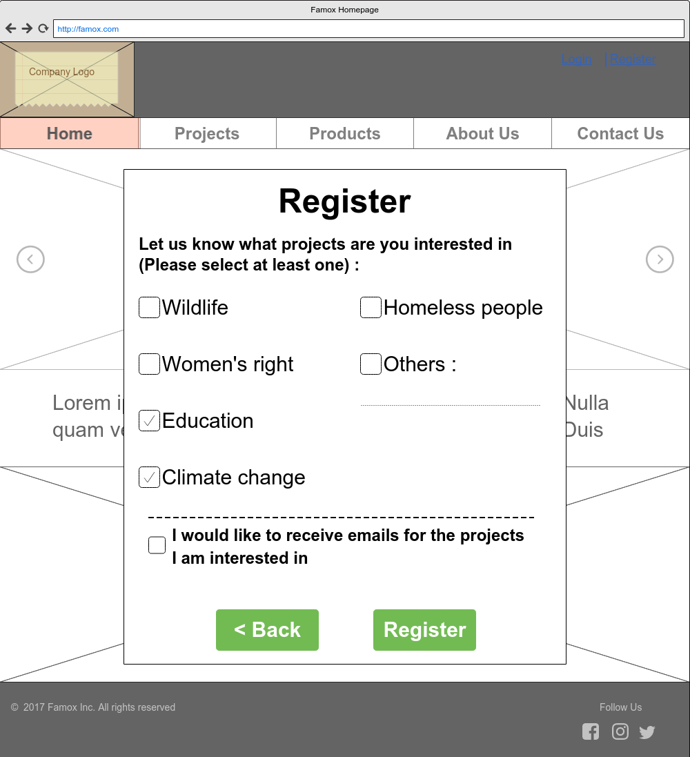

Logout Page

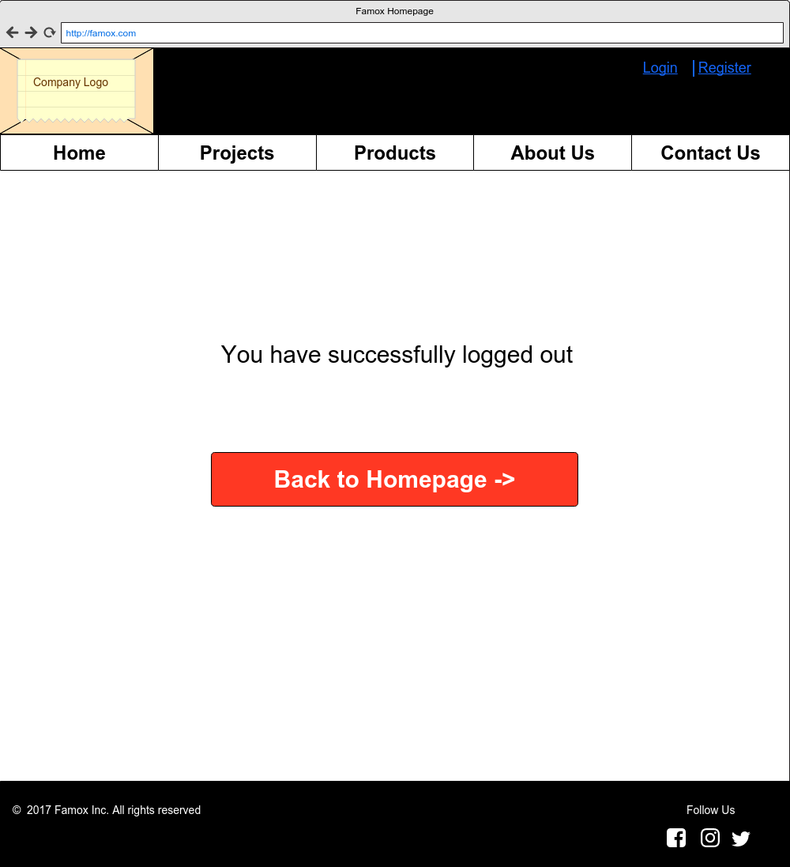

Donate to Project (Client View)

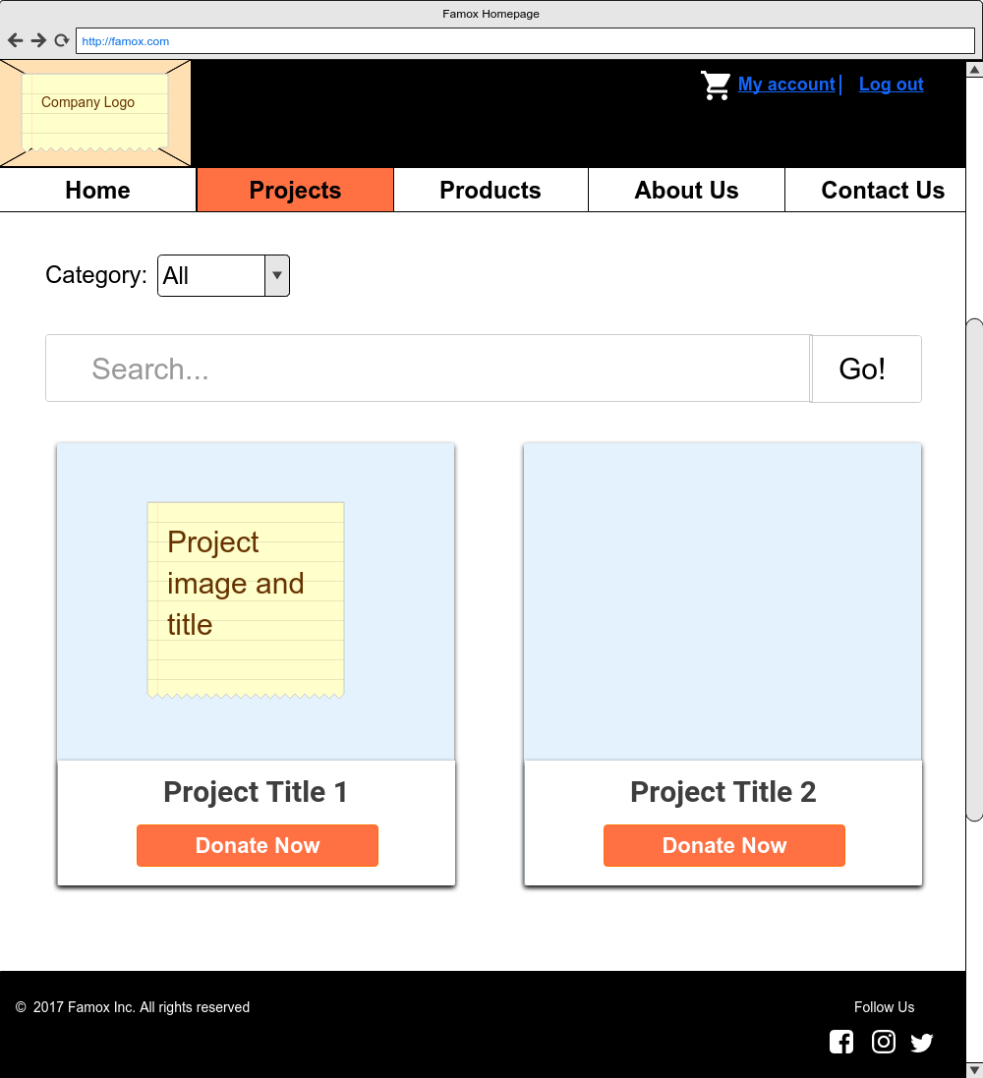

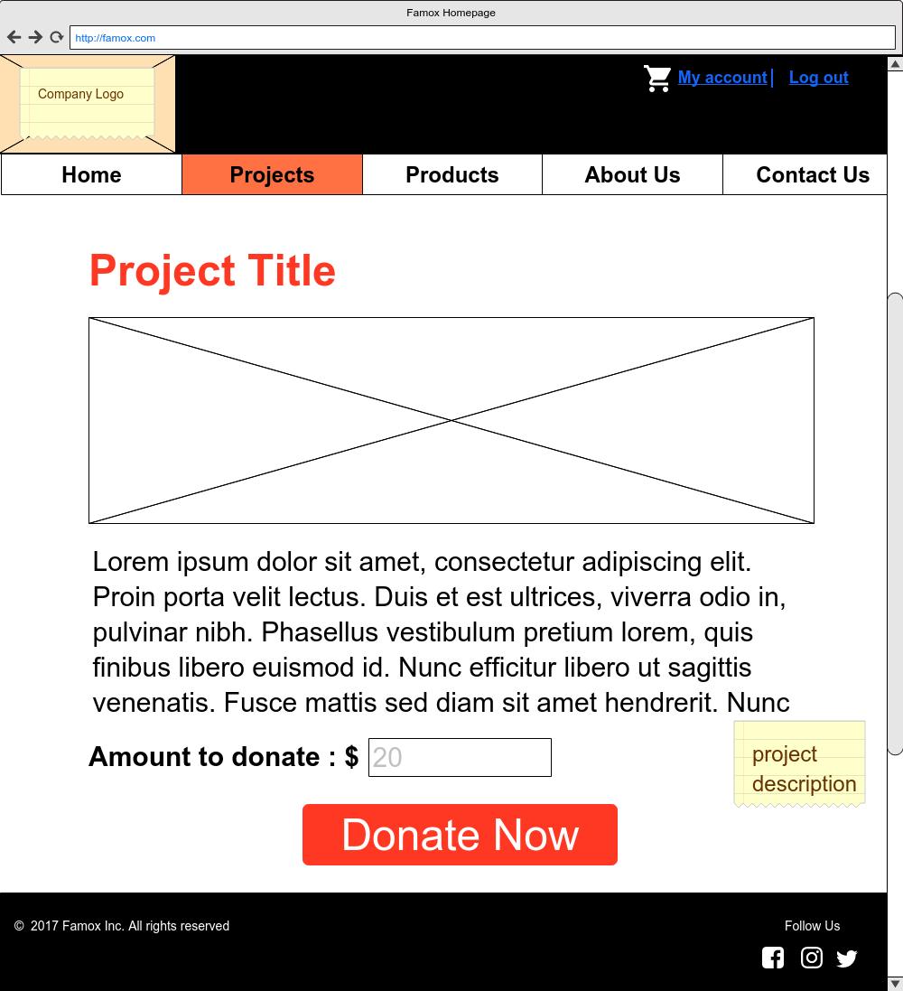

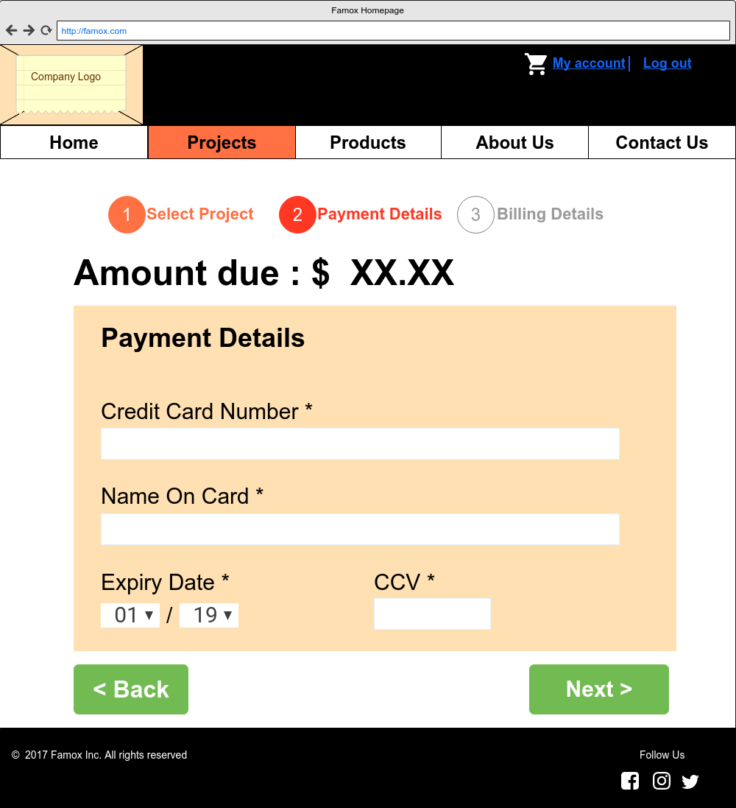

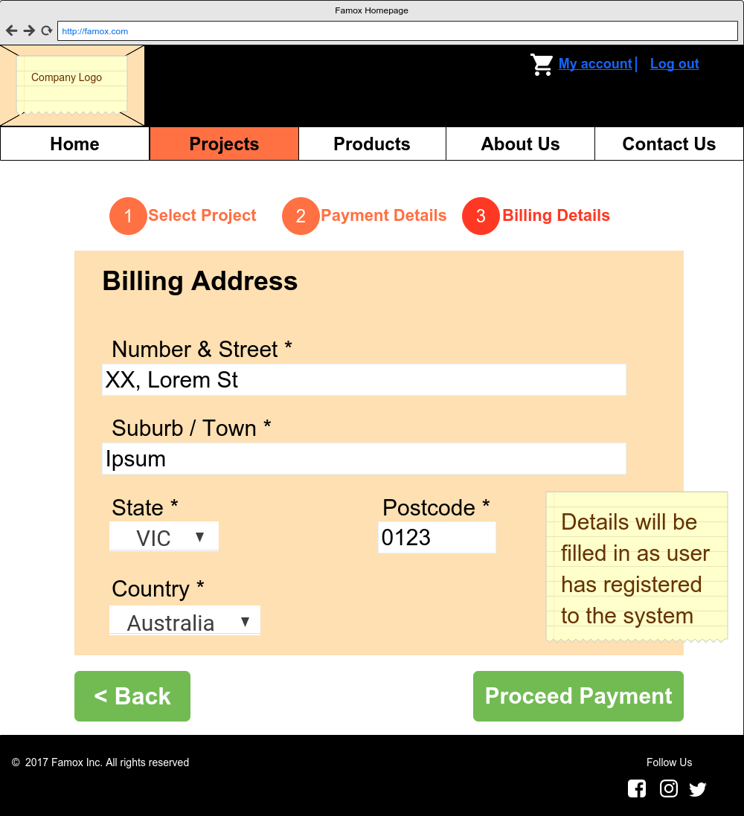

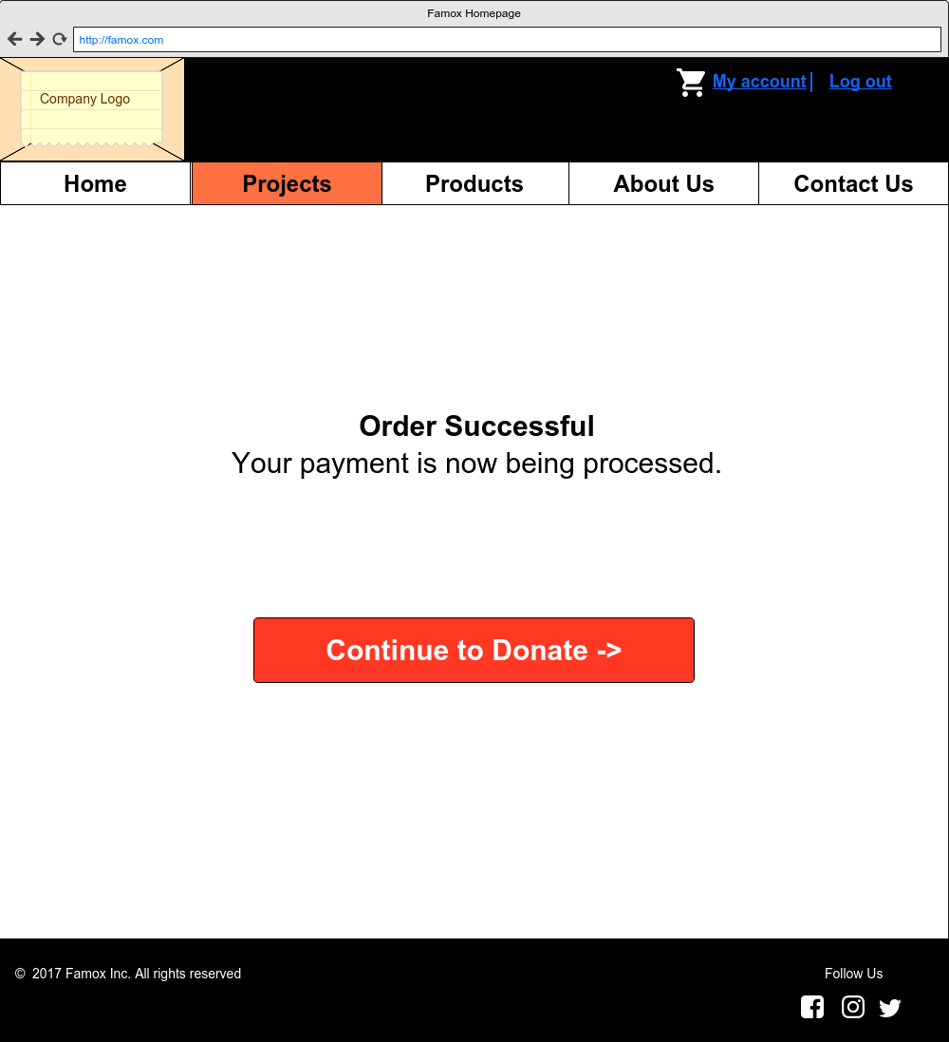

Purchase Product (Client View)

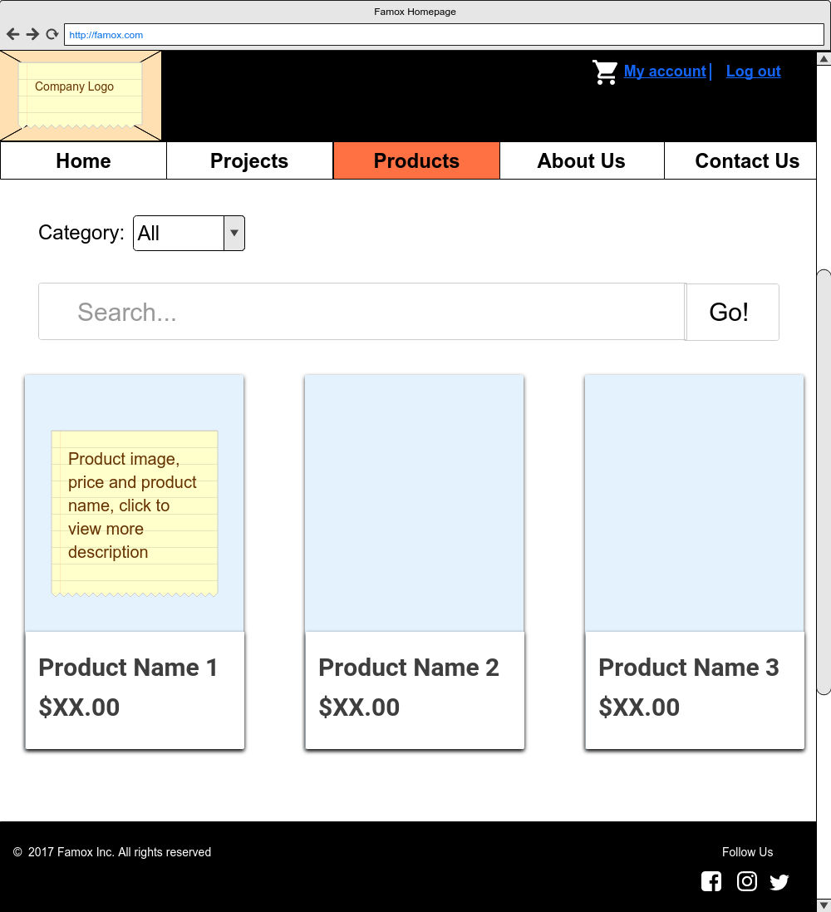

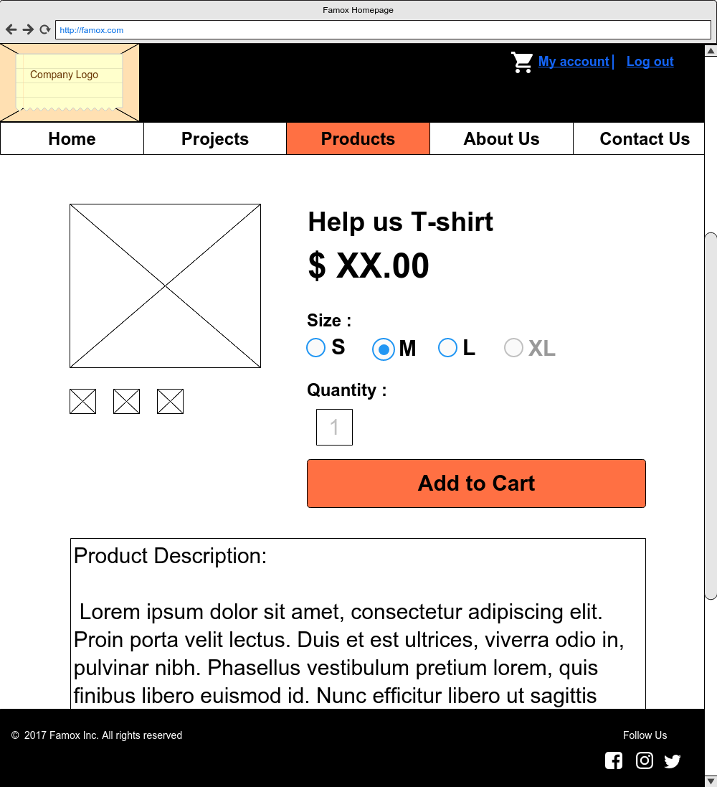

Shopping Cart & Checkout Page (Client View)

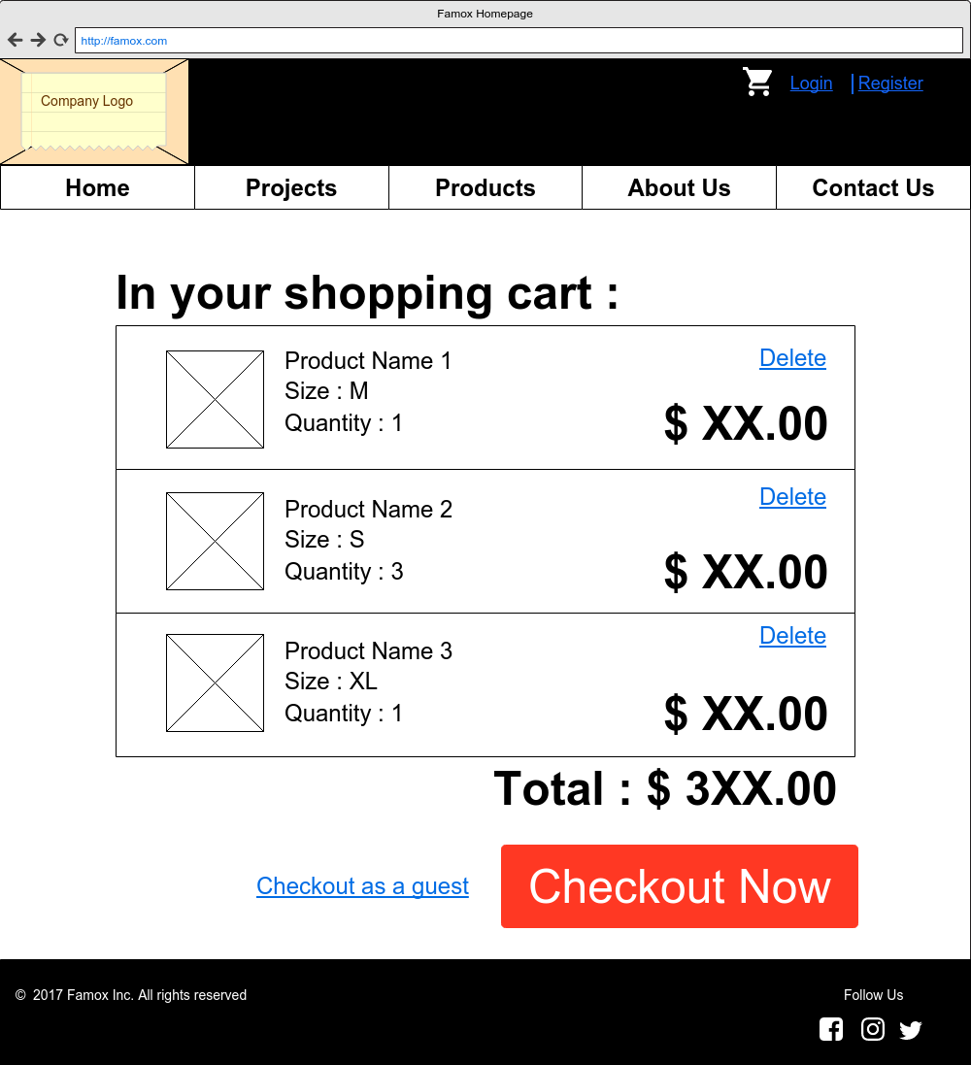

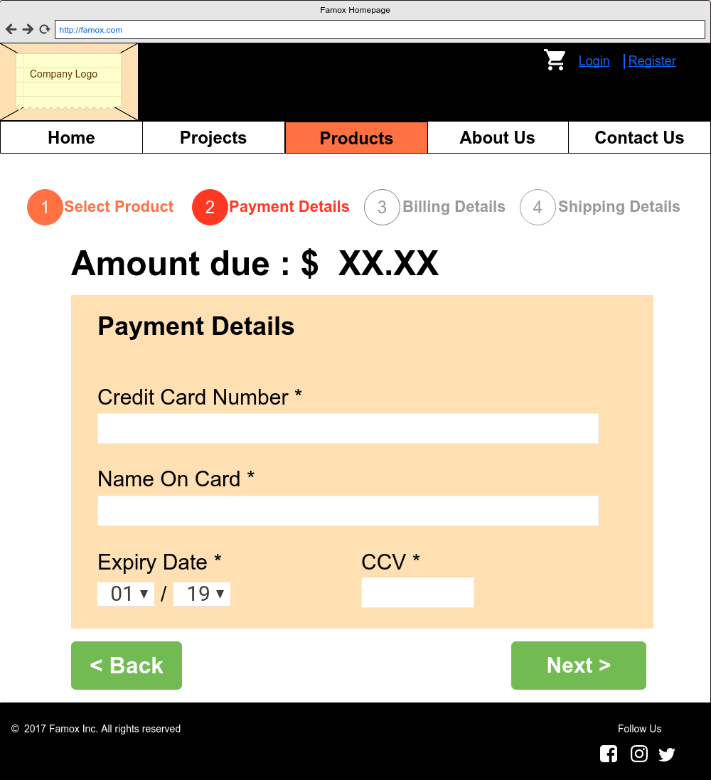

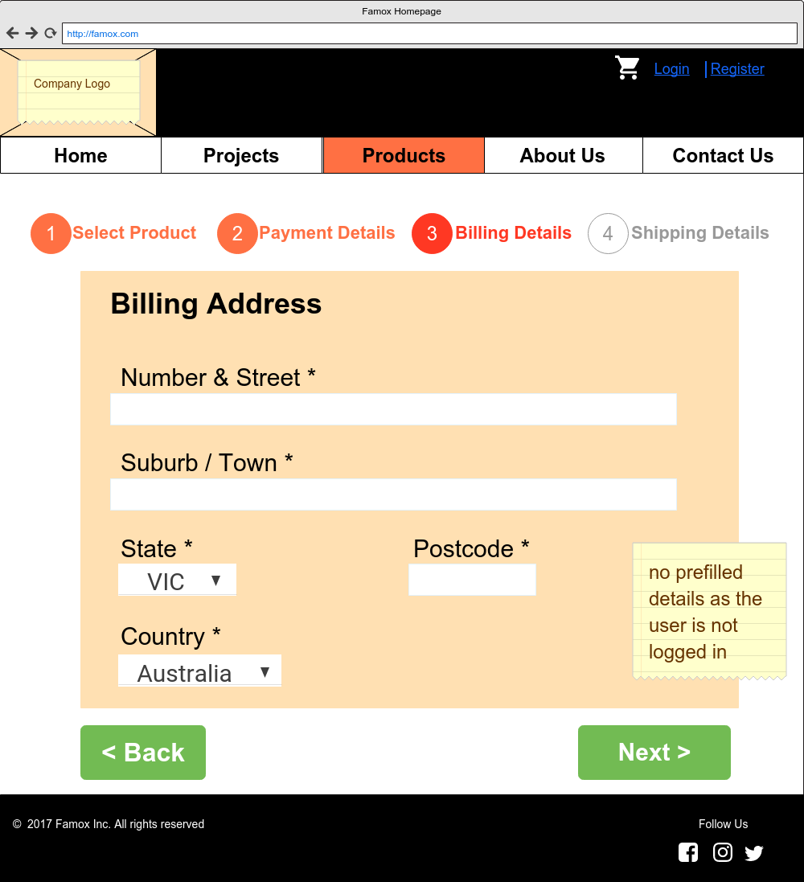

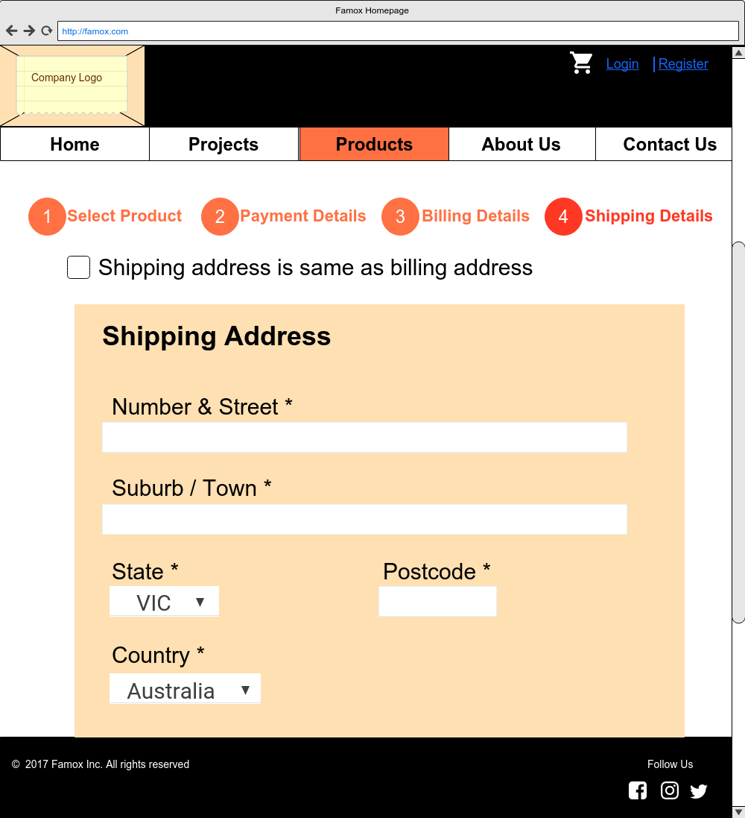

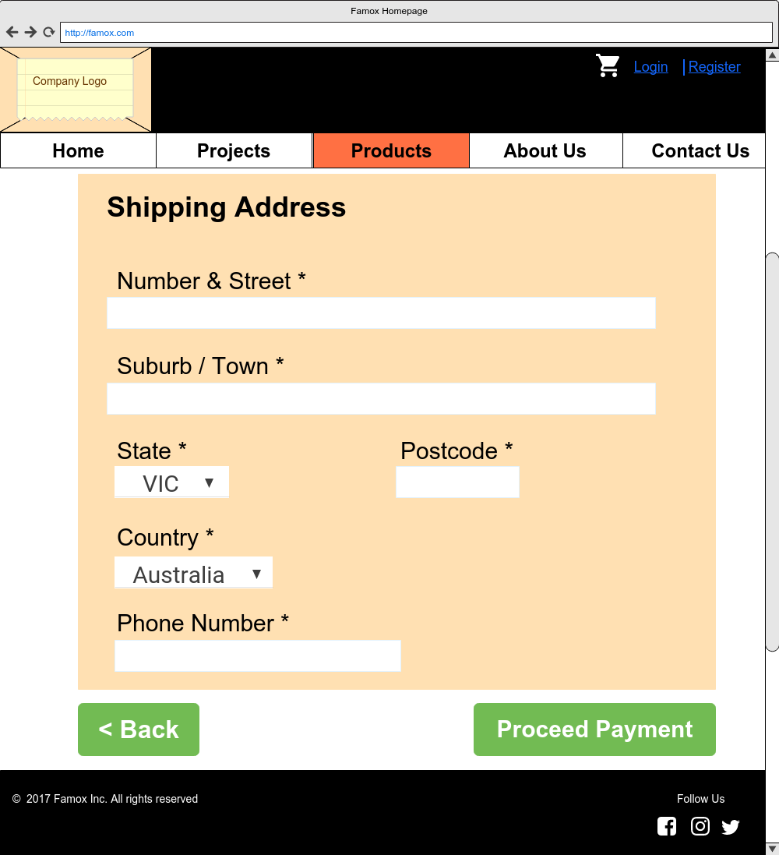

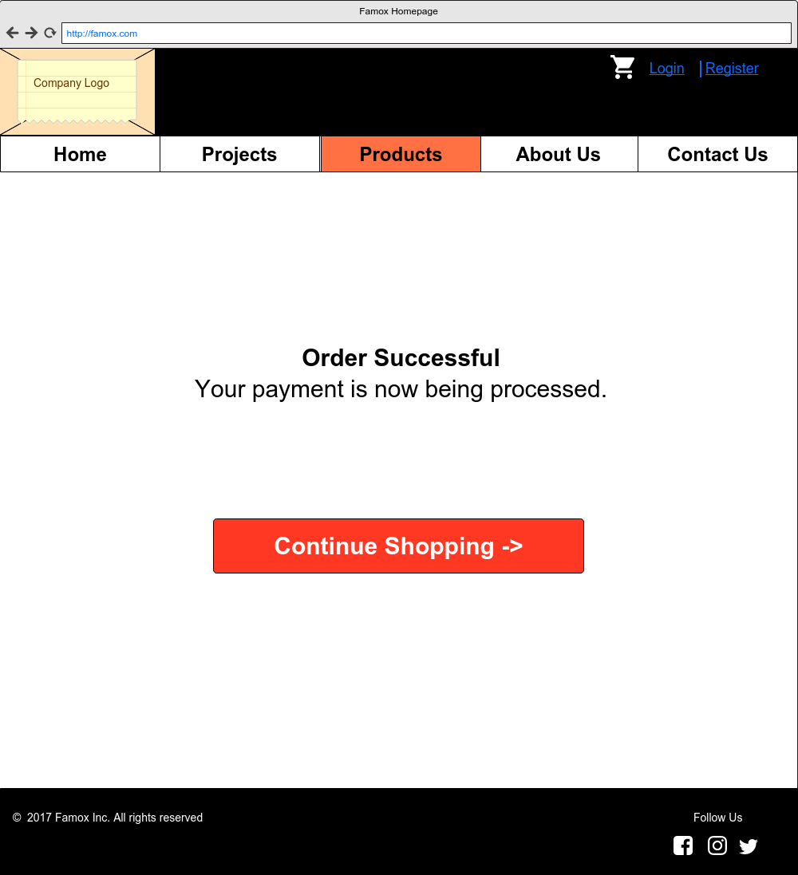

About Us Page

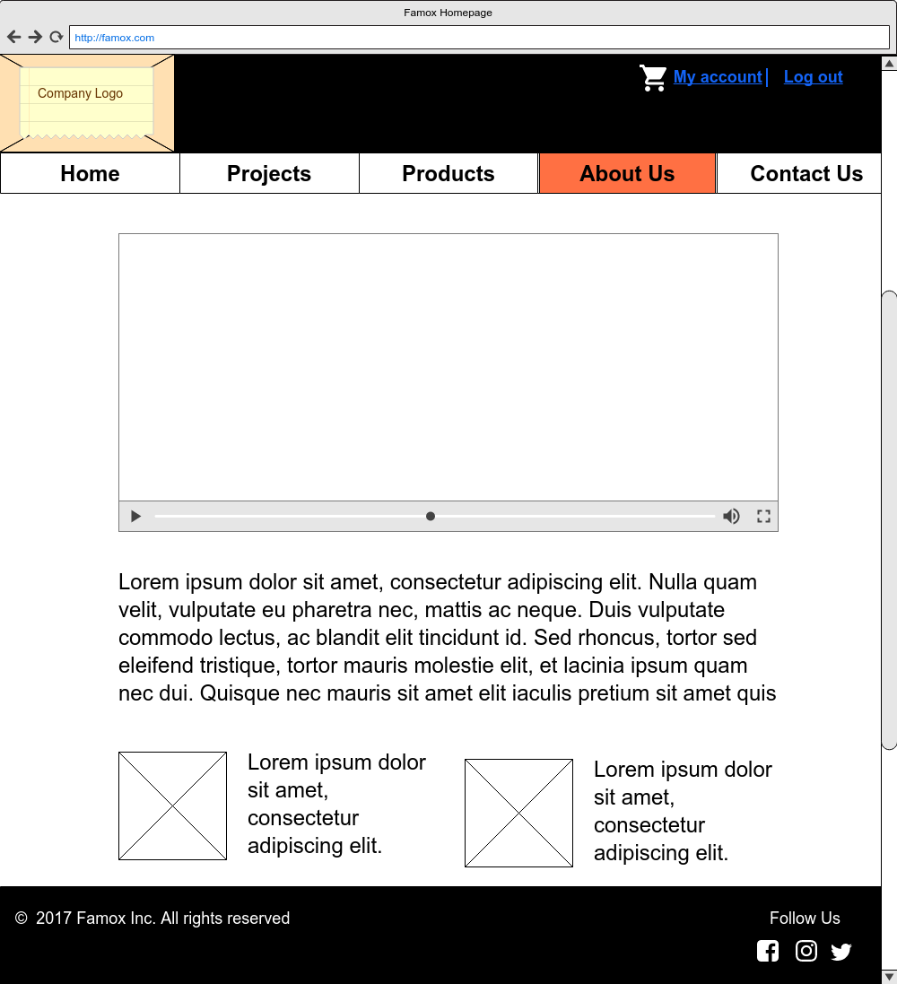

Contact Us Page

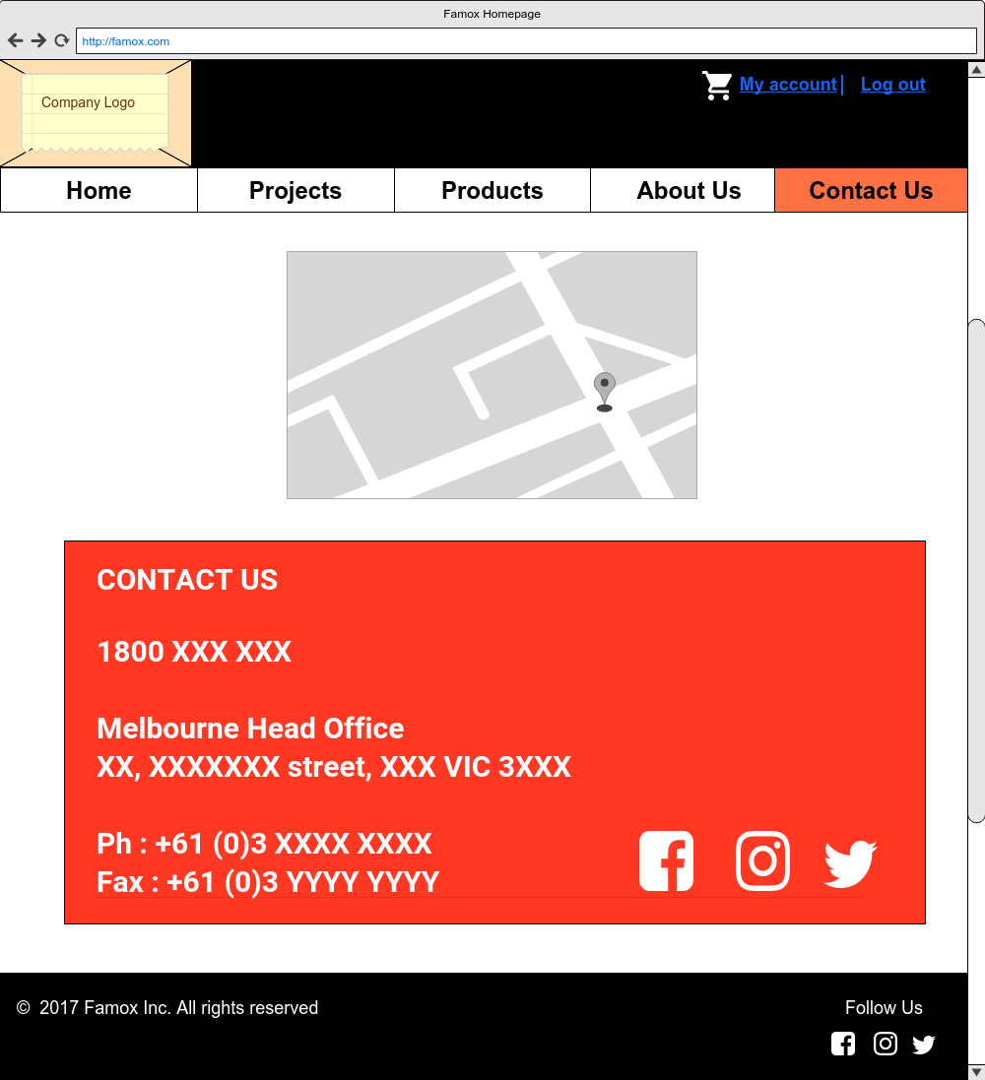

Project Page (Admin View)

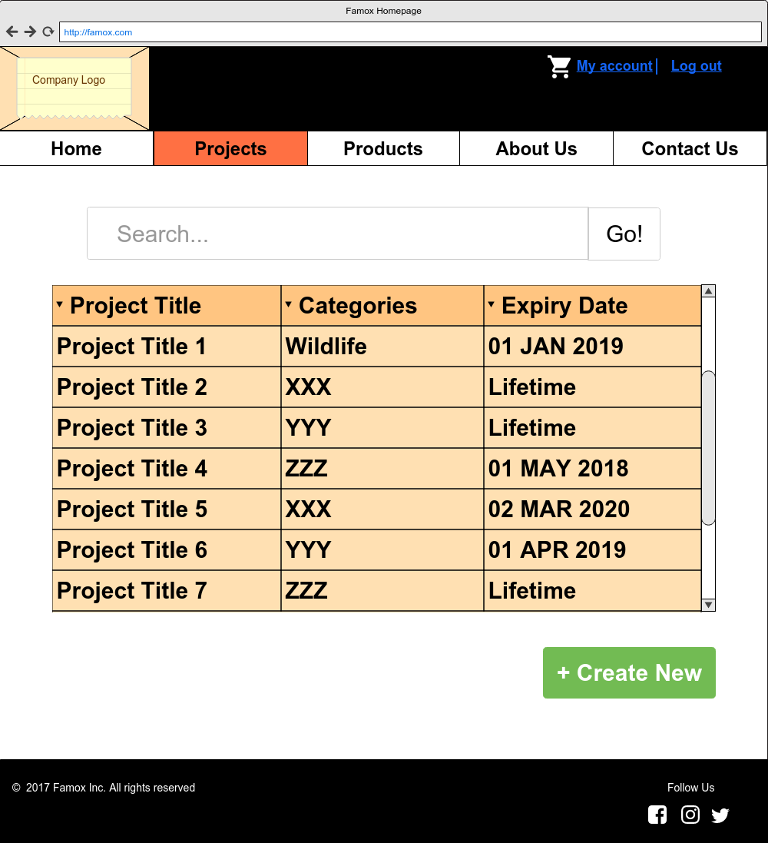

Create Project Page (Admin View)

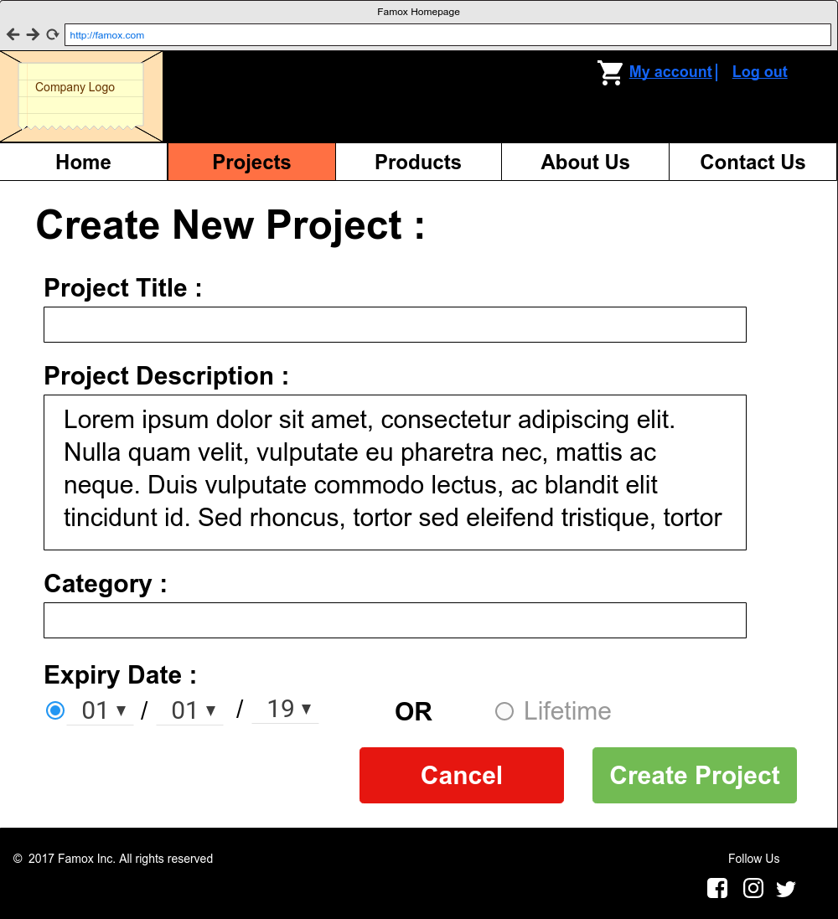

Project Details Page (Admin View)

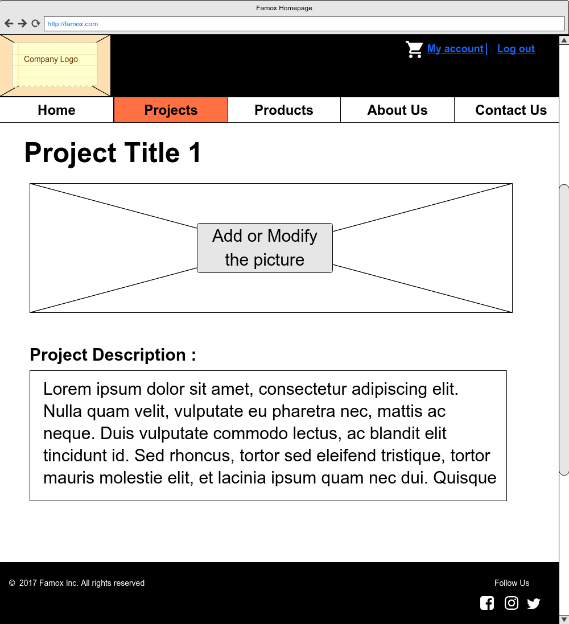

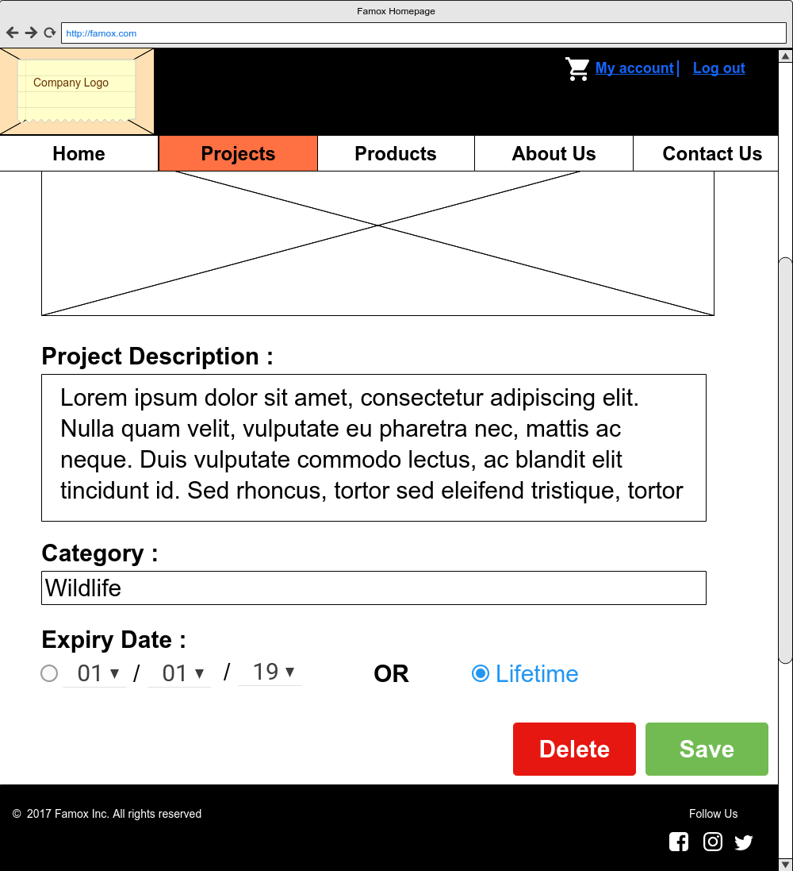

Project modification successful confirmation message (After “Save” button is clicked)

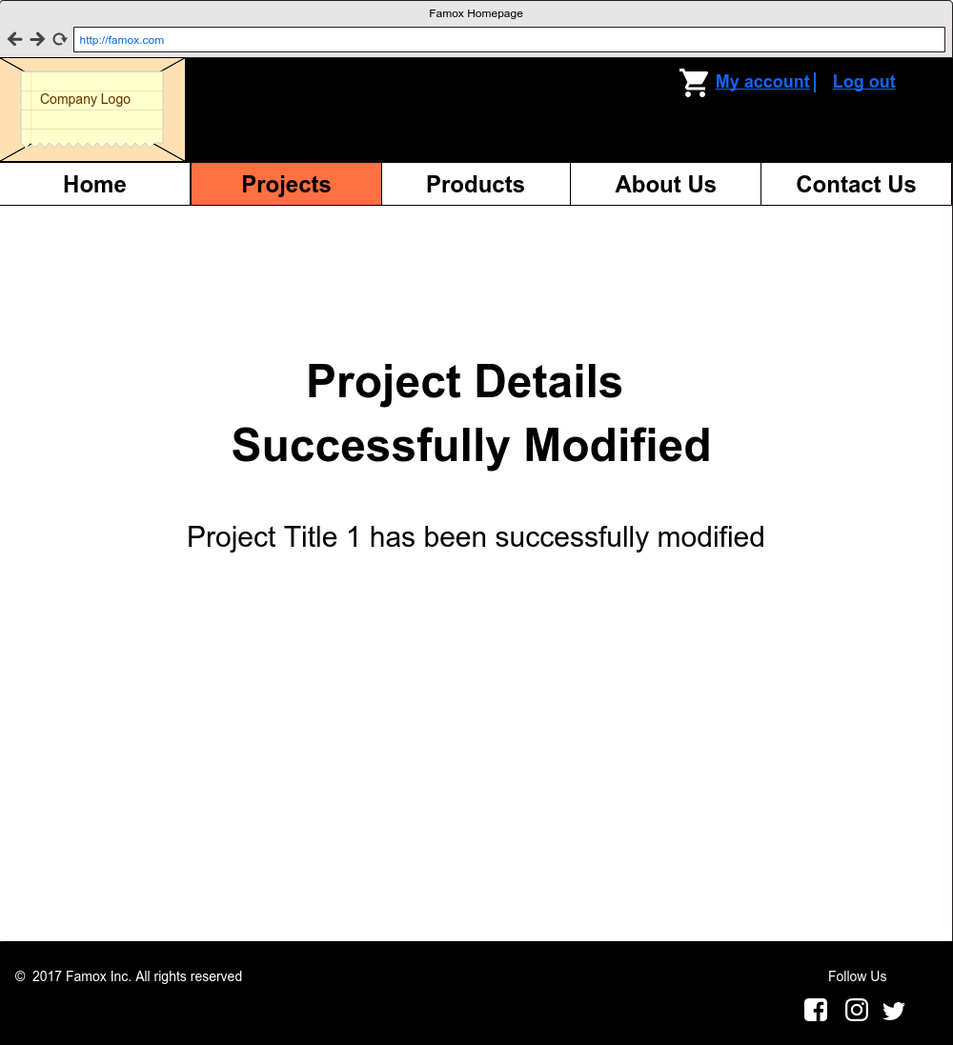

Project deletion successful confirmation message (After “Delete” button is clicked)

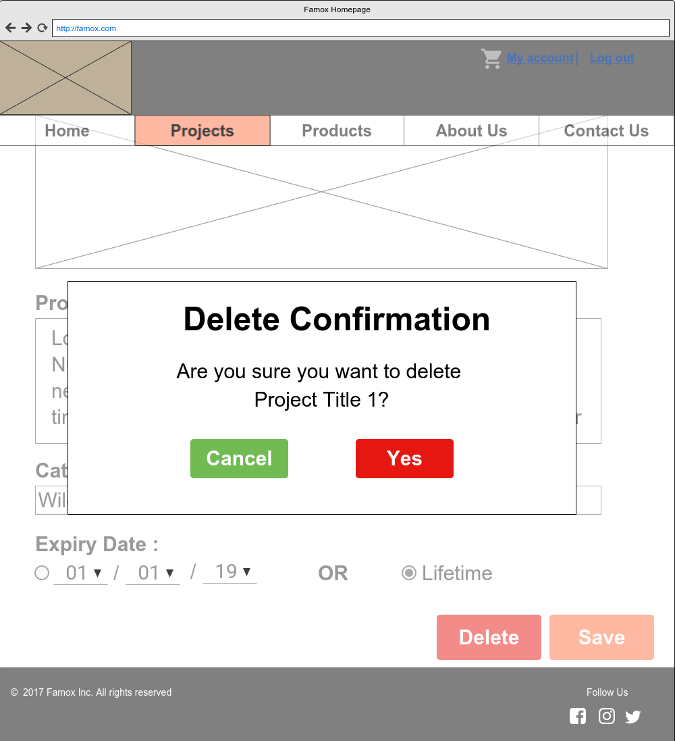

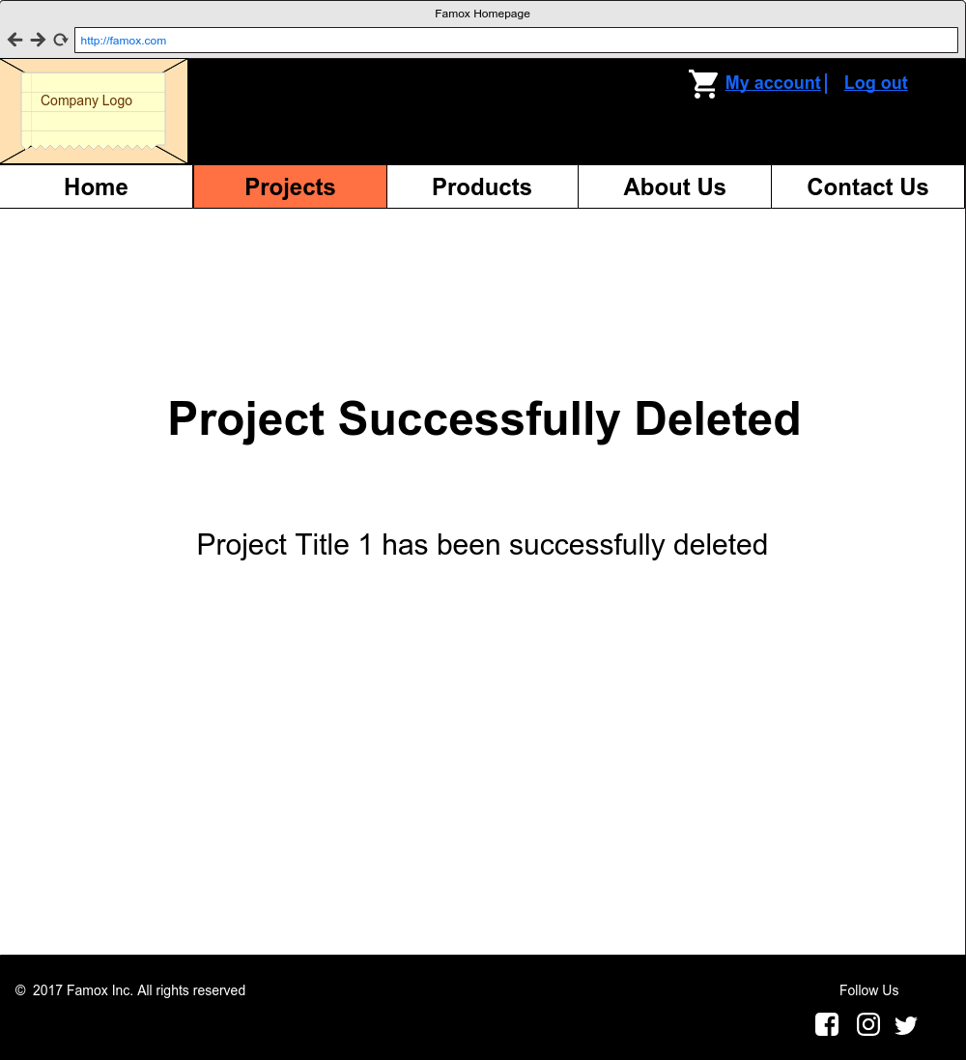

# Work breakdown

|  |  |  |
| --- | --- | --- |
| **Function** | **26372452** | **24201596** |
| Data Model | 10 | 90 |
| Prototypes | 90 | 10 |