BRAIN BASHERS

1 (Puzzle Copyright © Kevin Stone)
Complete this grid of four common 4-letter words written horizontally.
Once complete, the first and last columns are two related words.
 | A | S
 | V | E
 | X | L
 | I | V

2 (Puzzle Copyright © A. Cyril Pearson)
Using exactly four straight lines, without taking your pen off the paper, can you join all nine dots?


3 (Puzzle Copyright © Randall Fine)
A group of trainee astronauts are all sitting around the rectangular table, waiting to start their first day of training. From the clues given below, can work out where everyone sits?
- Harvey has a higher seat number than Jennie.
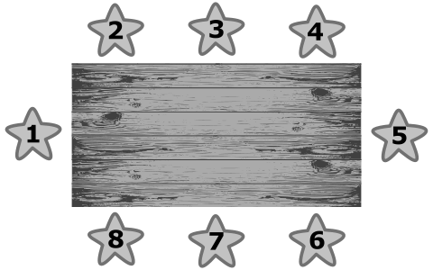
- Peter is across from Harvey.
- Neither Joyce nor Lia is in seat 8.
- Rick is across from Kenny, and Rick is also next to Joyce.
- Lia is next to Kenny.
- Jennie is at Seat 4 and next to Harvey.
- Peter is next to Lia.
- Mark has the remaining seat.

4 (Puzzle Copyright © Kevin Stone)
A very long time ago, at the beginning of the week, I was given some money for my birthday.
On Monday, I spent a quarter of the money on clothes.
On Tuesday, I spent one third of the remaining money on music.
On Wednesday, I spent half of the remaining money on games.
Finally, on Thursday, I spent the last $12.50 on a book.
How much birthday money did I receive?

