NYT GAME DAY: OCT 22, 2024
custom puzzles

Hy-Tech Club Connections
Group these words into four categories (four words per category):
BEAR | GECKO | CICI | PYTHON
JET | CSS | WORM | SUSHI
JAVA | DOMINO | ROMEO | CROCODILE
SHARK | ALLIGATOR | IGUANA | HTML

Category #1:
_________________________________________________________
Category #2:
_________________________________________________________
Category #3:
_________________________________________________________
Category #4:
_________________________________________________________
Flip for more 🔄
NYT GAME DAY: OCT 22, 2024
custom puzzles

Hy-Tech Club Crossword
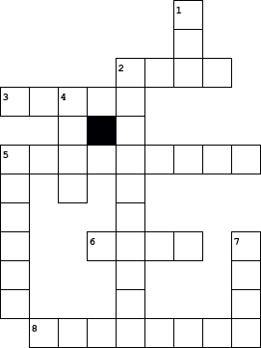
  Across
  2. | a restaurant famous for Detroit-style pizza
  3. | the cheapest catering option for 50 students
  5. | an event held January 11-12, 2025
  6. | the cost of all Hyland Tech Outreach programs
  8. | the city where we currently are
  Down
  1. | the name of a web 101 instructor
  2. | the primary topic of the web 102 course
  4. | the name of a web 102 instructor
  5. | the company where we currently are
  7. | the name of a web 103 instructor
Flip for more 🔄

