Metadata

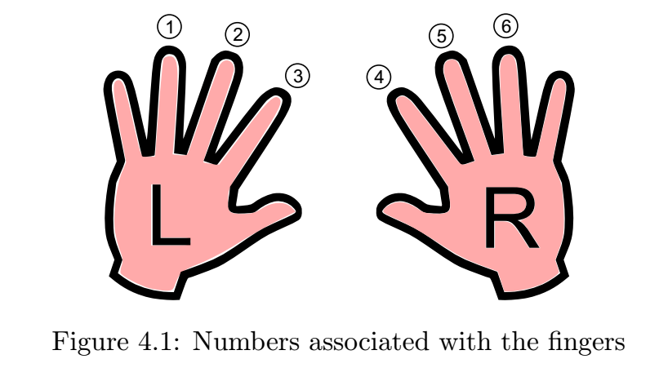

1. Each finger takes in 2 season (15 days different) and every season take twice, so the total image 24 for each finger
2. Name of file is {person_id}_{finger_id}_{measurement_id}_{date}-{time}{.png}