c. Assumptions made for the simulated system:

We have made several assumptions for our simulated system to facilitate our performance testing while also best imitating the real case scenario.

The first assumption is that all images in the simulated system are stored and uploaded through the S3 bucket for further analysis. In our simulations, test images are first stored in a public S3 bucket. Our system will then pull these images from the public bucket and copy them to another private S3 bucket. After this, the private S3 bucket will notify SNS of the images uploading event the SNS can then trigger the Lambda function to call the Amazon Rekognition API to analyze these images.

Another assumption is that our current simulated system focuses on analyzing the images and evaluating the healthy diet score for one single user. In our simulations, we assume the images uploaded belong to one user and we then assign the healthy diet score for him based on the image inputs.

The third assumption in our simulated system is that we take a general approach when evaluating the healthy diet score for the user. We assume a total of 100 points for the healthy diet scores and divide all foods into three categories: unhealthy foods, healthy foods and other foods that are fair. In our simulated system, we assume healthy foods mainly include vegetables, fruits, salads and other foods that are regarded as healthy by the general public; while unhealthy foods include deep-fried foods, desserts and other junk foods. A detailed explanation of our evaluation algorithms can be found in our report.

**Image Recognition and Evaluation**

In this section, we will describe how our simulated system use Lambda functions to call Amazon Rekognition API to analyze images and evaluate users’ healthy diet conditions.

*Overview of the Implementation*

In general, our simulated system works as following. After SNS triggers the Lambda function, the Lambda function will call the Amazon Rekognition API to evaluate the food images. The Amazon Rekognition API will return tags/labels for each food image including a confidence level indicating how likely the food image will fall into each tag/label. A demonstration of this API is displayed in ***Appendix X***. Then we design an algorithm to analyze the tags and confidence level to return a healthy diet evaluation score for each food image. After the evaluation score is calculated for each image, we then store these scores in Dynamo database for further process.

*Implementation Details*

For the detailed implementation, in the Lambda function, we will call the “detect_labels” function of the Amazon Rekognition API. We use the images from our private S3 bucket as inputs and this function will return labels for the uploaded food images. Each label will mainly include two fields: the name of the label and the level of confidence that the image contains the object. When using the “detect_labels” function, we included a minimum confidence level filter to only return the labels with confidence level higher than or equal to 50%. The reason we choose 50% is that during our test of evaluating more than 200 images, all effective labels are above 50% confidence level. Also in Amazon Rekognition Developer Guide, the default suggested minimum confidence level is 50%.

After we get the name and confidence level field of the image labels, we then implement an algorithm to evaluate and score the food images based on their labels. Firstly, we filter all label names and exclude the labels which are irrelevant to food, such as dish/plate/bowl and other labels that are too general and not deterministic, such as food. The details of our algorithm work as following. We assume users’ healthy diet scores have a total of 100 points, with 0-40 as unhealthy, 40-70 as in fair health conditions and over 70 points as healthy. Then, we categorize all label names into three types: the first type is healthy and we assign 90 points for all labels in the healthy category; the second type is unhealthy and we assign 10 points for all labels in the unhealthy category; the rest are foods that are neither healthy nor unhealthy and we assign 55 points for all labels in this category. To determine which foods are healthy, we mainly include all fruits and vegetable. We list all healthy fruits and vegetable labels in a set and check whether each label returned fall into the healthy set. If the label falls into the set, we assign 90 points to that label. To decide which foods are unhealthy, we mainly consider fried foods, desserts and junk foods. Also, we list all unhealthy foods in a set and check whether each label returned fall into the unhealthy set. If the label falls into the set, we assign 10 points to that label. For the rest of the labels that neither falls into the healthy set or the unhealthy set, we assign 55 points to them.

For instance, to analyze the labels returned by the image showed in ***Appendix X1,*** we use the following approach. The “Food” label is too general and thus is excluded from our consideration. Now, there are three labels left: “Cake”, “Dessert” and “Butter”. Among the three labels, “Cake” and “Dessert” belong to the unhealthy category and therefore, we assign 10 points for these two labels. While the “Butter” label belong to the third category that are neither healthy nor unhealthy, therefore we assign 55 points to “Butter”.

After assigning scores for each label, we now focus on how to combine the scores for each label in order to get a final healthy diet evaluation of the food image for each user. Our algorithm is as following: each label has its own confidence level and we get the total score for each image by calculating the weighted average of the label scores based on the labels’ confidence level. The following example will illustrate this process.

Again, take ***Appendix X1*** for example, the calculation is as following:

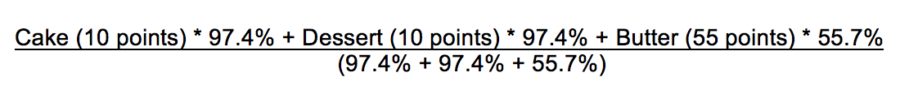

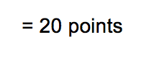

From this illustration, the healthy diet evaluation score for the cheesecake is 20 points. Since 20 points fall between 0 – 40 points, we draw the conclusion that cheesecake is an unhealthy diet.

After we evaluated the healthy diet scores for each food images, we then send the scores for each image to Dynamo Database in the Lambda function. Dynamo Database stores the score information and will then process the data for further implementation.

# Appendix X

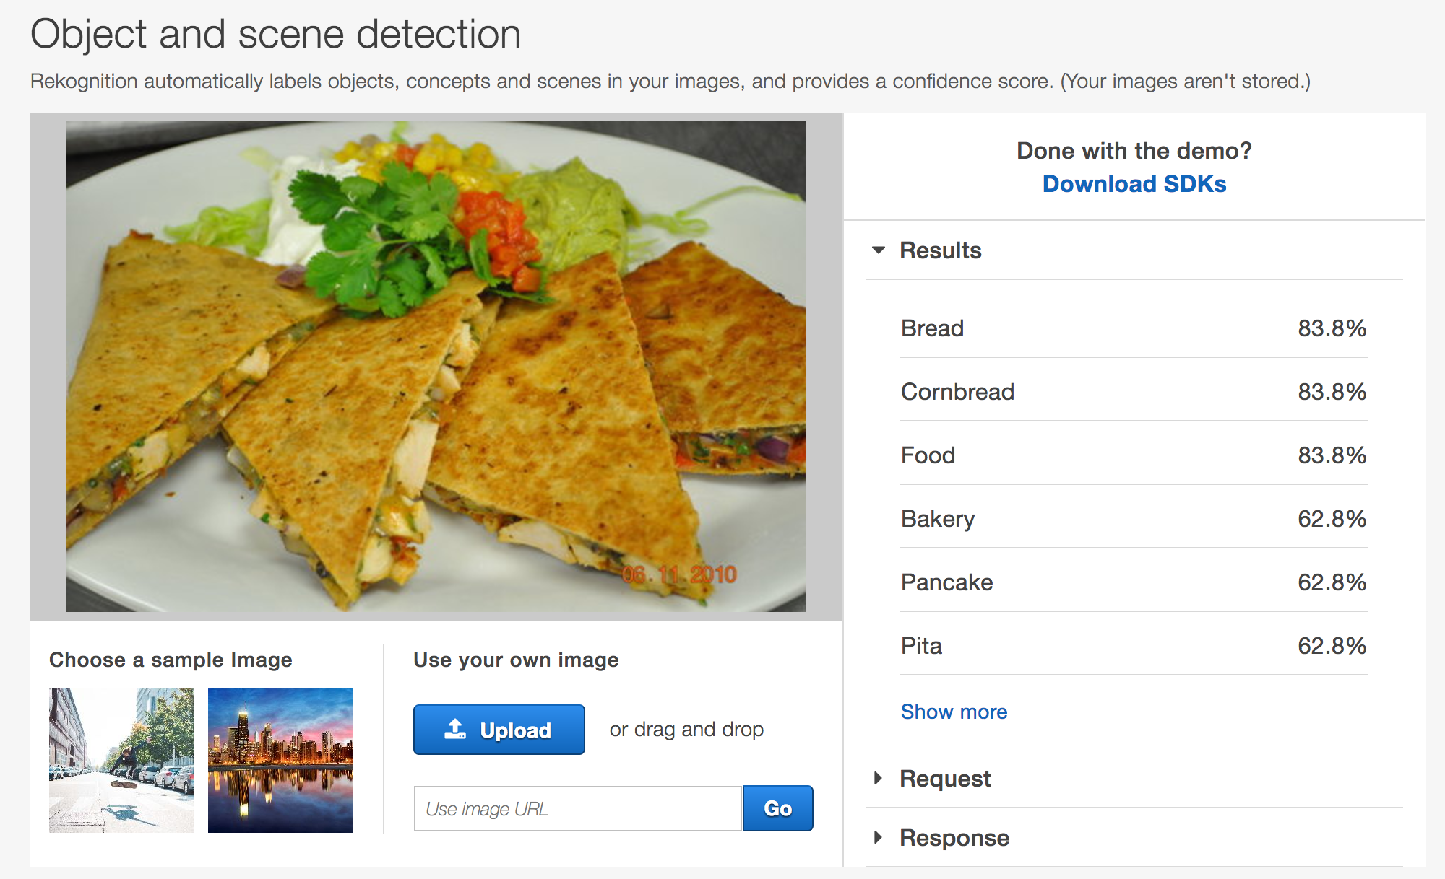

# Appendix X1

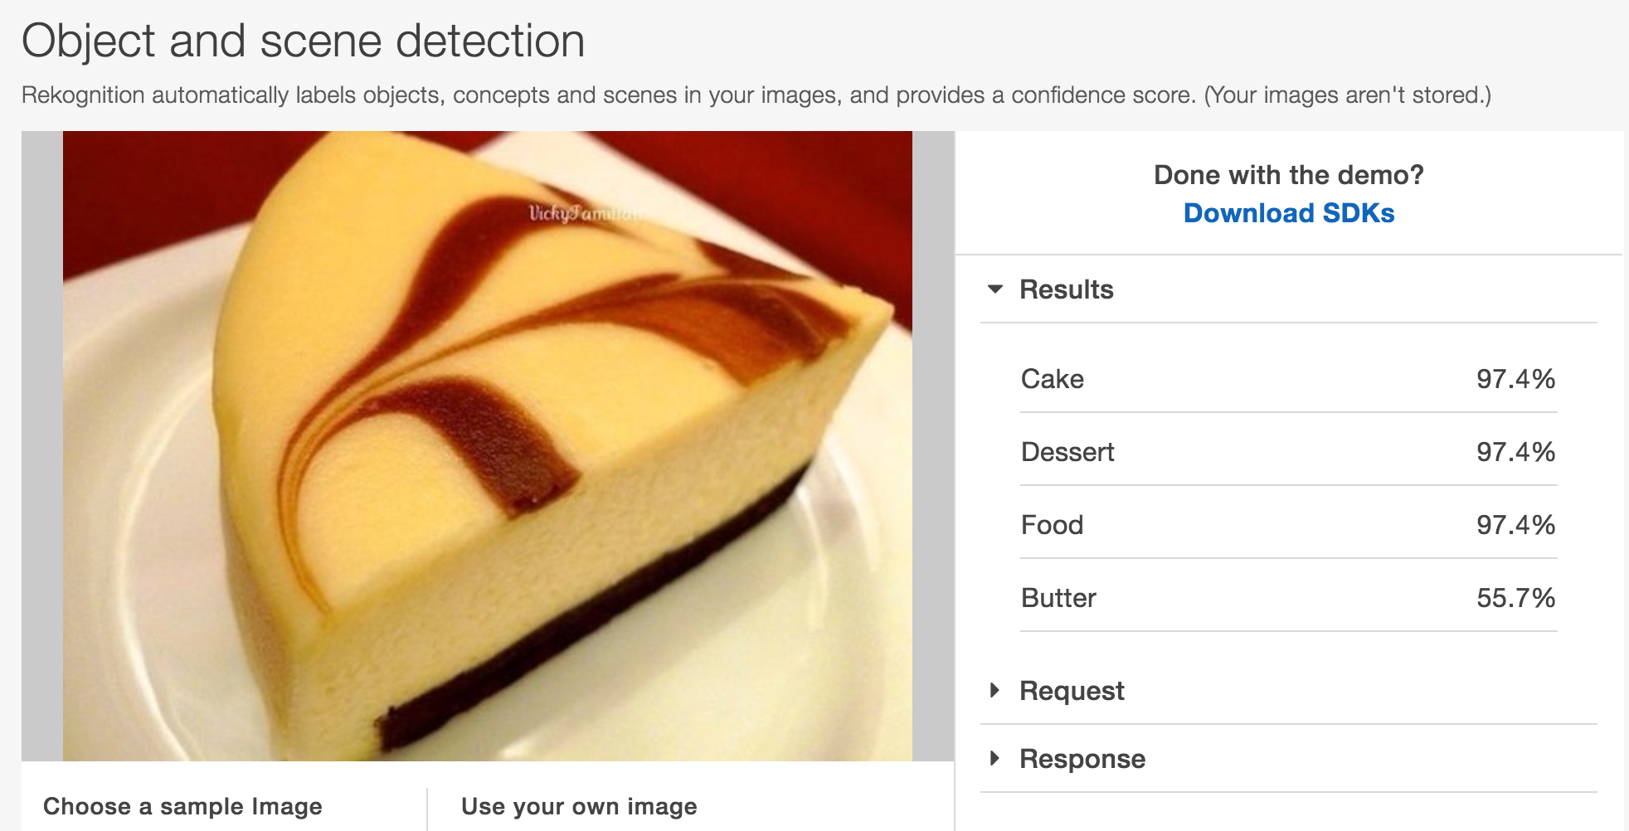

**Reference**

Min confidence:

http://docs.aws.amazon.com/rekognition/latest/dg/rekognition-dg.pdf