COMP4976 Polina Omelyantseva September 2026

Municipal Elections Management System
Table of Contents
Project description 1
Entity Relationship Diagram (ERD) 2
Application screenshots 3
Azure deployment screenshot 8
GitHub repository URL 9
GitHub Copilot prompt, instructions, and skills markdown files included in the repository 9

Project description
A full-stack ASP.NET Core MVC (.NET 10) web application that lets municipalities manage candidate registrations for the October 17, 2026 municipal elections while giving the public a place to research candidates and build a personal voting guide.
The system supports multiple municipalities, each with its own configurable elected positions (e.g., Mayor, Councilor, School Trustee) and seat counts. A Super Admin role can create and manage municipalities system-wide, while scoped Municipality Admin accounts can only manage the positions and candidates belonging to their own municipality, enforced on every action, not just hidden in the UI. Administrators can upload a logo per municipality and a photo per candidate, alongside biography, website, email, and social/video links.
The public-facing site requires no login: visitors can browse a searchable, filterable, paginated candidate directory, view full candidate profiles, compare two candidates side by side, and build a personal voting guide (session-based) that can be printed or exported as a PDF ahead of election day.

Entity Relationship Diagram (ERD)

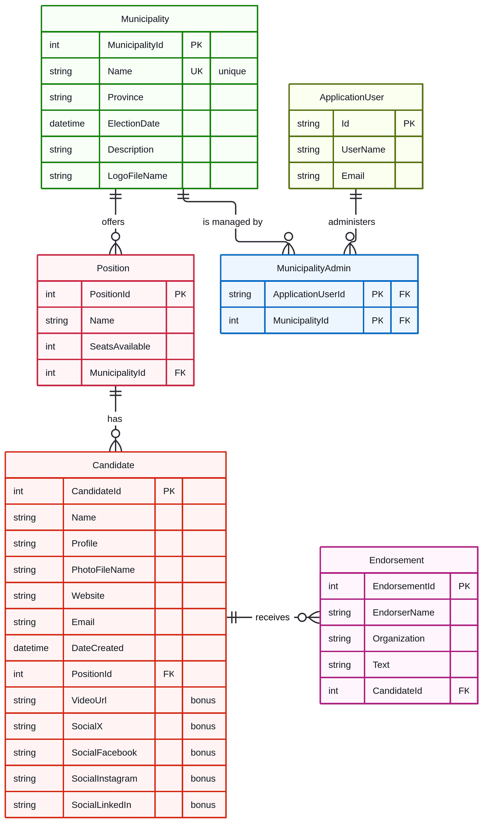

Application screenshots
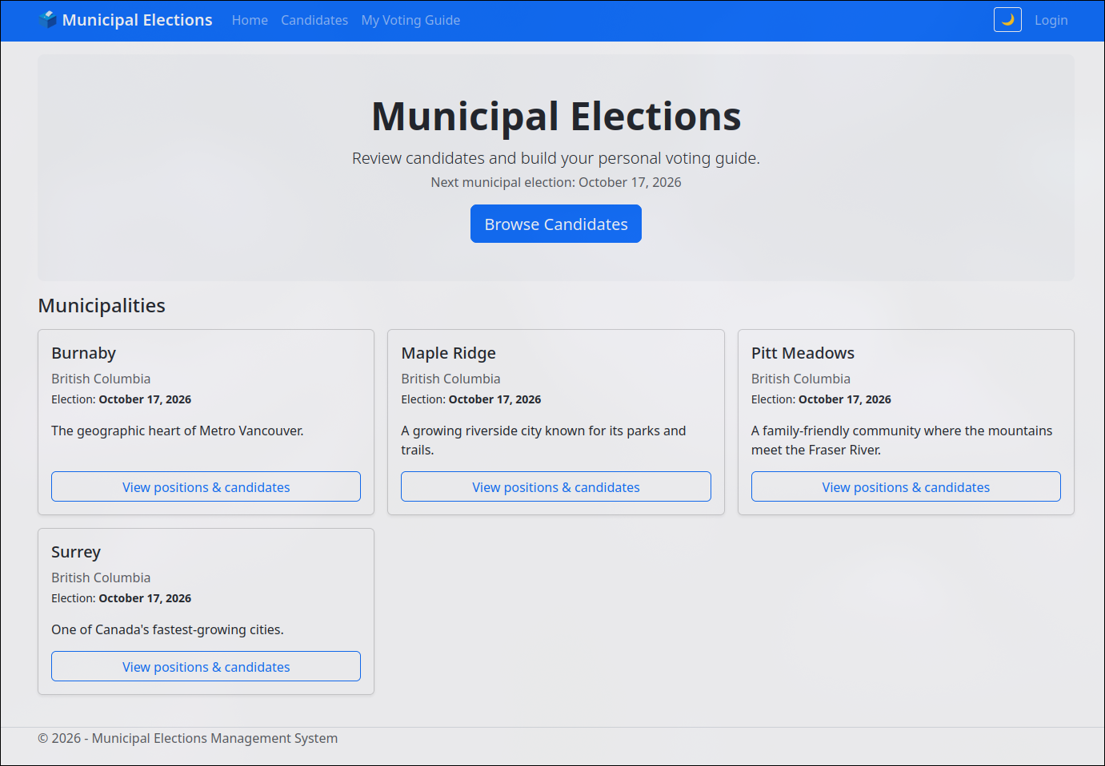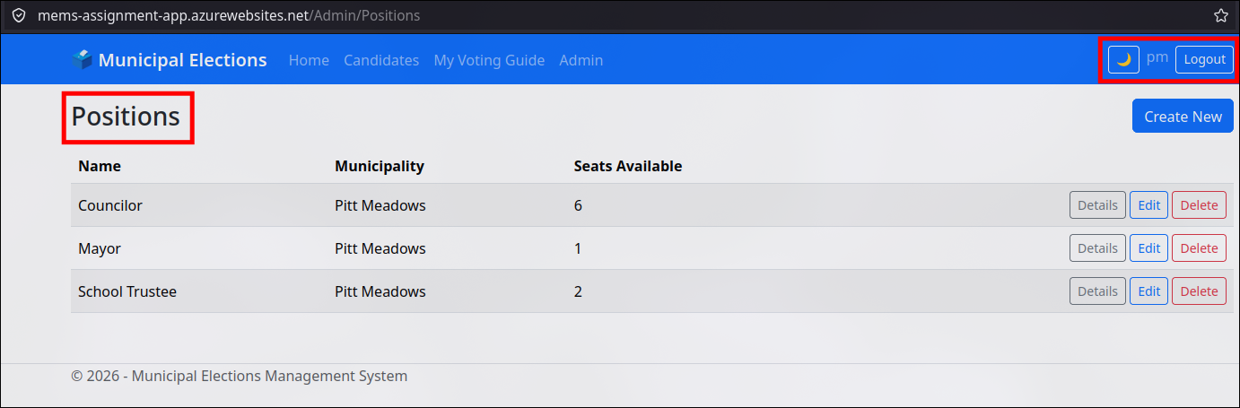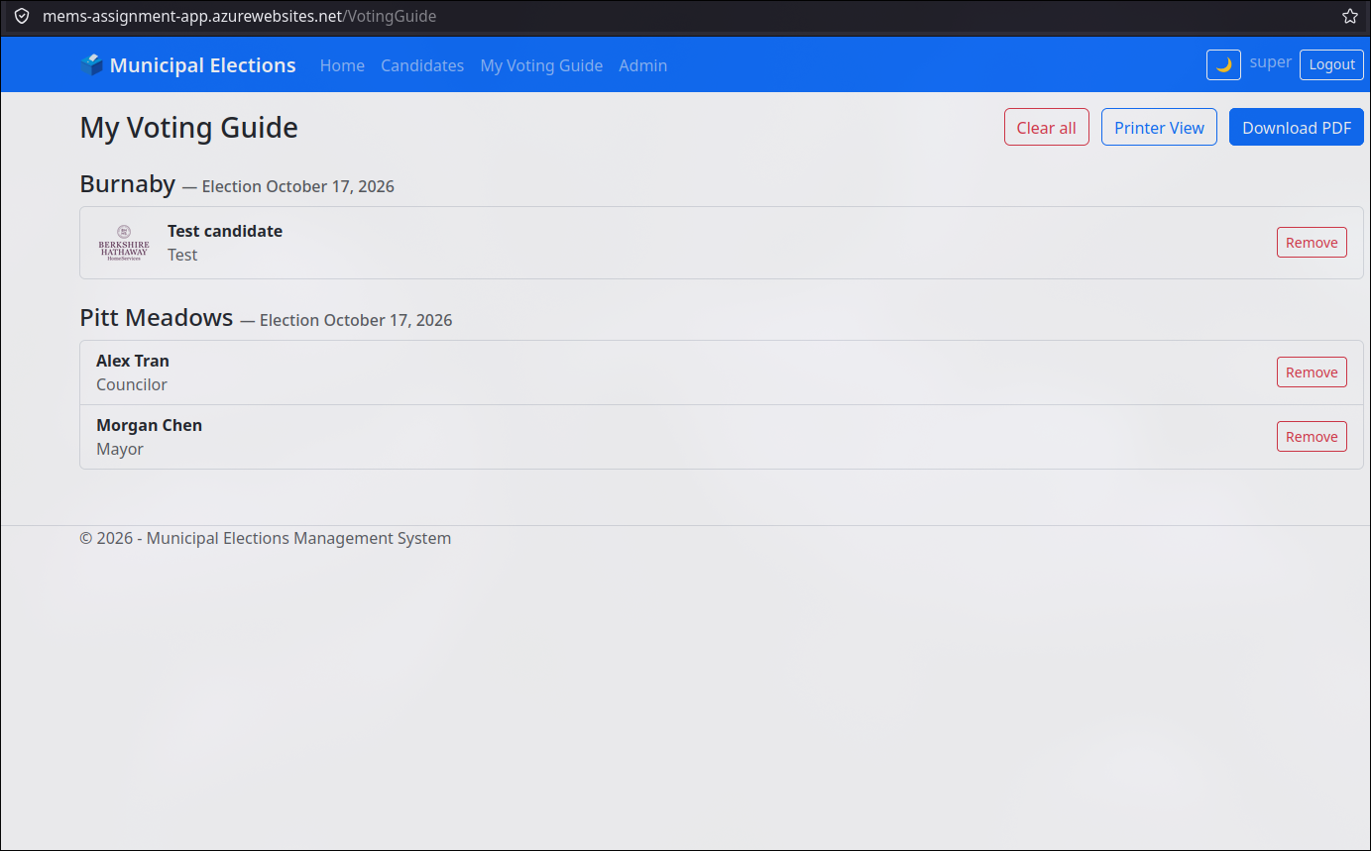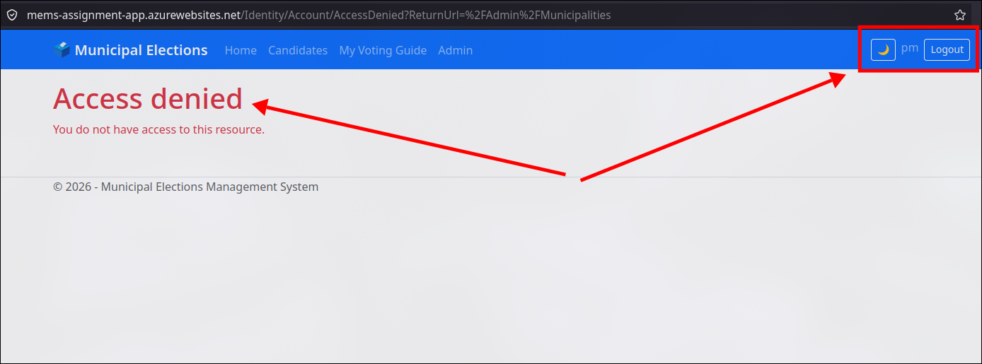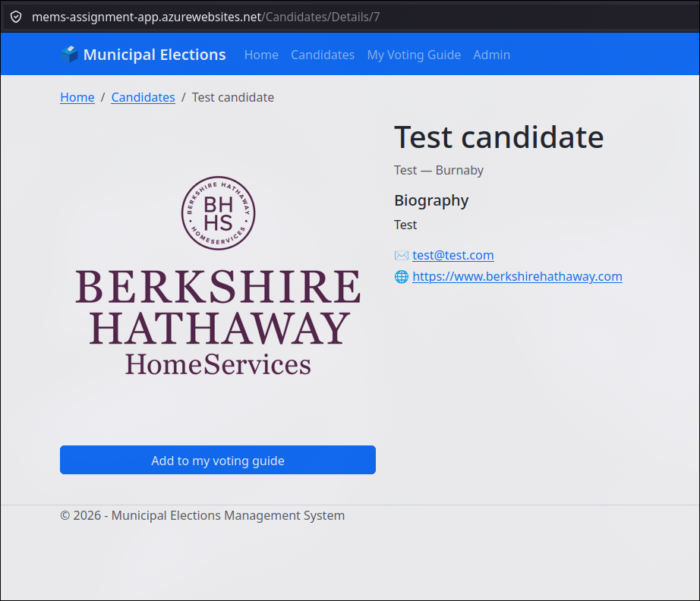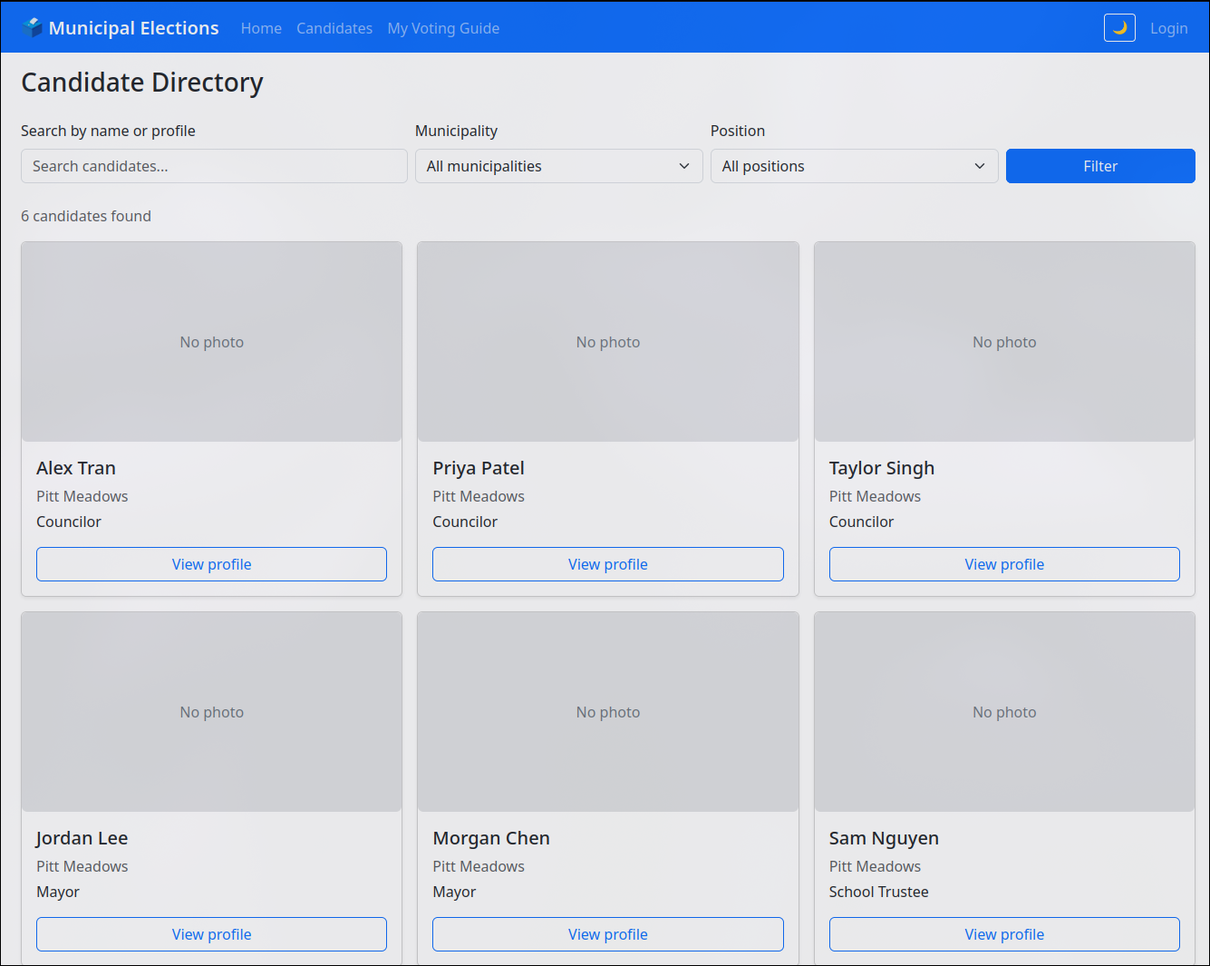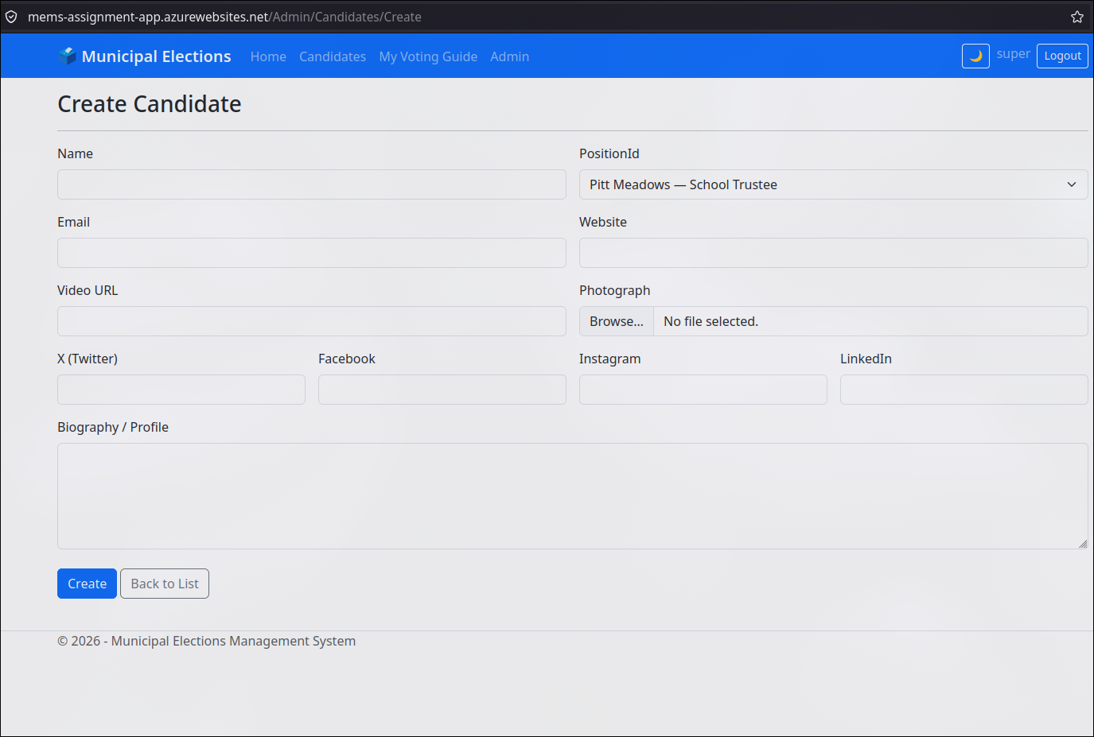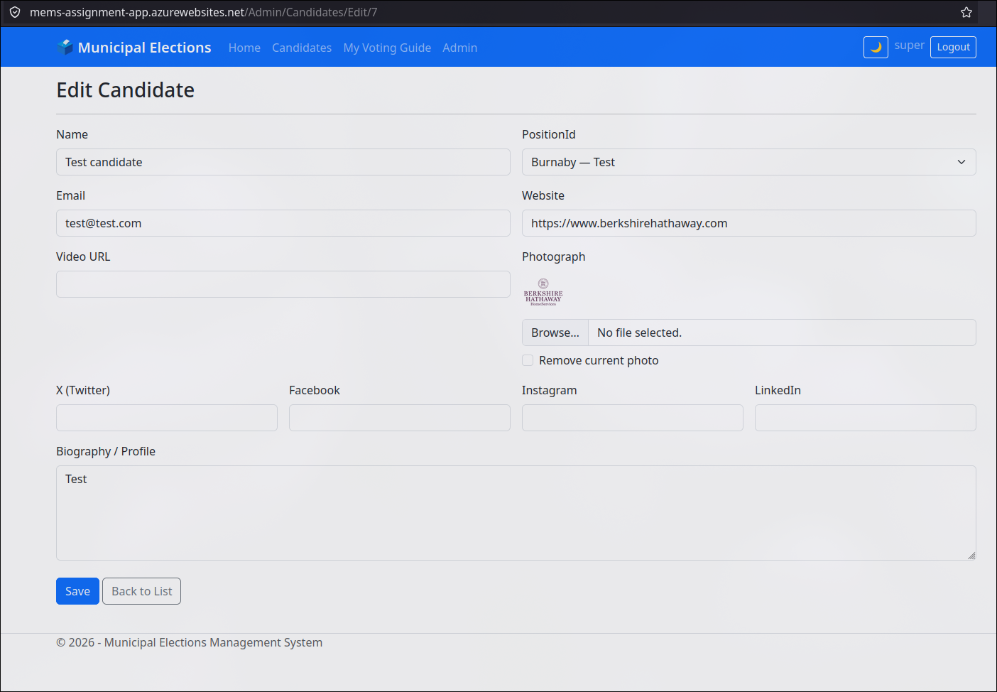
Azure deployment screenshot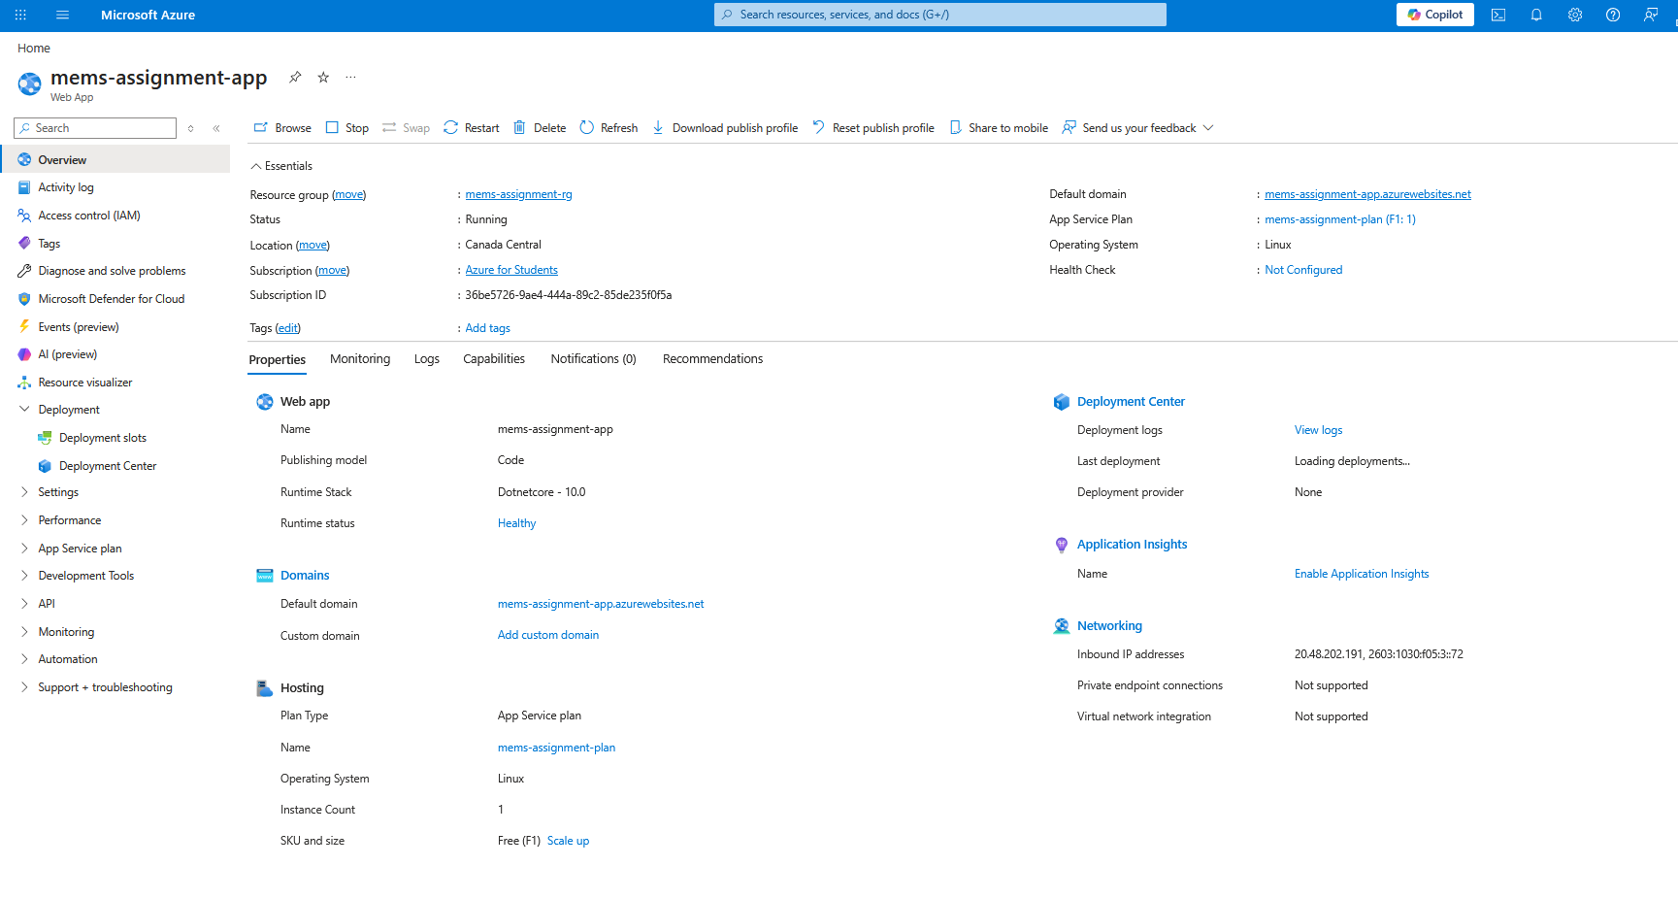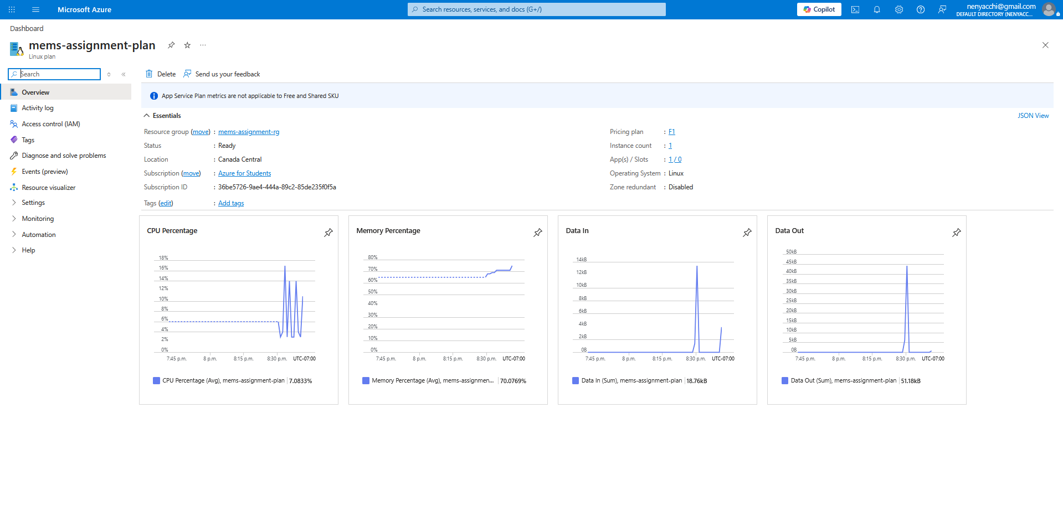
GitHub repository URL
https://github.com/hytyz/mems-4976

GitHub Copilot prompt, instructions, and skills markdown files included in the repository
