Tips and hints for the TEVO 3d printer kit

By David Yu

The picture below shows the three axis (x,y,z), which will be referenced throughout the document.

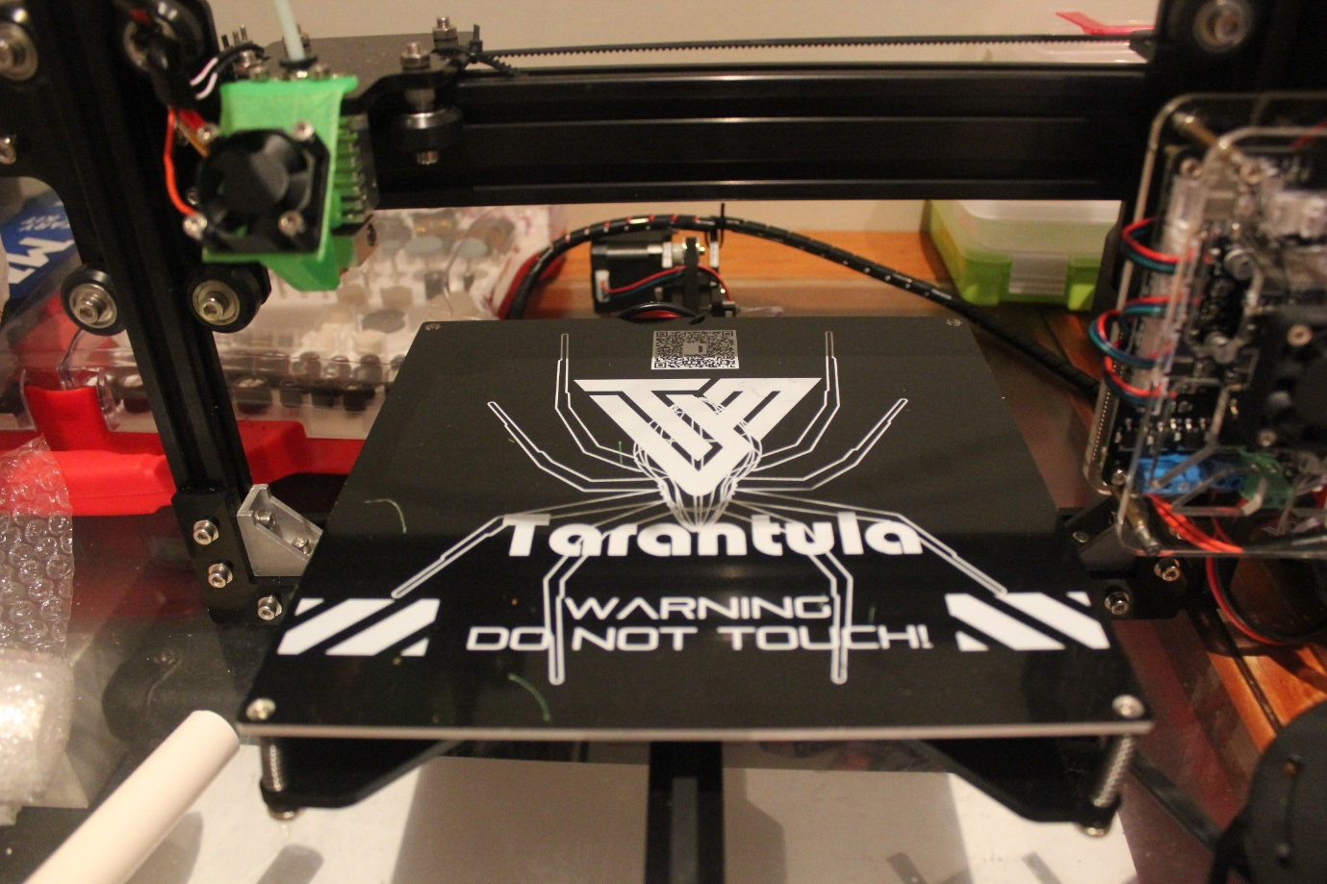

Z-axis

Y-axis

X-axis

1. Filament tube: once you have assembled the extruder you will need to insert the white filament guide tube (this should be done near the end of the printer assembly). To avoid clogging it is best to have the tube inserted all the way into the extruder so that no gaps are left. A good way to do this would be to remove the nut above the extruder and screw the nut back in once the filament tip is touching the base. Remove the nozzle from the heat sink to ensure the white filament guide is inserted all the way (Figure 1) (More information on the fan holder can be found at the end of the document)

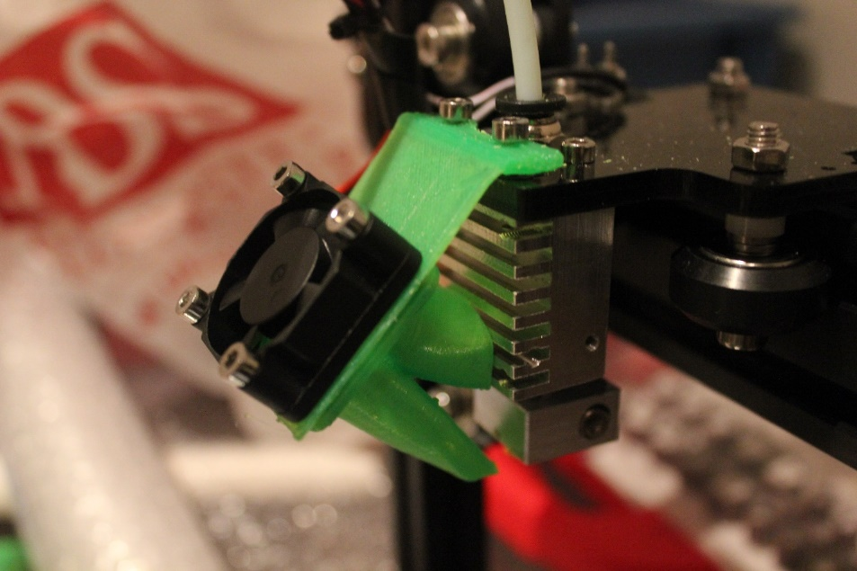

Filament tube should

end up around this point

Figure

1. The extruder motor assembly is not covered in the manual provided. But this link has the instructions: http://tevo3dprinterstore.com/pages/tevo-tarantula
2. You should ensure that the extruder motor is sufficiently above the controller board so that electronics board does not interfere with the spring lever handle. (Figure 2)

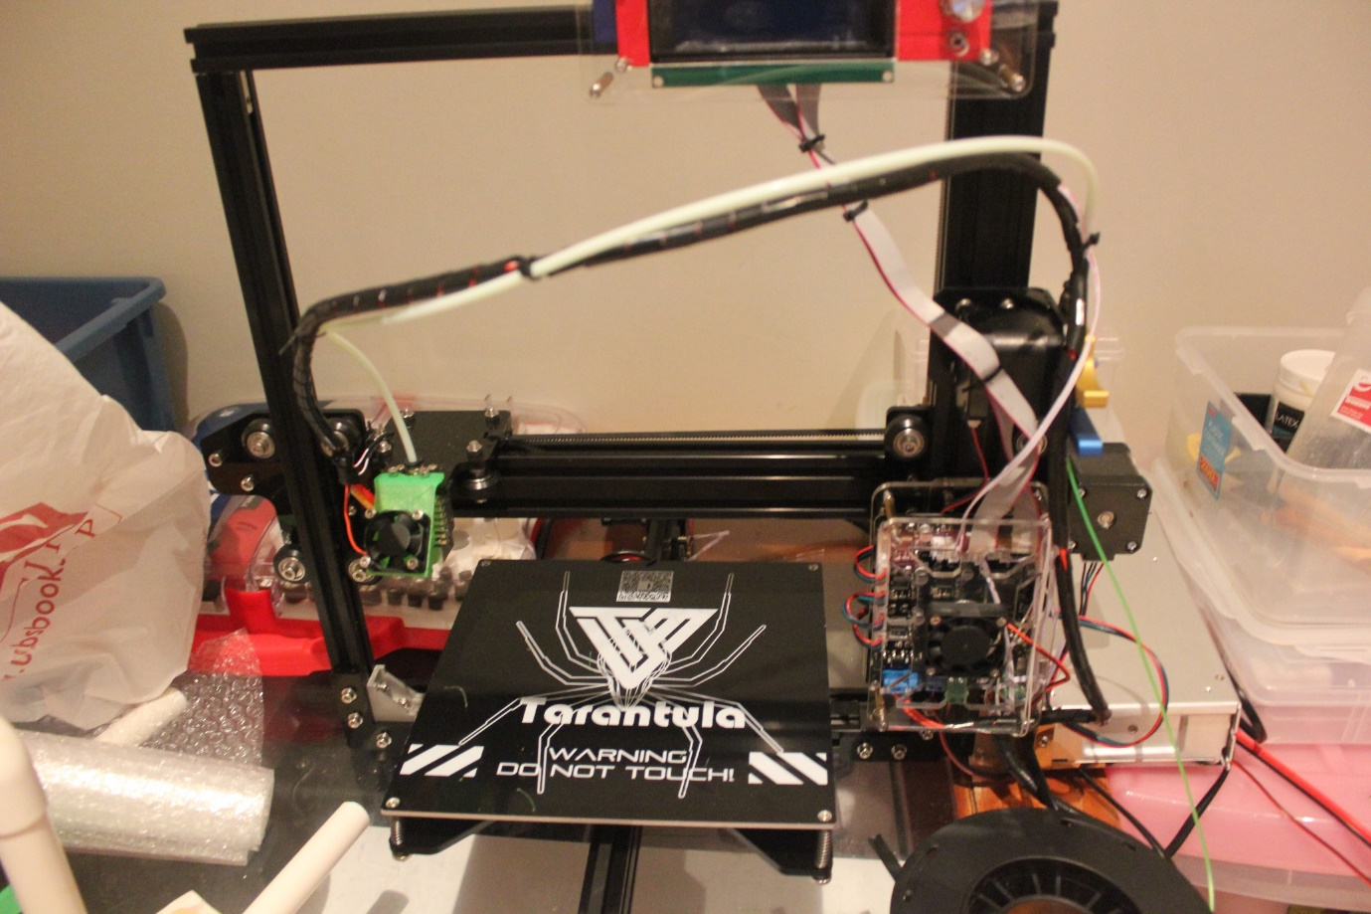

Distance between extruder motor and controller board

Figure

1. When assembling parts with eccentric nuts (Figure 3), ensure that they are fitted in the correct direction. To check, slide an aluminium rod across a rod through the nuts to check for wobbles. If wobbles exists, change the orientation of the eccentric nuts so the plate fits flush with the rods.

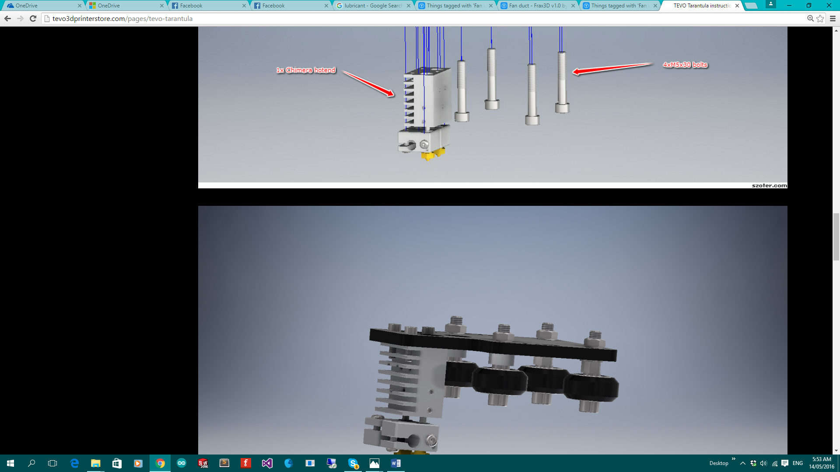

Figure

1. There are two L-shaped supports that are positioned at the bottom two corners of the chassis. (Figure 4)



Ensure rods are parallel

Figure

1. Remove protective layer from laser printed parts before assembling each part.
2. Before the x-axis goes on, it is very important that the two rails perpendicular to the base are parallel with each other and they are rigid. Use a square ruler or any other tool to ensure that they are perpendicular. (Figure 4)
3. The position of the y-axis end stop should be at the back of the printer, and the y-axis motor should be on the left side of the printer when looking from the front of the printer. (Figure 5)

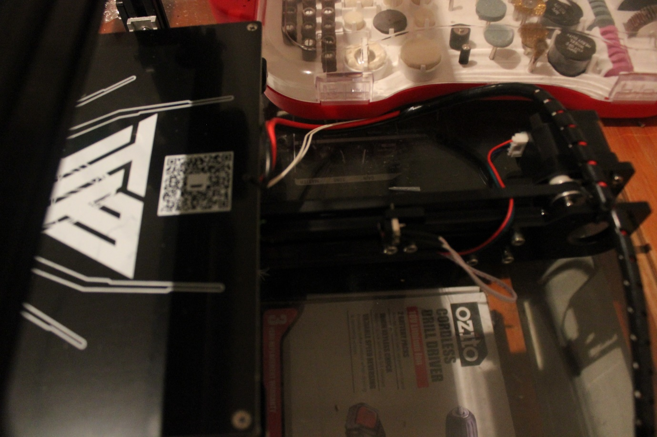

Figure

1. Use the black wire covered to hide the wires where possible, you can clip them into the rails (Figure 6). Before putting the x-axis on to the chassis remember to hide the wire onto one of the rails in the chassis as shown in Figure 6 below.

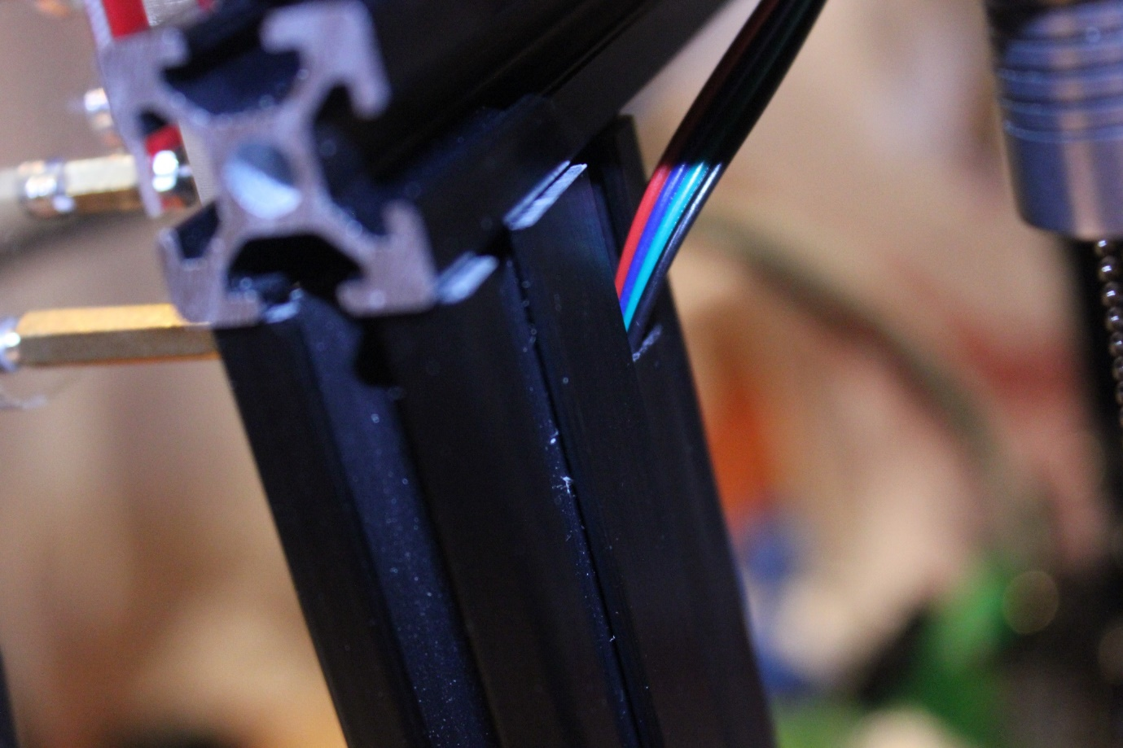

Figure

1. Once finished apply some lubricant/oil to the z-axis screw rail, they can be found in any hardware store.

Video guides for the printer build:

A very comprehensive youtube video playlist by ruiraptor can be found here :

https://www.youtube.com/playlist?list=PLY5Z2koT4Mi7Cy5oqh5DauDJuJxZ7PxND

Fan mount

This fan mount in the Figure below is a free addition to the kit. Elzariant designed the part on thingiverse.com (<http://www.thingiverse.com/thing:1569409>). The function of the fan mount is twofold, it cools the extruder and also the printed material.

If you want to print parts using PLA it is best to print a fan mount, otherwise parts with overhangs will curve up and ruin your print.

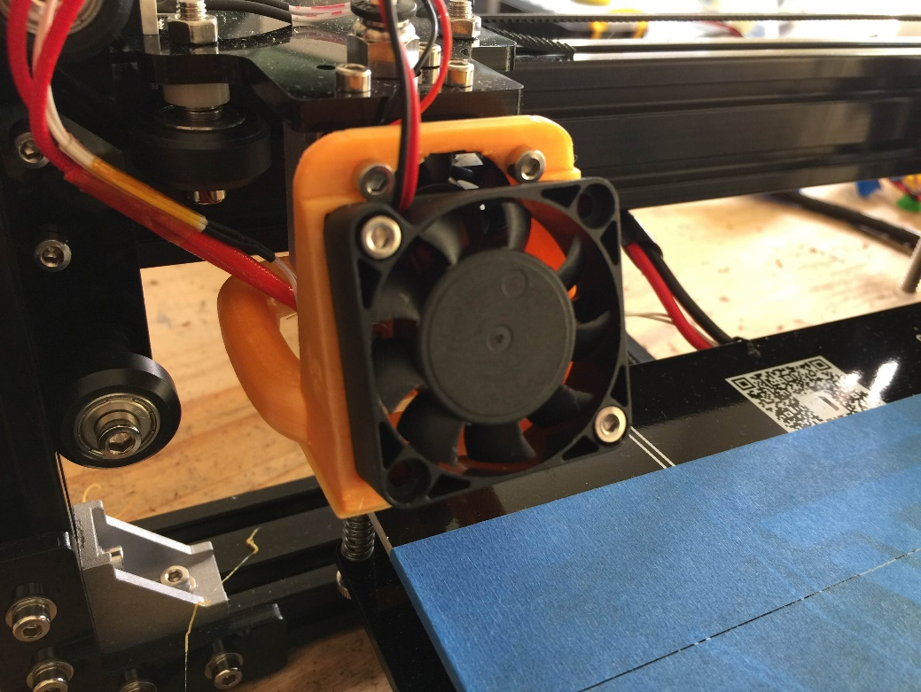

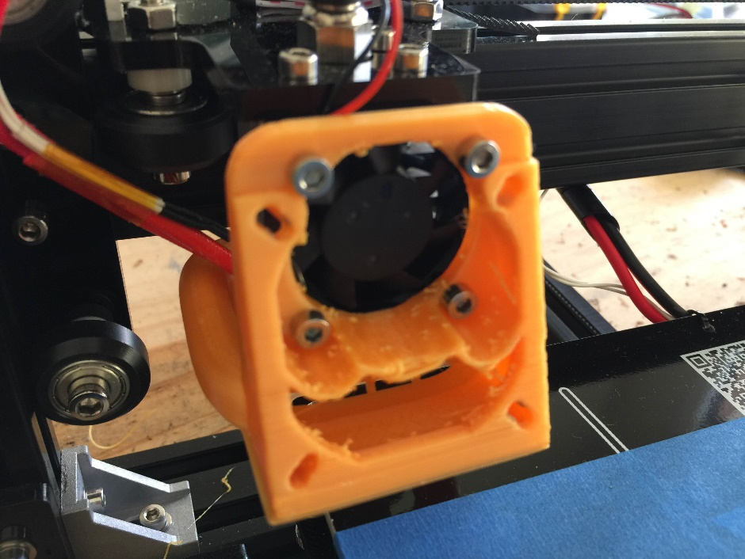

**Printing procedure**

A quick-start guide to printing:

1) If you have a model in SolidWorks, export it as a .stl file. You can download models from websites like Thingiverse as well

2) Use open-source software such as Slic3r to generate G-code (see below)

3) Save the generated G-code onto your SD card

3) Apply blue painting tape to the heat bed for better adhesion (not required for PLA but will result in better adhesion), reapply the tape when it is no longer sticky.

4) Zero the Z-axis (up/down) of your printer by using the control panel and adjusting the print bed.

* Firstly, go the control panel and select the “home all axis” button. Once it has finished select the “set home offsets”. This will set the printer’s zero.
* Move the nozzle to the four corners off the heat bed and at each corner twist the screws under each corner to move up/down the heat bed.
* Ensure the nozzle is touching the heat bed, but not pushing on it.

5) Preheat the hot end and the heat bed, and then print from SD by selecting the job on your SD card

Setting up Slic3r

1. Download slic3r for your OS: <http://slic3r.org/download>
2. Enter the setting for the printer:
   1. Nozzle diameter = 0.4mm
   2. Filament diameter = 1.75mm (depends on the filament you are using the one in the kit should be 1.75mm)
   3. Bed size: 200mm x 200mm
3. Change to Expert mode: File->Preferences-> Mode -> Expert

There is a config file (Slic3r_TEVO_TEST.ini) in this folder that has the settings that I have tested and seems to work fine. But you can enter your own values depending on the print you are printing. To load this config file: File -> Load Config Bundle -> Slic3r_TEVO_TEST.ini

The fan should always be on during prints to keep the extruder cool and this avoids the PLA from clogging. But if ever the extruder is clogged, disassemble the extruder and remove excess material.

3D modelling software

Personally, I use Thingiverse and Solidworks to design objects to print. However, I have an education version of Solidworks and the full version is not freely available. But there are many freely available 3D designing tools which can be found on the web, such as Autodesk and blender. (A list of software: http://www.shapeways.com/creator/tools)