<!DOCTYPE html>

<html>

<head>

<meta charset="UTF-8">

<title>201455033 이정현</title>

</head>

<body>

<h3 align = center> 201455033 이정현</h3>

<h3 style="text-align:center">201455033 이정현</h3>

</body>

</html>

[실행 코드]

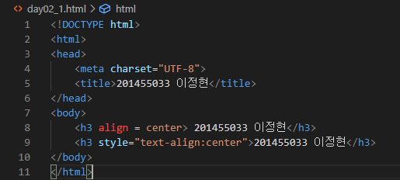

[실행 결과]

