**[실습1] 다음 실행창이 나오도록 코드를 작성하시오.**

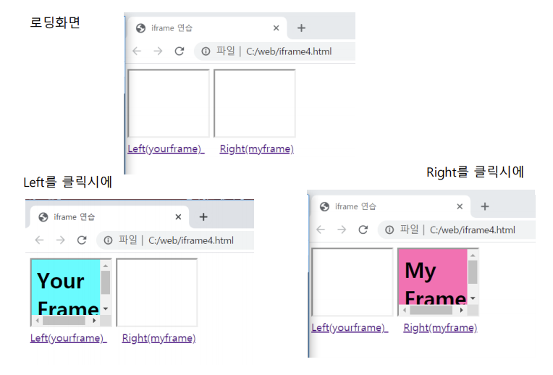

**[실습1 코드]**

<!DOCTYPE html>

<html>

<head>

<meta charset="UTF-8">

<title>201455033 이정현 iframe 실습</title>

</head>

<body>

<iframe name="left" width="120px" height="100px" frameborder="10px"></iframe>

<iframe name="right" width="120px" height="100px" frameborder="10px"></iframe>

<br>

<a href="yourframe.html" title="left" target="left">Left(yourframe)</a>

&nbsp; &nbsp;

<a href="myframe.html" title="right" target="right">Right(myframe)</a>

</body>

</html>

**[실습1 코드 캡처]**

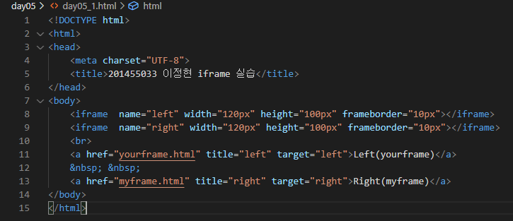

**[실습1 실행결과]**

**로딩화면**

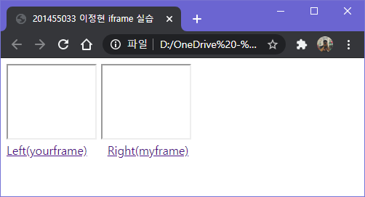

**left 클릭**

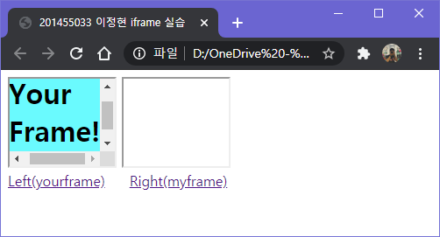

**right 클릭**

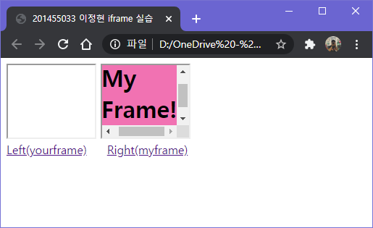

**[실습1 yourframe.html 코드 원본]**

<!DOCTYPE html>

<html lang="en">

<head>

<meta charset="UTF-8">

<meta name="viewport" content="width=device-width, initial-scale=1.0">

<title>201455033 이정현 yourframe</title>

</head>

<body bgcolor="cyan">

<h1 >Your Frame!</h1>

</body>

</html>

**[실습1 yourframe.html 코드 캡처]**

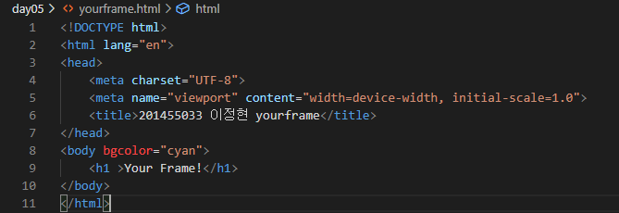

**[실습1 yourframe.html 실행 결과]**

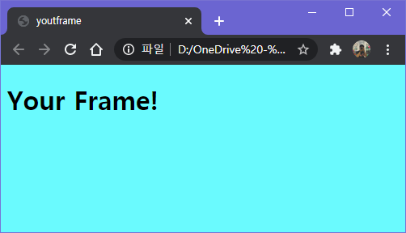

**[실습1 myframe.html 코드]**

<!DOCTYPE html>

<html lang="en">

<head>

<meta charset="UTF-8">

<meta name="viewport" content="width=device-width, initial-scale=1.0">

<title>201455033 이정현 myFrame</title>

</head>

<body bgcolor="hotpink">

<h1>My Frame!</h1>

</body>

</html>

**[실습1 myframe.html 코드 캡처]**

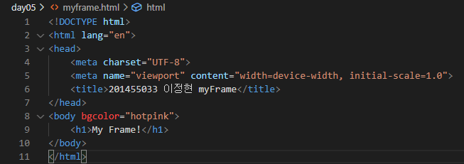

**[실습1 myframe.html 실행 결과]**

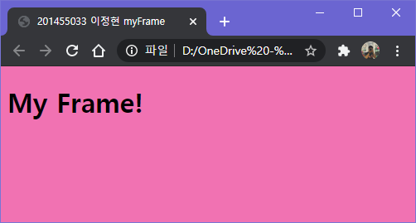

**[실습2 다음 실행창이 나오도록 코드를 완성하시오]**

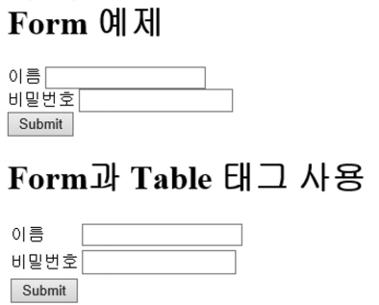

**[실습2 코드 원본]**

<!DOCTYPE html>

<html lang="en">

<head>

<meta charset="UTF-8">

<title>201455033 이정현 form 실습</title>

</head>

<body>

<h1> Form 태그 예제 </h1>

<form>

이름 <input type="text" name="user" size="12"><br>

비밀번호 <input type="password" name="pwd" size="12"><br>

<input type="submit" value="Submit"> <br>

</form>

<h1>Form과 Table 태그 사용</h1>

<form>

<table>

<tbody>

<tr><td>이름</td><td><input type="text" name="user" size="12"></td></tr>

<tr><td>비밀번호</td><td><input type="password" name="pwd" size="12"></td></tr>

<tr><td><input type="submit" value="Submit"></td></tr>

</tbody>

</table>

</form>

</body>

</html>

**[실습2 코드 캡처]**

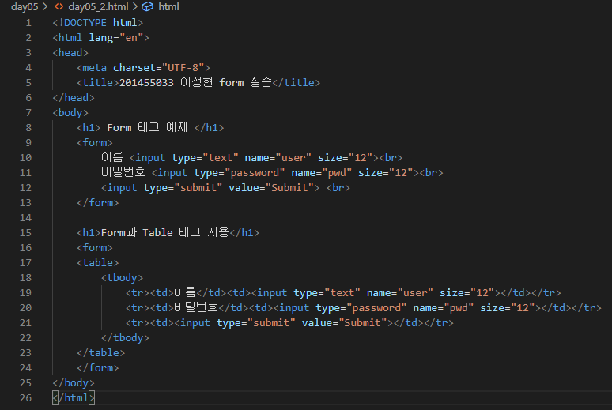

**[실습2 실행 결과]**

