**[실습1]**

**[코드 원문]**

<!DOCTYPE html>

<html>

<head>

<meta charset="UTF-8">

<title>201455033 이정현 Form 연습</title>

</head>

<body>

<form method="POST" action="go.php">

<table>

<tr> <td>아이디</td> <td><input type="text" name="id" size="15"></td>

<td>비밀번호</td> <td><input type="password" name="password" size="15"></td>

</tr>

<tr> <td>이름</td> <td><input type="text" name="username" size="15"></td>

<td>연락번호</td> <td><input type="text" name="tel" size="16"></td>

</tr>

</table>

<table>

<tr> <td>주소</td> <td><input type="text" name="address" size="45"></td>

</tr>

<tr> <td>이메일</td> <td><input type="text" name="mail" size="15">@

<select name="email" size="1">

<option value="-">-</option>

<option value="gmail">gmail.com</option>

<option value="naver">naver.com</option>

<option value="daum">daum.net</option>

</select>

</td>

</tr>

</table>

<hr>

선택사항 <br>

메일수신:

<input type="radio" name="agree" checked> 허용

&nbsp;

<input type="radio" name="agree"> 거부

<br><br>

<input type="submit"value="회원가입">

&nbsp;

<input type="reset"value="취소">

</form>

</body>

</html>

**[실습1 코드 캡처]**

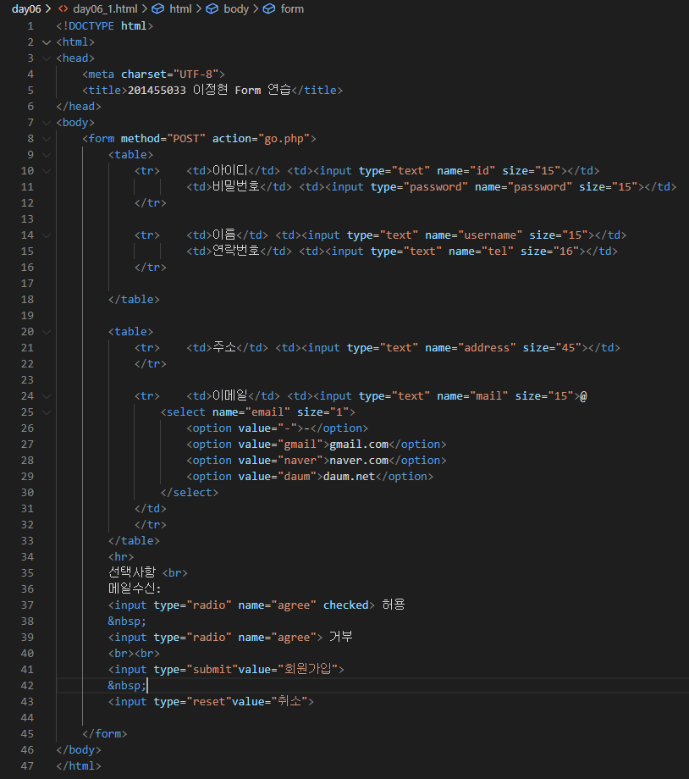

**[실습1 결과]**

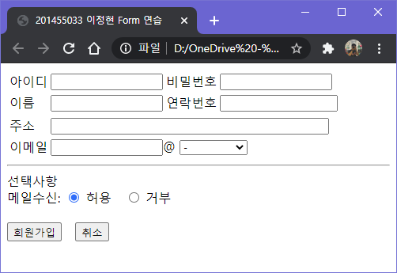

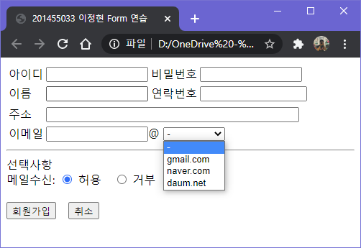

이메일 셀렉트는 제가 3개의 목록을 추가로 넣었습니다.

**[실습 2]**

**[코드 원문]**

<!DOCTYPE html>

<html>

<head>

<meta charset="UTF-8">

<title>201455033 이정현 기차예매</title>

</head>

<body>

<h2>기차 예매하기</h2>

<form action="go.php" method="post">

<table>

<tr>

<td>예약자 아이디</td> <td><input type="text" name="id" size="15"></td>

</tr>

<tr>

<td>비밀번호</td> <td><input type="password" name="password" size="15"></td>

</tr>

</table>

<table>

<tr>

<td>시간</td><td>장소</td>

</tr>

<tr>

<td>

<select size=6>

<option selected>08:00</option>

<option >10:00</option>

<option >12:00</option>

<option >14:00</option>

<option >16:00</option>

<option >18:00</option>

</select>

</td>

<td>

<select size=6>

<option selected>서울</option>

<option >인천</option>

<option >대전</option>

<option >대구</option>

<option >부산</option>

<option >춘천</option>

</select>

</td>

</tr>

<tr>

<td><input type="submit"value="예매"></td>

<td><input type="reset"value="취소"></td>

</tr>

</table>

</form>

</body>

</html>

**[실습2 코드캡처]**

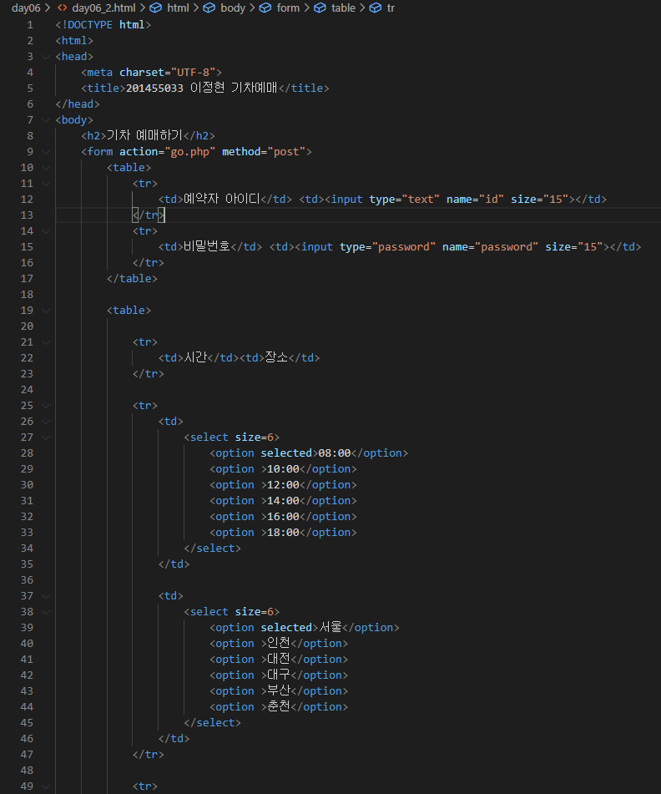

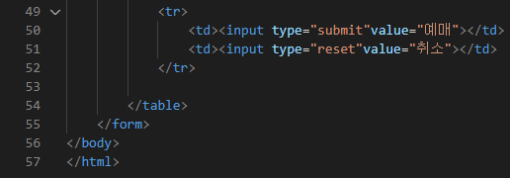

[실습 2 결과]

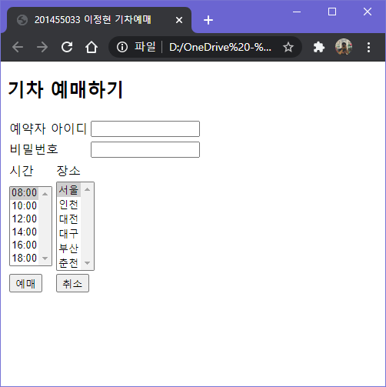

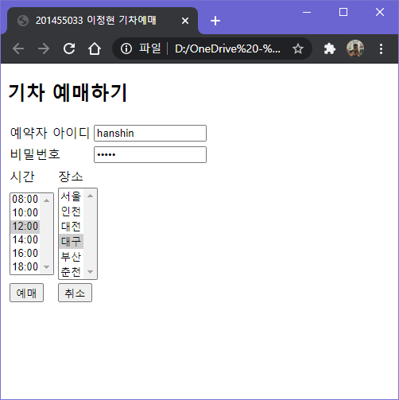

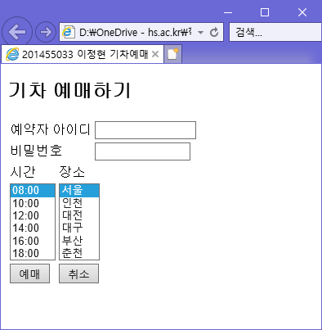

브라우저를 바꾸니 시간, 장소 셀렉트 크기가 같아졌습니다.