**[실습 1012]**

**[코드 원문]**

<!DOCTYPE html>

<html>

<head>

    <meta charset="UTF-8">

    <title>201455033 이정현 [1012 실습]</title>

    <style type="text/css">

        .cls1 {list-style-type: upper-roman;}

        .cls2 {list-style-type: square; list-style-position: outside}

        .cls3 {list-style-type: lower-alpha;list-style-position: inside}

        .cls4 {list-style-type: lower-alpha; list-style-position: outside}

    </style>

</head>

<body>

    <h1> 교과목 </h1>

    <ol class="cls1">

        <li>프로그래밍언어</li>

        <ul class="cls2">

            <li>C</li>

            <ol class="cls3">

                <li>&nbsp;&nbsp;C언어 입문</li>

                <li>&nbsp;&nbsp;C언어 응용</li>

            </ol>

            <li>Java</li>

            <ol class="cls4">

                <li>&nbsp;Java언어 입문</li>

                <li>&nbsp;Java언어 응용</li>

            </ol>

            <li>C++</li>

            </ul>

        </ul>

        <li>알고리즘</li>

        <li>웹프로그래밍</li>

        <li>컴파일러</li>

        <li>형식언어와 오토마타</li>

    </ol>

</body>

</html>

**[코드 캡처]**

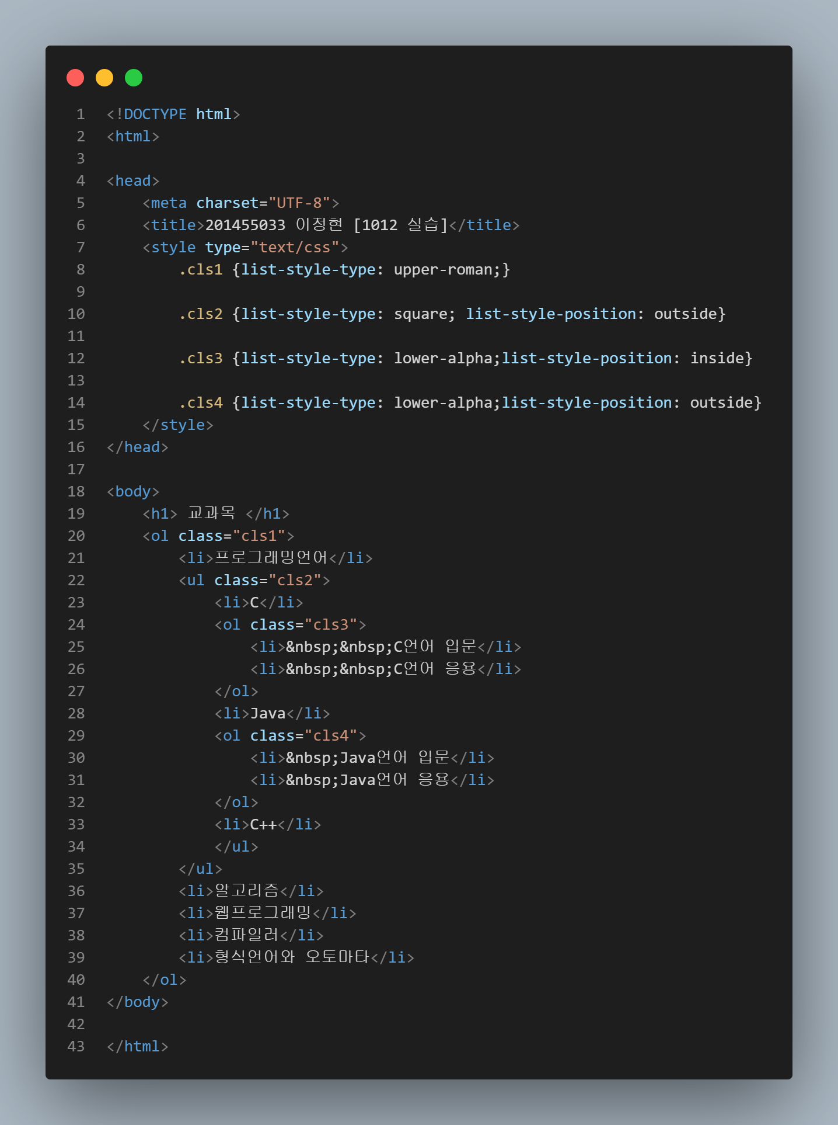

**[실행 결과]**

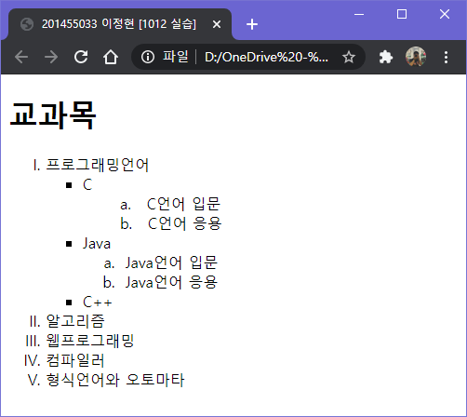

**[실습 1019 - 1]**

**[코드 원문]**

<!DOCTYPE html>

<html>

<head>

    <meta charset="UTF-8">

    <title>201455033 이정현 [1019 실습 1]</title>

    <style type="text/css">

        div{border:20px; height:50px; width:250px; border-color:red;}

        div.borderR1{

            border-style: dotted;

            border-radius: 20px;

        }

        div.borderR2{

            border-style: inset;

            border-top-left-radius: 20px;

        }

        div.borderR3{

            border-style: ridge;

            border-top-right-radius: 20px;

        }

    </style>

</head>

<body>

    <div class="borderR1"> (1) Republic of Korea </div>

    <div class="borderR2"> (2) Republic of Korea </div>

    <div class="borderR3"> (3) Republic of Korea </div>

</body>

</html>

**[코드 캡처]**

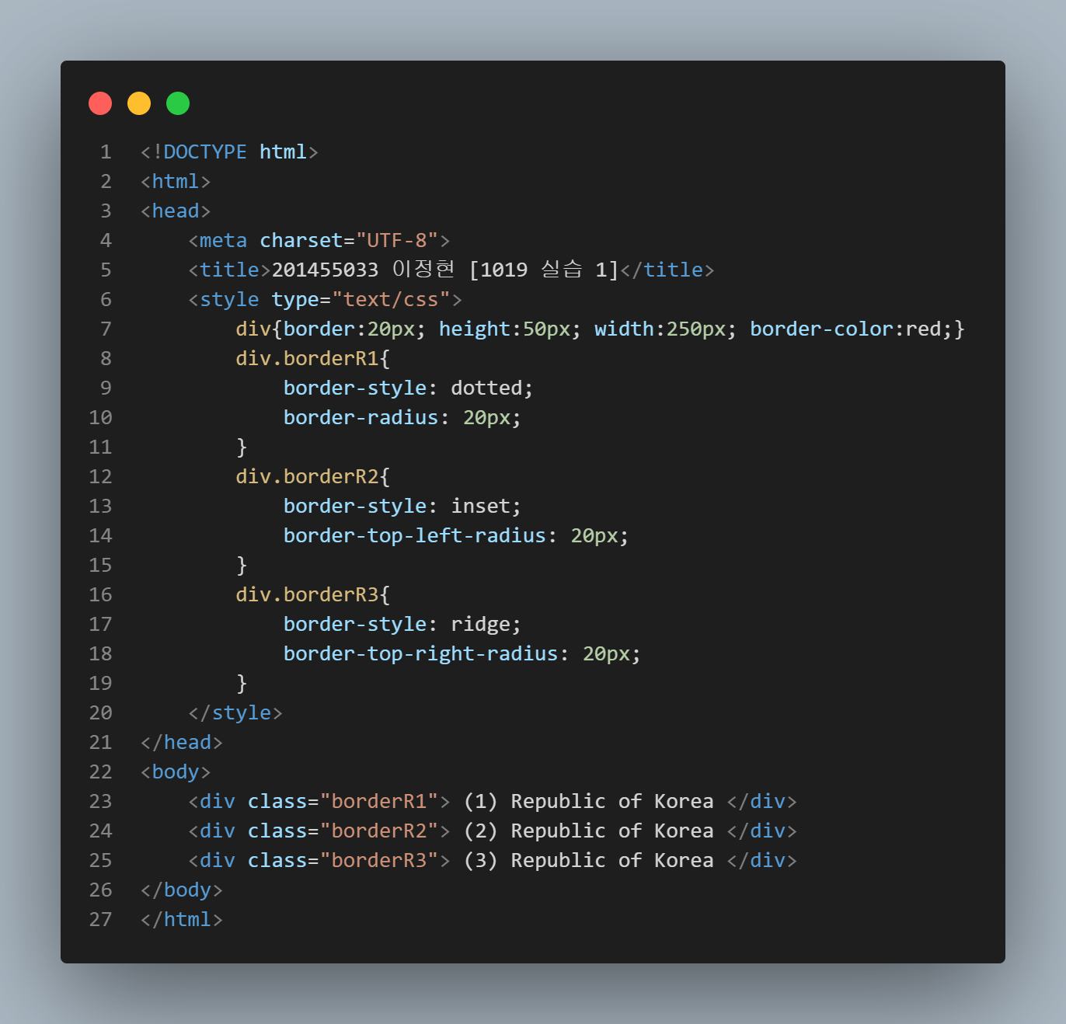

**[실행 결과]**

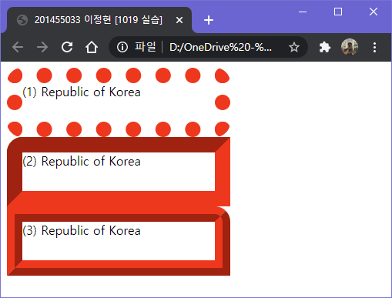

**[실습 1019 - 2]**

**[코드 원문]**

<!DOCTYPE html>

<html>

<head>

    <meta charset="UTF-8">

    <title>201455033 이정현 [1019 실습 2]</title>

    <style type="text/css">

        div{height:50px; width:250px;}

        div.border1{

            box-shadow: inset 2px 2px 20px red;

        }

        div.border2{

            box-shadow: 20px 20px 20px blue;

        }

    </style>

</head>

<body>

    <div class="border1"> (1) Republic of Korea </div>

    <div class="border2"> (2) Republic of Korea </div>

</body>

</html>

**[코드 캡처]**

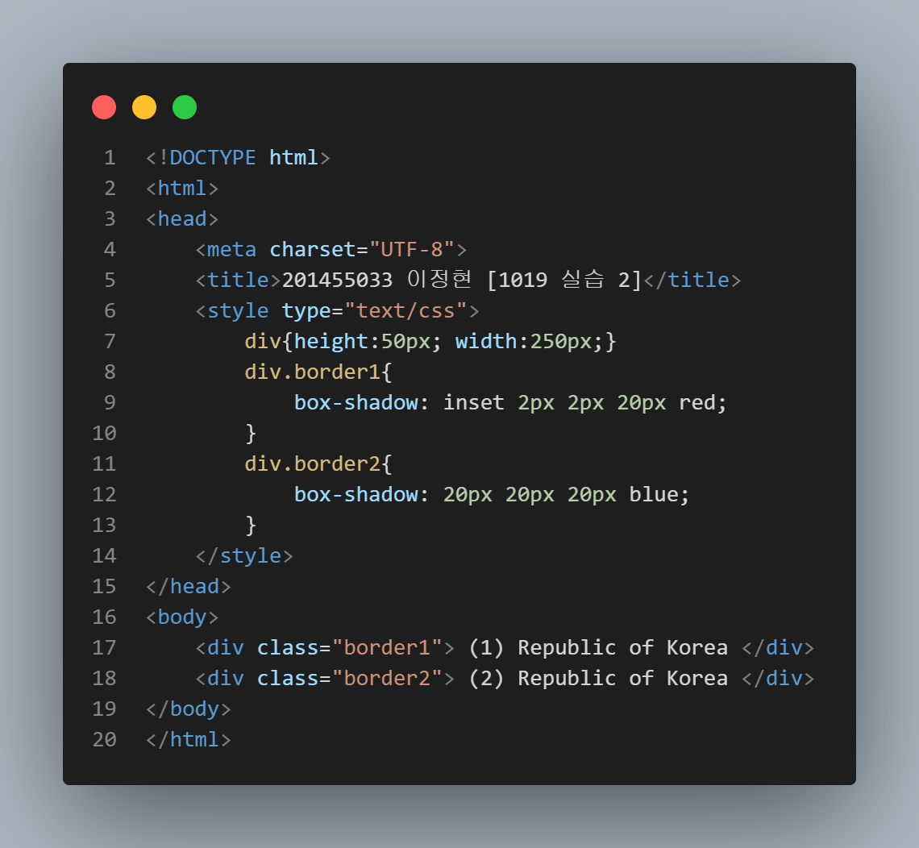

**[실행 결과]**

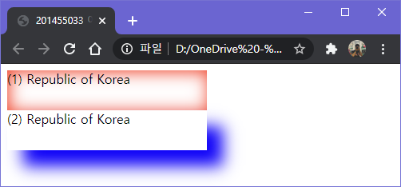

**[실습 1021]**

**[코드 원문]**

<!DOCTYPE html>

<html>

<head>

    <meta charset="UTF-8">

    <title>201455033 이정현 [1021 실습]</title>

    <style type="text/css">

        h1.fixed{

            background-color: darkgreen;

            position: fixed;

            left: 150px;

            bottom: 10px;

        }

    </style>

</head>

<body>

    <h1 class="fixed"> (1) Korea </h1>

    <h1> (2) Korea </h1>

</body>

</html>

**[코드 캡처]**

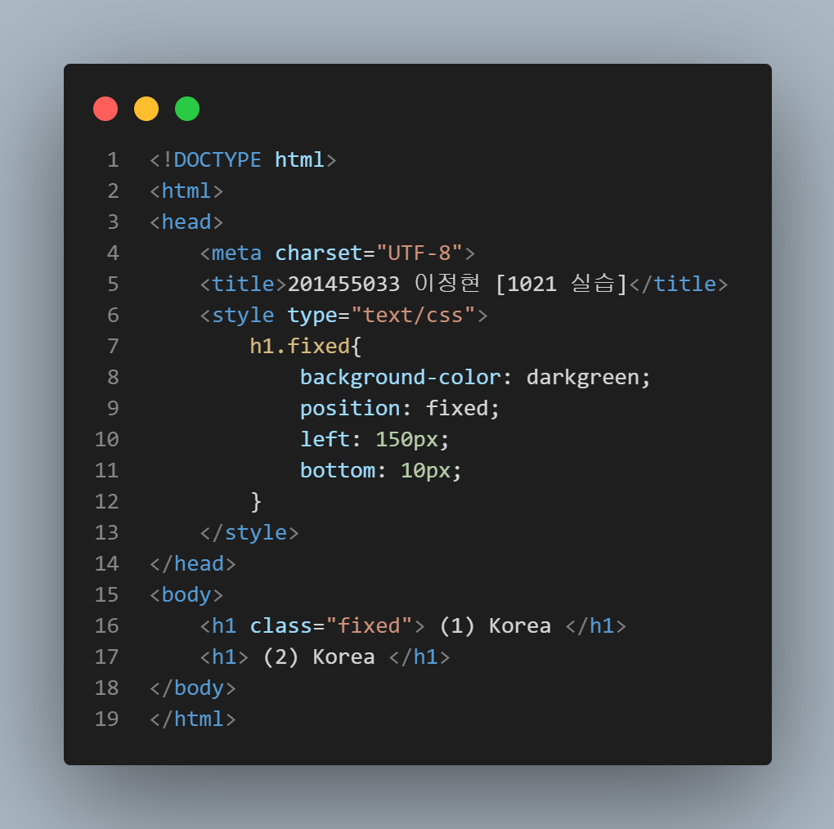

**[실행 결과]**

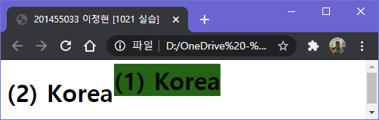

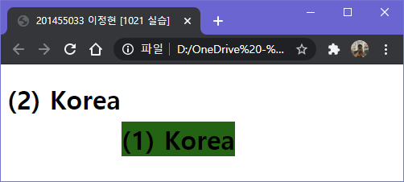

**[실습 1026 – 1] 교재 169페이지. 실습문제 6번.**

**[코드 원문]**

<!DOCTYPE html>

<html>

<head>

    <meta charset="UTF-8">

    <title>201455033 이정현 [실습 1026 - 1]</title>

    <style type = "text/css">

        h1{ width:300px; border:1px solid red;}

        h2{ width:300px; border:1px solid red;}

        .class1{

            white-space: nowrap;

            word-wrap: normal;

        }

        .class2{

            word-break: keep-all;

            word-wrap: break-word;

        }

        .class3{

            white-space: nowrap;

            word-wrap: normal;

            text-overflow: ellipsis;

            overflow: hidden;

        }

        .class4{

            word-break: break-all;

            word-wrap: break-word;

        }

    </style>

</head>

<body>

    <h1 class="class1"> 안녕하세요. 처음 뵙겠습니다! </h1>

    <h1 class="class2"> 안녕하세요. 처음 뵙겠습니다! </h1>

    <h2 class="class3"> 안녕하세요. 처음 뵙겠습니다! </h2>

    <h2 class="class4"> 안녕하세요. 처음 뵙겠습니다! </h2>

</body>

</html>

**[코드 캡처]**

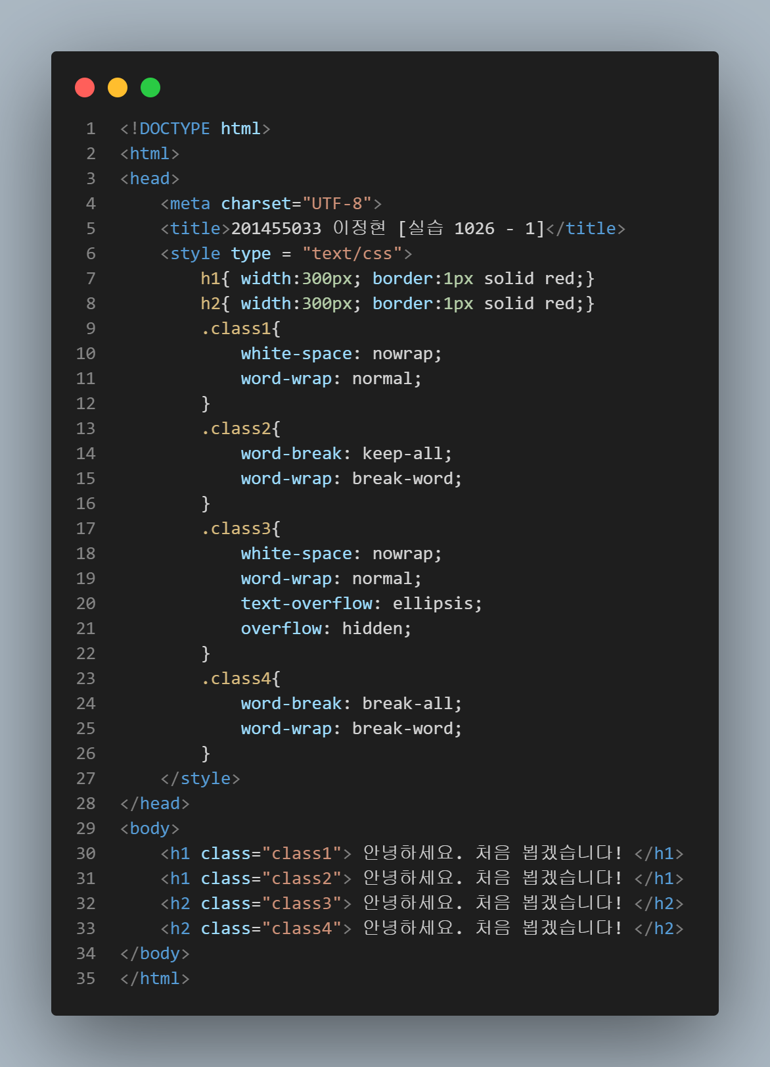

**[실행 결과]**

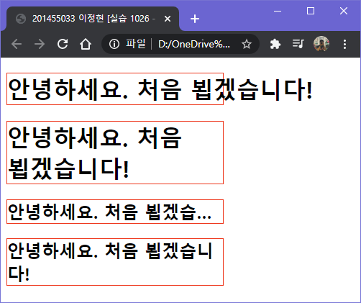

**실습[1026 – 2]**

**[코드 원문]**

<!DOCTYPE html>

<html>

<head>

    <meta charset="UTF-8">

    <title>201455033 이정현 [실습 1026 - 2]</title>

    <style type="text/css">

        body{color:white}

        #wrap{ width:446px; margin:0; margin-right: 10px; margin-left: 10px; min-height: 780px;}

        header, nav, section, aside, footer{text-align: center; border: 1px solid #999; margin: 5px; padding: 10px;border-radius: 20px;}

        header{height: 30px; background-color: green;}

        nav, section, aside {float:right; height: 300px;}

        nav{width: 50px; background-color: yellow; color: red;}

        section{width: 250px; background-color: blue; }

        aside{width: 50px; background-color: pink; }

        footer{height: 30px; background-color: gray; }

        .clear{clear:both}

    </style>

</head>

<body>

    <div id="wrap">

        <header> header </header>

        <nav> nav </nav>

        <section> section </section>

        <aside> aside </aside>

    <div class="clear">  </div>

        <footer> footer </footer>

    </div>

</body>

</html>

**[코드 캡처]**

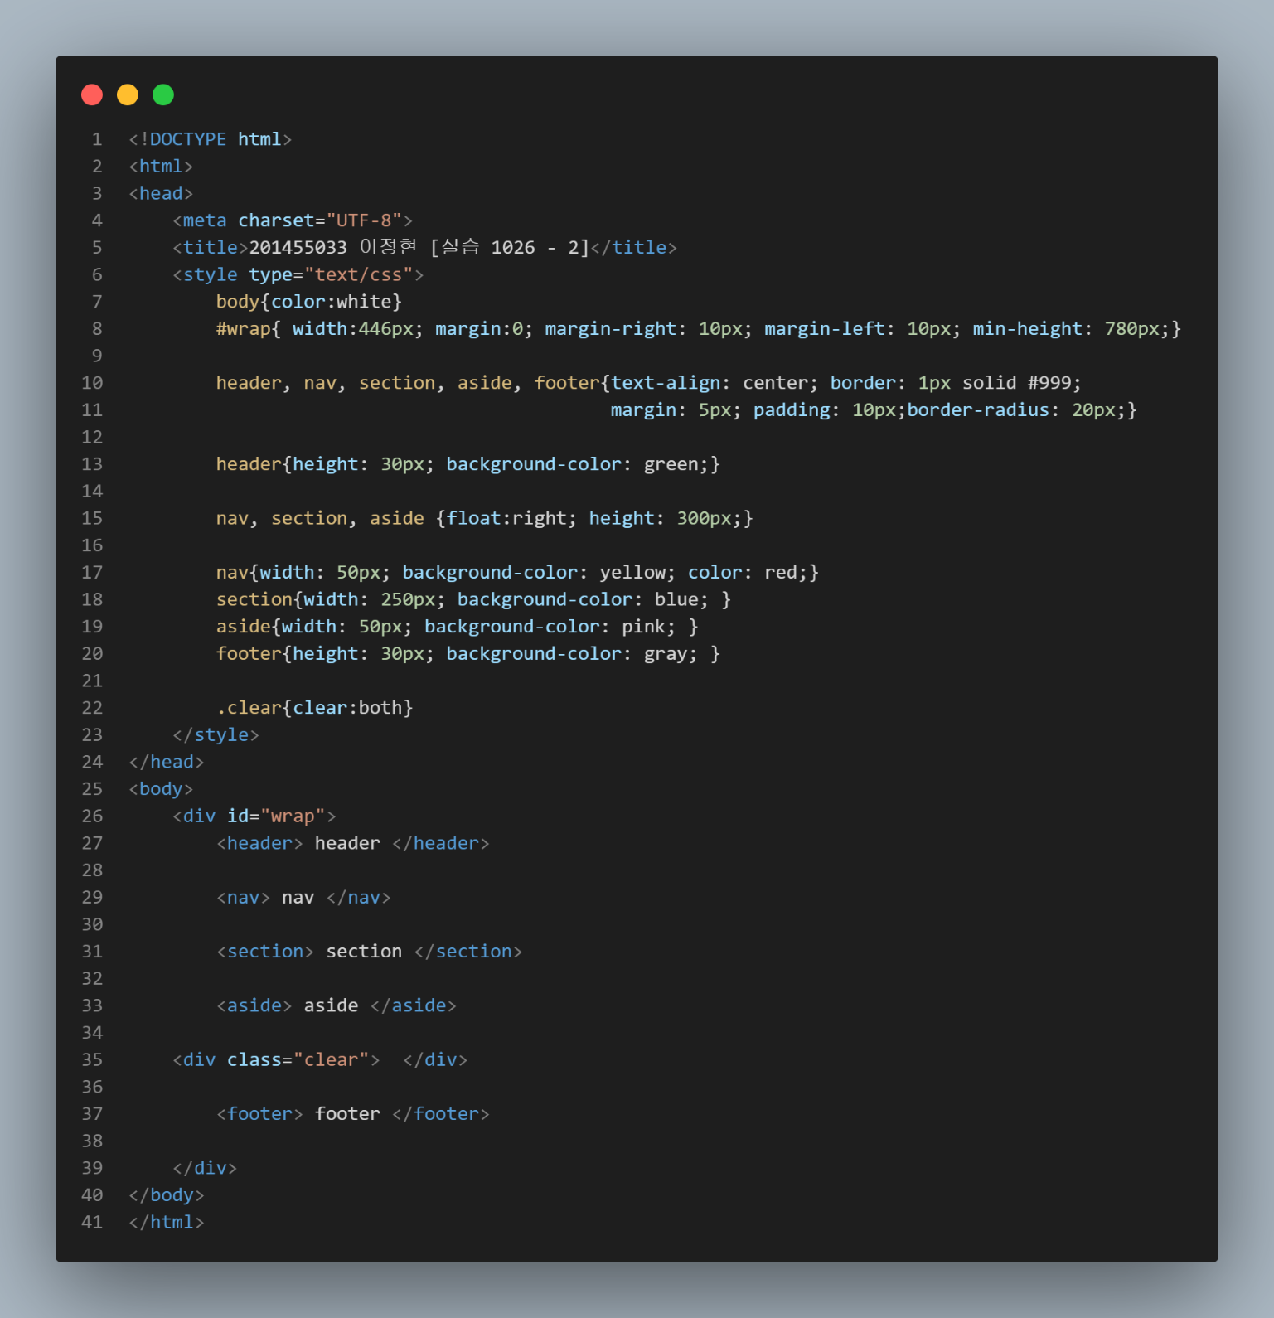

**[실행 결과]**

