**[과제 1] – 수업시간에 배운 다양한 태그를 사용해 회원가입 홈페이지를 작성하세요.**

1. **반드시 포함시켜야 하는 사항**

* 아이디, 비밀번호, 이메일, 생년월일, 주소, 전화번호, 직업, 취미, 가입동기, 자기소개서

1. **수업시간에 배운 다양한 태그를 적절 상황에 적절하게 사용할 것**

* 배우지 않은 태그 사용시 코드내의 주석을 해당 태그에 대한 설명을 삽입할 것

**[코드 원문]**

**register.html 코드 원문**

<!DOCTYPE html>

<html lang="ko">

<head>

    <meta charset="UTF-8">

    <title>201455033 이정현 회원가입페이지 만들기</title>

    <script>

<!--서비스 약관 동의 체크 후 회원가입 완료 페이지로 넘어가기 위한 자바스크립트 사용 -->

        function chk() {

            if (document.form1.service_agree.checked) {

<!--서비스 약관동의 체크박스 값 확인-->

                window.open('register_complete.html');

<!--체크 확인시 회원가입 완료 페이지 띄우기-->

            }

        }

    </script>

    <style type="text/css">

        h3 {font-family: 고딕;}

        h4 {font-family: 고딕;}

    </style>

</head>

<body>

    <center>

        <img src="Elin.ico" alt="Elin.logo">

        <hr>

        <h3>Project Elin 회원가입</h3>

        <h4>회원가입을 통해서 다양한 서비스를 이용해 보세요.</h4>

        <form name="form1">

            <table>

                <tr>

                    <td><input type="text" name="id" placeholder="아이디" size="20"></td>

                </tr>

                <tr>

                    <td><input type="password" name="psw" placeholder="비밀번호" size="20"></td>

                </tr>

                <tr>

                    <td><input type="text" name="usrname" placeholder="이름" size="20"></td>

                </tr>

                <tr>

                    <td><input type="email" name="mail" placeholder="이메일" size="20"></td>

                </tr>

            </table>

            <details>

                <summary>세부사항 입력</summary>

                <table border="3px">

                    <tr>

                        <td>생년월일</td>

                        <td><input type="date" name="birthday" placeholder="생년월일"></td>

                    </tr>

                    <tr>

                        <td>휴대폰 번호</td>

                        <td>

                            <input type="radio" name="telecom" value="SKT"> SKT

                            <input type="radio" name="telecom" value="KT"> KT

                            <input type="radio" name="telecom" value="LGU+"> LGU+

                            <br>

                            <select>

                                <option name="phonenum_pre" value="010"> 010 </option>

                                <option name="phonenum_pre" value="011"> 011 </option>

                                <option name="phonenum_pre" value="016"> 016 </option>

                                <option name="phonenum_pre" value="018"> 018 </option>

                            </select>

                            <input type="text" name="phonenum_mid" pattern="[0-9]{3,4}" size="4"> - <input type="text"

                                pattern="[0-9]{4}" name="phonenum_post" size="4">

                        </td>

                    </tr>

                    <tr>

                        <td rowspan="3">주소</td>

                        <td><input type="text" name="ZIPCODE" placeholder="우편번호" size="6">

                            <input type="button" value="우편번호 찾기"

                                onclick="window.open('https://www.epost.go.kr/search.RetrieveIntegrationNewZipCdList.comm')">

<!--우편번호 찾기 버튼 클릭시 이벤트 처리. 우체국 홈페이지 연결-->

                        </td>

                    </tr>

                    <tr>

                        <td><input type="text" name="address" placeholder="주소"></td>

                    </tr>

                    <tr>

                        <td><input type="text" name="address_detail" placeholder="상세주소"></td>

                    </tr>

                    <tr>

                        <td>취미</td>

                        <td><input type="text" name="hobby" placeholder="취미"></td>

                    </tr>

                    <tr>

                        <td>직업</td>

                        <td><input type="text" name="job" placeholder="직업"></td>

                    </tr>

                    <tr>

                        <td>가입동기</td>

                        <td><input type="text" name="regist" placeholder="가입동기"></td>

                    </tr>

                </table>

                <h3>자기소개서</h3>

                <textarea name="intro" cols="44" rows="10"> 간단한 자기소개를 부탁드립니다. </textarea>

            </details>

            <br>

            <input type="checkbox" name="email_agree"> 서비스에 대한 소식을 이메일로 받아봅니다.

            <br>

            <input type="checkbox" name="service_agree" required> 제공하는 서비스 약관에 동의합니다.

            <br> <br>

            <input type="submit" value="가입하기" onclick="chk()"

                style="font-size: large; background-color: cornflowerblue; color: white; width: 350px; height: 30px;">

        </form>

    </center>

</body>

</html>

**register_complete.html 코드 원문**

<!DOCTYPE html>

<html lang="ko">

<head>

    <meta charset="UTF-8">

    <title>201455033 이정현 회원가입페이지 만들기</title>

    <style type="text/css">

     h3{font-family: 고딕;}

     h4{font-family: 고딕;}

    </style>

</head>

<body>

    <center>

        <img src="Elin.ico" alt="Elin.logo">

        <hr>

        <h3>Project Elin 회원가입 완료!</h3>

        <h4>이제 다양한 서비스를 이용해 보세요.</h4>

    </center>

</body>

</html>

**[코드 캡처]**

**register.html 코드 캡처**

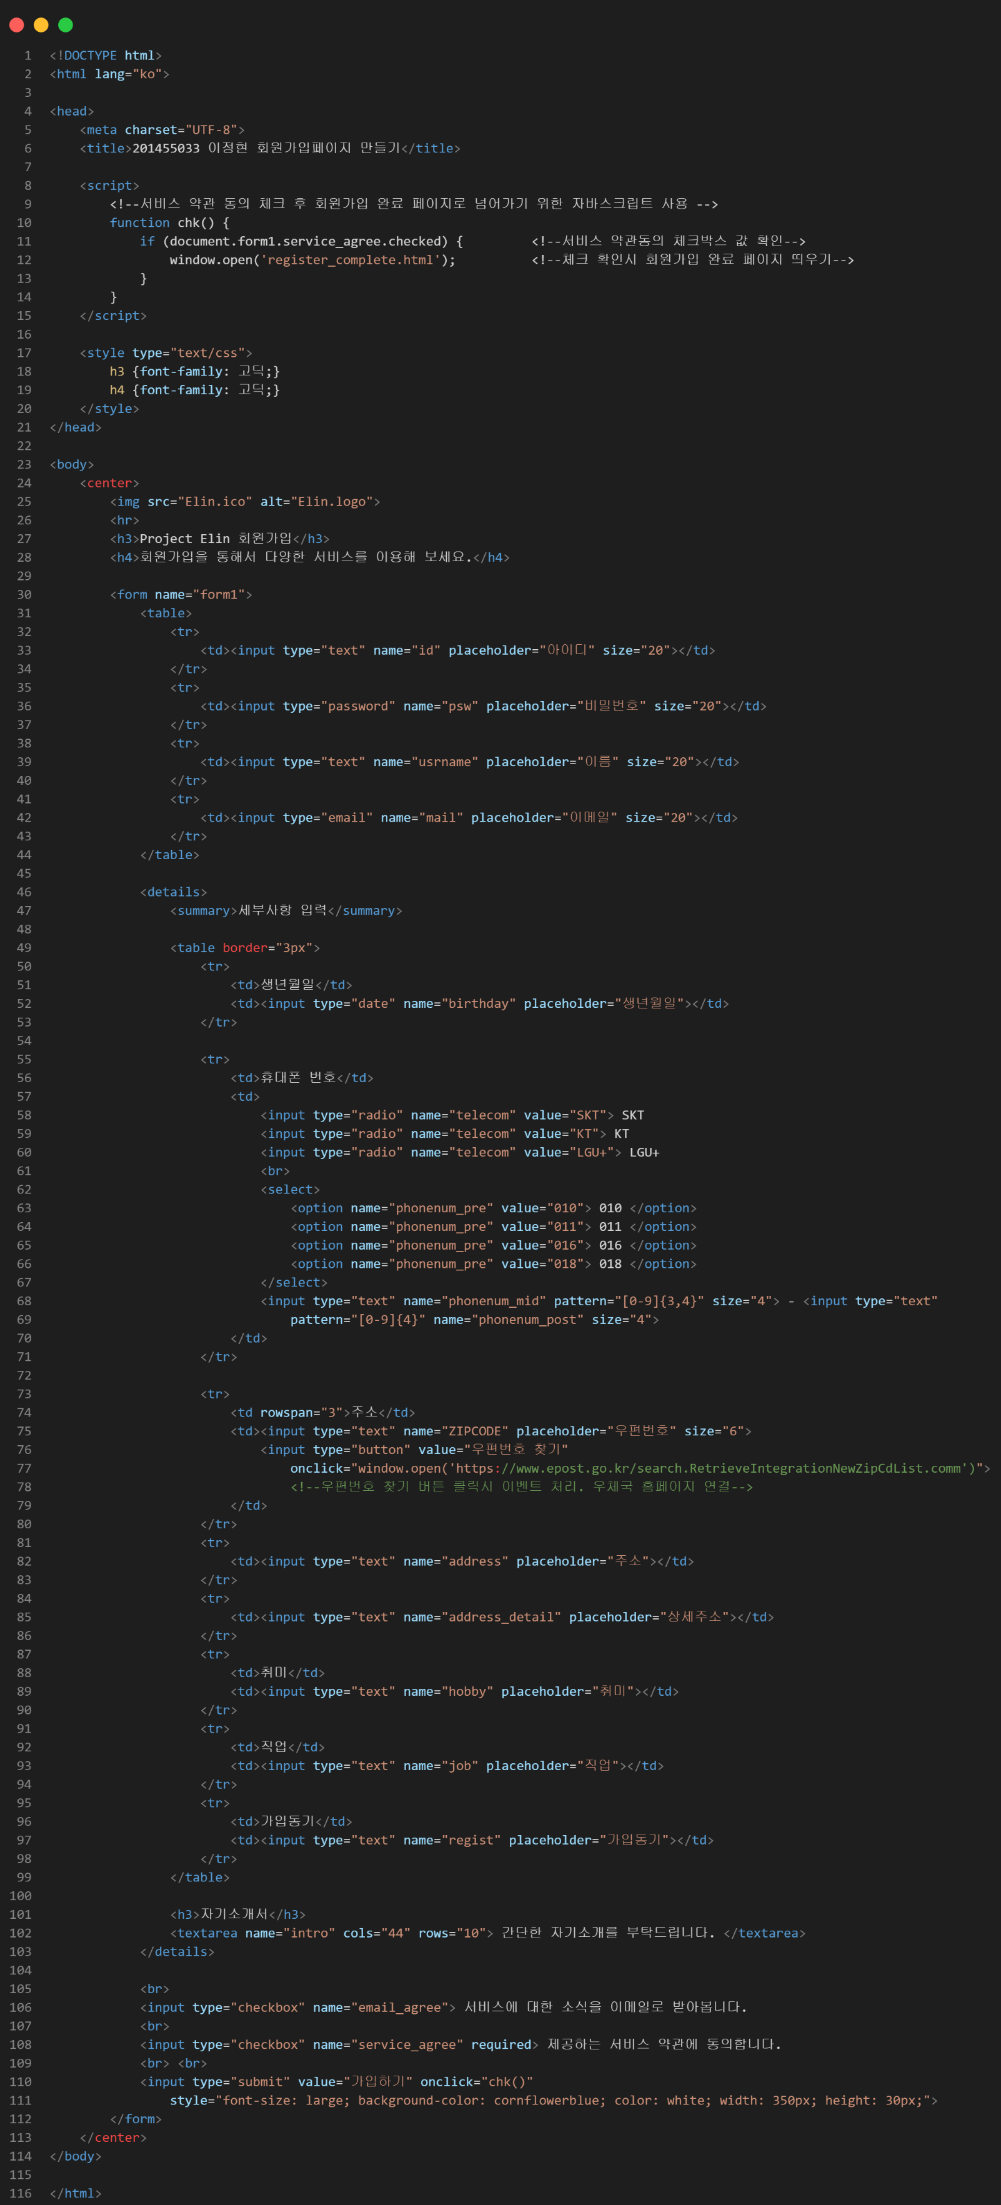



**register_complete.html 코드 캡처**

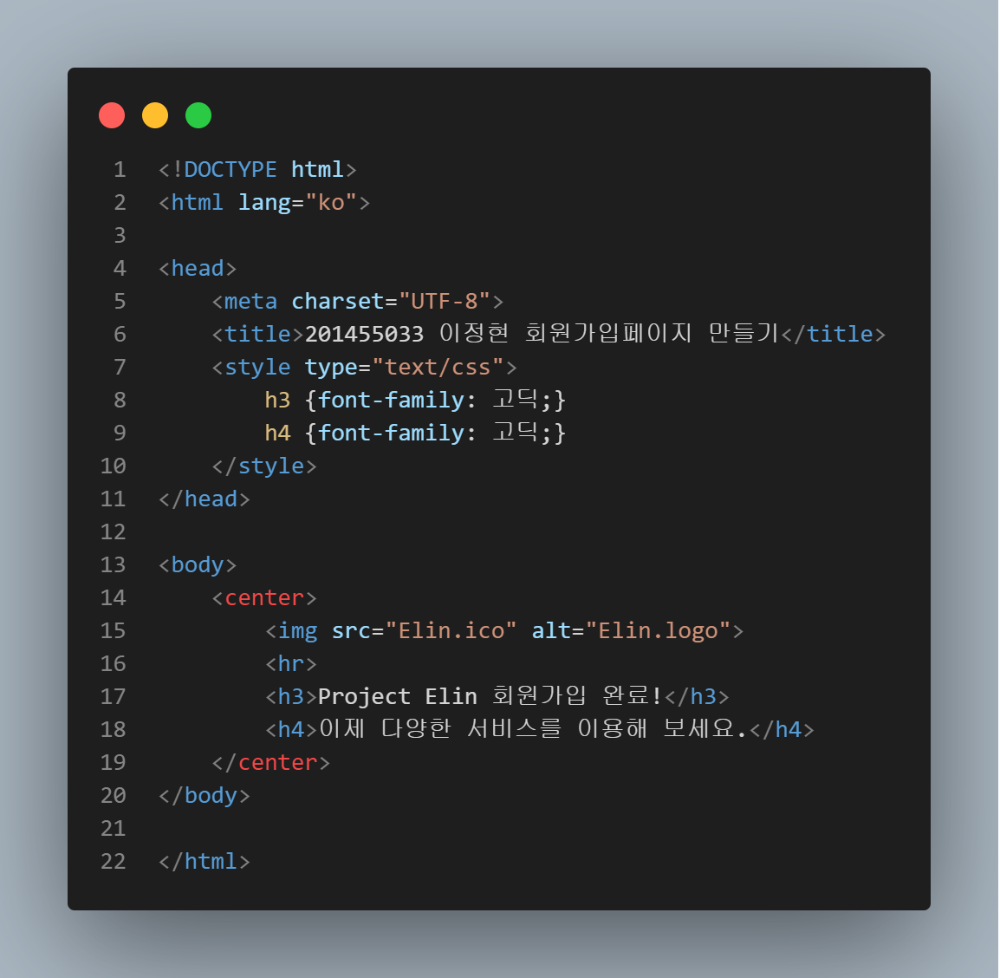

**[실행결과]**

**메인화면**

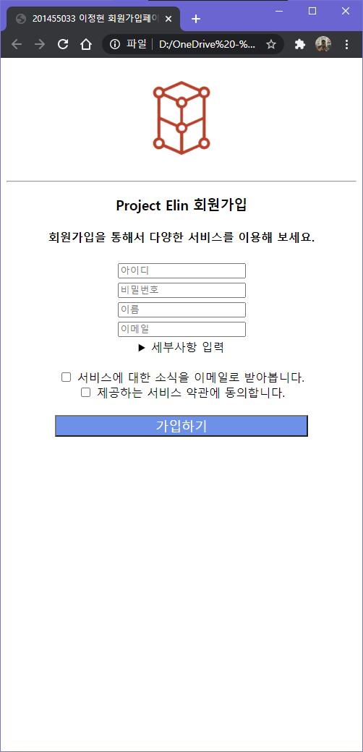

**세부사항 입력 클릭 시**

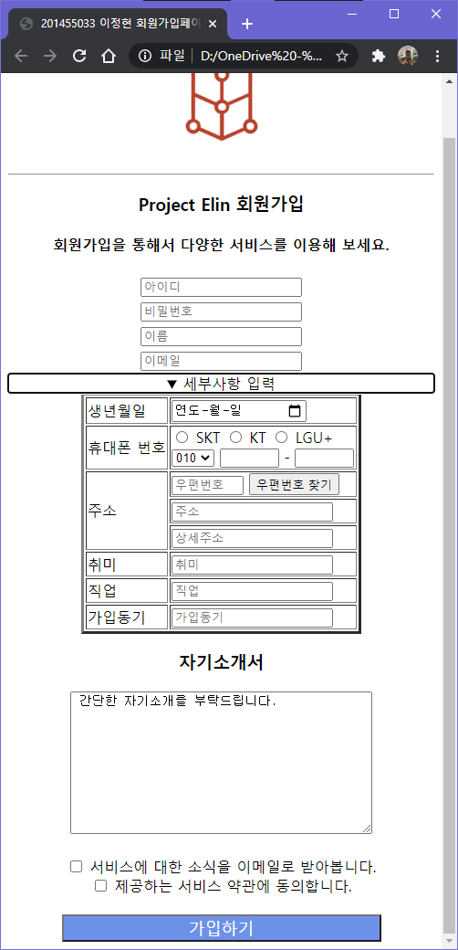

**올바르지 않은 번호 입력 시**

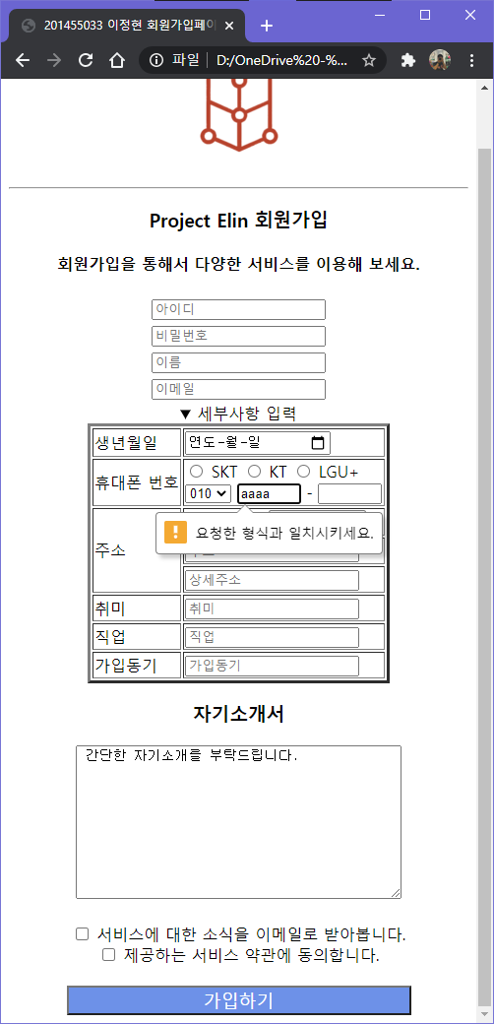

**우편번호 찾기 버튼 클릭 시**

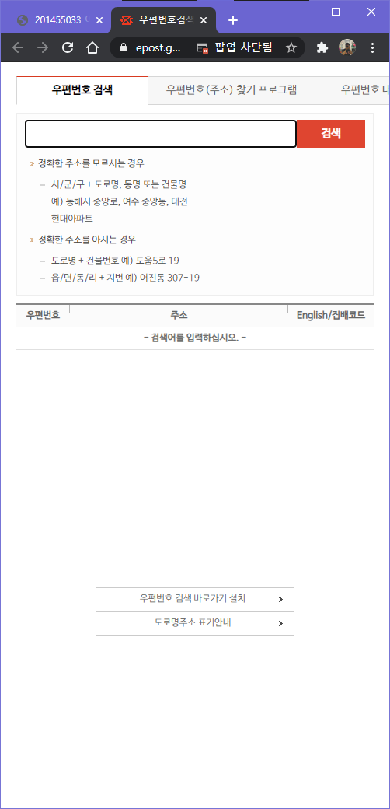

**약관 동의 없이 가입하기 클릭 시**

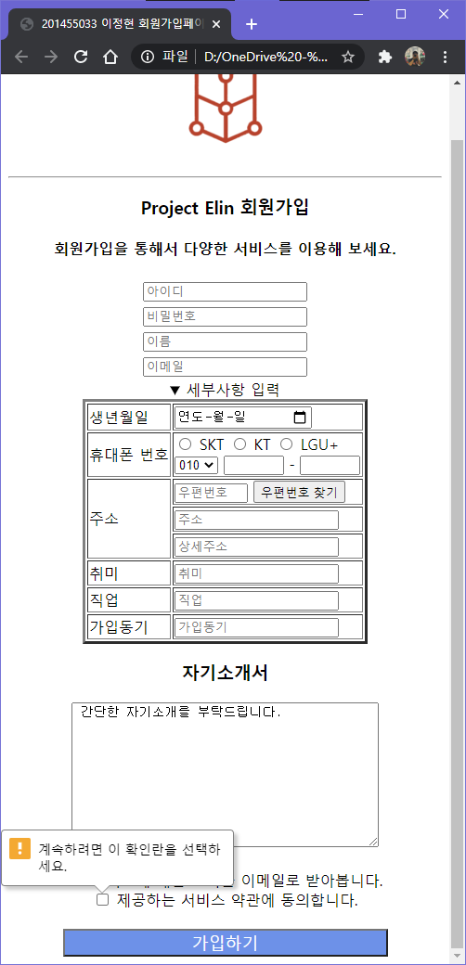

**약관 동의 후 가입하기 클릭 시**

