Assignment 1

2016310932 배현웅

* Environment

Python version : 3.6.9

Operating system : Ubuntu 18.04.4 LTS

* How to design assignment code

I divide three section; copy function, thread class, main function.

In copy function, it covers logging in the log.txt and transmission(copy) process. Just open two file,(source file, destination file) read from source file every 10KB(=10\*1000 = 10000) and write to new file. After copy finish, log which show completion is written.

In thread class whose name is machine,

it controls thread with queue library which hold resources. What is resource in this code, each resource means the ticket to run thread. If it uses them all, no more thread cannot run. It allocates 11 resources just in case. Anytime main function run one of threads, queue which call q in my code will get one of resources. After finishing copy, it returns again.

In main function,

It makes clear log file which call log.txt, then allocate resources in queue(=q). After that, get input text then decide which action to do. If user wants to exit, check whether there is any thread running by thread list which store thread resources. After join function call for every thread, the program terminates.

Otherwise, by os library, it checks whether input file exists. If it doesn’t exist, print wrong filename, then get input file name again. If input file exists, get target file name, and run thread. Add this to thread list for join function call.

* How to test code

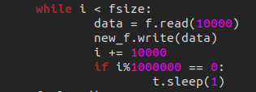

To test code, I need enough time to check it. So I add some code in copy operation to hold some time for it.

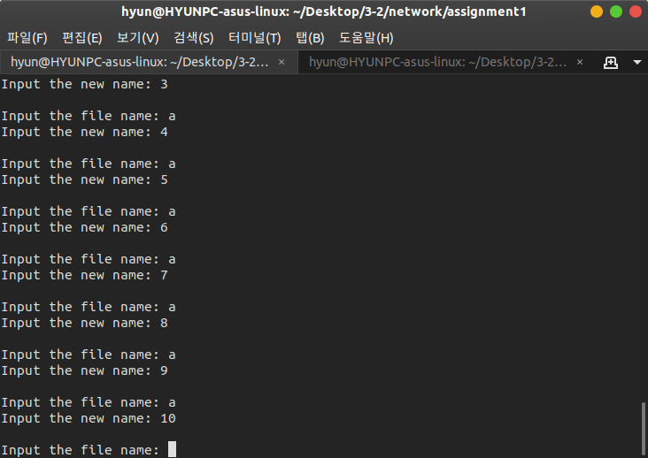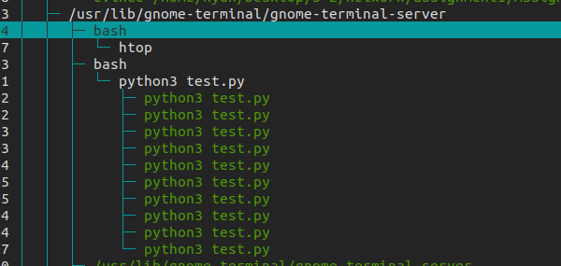

I check it by htop. Then Check whether all threads run well.

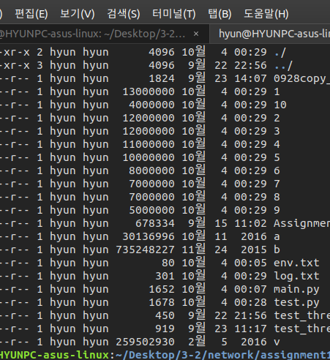

In the terminal, I check the transmission works well by ll (ls –al) command continuously. Whenever I type ll command, the ongoing transmission can be seen by increasing file size.

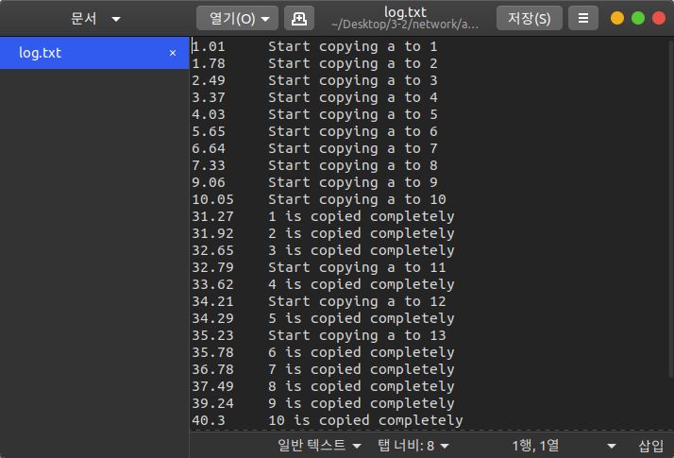

Then I check log.txt, when one thread which see in the htop program terminates, I can see log is written.

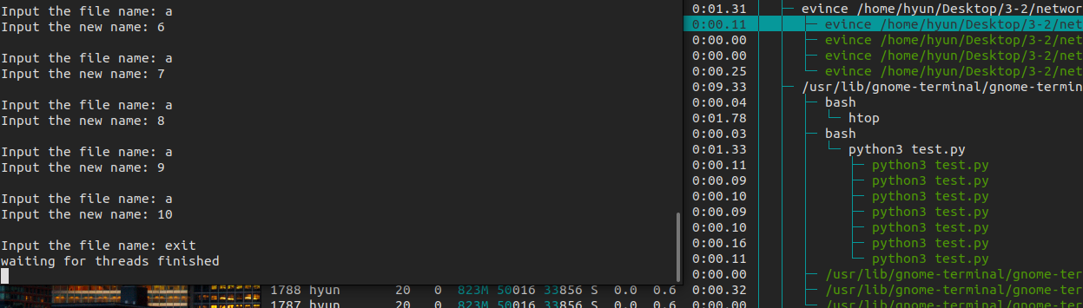

When the copy operation is not end (threads are not terminate), exit operation wait for all threads finish their action.

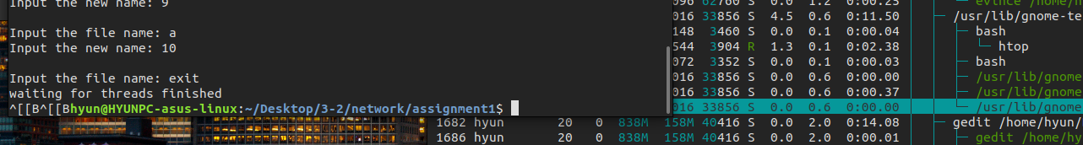

After all transmission is end, Main program can terminate.

Although the picture is not included, I also check new copy operation can continue.