Student Name : Aide Iskandar

Group : TS8

Date : 07 / April / 2021

LAB 4: ANALZING NETWORK DATA LOG

You are provided with the data file, in .csv format, in the working directory. Write the program to extract the following informations.

Exercise 4A: TOp TALKERS and LISTENERS

One of the most commonly used function in analyzing data log is finding out the IP address of the hosts that send out large amount of packet and hosts that receive large number of packets, usually know as TOP TALKERS and LISTENERS. Based on the IP address we can obtained the organization who owns the IP address.

List the TOP 5 TALKERS

Rank | IP address | # of packets | Organisation
1 | 193.62.192.8 | 3041 | Janet University Network
2 | 155.69.160.32 | 2975 | Nanyang Technological University (NTU)
3 | 130.14.250.11 | 2604 | National Library of Medicine
4 | 14.139.196.58 | 2452 | NKN EDGE Network
5 | 140.112.8.139 | 2056 | National Taiwan University

TOP 5 LISTENERS

Rank | IP address | # of packets | Organisation
1 | 103.37.198.100 | 3841 | A-STAR
2 | 137.132.228.15 | 3715 | National University of Singapore (NUS)
3 | 202.21.159.244 | 2446 | Republic Polytechnic. Multihoming AS
4 | 192.101.107.153 | 2368 | ESNet
5 | 103.21.126.2 | 2056 | Powai

Exercise 4B: TRANSPORT PROTOCOL

Using the IP protocol type attribute, determine the percentage of TCP and UDP protocol

 | Header value | Transport layer protocol | # of packets
1 | 6 | TCP | 56064
2 | 17 | UDP | 9462
3 | 50 | TCP / UDP | 1698

Exercise 4C: ApplicationS PROTOCOL

Using the Destination IP port number determine the most frequently used application protocol.
(For finding the service given the port number https://www.adminsub.net/tcp-udp-port-finder/ )

Rank | Destination IP port number | # of packets | Service
1 | 443 | 13423 | HTTPS
2 | 80 | 2647 | HTTP
3 | 52866 | 2068 | Unassigned Dynamic Port
4 | 45512 | 1356 | Unassigned  Dynamic Port
5 | 56152 | 1341 | Unassigned  Dynamic Port

Exercise 4D: Traffic

The traffic intensity is an important parameter that a network engineer needs to monitor closely to determine if there is congestion. You would use the IP packet size to calculate the estimated total traffic over the monitored period of 15 seconds. (Assume the sampling rate is 1 in 1000)

Total Traffic (MB) | 64.78MB (2 decimal place)
Total Traffic for 1000 sampling rate in 15 sec | Assume “Sflow” program collects data every second  64.78 * 15 = 971.67MB (2 decimal place)

Exercise 4E: ADDITIONAL ANALYSIS

Top 5 communication pairs;
- ('137.132.228.15/193.62.192.8', 4951)
- ('130.14.250.11/103.37.198.100', 2842)
- ('14.139.196.58/192.101.107.153', 2368)
- ('140.112.8.139/103.21.126.2', 2056)
- ('140.90.101.61/167.205.52.8', 1752)]
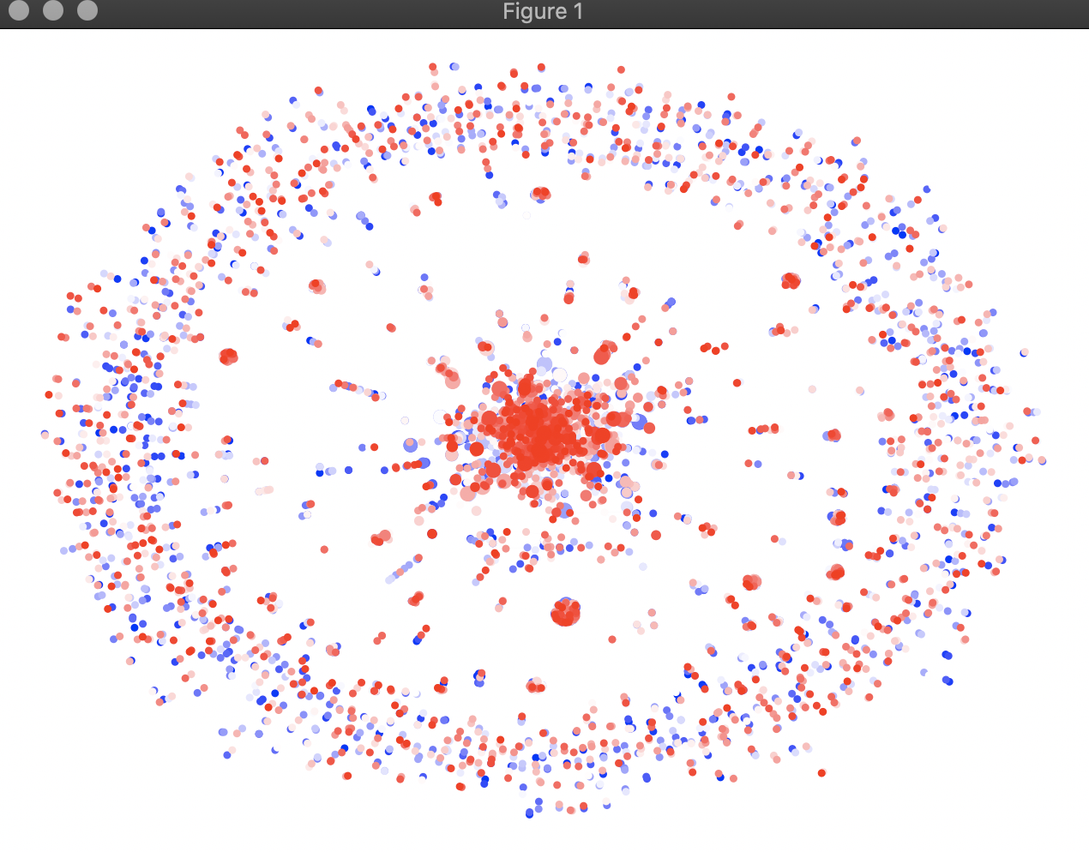
This is a spring graph that shows the current active connection of all the communication pairs. The most amount of active connection are concentrated in the center of the graph, where red dots where the source IP have more than 75 > active connections at present

Exercise 4F: SOFTWARE CODE

Please attach a copy of your code in an appendix.

https://drive.google.com/file/d/1abnZgyEg4MrcFJuuLT7TdYVVmPJe06p2/view?usp=sharing

