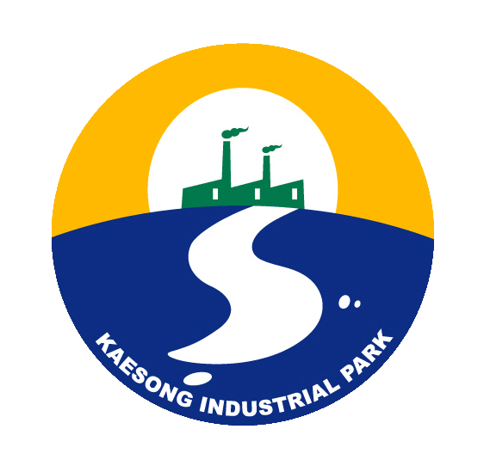
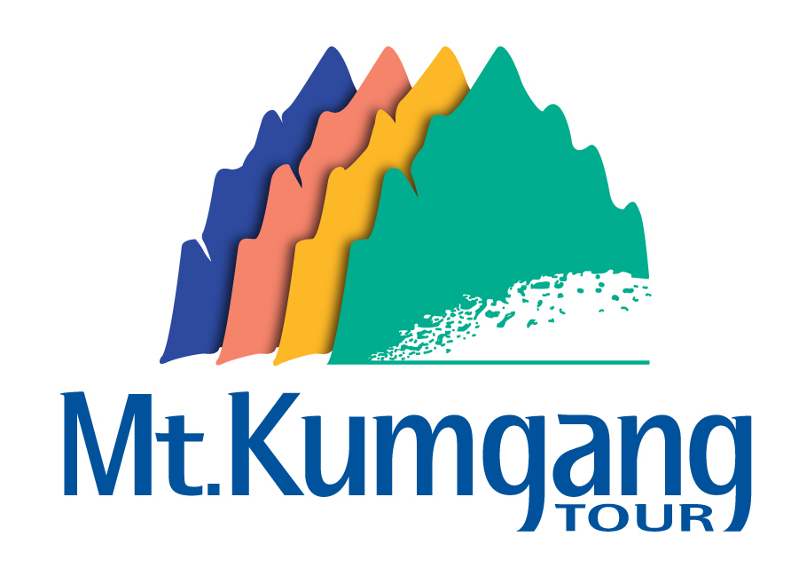
Hyundai Asan Newsletter

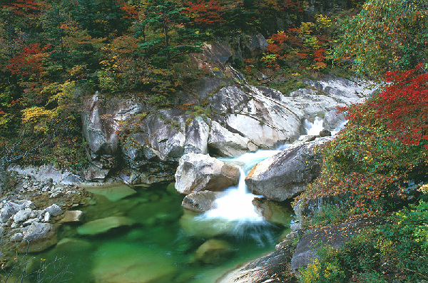
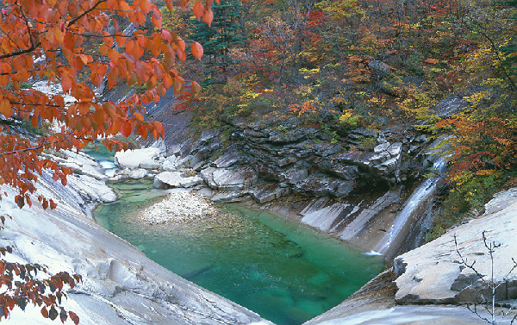
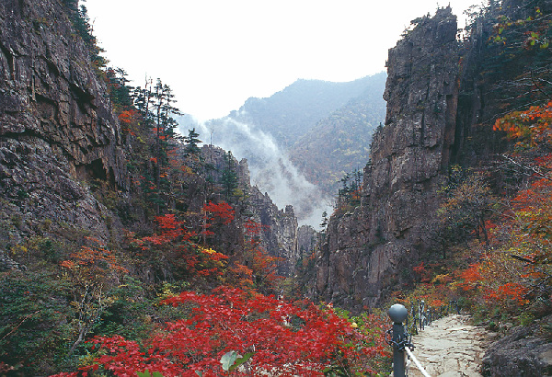
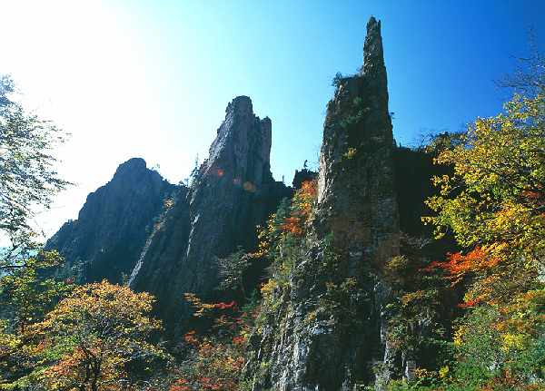

Okryudong

Chilcheung-am

Samsunam
Dongsukdong Fall
Fall of Mt. Kumgang

- Chairwoman visited Kaesong

Hyun Jeong-Eun, Chairwoman of Hyundai Group, visited the KIC (Kaesong Industrial Complex) on September 24th. Mrs. Hyun, accompanied with 14 Hyundai executives, inspected around the entire industrial complex and encouraged employees of Hyundai Asan and business partners from the South.
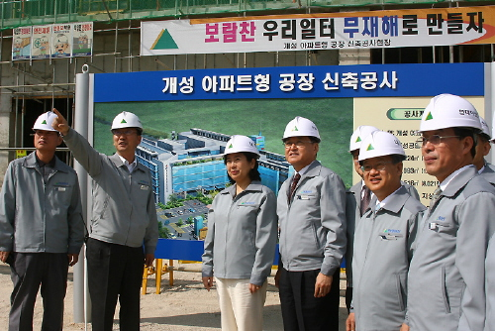
In the midst of the controversy over Inter-Korea Business, the Chairwoman made a decision to pay a visit to the KIC in order to show her determination to continue the grand project.
During her visit the Chairwoman met Park Chul-su, Vice President of Central Special District General Bureau’s Kasesong Office, which is the North-Korea Authority for KIC development. Meeting with the Leader from the south, the North-Korean official showed great enthusiasm and passion for KIC, saying “Kaesong Industrial Complex is essential for the prosperous future of the South and the North, so we must make this grand project a success.” He also added that the KIC development project will certainly be continued for under any circumstances.

♦ Hyundai Chairwoman Invited to Blue House

On October 11th, Chairwoman Hyun Jeong-Eun was invited to a luncheon with President Roh Mu-Hyun after the recent nuclear test by North Korea. Mrs. Hyun, with Hyundai Asan CEO Yoon Man-Joon and CEOs from companies in the KIC and Mt. Kumgang appealed regarding difficulties caused by the nuclear test.
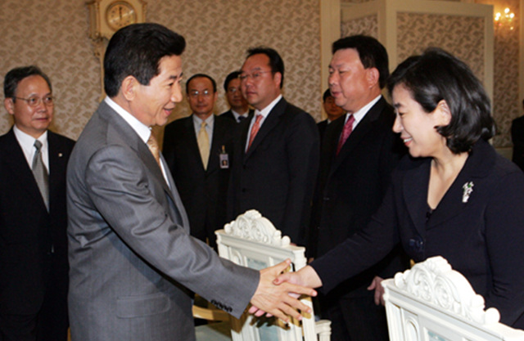
They, however, strongly expressed their firm determination to continue Inter-Korea Business Cooperation. Mrs. Hyun said to the President, “We will continue with Mt. Kumgang Tourism Business even if there is only one customer. We expect that the administration will give us great support and courage”

- Special Tour for Foreigners Only Eventually Launched
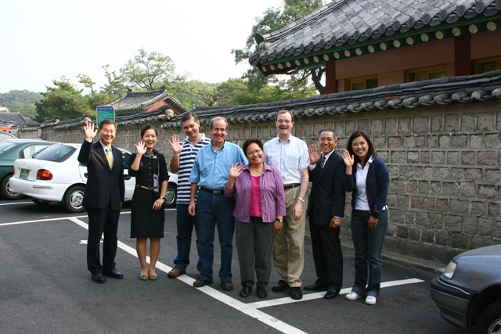
The Special Tour Package for Foreigners finally made a successful start on September 29th. Foreign tourists from the Philippines, South African Republic, Slovakia, and U.S.A. took part in the 2 nights and 3 days trip.
Even though the tour package for foreigners was only recently introduced, the participants expressed high satisfaction with it. Most of them

said they were extremely excited by their first-ever visits to the country. The scenic view around Mt. Kumgang such as fantastic rocks and stones, jade-colored pure water also deeply
impressed the visitors from the abroad.
On the other hand, some expressed that they want more opportunities to have contacts with North Korean people. We believe that the tour will be greatly enhanced as the North Koreans have more chances to be exposed to the outside world and people. Therefore, we strongly recommend you to make a visit to this destination!
We welcome you to Mt. Kumgang, with beautiful scenes and hopes for peace on the Korean peninsula wait for you. It’s more than a just trip.
The 2 nights and 3 days package runs every 2 weeks on Friday (Oct. 13th and 27th, Nov. 10th and 24th, and Dec. 8th and 22nd). 1 Nights and 2 Days Package runs every 2 weeks on Saturday (Oct. 28th, November 11th and 25th, Dec. 9th and 23rd)
Reservation has to be made at least 2 weeks in advance.
For more information, call 82-2-3669-3916(or 3726) or send mail to invest@hdasan.com

III. Hyundai Asan Signs MOU with Jeju Airline
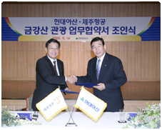
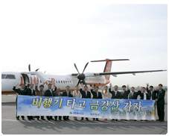

On September 14th, Hyundai Asan and Jeju Airline Signed an MOU concerning taking advantage of air travel to Mt. Kumgang Tour.
According to the MOU, chartered planes will fly between Kimpo Airport (Seoul) and Yangyang Airport, which is placed only about 80km away from MDL (Military Demarcation

Line). Shuttle bus service to the South CIQ will be provided.
Travel time between Seoul and Mt. Kumgang is expected to be shortened to only 3 hours, which was 6~7 hours before. Tourists will save up to 3 hours and have more spare time. We are very pleased to provide our customers with more conveniences.
Hyundai Asan and Jeju Airline are also planning to provide tour package fees and airfares at a discount.

IV. Preview in Seoul 2006

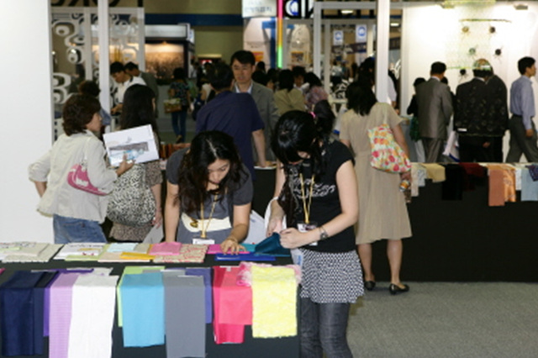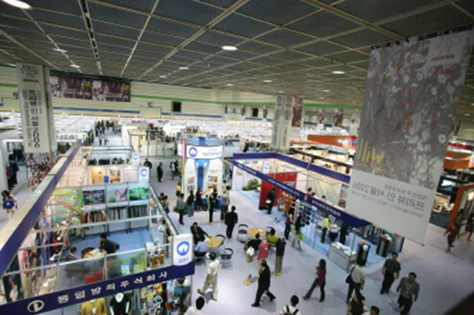

Resident companies in the KIC took part in ‘Preview in Seoul 2006 International Textiles and Fashion Inter-exchange’ held at the Coex from September 6th to 8th.
14 companies from the KIC participated in the exhibition and displayed textiles, shoes and etc. produced in Kaesong.
During the exhibition, Korea Land Corporation, the main developer of the KIC held a business explanation meeting and introduced lot sale plan for factories and current residents’ operation situation.
The international exhibition was a significantly meaningful chance to introduce the high quality of made-in-Kaesong products.
Through this exhibition, the KIC showed great potential again. It was proven that the interaction between the South’s capital and technology, and the North’s cheap labor are making an excellent synergy and leading Kaesong to a world-competitive industrial zone.

Contact
◆ 12F Hyundai Building, 140-2 Kye-Dong, Chongro-Ku, Seoul 100-793, Korea
(Planning Division / Foreign Investor Relations)
◆ Tel: 82-2-3669-3916 Fax: 82-2-3669-3690
◆ E-mail: invest@hdasan.com Homepage: http://www.hdasan.com


