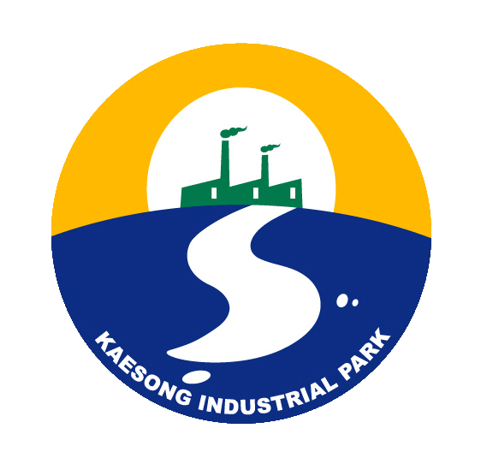
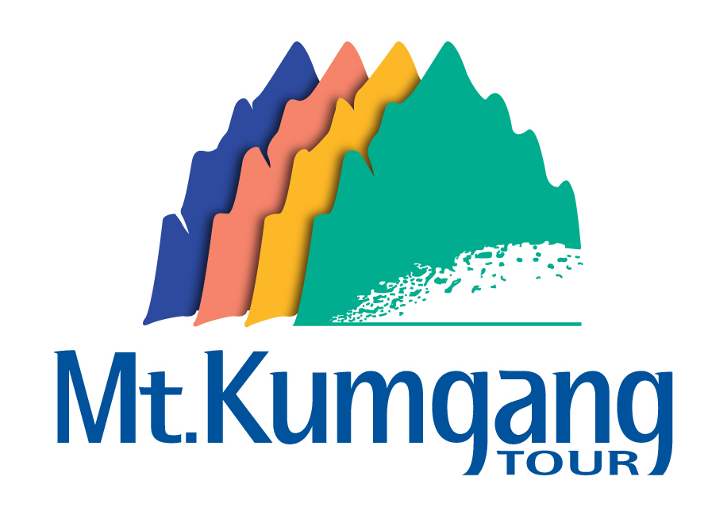
Hyundai Asan Newsletter

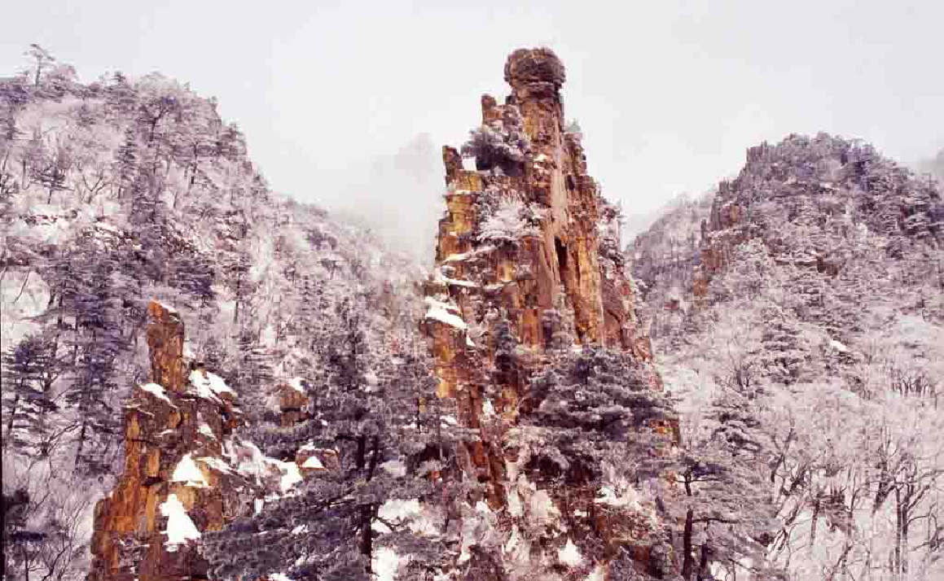

Winter at Mt. Kumgang
(Manmulsang: Ten Thousands of Rocky Features)

- Kaesong Investment Program 2006 held on Nov. 3rd
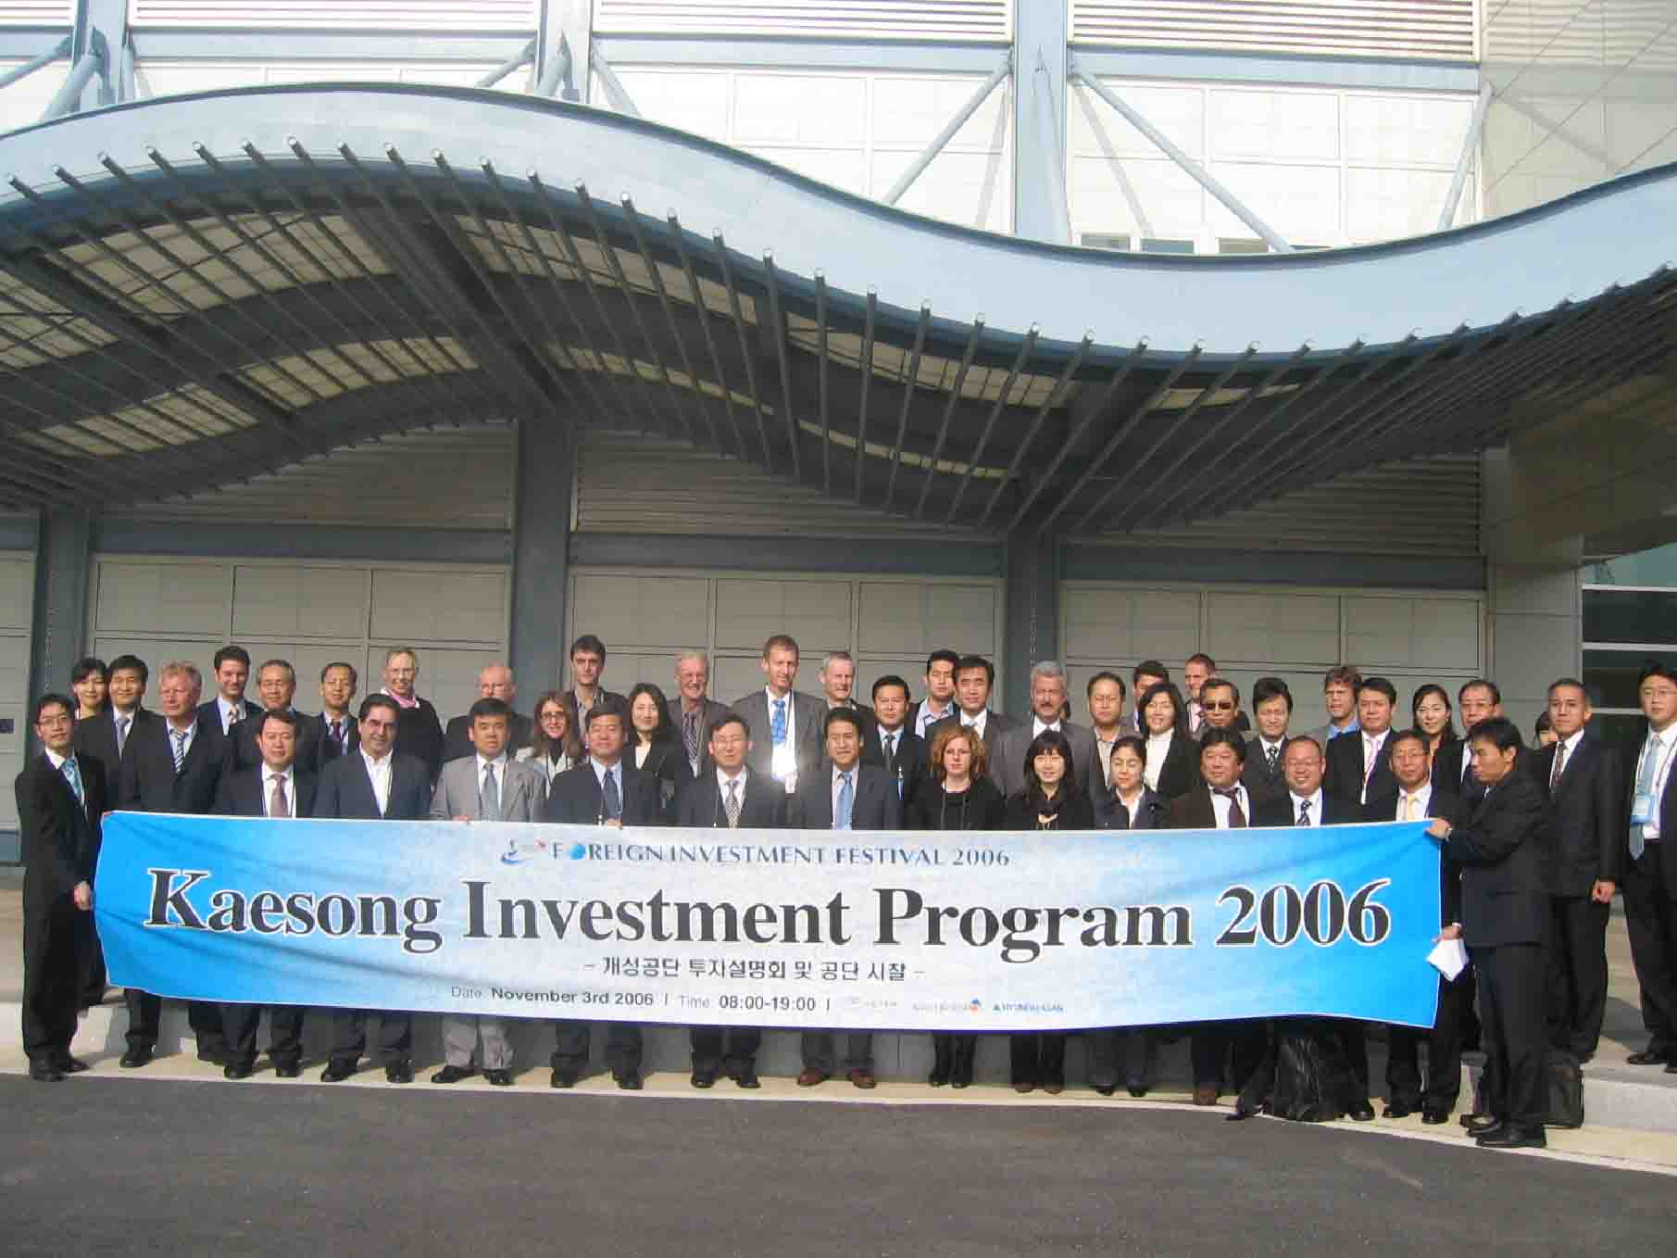
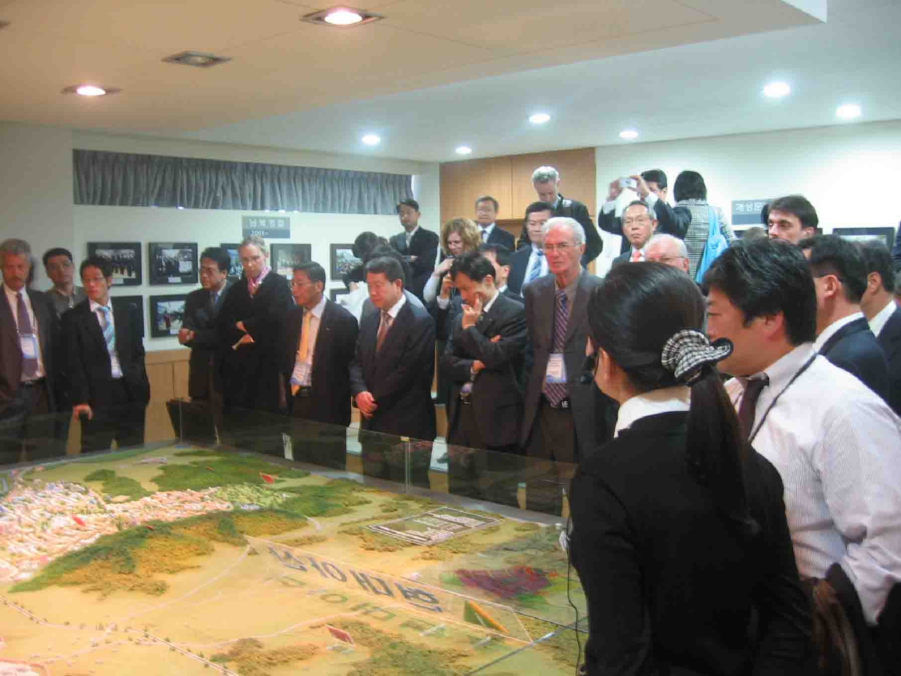
On November 3, Hyundai Asan and KOTRA held the Kaesong Invest Program 2006. Over 50 foreign business executives including MBT, HATLAPA, Colliers International, First American Scientific Corp. and foreign press participated in this investment program which included a site tour to Kaesong Industrial Complex (KIC). The participants were briefed both by the Kaesong Industrial District Management Committee and Hyundai Asan Kaesong Office about the recent development status of the KIC and toured the two major factories (Shinwon and Samduk) in the pilot industrial complex. Also they had a Q & A session with representatives from Hyundai Asan and tenant companies. Delegations showed great interest in the KIC and were impressed by the on-going inter-Korean cooperation between the two Koreas noting that Kaesong has great potential for investment with skilled workers from North Korea, low costs and an ideal location.
“We are seriously considering to purchase land and building a factory here.” - The MBT (physiological foot wear company) founder and chairman Karl Müller.

- 8th Anniversary of Mt. Kumgang Tour
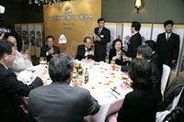
On November 17th to 19th, about 250 people including the former Minister of the Unification Jung Sea-Hyun, the Buddhist priest Jikwan, the president & CEO of the North Korean Myong Seung Ji general development guidance bureau Jang Woo-Young and officials from South and North Korea participated in

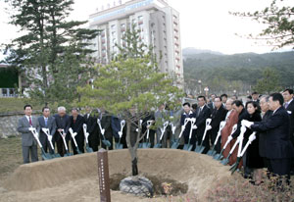
Hyundai’s 8th anniversary of the Mt. Kumgang tour. Prior to the ceremony, the first South Korean bank branch at the Mt. Kumgang tourism zone, National Agricultural Cooperative Federation, held an opening ceremony. This branch will offer basic financial services such as foreign exchange, deposits, and loans.
At the ceremony, chairwoman of the Hyundai Group, Hyun Jeong-Eun said that Mt. Kumgang is a cherished place representing world peace and although Hyundai faces difficulties due to decreased tourists caused by the recent political issues, Hyundai would continue to lead the Mt. Kumgang tourism business to a great success. Chairwoman Hyun and the invited guests attended dinner at Oe-Kumgak, Chinese restaurant located in the Hotel Oe-Kumgang, where she made a toast to celebrate the anniversary and wish for the further advancement of the Mt. Kumgang tourism business.

- US Congressmen See KIC Project Positively
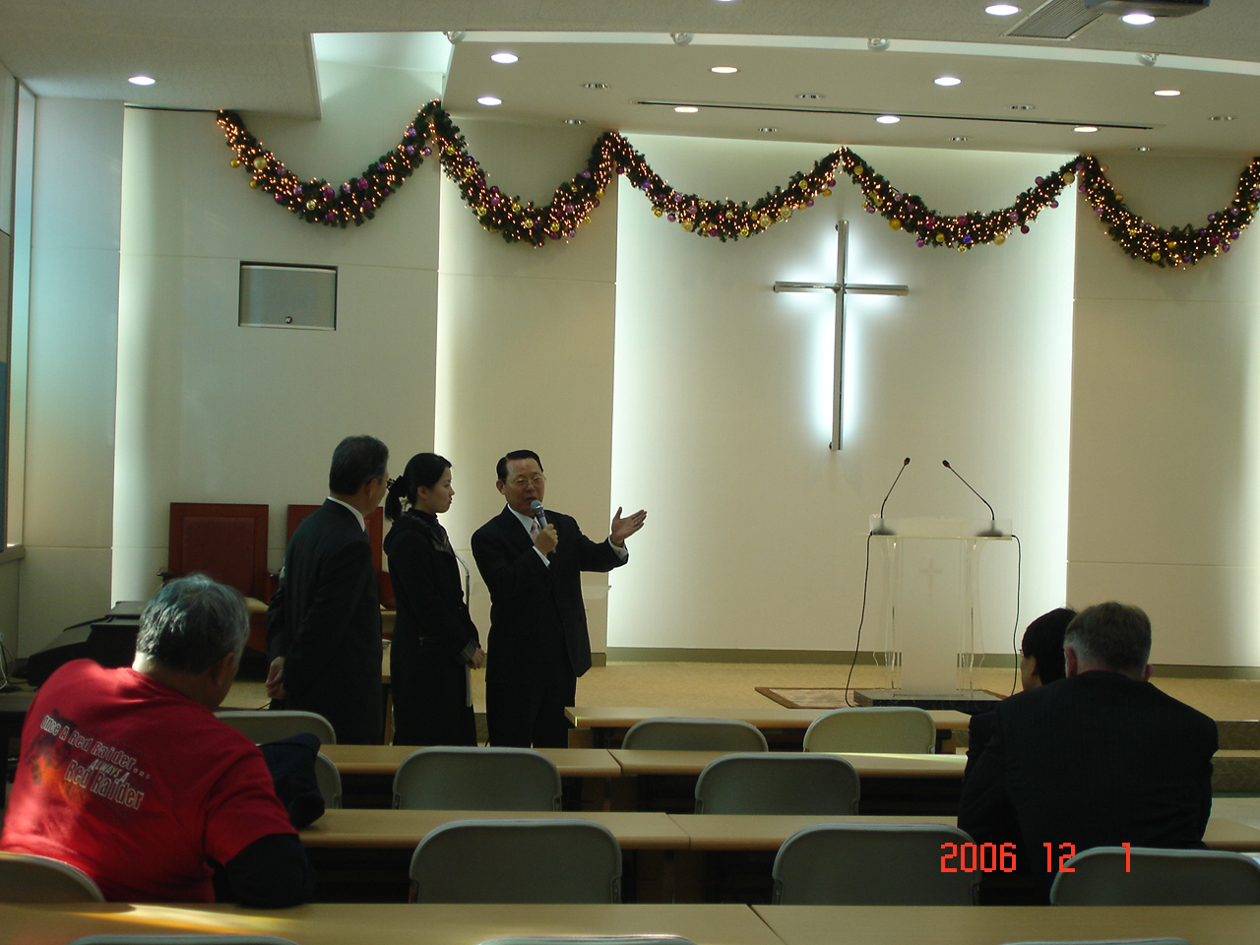
Three U.S congressmen and three South Korean assemblymen participated in the one-day trip to Kaesong Industrial Complex (KIC) in North Korea on December 1. The trip was organized by the Ministry of Unification. During the visit, the politicians met with Kim Dong-keun, president of the complex’s Industrial Management Committee, toured the different firms and were also briefed at Hyundai Asan Kaesong Office about the recent development status of KIC.
Church in Shinwon,
a tenant company in KIC

These US lawmakers described the Kaesong Industrial Complex as a “positive” project.

“The project is ideal because it combines the economic advantages of both sides, “ Rep. Jim McDermott of Washington state was quoted by a Ministry of Unification official as saying after visiting the complex.
Rep. Eni Faleomavaega of American Samoa said the joint complex was a “positive” and “win-win” project for the two Koreas, and Rep. Micheal Honda of California said the project would help Kaesong become a more balanced city.

IV. New Price for Mt. Kumgang Tour for Winter, 2006
- Regular Price(with Korean guide & tourists)

Accomodation | Price | Period
Hotel Oe-Kumgang | US $306 | Dec 1,2006 ~ Mar 19, 2007
Kumgang Family Beach Hotel | US $306 | Dec 1,2006 ~ Mar 19, 2007

This package basically includes the following:
• 2 Nights 3 Days accommodation
• Korean-speaking guide (guides will join at the gathering place)
• Free continental Breakfast
• Traveler’s insurance

- Special Weekend Tour Package for Foreigners Only
Classification | Tour Price
Classification | Dec.8th | Dec.22nd ~ Feb.
Adult | US $551 | US $440
Age 14~19 | US $440 | US $384
Age 7~13 | US $412 | US $375
25 months ~ 6 | US $103 | US $103
Under 24 months | US $82 | US $82

※ ① If you want a separate seat for child who is under age 6, there’s extra charge. (for Limousine bus and Acrobatic show)
② The price is subject to change according to exchange rate between Won and USD.

This package basically includes the following:
• 2 Nights 3 Days in Hotel Oe-Kumgang (breakfast is included)
• Round-trip limousine bus transportation between Seoul and Mt. Kumgang
• English-speaking guide (guides will travel together from Seoul)
• The acrobatic show (performed by world-famous Pyongyang Moranbong
Acrobatic Troupe, VIP seats will be provided)
• Traveler’s insurance

※ Reservation has to be made at least 1 week in advance.

Contact
◆ 12F Hyundai Building, 140-2 Kye-Dong, Chongro-Ku, Seoul 100-793, Korea
(Planning Division / Foreign Investor Relations)
◆ Tel: 82-2-3669-3691 Fax: 82-2-3669-3690
◆ E-mail: invest@hdasan.com Homepage: http://www.hdasan.com


