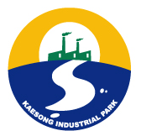
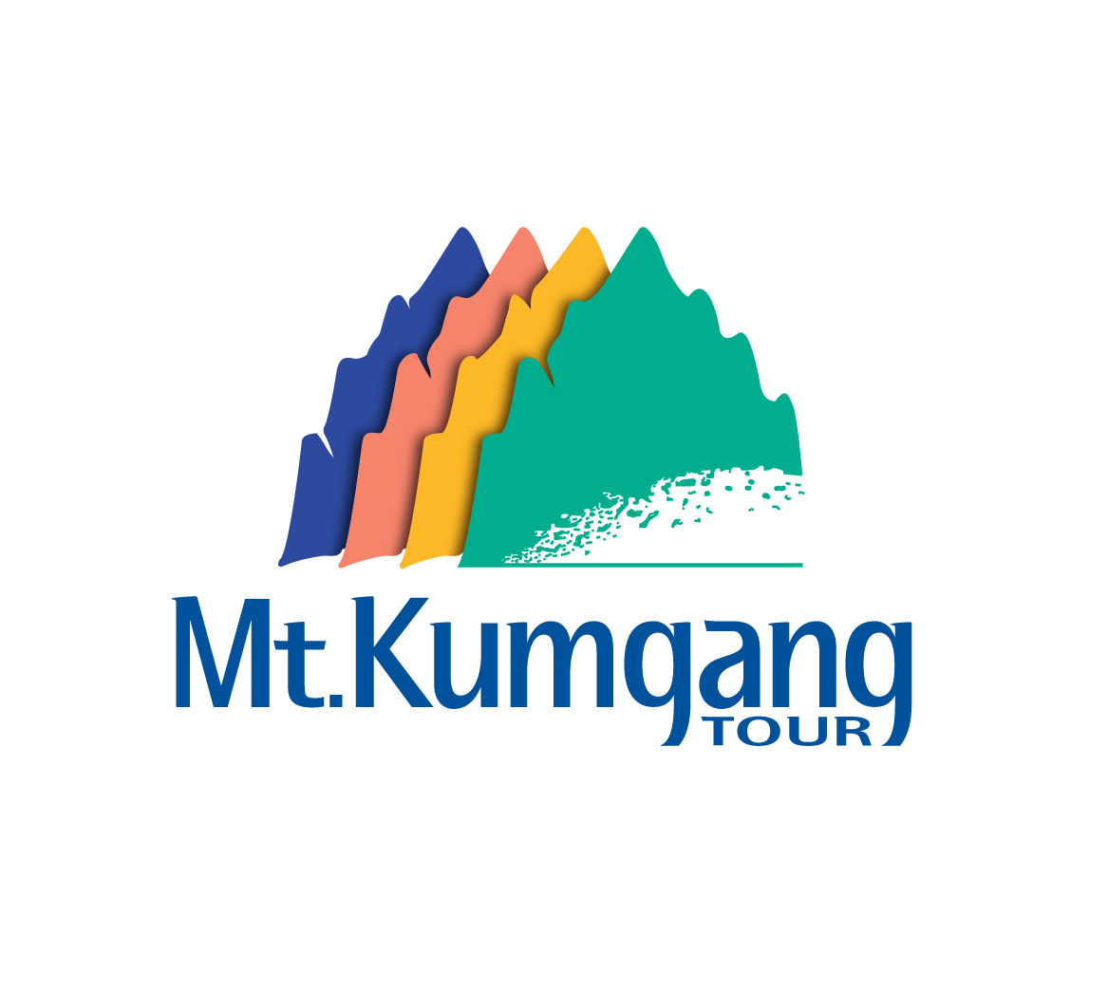

Hyundai Asan Newsletter

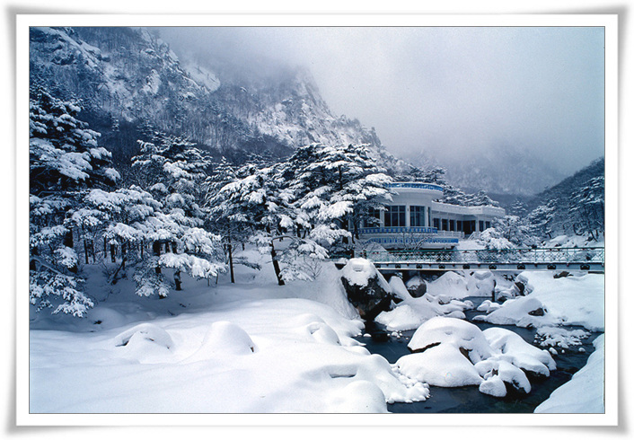

(Sulbongsan :Mt. Kumgang covered with snow)



1. New Year’s Greeting

Dear Hyundai Asan Newsletter Readers,
We thank you for your consistent interest and warm support for
Hyundai Asan’s inter-Korean cooperative business.
Hyundai Asan will continually strive for the peace and co-prosperity
in the Korean peninsula through economic cooperation.
We wish you a very pleasant Happy New Year.
Man-Joon Yoon / President & CEO

2. ‘2007 New Year’s greeting event’ in Mt. Kumgang
The ‘New Year’s Greeting Event’ was held in the Mt. Kumgang from Dec. 30, 2006 to Jan. 1, 2007. This is an annual event and has been one of the most popular programs among South Korean tourists and foreigners. The Mt. Kumgang seashore, where the New Year’s Greeting Event took place, is well known for its feminine-like qualities displaying a harmony of colors from white sand, green pine trees, and blue sea water. The participants sent out the old year and brought in the New Year at Mt. Kumgang while wishing themselves a bright future and happiness.
- Participants of Seoul-based foreign diplomats : Total 34 persons
- Algeria, Chile, Ecuador, Honduras, Oman, Peru, Slovakia, Thailand, Ukraine

3. CYTS’s top manager surveyed Mt. Kumgang

For the attraction of Chinese tourists to Mt. Kumgang, Hyundai Asan and Chinese Youth Travel Service(CYTS) which is well-known Chinese national tour company made a site survey in Mt. Kumgang on Dec 14~16. Now together with CYTS, Hyundai is preparing new Chinese group tour package products visiting Mt. Kumgang via Seoul, Gangwon-do at reasonable price.
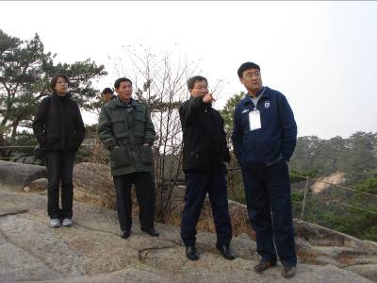
According to KNTO’s report (Korean National Tourism Organization), Korea-visiting Chinese tourists in 2006 amounted to 900 thousands and prospects over 1 million tourists this year.
Within February, strategic cooperation agreement will be signed between both sides and first Chinese group tour package will be launched. CYTS’s top manger Mr. Zhiquan in charge of Korea tour department said that the outlook of new tour project is bright.

4. Chronicle of Hyundai Asan corp. in 2006
Month | Major events
Jan | ▪ 2006 New year’s greeting ceremony in Mt. Kumgang
Feb | ▪ 7th Round of Inter-Korean Red Cross Talks held in Mt. Kumgang   Annual Marathon Race organized by Tournet and Runner’s Club in Mt. Kumgang
March | ▪ Re-opening of Hotel Haekumgang after three months of brand-new renovation
May | ▪ Hyundai Asan’s survey of ‘Nae-Kumgang (Inner Kumgang)’ for the expansion of new  Mt. Kumgang tour course   Ground-breaking ceremony for the construction ‘apartment-style factory’ in Kaesong
June | ▪ Hyundai Asan and KOTRA co-hosts ‘Foreign Investment Kaesong Program’  - Participants : 100 foreign business executives including Doran capital partners, Tupperware Korea, Macquarie-IMM and Seoul-based foreign envoys
July | ▪ Opening of Hotel Oe-Kumgang after Hyundai’s renovation in Mt. Kumgang   14th inter-Korean family reunion held in Mt.Kumgang
June | ▪ Opening ceremony of Hwajin-po rest house (convenient and well-equipped gathering  place for the Mt. Kumgang tour) in Go-sung, South Korea
Aug | ▪ Third memorial ceremony of late Hyundai Group Chairman Chung in Mt. Kumgang
Sept | ▪ Hyundai Asan signs MOU with Jeju Airline (Jeju chartered planes will fly between  Kimpo Airport and Yangyang Airport near Mt. Kumgang)
Oct. | ▪ Foreign media journalists visited Mt. Kumgang tourism zone organized by the Korea  Press Foundation and the Foreign Press Club  - Participants : Over 40 foreign media journalists including BBC, CBS, Reuters, UPI, AP,  Newsweek and Time etc.   25th ‘Yun Isang Concert’ by the North Korean National Symphony orchestra  in Mt. Kumgang
Nov. | ▪ 8th Mt. Kumgang tour anniversary and opening of ‘Nongyup’ first South Korean bank branch in Mt. Kumgang   Hyundai Asan and KOTRA co-hosts ‘Foreign Investment Kaesong Program’  - Participants : Over 50 foreign business executives including MBT, HATLAPA, Colliers  International, First American Scientific corp. and foreign presses etc.
Dec | ▪ Total No. of Mt. Kumgang tourists in 2006 : 234,443 tourists  - Accumulated No. of tourists : 1,407,092 tourists

5. Mt. Kumgang tour package
- 1 nights and daily tour is available. Contact us! invest@hdasan.com
Classification | Tour Price 2 nights (Jan. ~ Feb. 2007)
Classification | Standard prices  (No including option tour etc) | Special Foreigner package  (Including option tour, limousine bus etc.)
Adult | USD 290 | USD 440 (290+150)
Under Age 19 | USD 240 | USD 380 (240+140)
Under Age 7 | USD 100 | USD 100

◻ Special foreigner package basically includes the followings :
- 2 Nights 3 Days in Hotel Oe-Kumgang (breakfast is included)
- Round-trip limousine bus transportation between Seoul and Mt. Kumgang
- English-speaking guide (guides will travel together from Seoul)
- Option tour : The acrobatic shows, hot spring spa etc.
- Traveler’s insurance

◻ Contact
- 12F Hyundai Building, 140-2 Kye-Dong, Chongro-Ku, Seoul 100-793, Korea
- Planning Division / Foreign Investor Relations)
- Tel: 82-2-3669-3691 Fax: 82-2-3669-3689
- E-mail: invest@hdasan.com Homepage: http://www.hdasan.com
- Reservation has to be made at least 1 week in advance.

