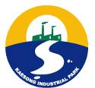
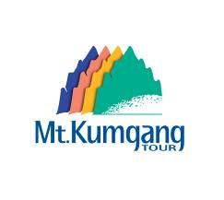

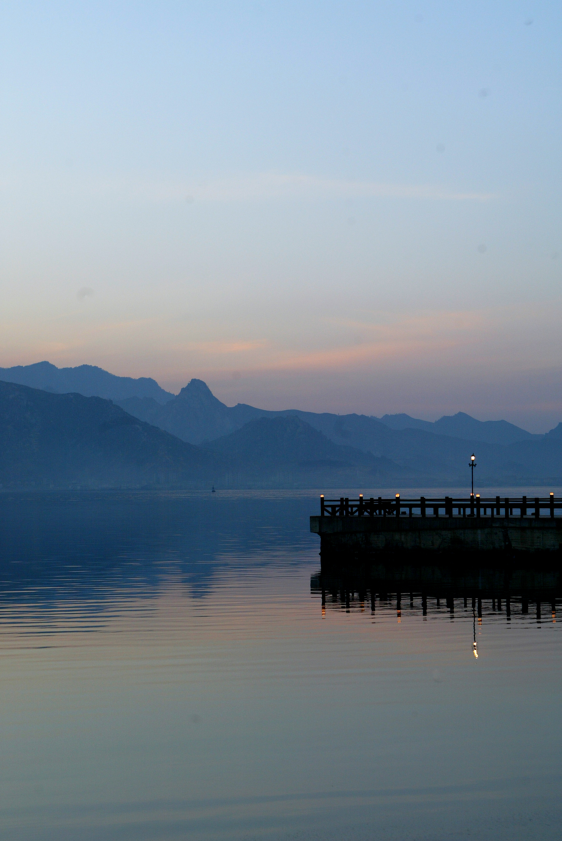



Hyundai Asan Newsletter

1. NaeKumgang (Inner Mt. Kumgang) tour will open
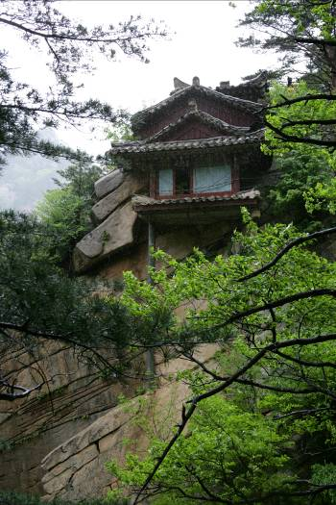
Hyundai Asan and North Korean counter-part ‘Myongseungji General Development Guidance Bureau’ and ‘APPC’ (Asia Pacific Peace Committee) has discussed to expand Mt. Kumgang tour to NaeKumgang (Inner Mt. Kumgang). Inner Mt. Kumgang is famous for spectacle beauties and Buddhist heritages of Manpokdong valley, Boduck temple, Myogilsang, Peohun temple, Myounggeungdae etc. Currently, only the outer Mt. Kumgang is available to the tourists.
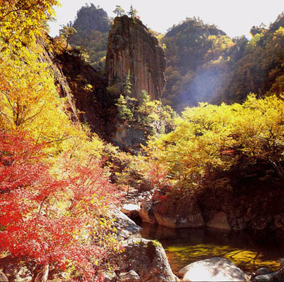
The basic principals have agreed after the first site survey of May 2006. The beautiful NaeKumgang tour course will open on April after the second site survey of the road conditions, itineraries and facilities of NaeKumgang in March.

Along with the opening of the NaeKumgang tour and Mt. Kumgang golf course in July, the Korean National Tourism Organization (KNTO) will also open a duty free shop in Mt. Kumgang. Hyundai Asan will continually try to provide more activities, restaurants and itineraries at Mt. Kumgang. We expect that these new itinerary and facilities will attract more than 400,000 tourists this year.

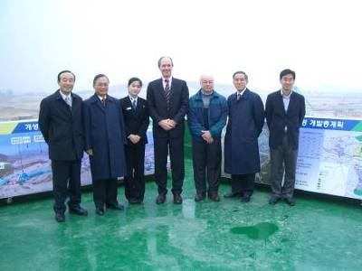
2. The Rating Agency Moody’s visited Kaesong Industrial Complex
High-level executives of Moody’s Investor Service visited Kaesong Industrial Complex (KIC) on February 9, 2007.
After briefing of Hyundai Asan and Kaesong Industrial District Management Committee (KIDMC), they looked around the factories under operation. Moody’s Mr. Byrne, director of Moody’s international credit department, said ‘this trip helped us to understand the inter-Korean cooperative business better’. According to the South Korean official of Ministry of Finance, Moody’s was quite sensitive to the political issues of North Korea and deeply considered the possibilities of raising sovereign rating of South Korea.
* Current rating of South Korea: A3 (since March 2002)

3. Kimberly Clark visits KIC for investment site survey
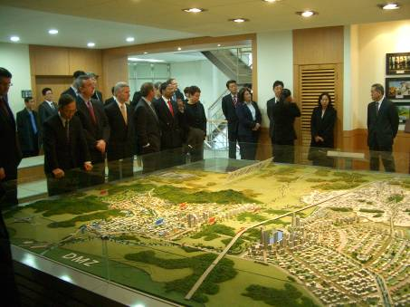
Kimberly Clark’s Chairman Mr. Tom Falk and its Korean affiliate Yuhan-Kimberly’s CEO Kook-Hyun Moon visited KIC for a site survey on February 27, 2007.
Kimberly Clark is the leading global company which produces health and hygiene products. It has more than 55,000 employees worldwide and annual sales reaching to $16.7 billion in year of 2006. Kimberly has a plan to expand its production facilities to catch up with sales in Asia Pacific emerging market.
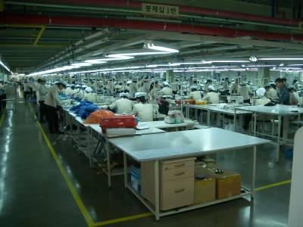
At the Q&A session with Hyundai Asan and KIDMC, Kimberly’s top executives showed their keen interest by asking questions about North Korean labor, investment environments, laws & regulations, lot sale, labor cost and qualities etc.
After close examination of investment environments of KIC, Kimberly will later make its decision for their move into KIC.

4. Former US Defense Secretary Perry visited Kaesong
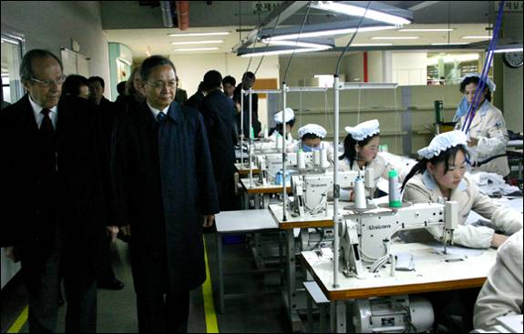
Former US Secretary of Defense William James Perry and former US Ambassador Stephen Warren Bosworth made a visit to Kaesong Industrial Complex on February 22, 2007. After looking around the factories, Mr. Perry addressed KIC as ‘future of the Korean Peninsula’ and called the South and North Korean workers as a ‘frontiersmen’.
They visited South Korea on a four day schedule and met high ranking South Korean official of Ministry of Unification and Ministry of Foreign Affairs and Trade.

5. EUCCK’s monthly journal ‘infomag’ covers Hyundai Asan’s inter-Korean economic cooperation
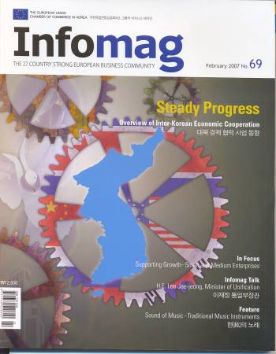
European Union Chamber of Commerce in Korea (EUCCK) specially covers the Hyundai Asan’s inter-Korean economic cooperation by the tile ‘Peace Ventures’ through their monthly magazine ‘Infomag’ (February edition). Hyundai Asan President & CEO Yoon, Man-Joon, had an interview with Mr. Jean-Jaques Grauhar, the publisher of Infomag.
In the article, president Yoon said that ‘Both North and South want to unification. The inter-Korean projects are part of this effort. We know that it cannot be achieved in a hurry, but progress has to be made step by step. We will constantly work towards this goal’. He also said that ‘Kaesong Industrial complex is not only open to South Korean companies but also to foreign investors. Legal preparations for foreign investors have already been made’
* Related full articles: Click here http://infomag.eucck.org

6. Hyundai Asan’s briefing and meeting from January to February
Date | Contents | Meeting site
1. 29 | Seoul, Tokyo, Beijing-based U.S Ambassadors  - Seoul-based US Ambassador: Alexander Vershbow etc. | Dorasan CIQ
2. 5 | Korea Society  - Former Chairman Donald P. Gregg  - Chairman Evans Revere | Hyundai’s office
2. 28 | Daiwa securities Seoul branch  - Strategist Keiju Kurosaka | Hyundai’s office

7. Mt. Kumgang tour package
- 1 nights and daily tour is available. Contact us! invest@hdasan.com
Classification | Tour Price 2 nights (High demand season, Mar 20 ~ July 26)
Classification | Standard prices  (No including option tour etc) | Special Foreigner package  (Including option tour, limousine bus etc.)
Adult | USD 390 | USD 540 (390+150)
Under Age 19 | USD 330 | USD 470 (330+140)
Under Age 7 | USD 290 | USD 390 (290+100)
- Reservation has to be made at least 1 week in advance.

◻ Special foreigner package basically includes the followings:
- 2 Nights 3 Days in Hotel Oe-Kumgang (breakfast is included)
- Round-trip limousine bus transportation between Seoul and Mt. Kumgang
- English-speaking guide (guides will travel together from Seoul)
- Option tour: The acrobatic shows, hot spring spa etc.

◻ Contact
- 12F Hyundai Building, 140-2 Kye-Dong, Chongro-Ku, Seoul 100-793, Korea
- Tel: 82-2-3669-3726 Fax: 82-2-3669-3689
- E-mail: invest@hdasan.com Homepage: http://www.hdasan.com

EUCCK Infomag (February 2007)

Hyundai Asan - Peace Ventures

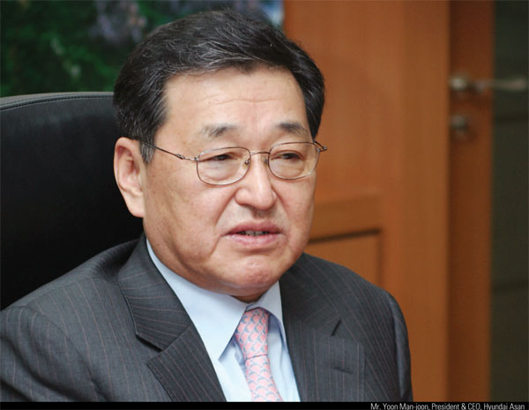
South Korea's signature inter-Korean tourism project at Mt. Kumgang and the industrial complex at Kaesong have been successfully operated by Hyundai Asan an arm of the Hyundai Group. Although business last year was a bit below expectations, 2007 promises to be more fulfilling.
Since November 1998, with over 1.5 million tourists visiting Mt. Kumgang in North Korea, a new chapter for reconciliation and peace opened in inter-Korean cooperation. The tourism project has now become a symbol of inter-Korean cooperation and peace as well as mutual trust and interaction.
Hyundai Asan, the sole operator of the inter-Korean projects, aims at developing Mt. Kumgang as a multipurpose tourism complex of international standards. Meanwhile, Kaesong Industrial Complex, a successful business model of inter-Korean cooperation, is also growing rapidly and making splendid progress in creating a promising future for both Koreas. This pilot industrial complex built in 2004 at Kaesong, just across the DMZ, showcases its great competitive advantages in workforce, location and logistics.

As noted by Mr. Yoon Man-joon, President & CEO, Hyundai Asan, both the projects have turned confrontation and tension between the two Koreas for the past 50 years into peace, stability, mutual understanding and co-prosperity.
"The company will continue to do its utmost to lead this historic mission ultimately to a success," he told Infomag in an exclusive interview.
He admitted that last year, business was a bit below expectations, due to tensions over North Korea's missile and nuclear tests. The number of tourists to fell and the company could manage to meet only 66 percent of its sales target. Investors have also delayed their investment plans for the Kaesong industrial project.
About 240,000 South Koreans visited the resort in 2006, far below the targeted 400,000. In the latter part of the year, the problem deepened, as fewer tourists signed up for the tour, affected in part by the North's missile and nuclear tests. The South Korean government soon afterwards also decided to stop its annual financial subsidy of 2 billion won, to teachers and students wanting to visit the resort during their winter vacation.
"However, we are confident that this year, we will be able to achieve our targets which are 40 percent more than in 2006. Every effort is being made to reassure tourists and investors that these projects are politically neutral," he said.

More tourists will visit Mt. Kumgang this year, attracted by an 18-hole golf course and newly developed tours to the inner side of the resort, Inner Kumgang that so far has not been open to tourists.
Mr. Yoon noted that Mt. Kumgang is not just another tourist spot for South Koreans. It is entrenched in their history, culture and religion.
"Everyone in South Korea yearns to see Mt. Kumgang at least once. It is closely linked to our culture, and there is even a nursery rhyme on the mountain which is sung in South Korean schools. For this reason, South Koreans feel involved with this project," he said.
He said that the feelings are mutual on both sides of the DMZ. There has been a very positive response from North Korea to the development of this project and encouraging tourists to visit the place.
As regards the Kaesong Industrial Complex, he said that the land preparation for the Phase I 800 acres among total 16,000 acres is scheduled to be completed in the first half of this year and factory lots of 64 acres were already sold to 39 companies and 20 companies are successfully under operation.

"The projects are a good opportunity for North Korea to face the market economy. The project is not only open to South Korean companies, but also to foreign investors. Legal preparations for foreign investors have already been made," he said.
Mr. Yoon said that for this purpose, it is hoped to reserve 32 acres of land exclusively for foreign investors. The advantages for the foreign investors are numerous, as they can avail of low-cost and highly skilled labor force from North Korea.
Moreover, he emphasized that products manufactured in Kaesong should be offered the same preferential tariffs as South Korean products for the ultimate success of the Industrial Complex. Some of the countries including Singapore, EFTA and ASEAN countries have already agreed as such in the free trade agreements that have been signed.
"I am sure that the first foreign investor in Kaesong will be from EU. We appreciate the EU for its support in bringing peace on the Korean peninsula. As EU is well known for its political objectivity, I hope it will offer reasonable solutions to the 6 party talks," he said.
"Both North and South want unification. The inter-Korean projects are part of this effort. We know that it cannot be achieved in a hurry, but progress has to be made step by step. We will constantly work towards this goal," he said.
By pioneering the Mt. Kumgang project, Kaesong Industrial Complex, North Korean SOC programs, inter-Korean Sports and Cultural Exchange, and other programs relating to inter-Korean economic cooperation, Hyundai Asan is promoting reconciliation and mutual prosperity. The main goal is unification and prosperity of the Korean peninsula, he said.

Heavenly Place
Mt. Kumgang is a strikingly beautiful mountain with numerous peaks and curious rocks amounting to some 12000 and waterfalls and pools formed by crystal-like clear waters flowing from hundreds of gorges. Situated along the east coast of the central part of Korea, it has an area of 530 square kilometers, is 60 kilometers long from north to south and 40 kilometers wide from east to west.
Thanks to its natural condition, the mountain shelters various species of plants, ranging from those in Temperate Zone to those in Sub-arctic Zone, of which there are species indigenous to the area, as well as provides a habitat for a great number of animals.
It is permeated with numerous legends and cultural relics handed over down through generations and offers outstanding scenery in all seasons. It became a spiritually and culturally symbolic mountain for all South and North Koreans.
The area is divided topographically into three parts - Outer Kumgang, Inner Kumgang, and Sea Kumgang. Outer Kumgang has the majesty of Manmulsang (Rocks of Ten Thousand Features), the Chipson Peaks and other peaks representing the dale beauty of Mt. Kumgang and has numerous waterfalls and valleys. By contrast, Inner Kumgang offers soft and graceful valleys (Including the Manpok Valley) and has gentle ravines. Sea Kumgang is well-known for the serene beauty of its charming lakes and seashore rocks.
In Mt. Kumgang there are many hotels and restaurants including the Okryugwan Restaurant in Onjong village, the Mokran Restaurant in the Kuryong Falls course and the Tanpung Restaurant in the Samilpo lake course. They serve local specialties such as edible greens, mushrooms, crabs and abalones. Western dishes and drinks are also served. Roast meat is popular among tourists. Spas in Mt. Kumgang are also famous and are good for the health. A fantastic North Korean acrobatic show is another extraordinary amusement.

