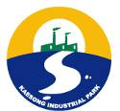
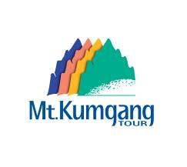

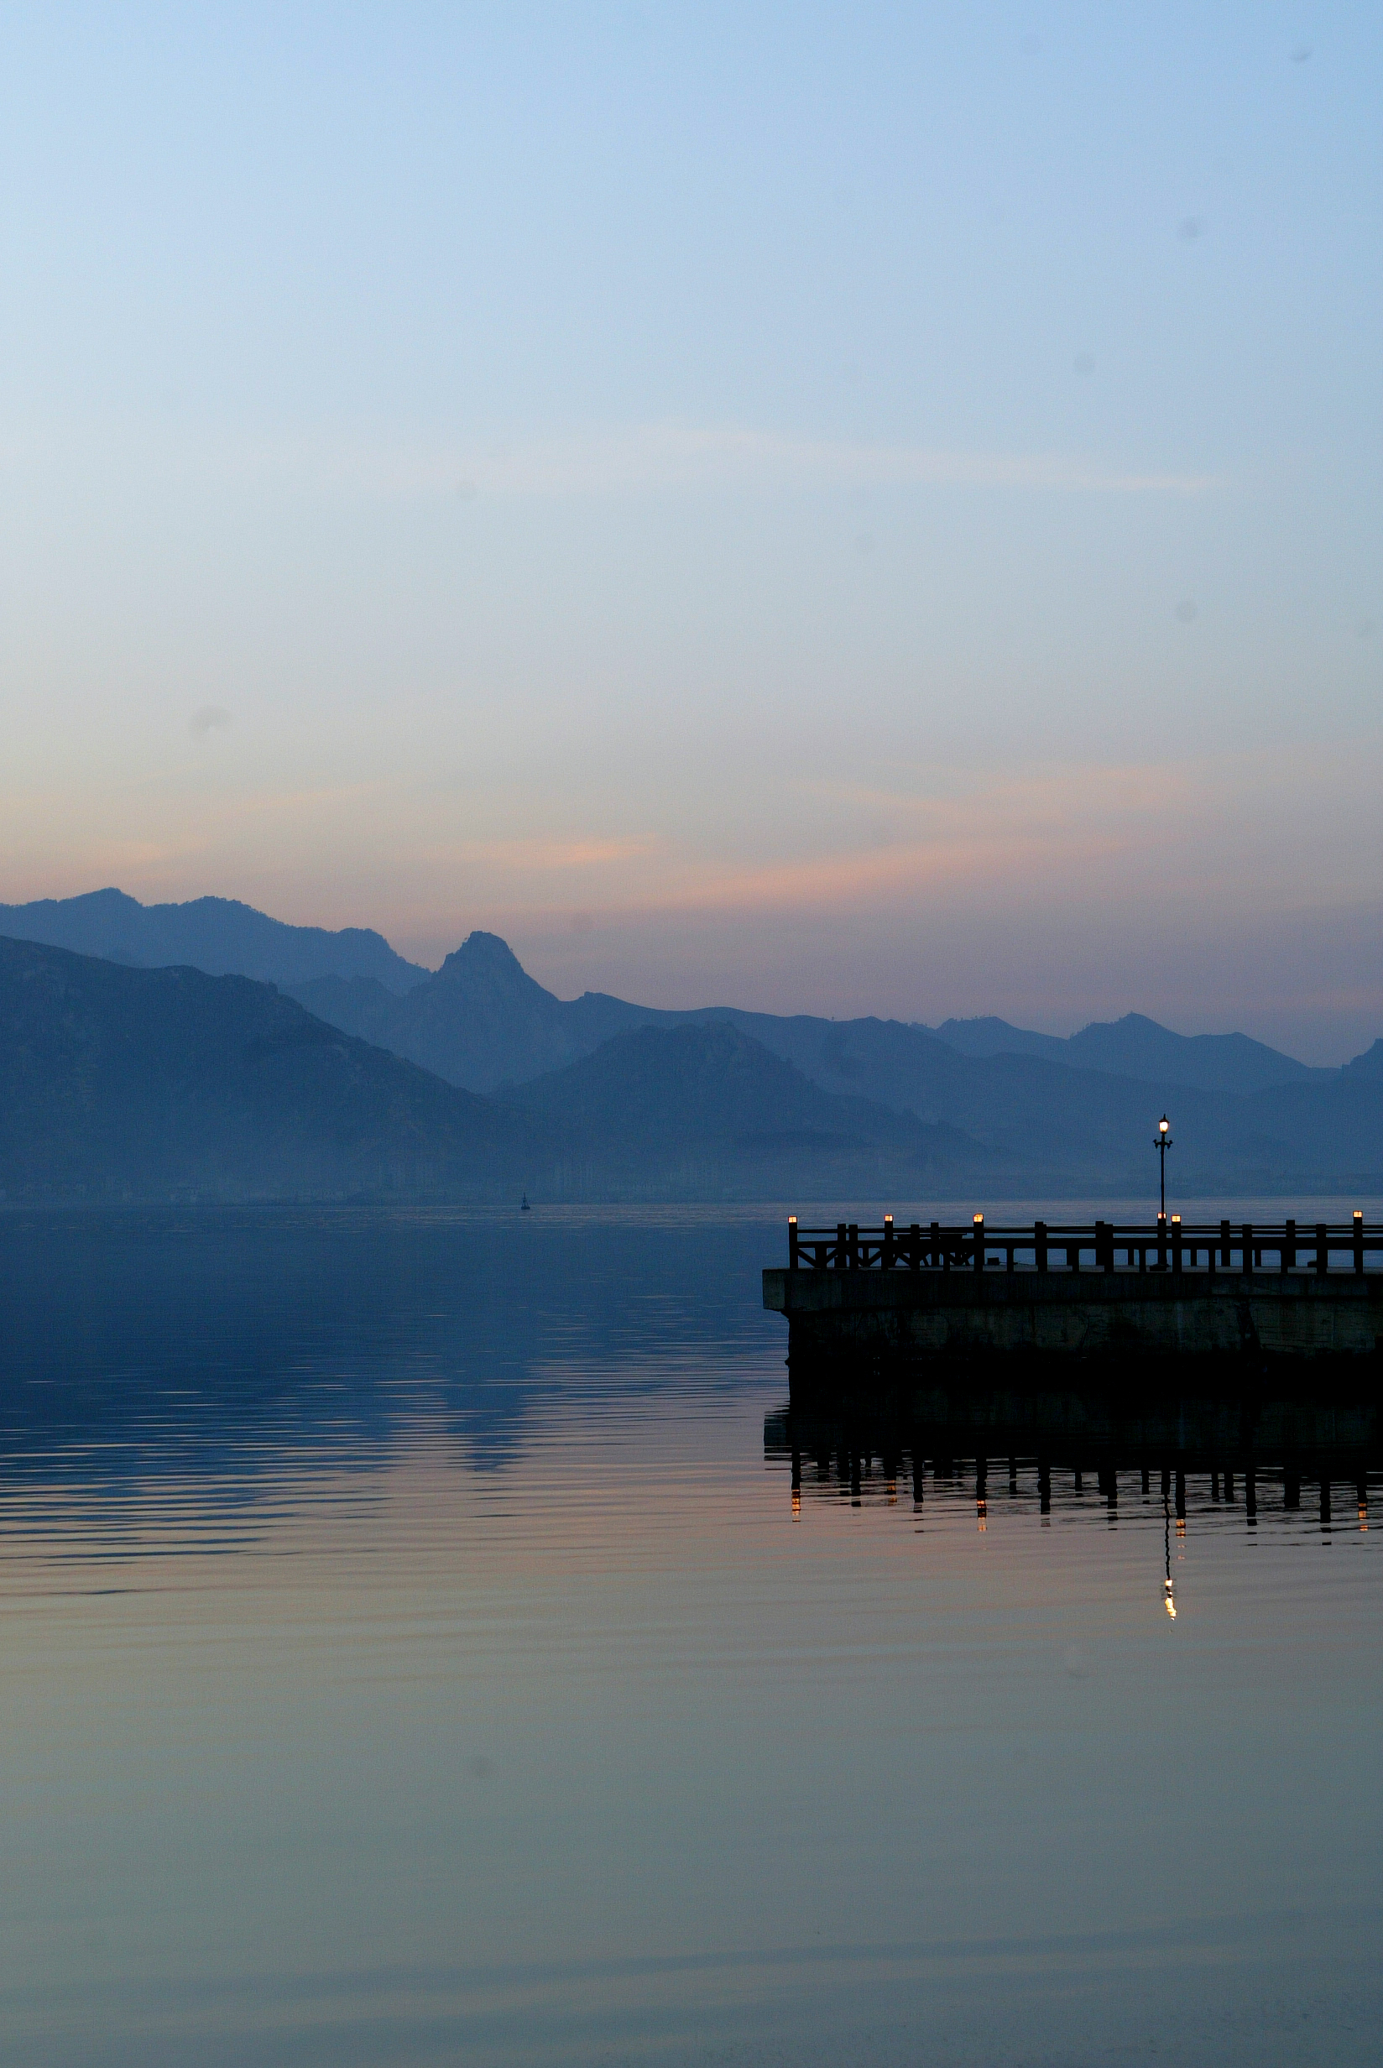



Hyundai Asan Newsletter

1. Shareholders meeting held on March 13, 2007

Hyundai Asan’s general meeting of the shareholders was held in the Hyundai Bldg. on March 13, 2007. In spite of the many difficulties such as the North Koreans’ nuclear tests, the annual report for year 2006 shows that Hyundai Asan achieved a net profit of U$ 15.2 millions.

Even in the year 2007, Hyundai Asan will do its best to expand its inter-Korean cooperative business with North Korea. Our main goal in 2007 is as follows:

❑ Mt. Kumgang tour business

- Expand the tour course into NaeKumgang (inner-Kumgang)

- Open a golf resort in Mt. Kumgang - Target tourist number: 400,000

❑ Kaesong Industrial Complex (KIC)

- Complete the necessary infra-structure for KIC such as power substation, sewage treatment, water supply plant and job training center

- Additional lot sales of 450 acres in 1st phase development in the first half of 2007

❑ Deepen the SOC projects (road, railroad, tele-communication, dam etc)

❑ Start Kaesong city tour and Mt. Baekdu tour

❖ Financial Statement of Fiscal Year 2006 (Unit : U$ millions)
Year | 2006 | 2005 | 2004
Revenue | 234.7 | 247.3 | 187.7
Net Earning | 15.2 | 14.9 | 0.7
Total Asset | 351.3 | 345.4 | 338.0

2. IFJ journalists visits Mt. Kumgang
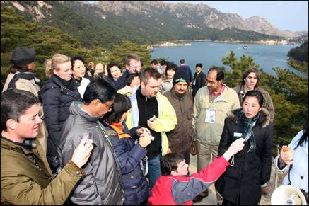
A special conference of International Federation of Journalists (IFJ) was held in Seoul, Mt. Kumgang and Kaesong Industrial Complex from March 12th to March 17th.
IFJ is the world’s largest organization to promote and defend the freedom press. Approximately 350 reporters and journalists from more than 70 countries participated in the Seoul conference with the theme for ‘Peace and reconciliation on the Korean Peninsula’. After the Seoul seminar, 120 journalists visited Mt. Kumgang on March 14th and March 15th and continued to Kaesong Industrial complex on March 16th..
The IFJ delegation to Mt. Kumgang and Kaesong including IFJ General Secretary Mr. Aidan White issued a statement calling for a denuclearization and peace in the Korean Peninsula, abolishment of laws against the freedom press and for the enhancement of the journalist’s rights and interests.

3. Hyundai will attract more American travelers

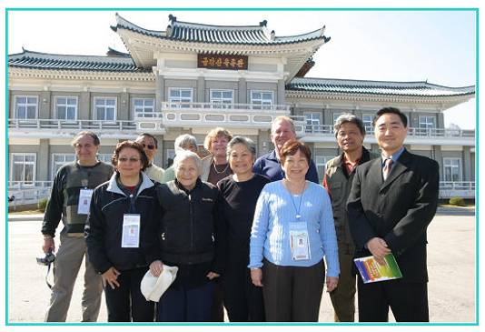
For the year 2007, American Society of Travel Agents (ASTA) International Destination EXPO was held in Jeju Island on March 25th to March 29th. This event was organized and sponsored by the Korea National Tourism Organization (KNTO) and by the government of Jeju.

The ASTA is the world’s largest organization in travel industry and 11,000 foreign and Korean travel experts who seek to gather information and learn about travel products in Korea participated in the EXPO.

At the post-tour program, eleven top-level travel experts including Mr. Anthony Paul, President of 4 Seasons Travel Co., visited Mt. Kumgang on March 29th to March 30th. Mr. Paul said that the ‘South Korea and North Korea including Mt. Kumgang is not a familiar travel destination to the Americans, partly because they do not know much about the country but also because they think the divided country is unsafe. But once coming here, I feel that the scenic Mt. Kumgang has big potentials for a global tour resort.’

4. Chinese Travel Company in Beijing visited Mt. Kumgang

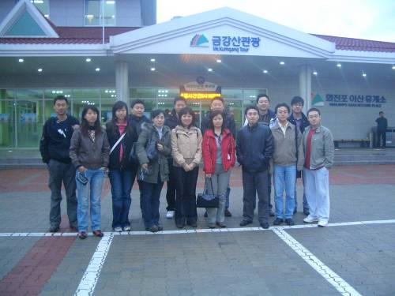

To boost the sales of the new tour package for Chinese tourists to Mt. Kumgang, Hyundai Asan and the Chinese Youth Travel Service (CYTS) made a tour to Mt. Kumgang on March 30th to April 1st. CYTS’s marketing directors and top managers in Beijing branches participated in the tour.

Hyundai Asan has already signed the sales agreement with CYTS on February 2007 and twenty Chinese tourists already had visited Mt. Kumgang on Feb. 22nd to Feb. 23rd.

Sixty Chinese tourists have already booked for the Mt. Kumgang tour in May during the Chinese Labor holidays.

CYTS’s marketing manager Mr. Limin Yu, head of the Korean tour department said that the demand for the new tour packages will gradually grow and will make it as their main product in the CYTS’s Korean outbound market.
- According to KNTO’s report (Korean National Tourism Organization), Chinese visited Korea in 2006 was 900 thousands and it will be more than 1 million tourists this year.

5. Mt. Kumgang tour package
Classification | Tour Price 2 nights (High demand season, Mar 20 ~ July 26)
Classification | Standard prices  (No including option tour etc) | Special Foreigner package  (Including option tour, limousine bus etc.)
Adult | USD 390 | USD 540 (390+150)
Under Age 19 | USD 330 | USD 470 (330+140)
Under Age 7 | USD 290 | USD 390 (290+100)
- 1 nights and daily tour is available.
- Reservation has to be made at least 1 week in advance.

◻ Special foreigner package basically includes the followings:
- 2 Nights 3 Days in Hotel Oe-Kumgang (breakfast is included)
- Round-trip limousine bus transportation between Seoul and Mt. Kumgang
- English-speaking guide (guides will travel together from Seoul)
- Option tour: The acrobatic shows, hot spring spa etc.

◻ Contact
- 12F Hyundai Building, 140-2 Kye-Dong, Chongro-Ku, Seoul 100-793, Korea
- Tel: 82-2-3669-3726 Fax: 82-2-3669-3689
- E-mail: hcjun@hdasan.com Homepage: http://www.hdasan.com

