0. Name:

1. What is the working definition of “**probability”** in BIO 211?
   1. Distributing equally likely belief to the unknown variations of counterfactuals
   2. The appearance of truth a statement or event bears in the light of present evidence
   3. The proportion of times an event occurs when the experiment is repeated independently, indefinitely
   4. A number measuring deviation from expectation in future experimental outcome
   5. Chance, hap, or luck, regarded as a cause of events and changes in people’s affairs

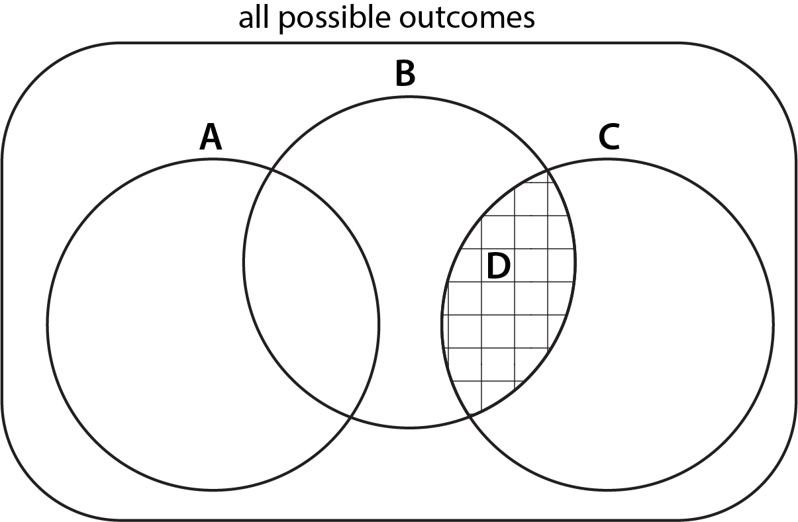  
Figure 1: Answer Questions 2, 3 & 4 using this Venn diagram which depicts 4 events A, B, C, as circles, and D as shaded area. Hint: recall that each event represents a set of possible outcomes (e.g. A = {HH, HT, TH} = “at least one head”). For the most general interpretation, think of each area in the Venn diagram as having at least one unique observation.

1. Suppose the Venn diagram represents randomly measured neuron from a rodent. Each subset represents a measured characteristic of a neuron. **A**: bursting, **B**: rebound spiking, **C** tonic, and **D**: resonating. Which of the following statement is **ALWAYS TRUE**?
   1. Tonic neurons are also resonating.
      1. Incorrect. Tonic neurons are within C, and only a subset of them are also resonating.
   2. Pr[ bursting and tonic ] = 1
      1. Incorrect. There are plenty of events that are not covered by bursting and tonic. In fact, it is impossible to be both bursting and tonic at the same time. Therefore, the probability should be 0.
   3. Pr[ rebound spiking and tonic ] = Pr[ resonating ]
      1. Correct! All resonating neurons are rebound spiking and tonic, and vice versa.
   4. Pr[ rebound spiking or tonic ] = Pr[ resonating ]
      1. Incorrect! ‘OR’ makes the set larger, and hence the probability of the union of two sets B and C is on the LHS. Pr[ D ] is less than or equal to that.
   5. If a neuron is rebound spiking, it cannot be tonic.
      1. Incorrect! Any neuron that is resonating is both rebound spiking and tonic at the same time.
2. Which of the following statements is **ALWAYS TRUE**?
   1. Pr[ A and B and C ] = 1
      1. Incorrect! There cannot be anything that’s A and B and C. Thus its probability is 0, not 1.
   2. Pr[ A or D ] = Pr[ A ] + Pr[ D ]
      1. Correct! A and D are mutually exclusive so the sum rule applies.
   3. Pr[ A or B or C ] = Pr[ A ] · Pr[ B ] · Pr[ C ]
      1. Incorrect! Or corresponds to the sum rule, not the product rule.
   4. Pr[ C ] = 1 - Pr[A] - Pr[B] - Pr[D]
      1. Incorrect! Take a look at the diagram and try again.
   5. Pr[ A and B ] = Pr[ A ] · Pr[ B ]
      1. Incorrect! There’s no indication that A and B are independent, hence the product rule may not apply blindly.
3. Which of the following statements about probability is **NOT NECESSARILY TRUE**?
   1. Pr[ A | B ] = P[ B | A ] · Pr[ A ] / Pr[ B ] when Pr[ B ] > 0
      1. Incorrect. This is the Bayes rule!
   2. Pr[ A and D ] ≥ 0
      1. Incorrect. Probability of any event is non-negative.
   3. Pr[ A and B ] = Pr[ A ] · Pr[ B ]
      1. Correct! There’s no way to know if A and B are independent.
   4. Pr[ B and C and D ] ≤ 1
      1. Incorrect. Probability of any event is less than equal to 1.
   5. Pr[ A or D ] = Pr[ A ] + Pr[ D ]
      1. Incorrect. A and D are mutually exclusive, therefore the sum rule applies.
4. How many possible experimental outcomes (sequence of heads and tails) are there to have *X* tails when tossing a slightly biased coin *n* times where the probability of heads is *p*?
   1. *n*! / ((n – X)! · X!) · pX · (1-p) n-X
   2. *n*! / (X! · (n – X)!)
   3. *(n-X)*! / n!
   4. 2*n* / n!
   5. 2*n*  
        
      Incorrect! If there were n = 3 coins, how many ways are there to get 1 head and X = 2 tails? HTT, THT, TTH, obviously. Now, recall that n! = n·(n-1)·(n-2)···(1)  
        
      Correct! This is the *binomial coefficient* for the binomial probability.
5. In the first hour of a hunting trip, the probability that an elite pride of lions will encounter a buffalo is 10%. *If it encounters a buffalo*, the probability that the pride successfully captures it is 99.9%. (Hint: “If” indicates a conditional probability)  
     
   What is the probability that the lions will go for a one-hour hunt for buffalo by a pride of lions will end in a successful capture? i.e. Pr[ pride goes for a hunting trip for an hour and captures a buffalo ] = 9.99%  
   (Hint: use the Bayes rule)

Incorrect! Hint: the probability that the pride successfully captures a buffalo it encounters is already a conditional probability. Pr[ pride goes for a hunting trip for an hour and captures a buffalo ] = Pr[ encounter a buffalo ] * Pr[ successfully captures | encounters a buffalo ]

1. Out of 10 surgeries tracked in a study, unfortunately 5 were followed by surgical site infections.
   1. Estimate the proportion of surgical site infection rate (per surgery):  
      0.5  
        
      Incorrect! Proportion is in between 0 and 1.  
      Correct! It’s the ratio of infections over the total number of surgeries.
   2. What is the 95% confidence interval using the Agresti-Coull method (formula given below, this is more accurate than the 2SE thumb rule)? Do not use percent and report in “[0.XXX, 0.XXX]” format (without the quotes).

 

[0.238, 0.762]

Incorrect! Use the given equation with n = 10 and X = 5. Use the right format.

Correct! Note that the confidence interval is quite large due to the small sample size.

* 1. Assume an underlying probability of infection p = 50% for each surgery. What is the probability to obtain the exact infection rate calculated in (a)? Do not use percent and report in “0.XXX” format (without the quotes).

(10 choose 5) p^5 (1-p)^5 = 252 / 1024 = 0.246 = 24.6% = 0.246  
  
Correct! The exact probability can be calculated from the binomial probability. Note that this is a fairly high chance, but still far from 100%.

Incorrect! Consider each surgery a binomial trial with two outcomes: infection and non-infection. In this imaginary world where each surgery ends up in 50% chance infection, how can you use the binomial probability to get 5 infections out of 10 surgeries?

1. In Stony Brook, the probability of rain or snow during a winter day is 25%, for a spring day is 31%, for a summer day is 31%, and for a fall day is 23%. Each of these seasons lasts exactly one quarter of the year. Answer in proportions to two decimals (0.XX format).  
   1. Pr[ it (a random day) is winter ] = ¼ = 0.25  
        
      Incorrect! What is the probability that a random day of the year happens to be winter?
   2. Pr[ it’s raining or snowing | it’s winter ] = 0.25  
      (i.e., what is the probability of rain given a random winter day in Stony Brook?)

Incorrect! Read the question carefully. It describes conditional probabilities of this form.

* 1. Pr[ it’s raining or snowing ] = 0.25 / 4 + 0.31 / 4 + 0.31 / 4 + 0.23 / 4 = 0.28  
     (i.e., what is the probability that it rains on a random day in Stony Brook?)  
       
     Incorrect! Pr[ raining ] = Pr[ “raining and winter” or “raining and summer” or “raining and spring” or “raining and fall” ]. Use the sum rule and definition of conditional probability.
  2. Pr[ it’s winter | it’s raining or snowing ] = Pr[ raining | winter ] * Pr[ winter ] / Pr[ raining ] = 0.25 * 0.25 / 0.275 = 0.23  
       
     Incorrect! if you were told that on a particular day it was raining in Seattle, what would be the probability that this day would be a winter day? Use Bayes rule.