General ethos:

My overall page will be sky-blue based color. Sky blue color makes children comfortable. I want to make them feel like seeing the sky, so I can trigger their interest. However there will be clear distinction between text and background so that kids can recognize well. Generally the corner of the box and button is not round, but I made them round to give more stability. Kids will feel more comfortable with round types than angled one. By the size of the webpage goes up and down, the font size also be made to be harmonized with it. Not much difference in the actual structure which shows the layout will be made, because too much change can give confusion to kids. Diverse and funny font-family will be used not to make them feel bored while searching the webpage. The overall structures will be kept simple without too much boring, so that the users can find what they want easily. There might be some effect on specific clickable buttons. For example, the word will be bigger when they are hovered over by mouse.

SITE MAP:

Accessibility

The accessibility page will be made separately with an accessibility statement. Alt attributes for images will be used by using screen readers. However, if the image is purely decorative there will be no alt attribute to images. According to W3C’s web accessibility( which you can access by typing: http//www.w3.org/TR/WCAG/) guideline, the text will be made easier for users to see the content. The text and contents will be readable and understandable. If there will be any more problems to access to the webpage, the users can contact to the homepage, and the solution will be made.

Mark-ups

I have used two breakpoints. If I jumped directly from desktop version to smartphone version, it might show too much change and give some confusion to users. Therefore, I made middle version. From the left side, it is mobile, narrow, desktop version.

<MAIN HOMEPAGE>

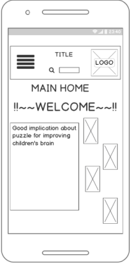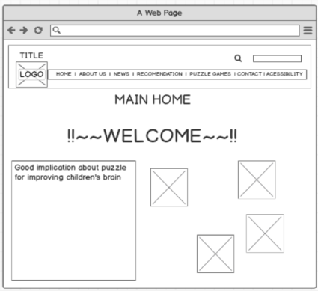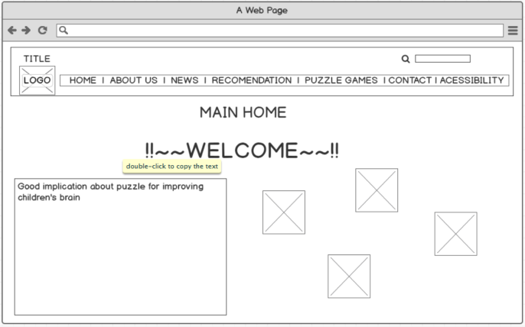

<ABOUT US>

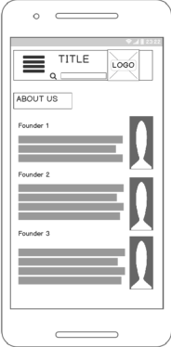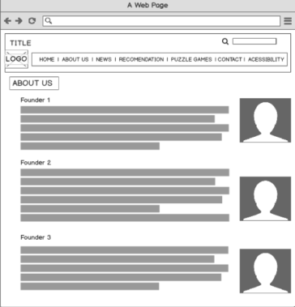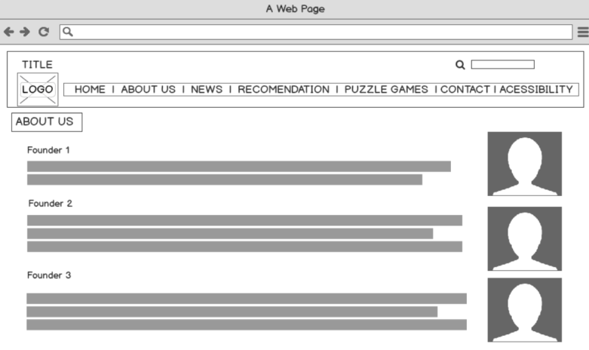

<NEWS>

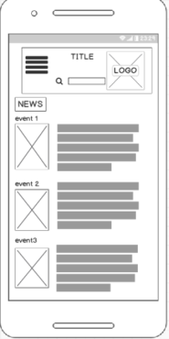 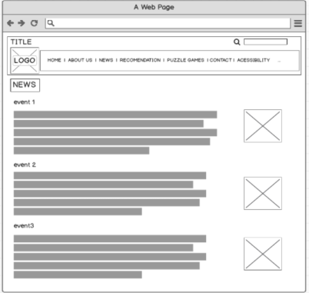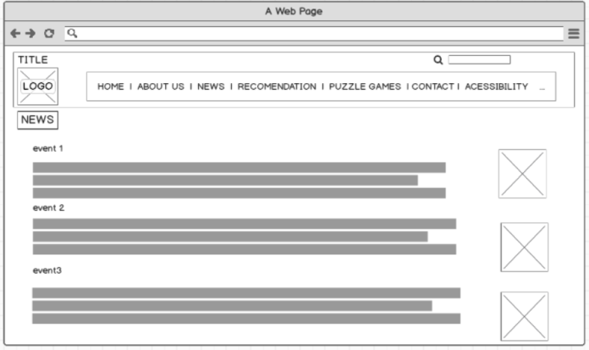

<RECOMMENDATION>

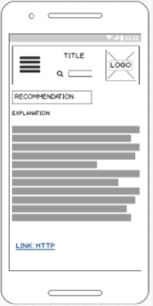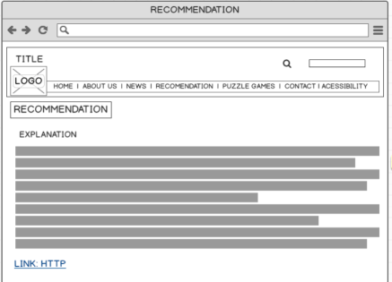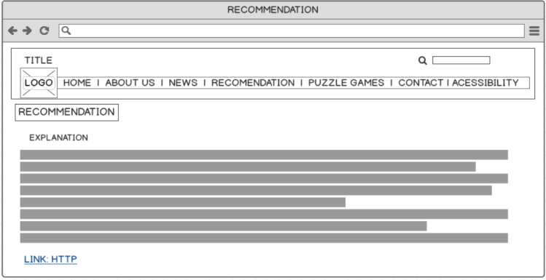

<PUZZLE GAME>

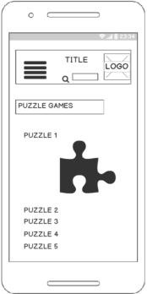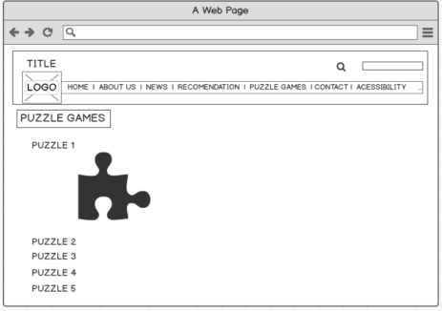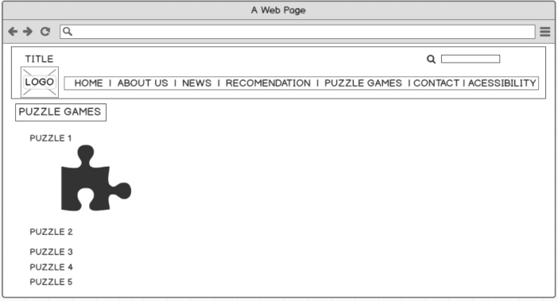

<CONTACT>

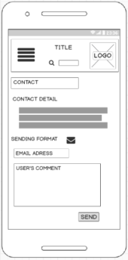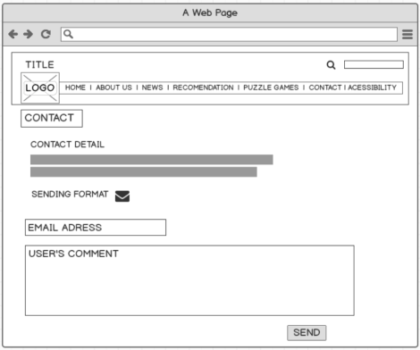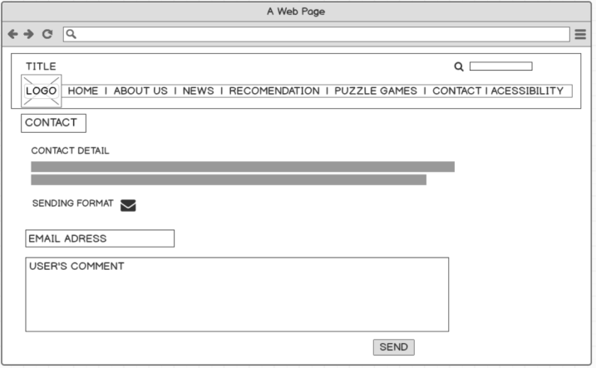

<ACCESIBILITY>

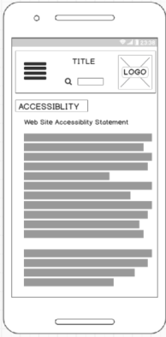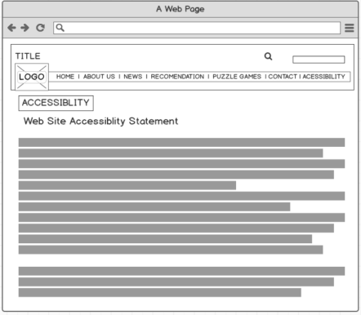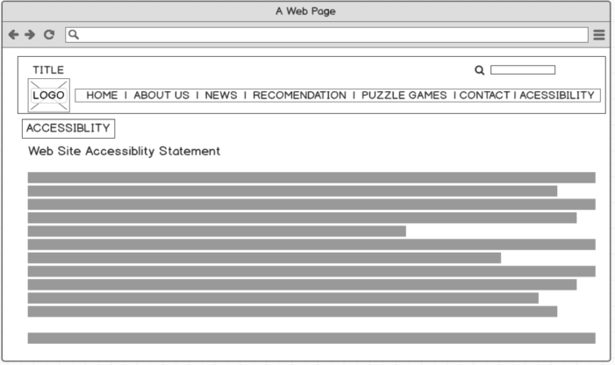

MENU SYSTEM:

As mentioned above, the webpage will be kept simple with flexibility. Therefore, there will be no any menu system approach in the desktop and narrow version of web browsers. In these versions, there will be enough space to list all the menu elements in a line. Also, it shows maximum compatibility because of independencies from using JavaScript. However, the toggle menu method will be used just in mobile version, since it will be hard to display all the menu elements in narrow window. Users can keep their place with using toggle menu. With the toggle menu, users can be easily search the category they want. In addition, the page will not be jumped over with toggle menu, so the users feel less confusion. Hence, toggle menu will be used just for the mobile versions.

Puzzle game design:

The puzzle game of spotting the differences will be chosen. I will provide three pairs of images for this game containing five different spots. The checking circle could be drawn once and after finishing the game, the congratulation words will be emerged. There will be next button, so if the users do not want to play the current game more, they can move onto the next game. To spot the differences, the bottom images will be used. Although the users can play the puzzle game on the every version of window including mobile, narrow and desktop version to be responsive website by following https://developers.google.com/webmasters/mobilesites/, there will be no change in the size of images. My puzzle game will be focused on desktop version, because puzzle game requires big screen as it needs to be looked at carefully. Moreover, there are less likely to young children are allowed by their parents to use Smartphone to do puzzle game. Therefore Main focus on the puzzle game is on supporting desktop version, but it can be still played on mobile version. There will be no special consideration in accessibility; it is really hard to be played without showing the actual images. Instead, the color of circle will be distinct from the color of background colors so the users can play recognize the different spots better.