Changes:

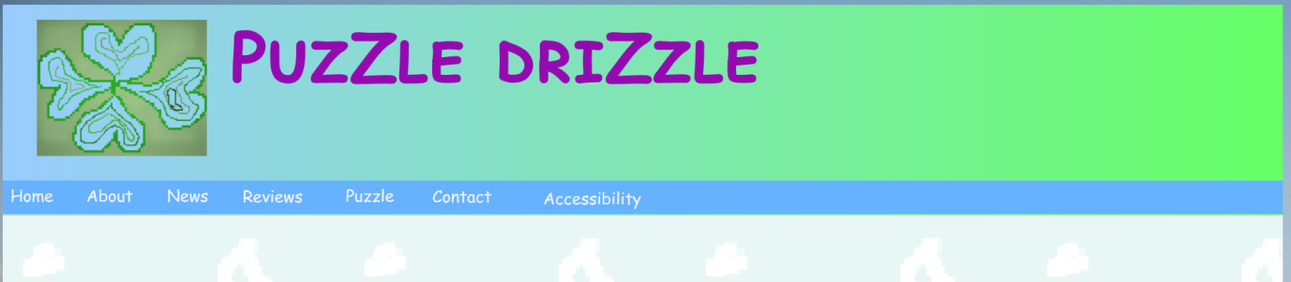

The first change is about searching box. It is removed in making the webpage, because the webpage is not that much complex. The second change is that title is not on the logo image in desktop and narrow version. It is for reducing the height of status bar so as to show main contents more.

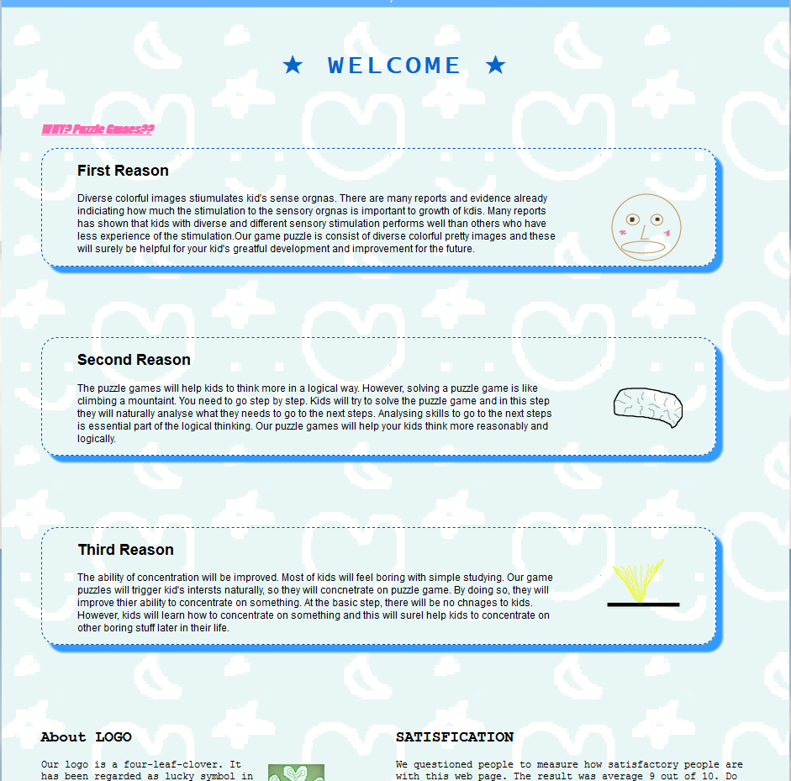 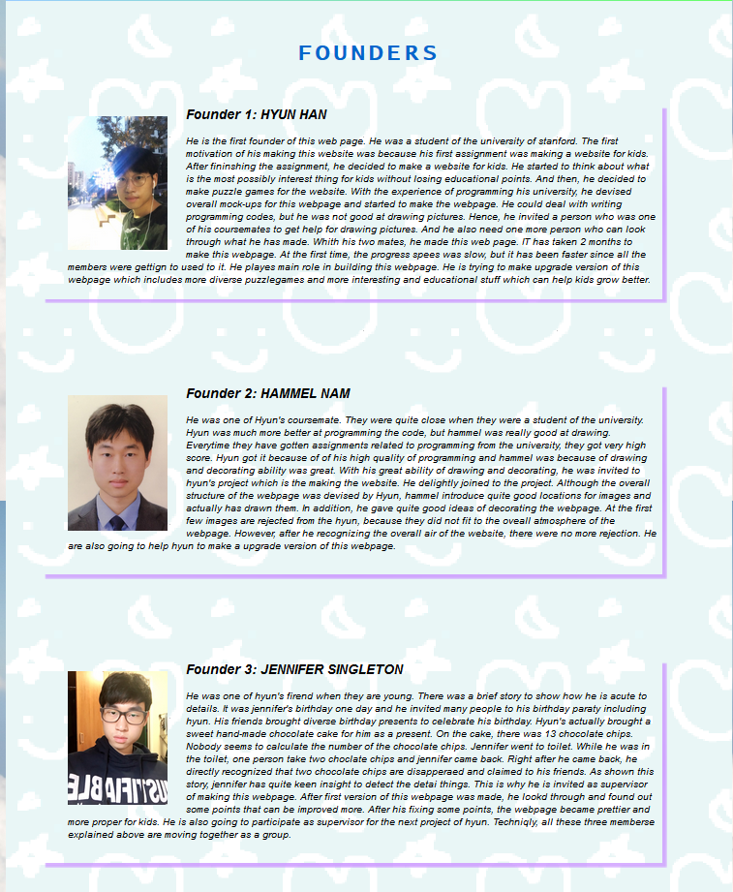

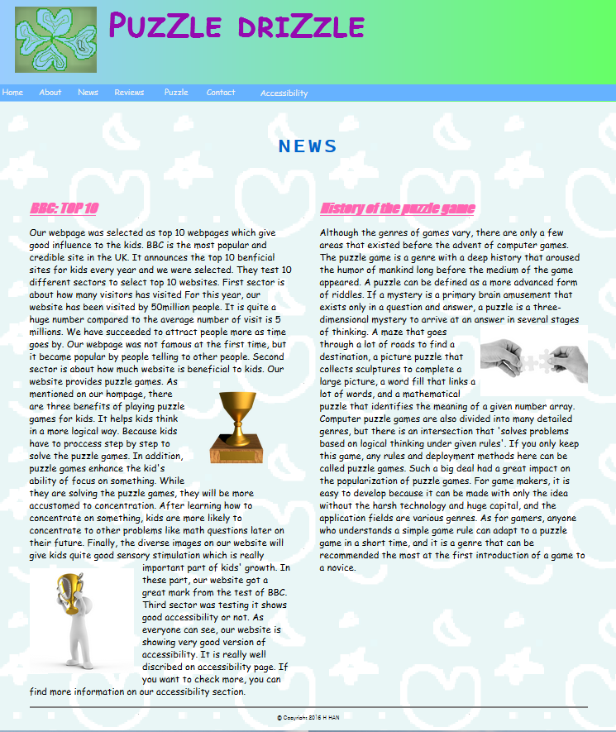 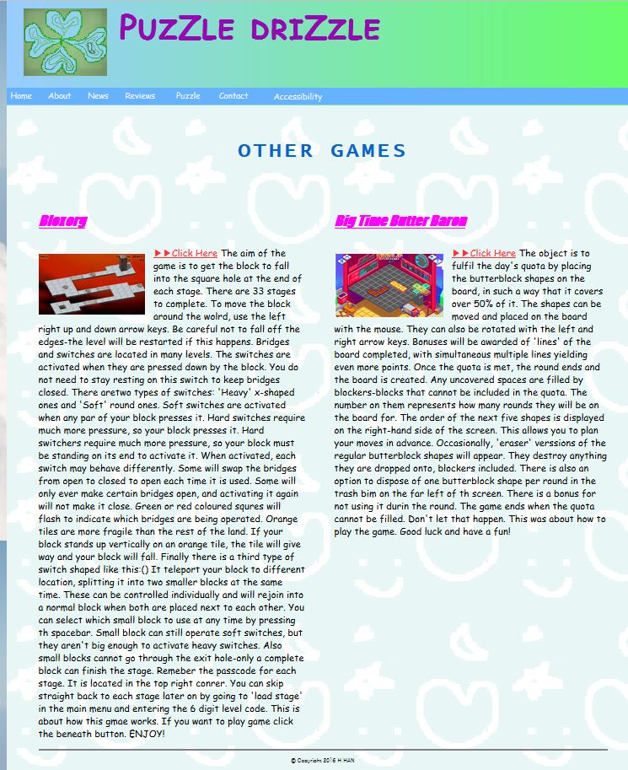

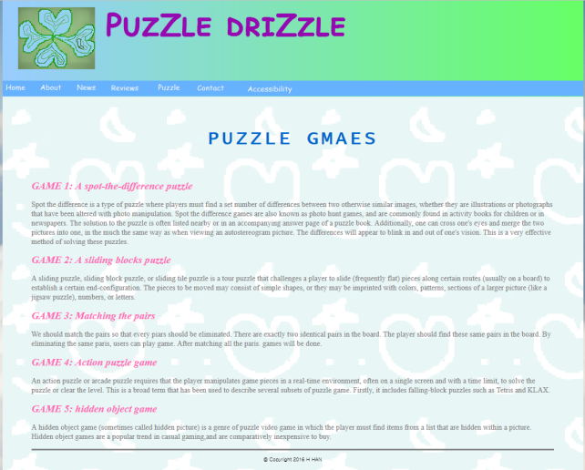 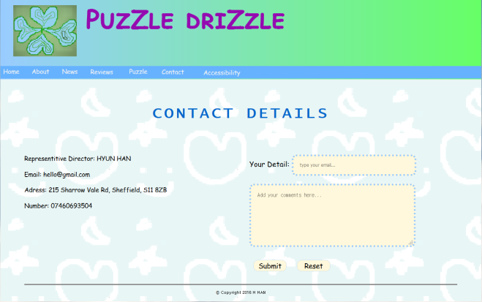

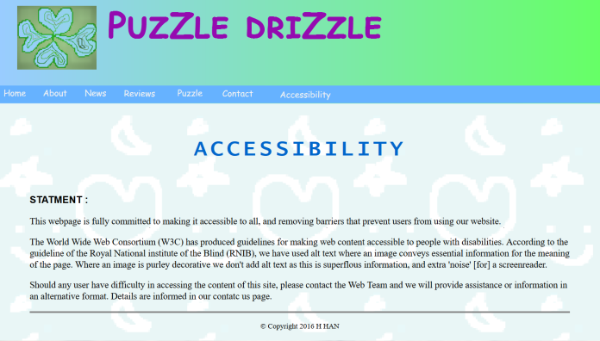

The third change, as shown above, has been made on the general structures on each page. While having made the webpage, some modification was required to display the contents properly I intended. The fourth change is on naming the elements of the menu. Recommendation is changed to the word review, because it has less character, so is easy to display on narrow version. In the same sense, puzzle games and about us has changed to just games. Finally, the fewer images are used than initial plan. Too much images is possibly interrupting the contents of the webpage. Therefore, important pictures are only used.

Organization:

My first initial template was based on the main homepages. In this page, all the essential structures are involved such as navigation, title, background images, etc. The pages has had very similar structure format with the main homepage. The only difference was on the way to display the contents. Some pages were effective to display horizontally like articles, and others were used separated into two parts like news paper. My basic structure of the webpage consisted of head and body. In body section, it is divided into four sections: header, navigation, main and footer. The two background images were used. One was for main part and the other one was for the whole body section. Moreover, I used firefox to check my webpage progress and web browser console as the debug tool. It has not shown the actual errors but it has indicated where the errors are occurred at least. Therefore I could figure the errors out after having looked through it carefully.

Optimisation:

First all the elements were moved into CSS file. I tried to keep markup lightweight and semantic to decrease the download sizes. Javascript was also attached to a separate file. I also compressed all the images in order to increase the speed of loading the images. The images I made through the program called Piskel and some pictures I downloaded free licenses pictures are usually have very big scale of size which trigger longer time to load images. In addition, I have used href=”#” instead of using href=”javascript:void(0)”. It makes anchor completely inaccessible when javascript is disabled. The changed version is leaner and faster a lot than javascript. I also erased “id’ on form method. The reason of name attribute is used together with id is just for ancient browsers.

Security:

As we are using official Sheffield university server, there will be less security issues in general. The biggest problem in security of submitting data is that it is hard to trust the users input. Some insane users can put some virus codes on the comments and send it. Moreover, internet traffic can be made. Therefore whenever sending password data over the internet we would better make sure it’s over HTTPS. In conclusion, using HTTPS or validation of the input from users is required.

Testing:

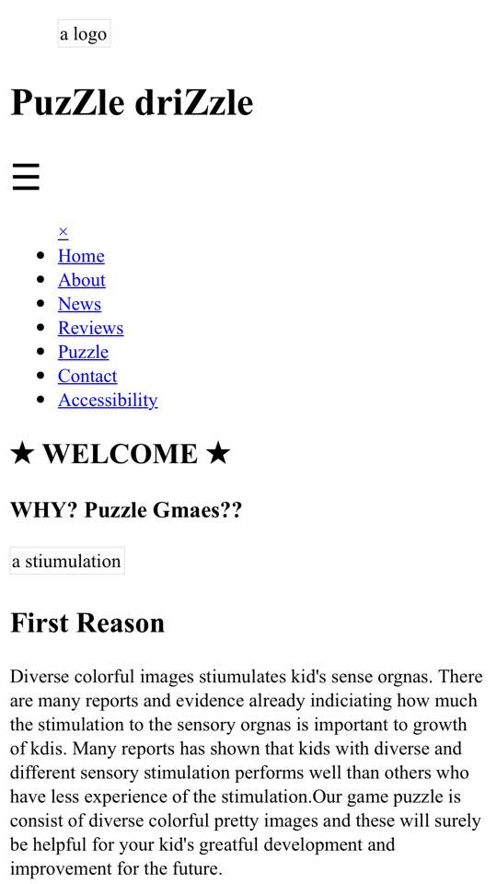

This is the screenshot when I load the webpage on the Smartphone. CSS file was not attached and other images were not, but we can know that it is working properly on mobile version. And all the browsers on this testing section are firefox mozila. Furthermore, my webpage is working properly in all major versions of web browsers.