Android

**구현 화면**

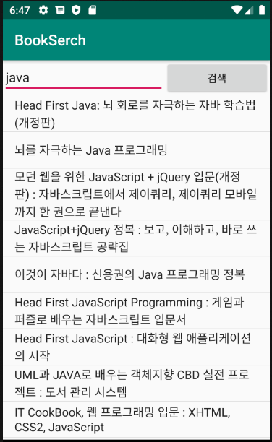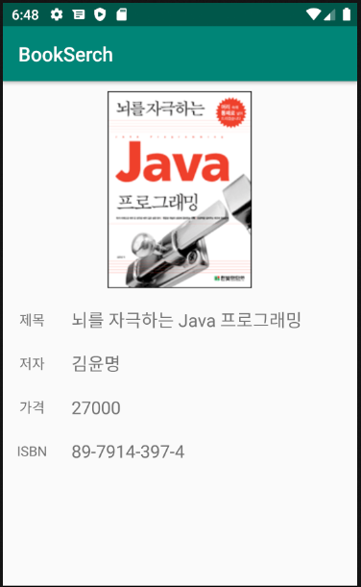

**Source Code**

**MainActivity**

package com.example.bookserch;  
  
import androidx.annotation.NonNull;  
import androidx.appcompat.app.AppCompatActivity;  
  
import android.content.Intent;  
import android.os.Bundle;  
import android.os.Handler;  
import android.os.Message;  
import android.util.Log;  
import android.view.View;  
import android.widget.AdapterView;  
import android.widget.ArrayAdapter;  
import android.widget.Button;  
import android.widget.EditText;  
import android.widget.ListView;  
  
public class MainActivity extends AppCompatActivity {  
  
 String TAG = "BookSearchActivity";  
 EditText etSearchBook;  
 Button btnSearch;  
 ListView lvBookList;  
 Handler handler;  
 BookInfoVO[] bookList;  
 String[] title;  
  
 @Override  
 protected void onCreate(Bundle savedInstanceState) {  
 super.onCreate(savedInstanceState);  
 setContentView(R.layout.*activity_main*);  
  
 etSearchBook = findViewById(R.id.*etSearchBook*);  
 btnSearch = findViewById(R.id.*btnSearch*);  
 btnSearch.setOnClickListener(mClick);  
 lvBookList=findViewById(R.id.*lvBookList*);  
  
 handler = new Handler(){  
 //handleMessage를 overriding하면서 instance를 생성.  
 @Override  
 public void handleMessage(@NonNull Message msg) {  
 super.handleMessage(msg);  
  
 Bundle bundle = msg.getData();  
 bookList = (BookInfoVO[]) bundle.getSerializable("BookList");  
 title = new String[bookList.length];  
 int i =0;  
 //ArrayList안에 VO들을 반복해서 제목만 뽑아서 String[]안에 저장  
 for(BookInfoVO vo : bookList){  
 title[i++]=vo.getBtitle();  
 }  
 Log.*v*(TAG,"title=="+bookList);  
 ArrayAdapter arrayAdapter = new ArrayAdapter(getApplicationContext(),android.R.layout.*simple_list_item_1*,title);  
 lvBookList.setAdapter(arrayAdapter);  
 }  
 };  
  
 lvBookList.setOnItemClickListener(new AdapterView.OnItemClickListener() {  
 @Override  
 public void onItemClick(AdapterView<?> parent, View view, int position, long id) {  
 String item = (String)parent.getItemAtPosition(position);  
 Intent intent = new Intent(MainActivity.this, BookInfor.class);  
 Log.*v*(TAG,"onItemClick item=="+item);  
 Log.*v*(TAG,"onItemClick item position=="+position);  
 Log.*v*(TAG,"onItemClick getBisbn=="+bookList[position].getBisbn());  
 Log.*v*(TAG,"onItemClick getBprice=="+bookList[position].getBprice());  
 Log.*v*(TAG,"onItemClick getBimgurl=="+bookList[position].getBimgurl());  
 Log.*v*(TAG,"onItemClick getBauthor=="+bookList[position].getBauthor());  
 intent.putExtra("isbn",bookList[position].getBisbn());  
 intent.putExtra("price",bookList[position].getBprice());  
 intent.putExtra("img",bookList[position].getBimgurl());  
 intent.putExtra("author",bookList[position].getBauthor());  
 intent.putExtra("item",item);  
 startActivity(intent);  
 }  
 });  
 }  
  
 ListView.OnClickListener mClick = new View.OnClickListener(){  
 @Override  
 public void onClick(View v) {  
 switch (v.getId()){  
 case R.id.*btnSearch*:  
 Log.*v*(TAG,"onClick_etSearchBook =="+etSearchBook.getText().toString());  
 Thread thread = new Thread(new BookSearchRunnable(handler,etSearchBook.getText().toString()));  
 thread.start();  
 break;  
 }  
 }  
 };  
}

**VO.class**

package com.example.bookserch;  
  
public class BookInfoVO {  
 private String bisbn;  
 private String btitle;  
 private String bdata;  
 private int bpage;  
 private int bprice;  
 private String bauthor;  
 private String btranslator;  
 private String bsupplement;  
 private String bpublisher;  
 private String bimgurl;  
 private String bimgbase64;  
  
 public BookInfoVO() {  
 }  
  
 public String getBisbn() {  
 return bisbn;  
 }  
  
 public void setBisbn(String bisbn) {  
 this.bisbn = bisbn;  
 }  
  
 public String getBtitle() {  
 return btitle;  
 }  
  
 public void setBtitle(String btitle) {  
 this.btitle = btitle;  
 }  
  
 public String getBdata() {  
 return bdata;  
 }  
  
 public void setBdata(String bdata) {  
 this.bdata = bdata;  
 }  
  
 public int getBpage() {  
 return bpage;  
 }  
  
 public void setBpage(int bpage) {  
 this.bpage = bpage;  
 }  
  
 public int getBprice() {  
 return bprice;  
 }  
  
 public void setBprice(int bprice) {  
 this.bprice = bprice;  
 }  
  
 public String getBauthor() {  
 return bauthor;  
 }  
  
 public void setBauthor(String bauthor) {  
 this.bauthor = bauthor;  
 }  
  
 public String getBtranslator() {  
 return btranslator;  
 }  
  
 public void setBtranslator(String btranslator) {  
 this.btranslator = btranslator;  
 }  
  
 public String getBsupplement() {  
 return bsupplement;  
 }  
  
 public void setBsupplement(String bsupplement) {  
 this.bsupplement = bsupplement;  
 }  
  
 public String getBpublisher() {  
 return bpublisher;  
 }  
  
 public void setBpublisher(String bpublisher) {  
 this.bpublisher = bpublisher;  
 }  
  
 public String getBimgurl() {  
 return bimgurl;  
 }  
  
 public void setBimgurl(String bimgurl) {  
 this.bimgurl = bimgurl;  
 }  
  
 public String getBimgbase64() {  
 return bimgbase64;  
 }  
  
 public void setBimgbase64(String bimgbase64) {  
 this.bimgbase64 = bimgbase64;  
 }  
}

**Runnable.class**

package com.example.bookserch;  
  
import android.os.Bundle;  
import android.os.Handler;  
import android.os.Message;  
import android.util.Log;  
  
import com.fasterxml.jackson.databind.ObjectMapper;  
  
import java.io.BufferedReader;  
import java.io.InputStreamReader;  
import java.net.HttpURLConnection;  
import java.net.URL;  
  
public class BookSearchRunnable implements Runnable{  
 private Handler handler;  
 private String keyword;  
  
 public BookSearchRunnable(Handler handler, String keyword) {  
 this.handler = handler;  
 this.keyword = keyword;  
 }  
 @Override  
 public void run() {  
 //Thread가 시작되면 수행하는 작업  
 String url = "http://70.12.60.100:8080/bookSearch/BookInfo?keyword="+keyword;  
  
 try {  
 URL objUrl = new URL(url);  
 HttpURLConnection conn = (HttpURLConnection)objUrl.openConnection();  
 conn.setRequestMethod("GET");  
  
 int responseCode=conn.getResponseCode();  
 Log.*v*("BookSearchRunnable","responseCode=="+responseCode);  
  
 //연결 성공후 데이터를 받아오기 위한 통로 생성.  
 BufferedReader bufferedReader = new BufferedReader(new InputStreamReader(conn.getInputStream()));  
 //서버가 보내주는 데이터를 문자열로 만든다.  
 String readLine = "";  
 StringBuffer responseText = new StringBuffer();  
 while ((readLine=bufferedReader.readLine())!=null){  
 responseText.append(readLine);  
 }  
 bufferedReader.close();  
 Log.*v*("BookSearchRunnable","responseText=="+responseText.toString());  
 //JACKSON library  
 ObjectMapper mapper = new ObjectMapper();  
 BookInfoVO[] resultArr = mapper.readValue(responseText.toString(),BookInfoVO[].class);  
  
 Bundle bundle = new Bundle();  
 bundle.putSerializable("BookList",resultArr);  
 Message msg = new Message();  
 msg.setData(bundle);  
 handler.sendMessage(msg);  
  
 }catch (Exception e){  
 Log.*v*("BookSearchRunnable","BookSearchException=="+e.toString());  
 }  
 }  
}

**BookInfo Activity class**

package com.example.bookserch;  
  
import android.content.Intent;  
import android.graphics.Bitmap;  
import android.graphics.BitmapFactory;  
import android.net.Uri;  
import android.os.Bundle;  
import android.os.Environment;  
import android.os.Handler;  
import android.util.Log;  
import android.widget.ImageView;  
import android.widget.TextView;  
  
import androidx.appcompat.app.AppCompatActivity;  
  
import java.io.InputStream;  
import java.net.URL;  
  
public class BookInfor extends AppCompatActivity {  
  
 String TAG = "BookInfor";  
 TextView tvTitle;  
 TextView tvISBN;  
 TextView tvPrice;  
 TextView tvAuthor;  
 ImageView ivBookImage;  
 Handler handler = new Handler();  
 String getUrl;  
  
 @Override  
 protected void onCreate(Bundle savedInstanceState) {  
 super.onCreate(savedInstanceState);  
 setContentView(R.layout.*activity_book_infor*);  
  
 tvTitle=findViewById(R.id.*tvTitle*);  
 tvISBN=findViewById(R.id.*tvISBN*);  
 tvPrice=findViewById(R.id.*tvPrice*);  
 tvAuthor=findViewById(R.id.*tvAuthor*);  
 ivBookImage=findViewById(R.id.*ivBookImage*);  
 Intent intent = getIntent();  
  
 Log.*v*(TAG,"getIntExtra price===="+intent.getIntExtra("price",0));  
 Log.*v*(TAG, "getIntExtra img ==="+intent.getStringExtra("img"));  
 getUrl = intent.getStringExtra("img");  
 tvTitle.setText(intent.getStringExtra("item"));  
 tvISBN.setText(intent.getStringExtra("isbn"));  
 tvPrice.setText(""+intent.getIntExtra("price",0));  
 tvAuthor.setText(intent.getStringExtra("author"));  
  
 Thread t = new Thread(new Runnable() {  
 @Override  
 public void run() {  
 try{  
 URL url = new URL(getUrl);  
// URL url = new URL(mm);  
 InputStream is = url.openStream();  
 final Bitmap bm = BitmapFactory.*decodeStream*(is);  
 handler.post(new Runnable() {  
  
 @Override  
 public void run() { // 화면에 그려줄 작업  
 ivBookImage.setImageBitmap(bm);  
 }  
 });  
 ivBookImage.setImageBitmap(bm); //비트맵 객체로 보여주기  
 } catch(Exception e){  
 }  
 }  
 });  
 t.start();  
 }  
}