SYSTEM SOFTWARE SETUP ON PC(UBUNTU 22.04/20.04)

1. Download Required Files Download rc.local and ORIN_NX_IMAGE.tar.bz2 from the following google drive link:
https://drive.google.com/drive/folders/1TDUXYL6gGu0oZq7z41naLT2DZZxhkUus?usp=sharing
2. Create a directory named New in your home directory using the following command.
mkdir ~/New

3. Move the downloaded ORIN_NX_IMAGE.tar.bz2 file from the Downloads directory to the New directory using these commands:
mv ~/Downloads/ORIN_NX_IMAGE.tar.bz2 ~/New/

4. Navigate to New Directory.
cd ~/New/

5. Extract the Linux_for_Tegra_2.tar.bz2 file using the following command.
sudo tar -xvJf Linux_for_Tegra_2.tar.bz2

6. It may take several minutes to complete the extraction. Once the process is finished, a directory named Linux_for_Tegra will be created in the New directory.

7. Enter into Linux_for_Tegra directory using below command.
cd Linux_for_Tegra/

8. Execute the following command to apply binaries.

sudo ./apply_binaries.sh

9. Install required dependency packages using following command.

sudo apt update

sudo apt install -y qemu-user-static sshpass binutils abootimg libxml2-utils nfs-kernel-server u-boot-tools android-tools-fastboot python3-pip lz4

pip3 install -U pip

10. After installing the packages, reboot the system.
sudo reboot

11. Connect the Jetson Orin Nano Super Developer Kit
- Place the Jetson Orin Nano Developer Kit in recovery mode by connecting a jumper between the FC REC and GND pins (refer to the following image ).
- Power on the developer kit using the provided power adapter.
- Connect a USB Type-C cable between the host PC and the developer kit.

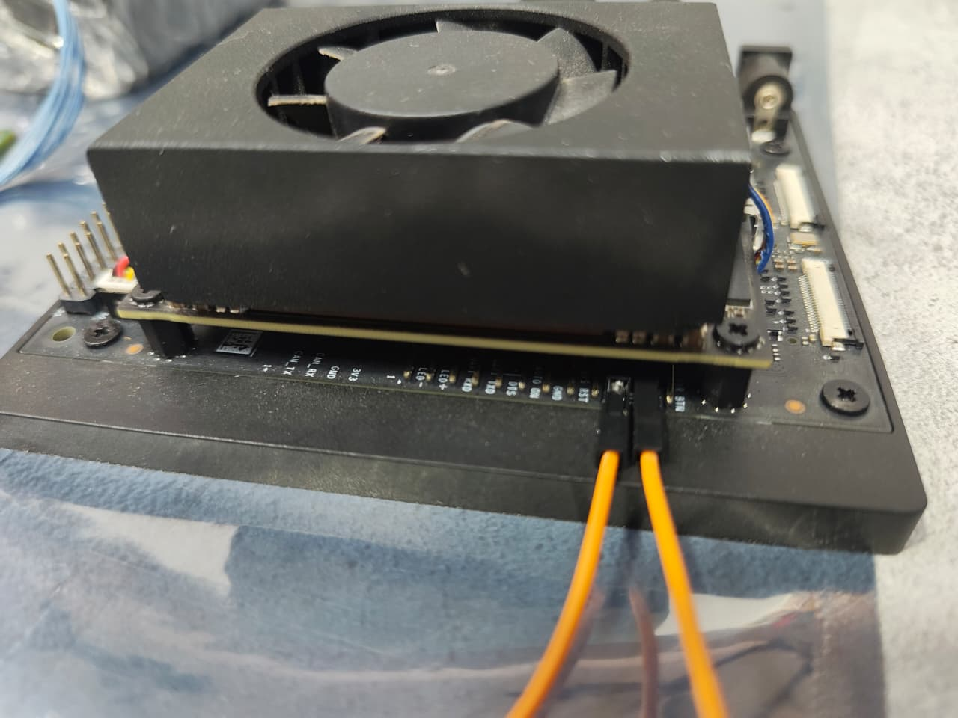

12. Check if the Jetson is detected in recovery mode using the following command.

lsusb
Look for an entry like NVIDIA Corp. APX. If not visible, try a different USB cable or port.

13. Run the following command to flash the Jetson Orin Nano Developer Kit

sudo ./nvsdkmanager_flash.sh --storage nvme0n1p1

14. Complete Flashing and Power On
- After successful flashing, remove the jumper from the recovery mode pins.
- Power on the Jetson Orin Nano Developer Kit with the Orin NX module and camera connected using the power adapter.
- Follow the connection instructions in the section below.

ADAPTER BOARD CONNECTION WITH ORIN NANO DEVELOPER KIT.

To connect a camera to the Jetson Orin Nano Developer Kit:
- Use a CSI cable to connect the camera from the adapter board to the CAM1 connector on the Jetson Orin Nano Developer Kit.
- Refer to the provided image for proper connection details.

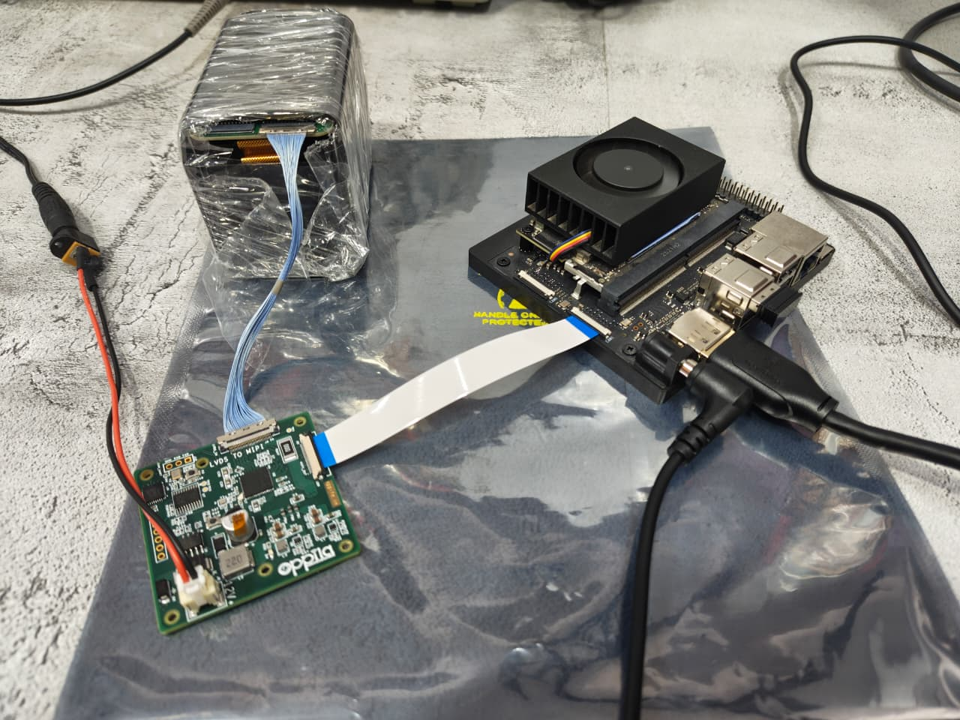

VIDEO CONFIGURATION AND FETCHING OVER GSTREAMER

1. Copy the rc.local file from your PC to the home directory of the Jetson Orin Nano Developer Kit using any pendrive.

2. On the jetson device, open the terminal by pressing Ctrl+Alt+t.

3. To configure the device for the LVDS camera, follow the process below and run the following command.(This is a one-time process, you only need to perform it after each new flash. It is not required after every boot)
sudo /opt/nvidia/jetson-io/jetson-io.py

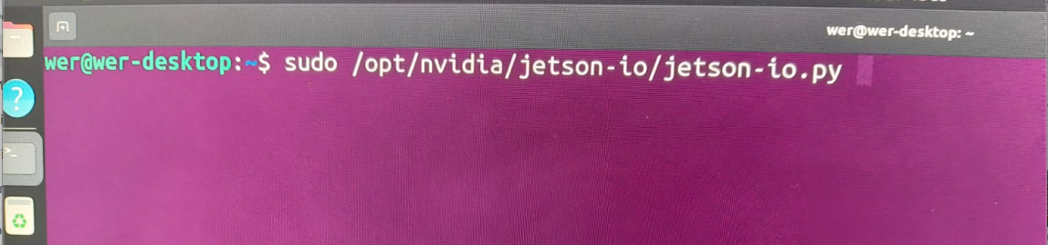

4. after enter into this command, configuration window will open, there you need to select Configure Jetson 24pin CSI Connector → Configure for compatible hardware → Camera IMX219-C → Save pin changes → Save and reboot to reconfigure pins.

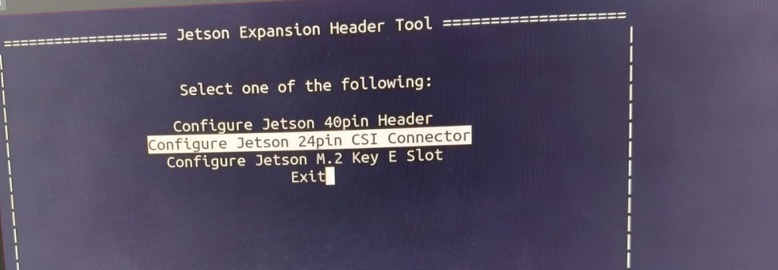

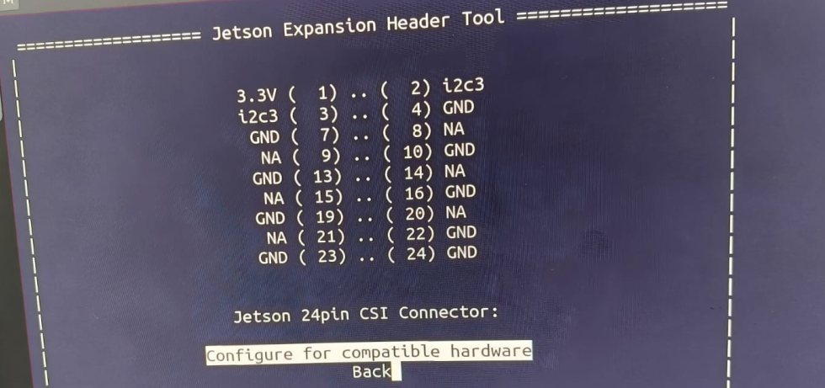

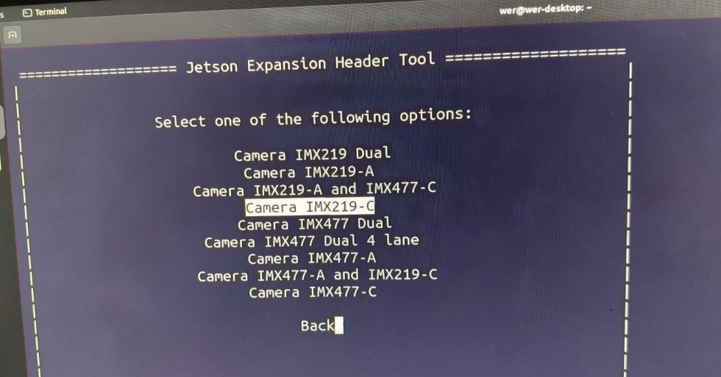

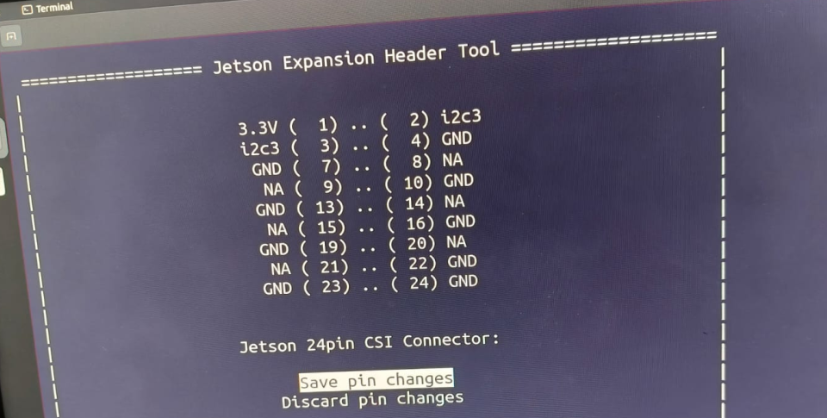

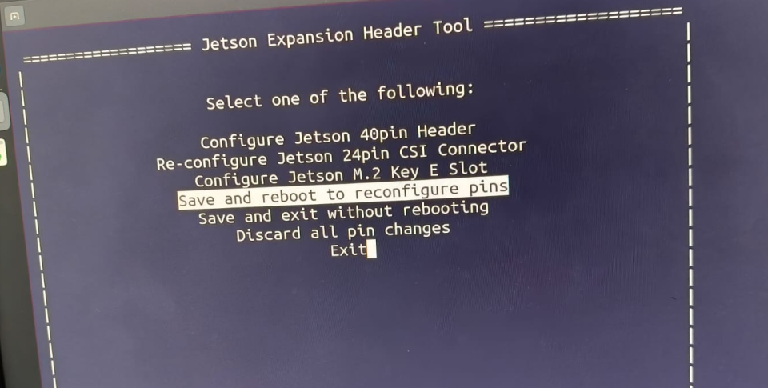

5. Finally press any key to reboot(this will reconfigure mipi pins for lvds camera)

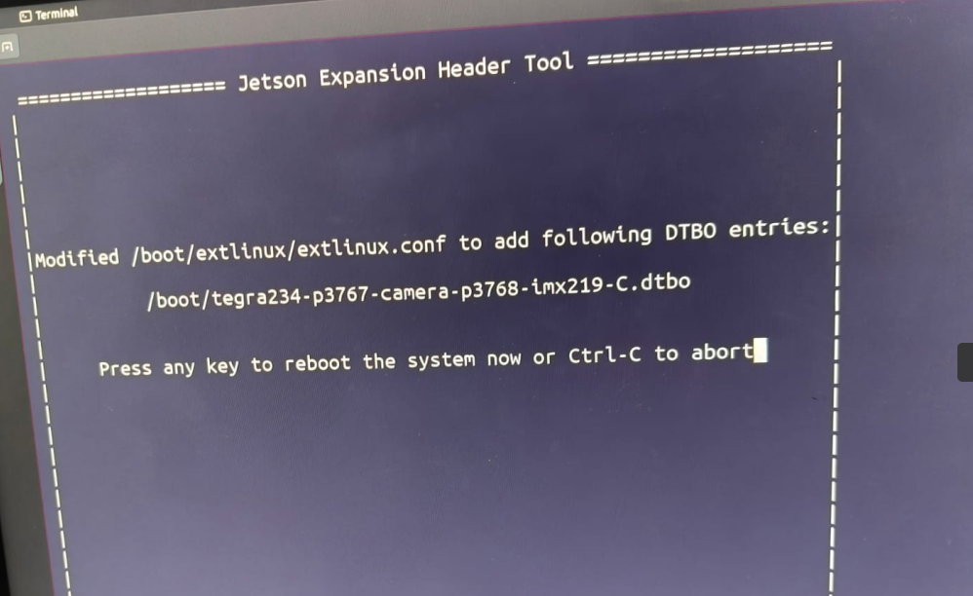

6. After logging again into the system, press Ctrl+Alt+T and run the following command to boost the clocks and enable debugging
sudo ./rc.local

7. Please check with the command in terminal → ls /dev/video
It should display the /dev/video0 node. If it video node is displayed, you can confirm that the driver has successfully loaded and created the video node.

8. Execute the following GStreamer command to stream video from the connected camera.
gst-launch-1.0 v4l2src device=/dev/video0 ! video/x-raw,format=UYVY ! videoconvert ! Xvimagesink

Note:-

1. If you encounter any issues, please check logs using sudo dmesg | grep -i lt9211c

2. If the problem persists, please contact: support@oppila.in

