|  |  |
| --- | --- |
| Student Name: | Park Jae Yeon, Hyun In Sik |
| Student Number: | 2009160067, 2009160192 |
| Homework: | Midterm Project |

**The goal of the project is to develop image transmission software that uses RTP as a transport. Before the transmission an image is compressed.**

**The project employs RTP transmission software we studied before, and color compression that employs imperfections in human visual system. Thus, the software should include the following functionality**

**Reading and writing PBM files**

**Color space conversion RGB to YCbCr and YCbCr to RGB**

**Down and up-sampling**

**Sending and receiving data using RTP**

**For simplicity assume that receiver knows parameters of the image being transmitted. Make sure that the image is transmitted in a compressed form.**

**The main function of the sender can be represented in the flow chart shown below:**

**Read a PBM image --> Convert to YCbCr --> Downsample Cb and Cr --> Send using RTP**

**The main function of the receiver can be represented in the flow chart shown below:**

**Receive using RTP --> Upsample --> Convert to RGB --> Write to a PBM file**

**You have to decide how compressed image is transmitted. Either every channel is transmitted separately i.e. with three different rtp_send_packets calls, or first you combine three color channels Y, Cb and Cr into a contiguous memory block and then send it at once.**

**The submitted source codes should contain substantial amount of comments.**

**SOLUTION**

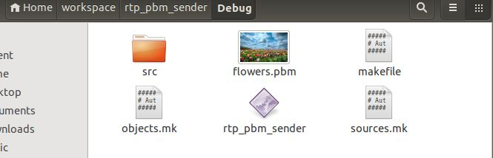

*First, sender have flowers.pbm to give receiver.*

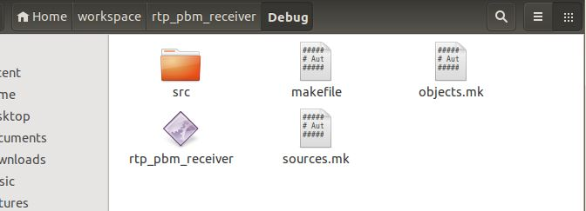

*Receiver haven’t pbm file yet.*

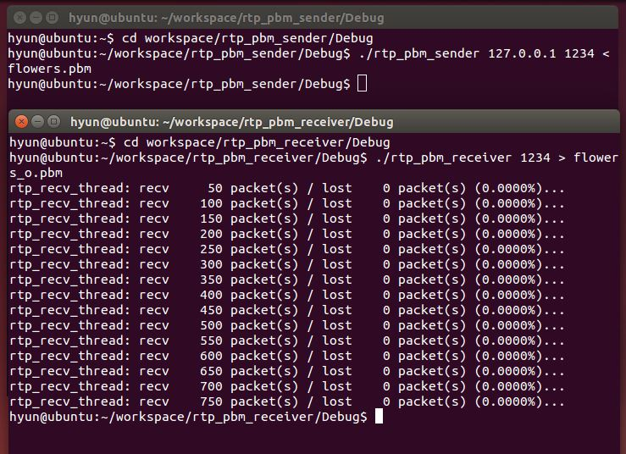

*We run rtp_pbm_sender/receiver programs, it will transfet pbm file using 4:2:0 image compression.*

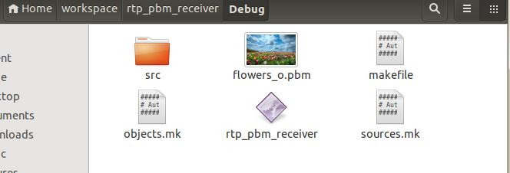

*Now, receiver have flowers_o.pbm file. This image is decompression file. YCbCr -> RGB*

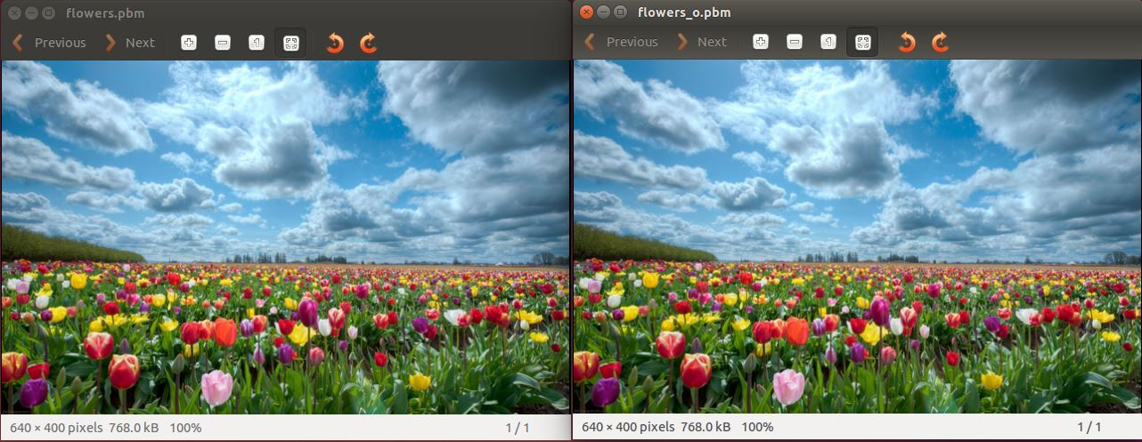

*We can compare original image and transferred image. It look good transfer and decompression very well.*