Nothing In Life Is Free (NILIF)

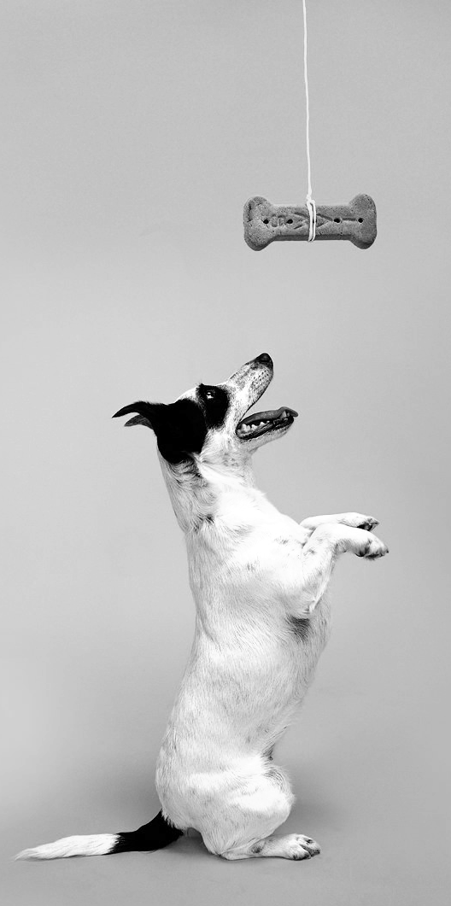
We use the Nothing In Life is Free (NILIF) program to help teach dogs how to be better prepared to live in a human society. NILIF will help improve your dogs’ behavior and teach him to learn to trust and look to people as his leaders. It also improves your dogs’ response to commands. The advantages of using NILIF are that it is a technique that all people, regardless of age, size, or personality-type can do; it is non-confrontational, therefore it never puts the people or dogs involved at risk; and it helps build a dog’s confidence by providing clear rules and enjoyable outcomes for good behavior. Having your dog consistently follow your commands at home, in low stress situations, makes it easier for him to follow commands when he is distracted, anxious or may be aggressive. NILIF uses only positive, reward-based training to teach these valuable lessons.

Why use the NILIF program?
NILIF is an excellent program for ALL dogs. The program is recommended for puppies and adults, even dogs that do not have any behavior problems as it can help to prevent these problems.

Other situations in which NILIF is recommended:

- Fearful dogs - NILIF makes your dog’s life more structured and predictable, and offers him many chances to earn good things; this can help lower his anxiety. It also teaches him to trust you as a leader; this can help build his confidence and provide a sense of security.

- Aggression to family members - NILIF requires that your dog works for everything he wants. This is a safe and non-confrontational way for people in the household to establish control over the valuable resources in the house (e.g. food, toys, and attention from favorite people). Whoever controls the resources is automatically the leader.

- Aggression to unfamiliar people or dogs - NILIF helps establish that you are the leader by requiring your dog to always be prepared to follow your commands to get something he wants. Since you are the leader, your dog does not have to defend himself by being aggressive since you will keep him safe and give him direction in difficult situations.

- Pushy but normal dogs - NILIF teaches dogs good manners. Many dogs learn how to get the things they want, like petting, food, being played with, or getting treats by being affectionate, but pushy. They paw at people, jump on people, push their way into a situation or even bark and whine to get attention. NILIF is like teaching a child to say, “Please” and “Thank You”.

The Rules of NILIF:

1. Your dog must “work” for all the “good things” in life
Work = obey a command the dog knows well. Commands you may want to use include the basics like: sit, down and stay or you may choose to have your dog do some more complicated tricks like: shake hands, rollover, wave, or play dead. An eye contact command is nice since your dog can perform it from any position (see eye contact command handout). Anything you can teach your dog is fair game.

NOTE: If your dog does not already know commands well you must teach him a few commands/tricks before you begin NILIF. Use only positive reinforcement methods to teach commands. Speak to your dog’s doctor about positive reinforcement training/selecting a trainer.

Good things = anything your dog wants or likes. This includes, but is not limited to: being fed, getting treats, being petted, being greeted, having his leash put on, having his leash taken off, having doors opened to come inside or go outside, being invited up on furniture, being played with, being brushed, being spoken too, having his belly rubbed, having a ball thrown to fetch, going in or out of the car, and greeting a guest. Essentially this includes anything but air and water. Air and water are free.

2. Pushy or demanding behavior is ignored.

Pushy or demanding behavior = anything your dog does to get your attention and “make” you do something for him. This includes, but is not limited to: whining, pawing, nudging, mouthing, jumping on, staring at, and barking at you.
Ignored = no attention AT ALL. Scolding, saying “NO”, pushing the dog away, or giving a command are all forms of attention. Instead, you should turn your back on your dog or even walk away. Wait until he is leaving you alone to give him the opportunity to earn something good (ie ask for a command and reward him for obeying).

3. Give the command only once.
Once = if your dog does not do what you want him to do, then you don’t do what he wants you to do. If he doesn’t obey, walk away, turn your back on him or just ignore him; he has lost the opportunity to earn something good. In a minute or so give him another chance to earn something good.

4. Everyone in the household and anyone who interacts with your dog on a regular basis must follow the NILIF rules.
Everyone = spouses, significant others, dog walkers, neighbors who drop by every day, and especially, children. Dogs often view children as either playmates or lower-ranking members of the “pack”. NILIF teaches dogs to view children as leaders, just like the grown-ups in the family. Having everyone follow NILIF provides consistency for the dog.

Also, all dogs in the house should follow this program so that they are treated the same and their hierarchy is not disrupted.

- Be patient, especially in the beginning.
It may take your dog a little while before he realizes that he really truly has to work for the things he wants. After all, up until this point everything in life was free!

An Example of NILIF in Action:
It’s your first day of using NILIF and you’re ready to take Fido for a walk. You pick up his leash and he comes running over to you. You tell him, “Fido, sit.” Fido is so excited that instead of sitting he runs around you wiggling his body, wagging his tail and jumping at the leash in your hand. You don’t repeat the command, scold him, or push him away when he jumps up or continues to be excited. You just calmly put the leash down and walk away. In a minute (or however long it takes Fido to calm down), you walk back to the leash and pick it up again. Again, Fido runs over and is too excited to listen to your command. You repeat the procedure (get the leash, give the command, Fido is too excited so you walk away) 10 times before Fido finally sits. When he sits you clip on the leash praise him and take him for a nice long walk.

The next day when it’s Fido’s walk time it takes 6 tries before he sits to have his leash put on. By the end of the first week of NILIF Fido is sitting automatically when you pick up his leash! When he is automatically sitting make sure to ask for another command since you always want the program to remain on your terms.


