G2 Slab Structure Visualization (No Lattice)

S1: Pd(100) (Pd⁰)
Side View | Perspective View
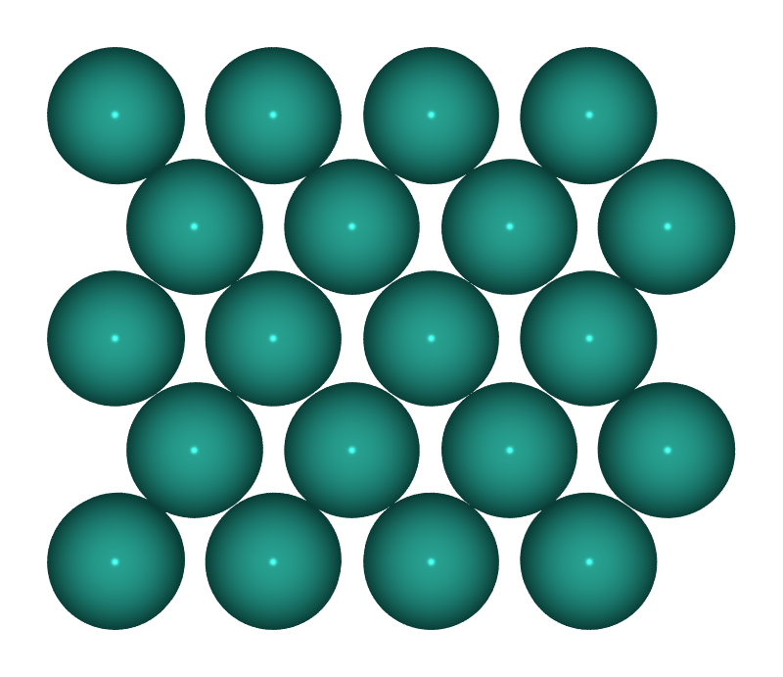 | 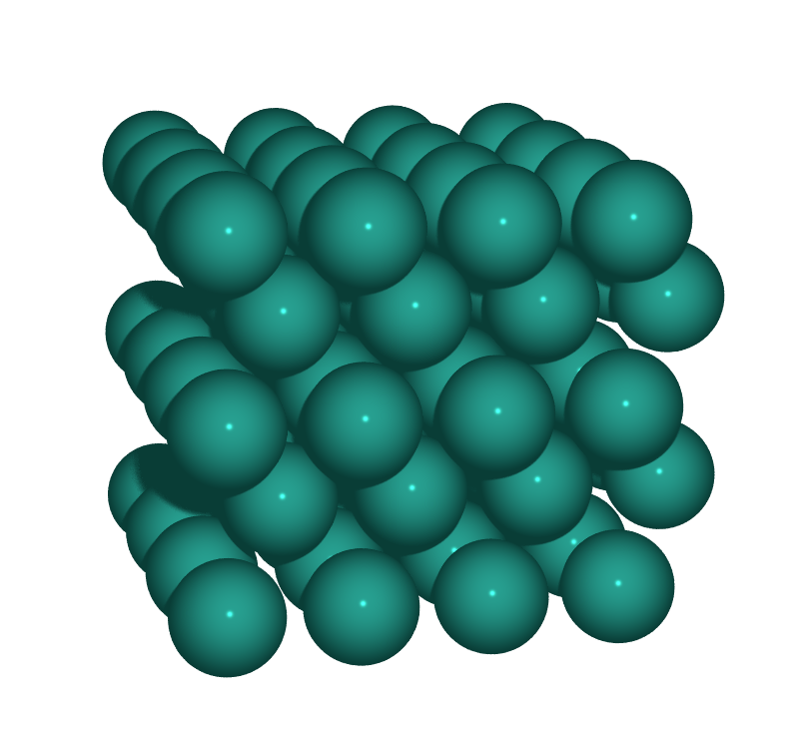

S2: PdO(101)/Pd(100) (Pd⁰/Pd²⁺)
Side View | Perspective View
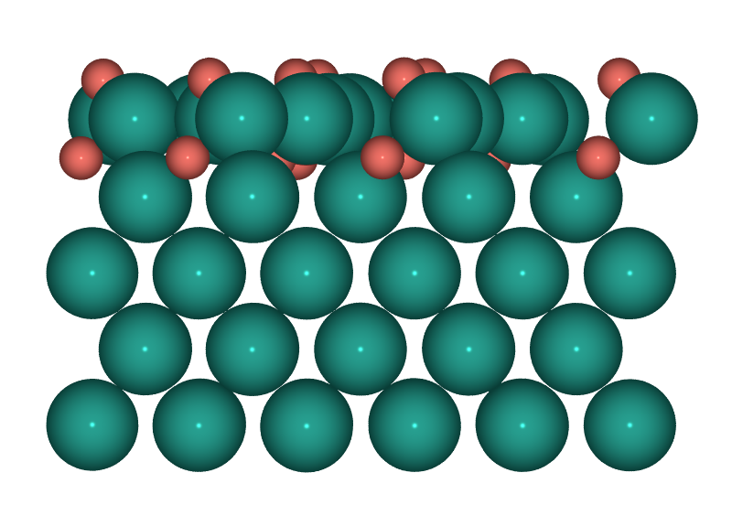 | 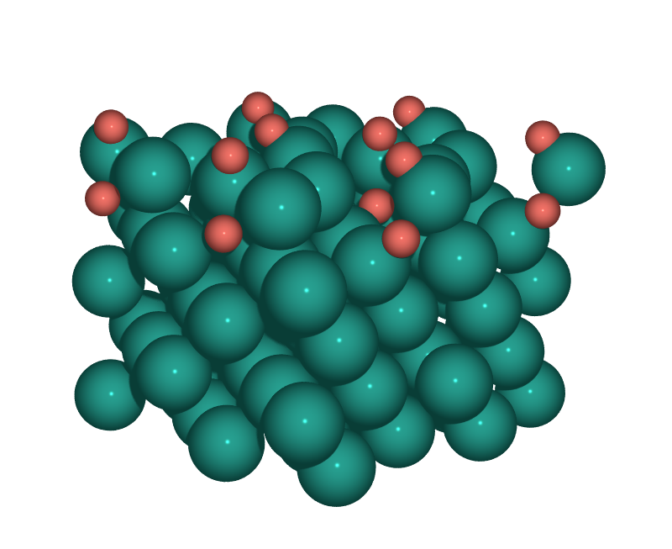

S3: PdO(100) (Pd²⁺)
Side View | Perspective View
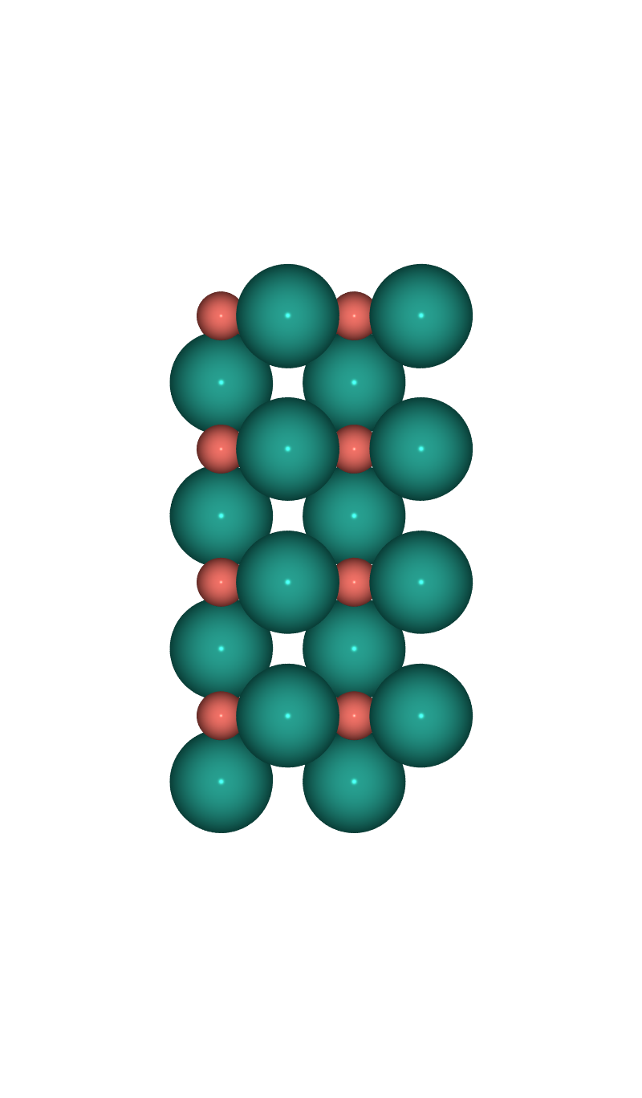 | 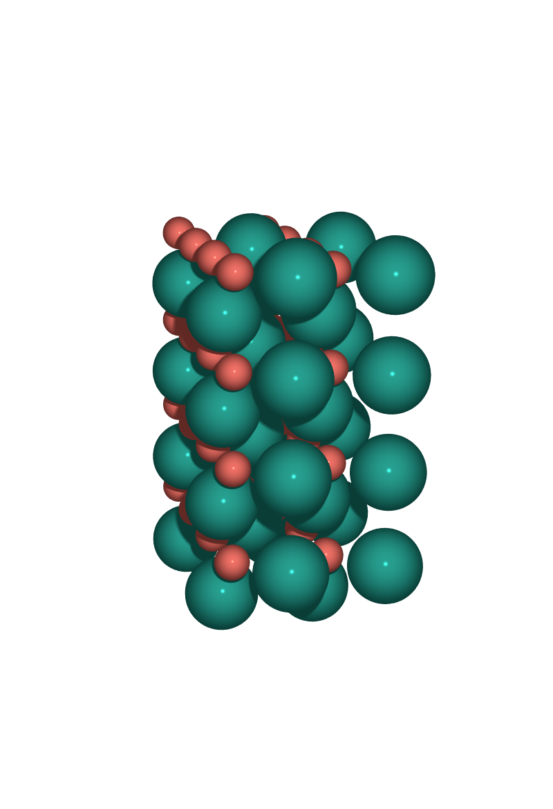

S4: PdO₂(110) (Pd⁴⁺)
Side View | Perspective View
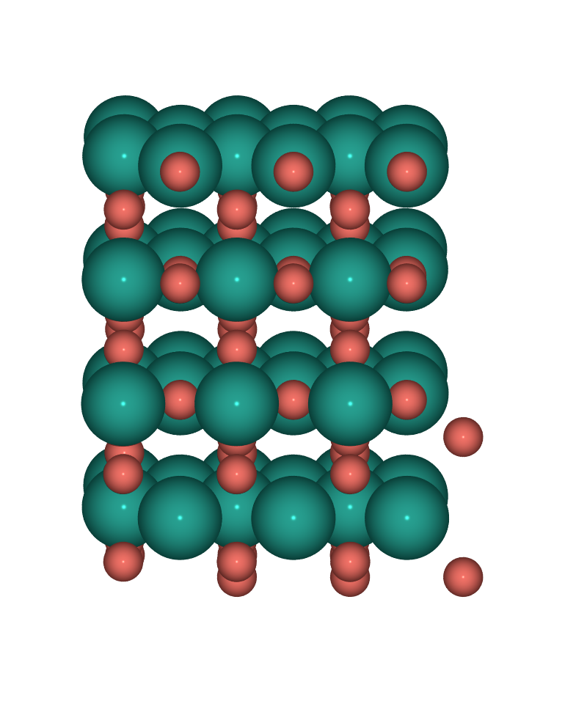 | 