G2 Slab Structures — Side View (ase3)
Side view (-90x) | Pd=1.3, O=0.7 | No lattice | ase3 texture
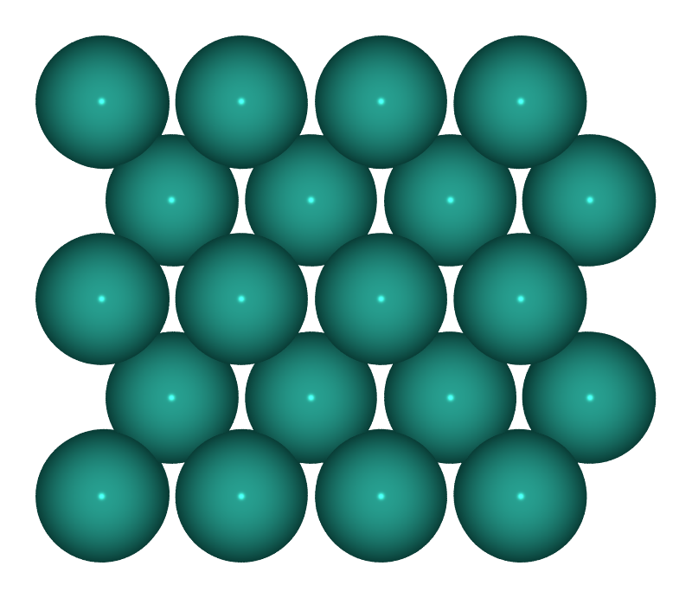  S1: Pd(100)  Pd⁰ — metallic baseline | 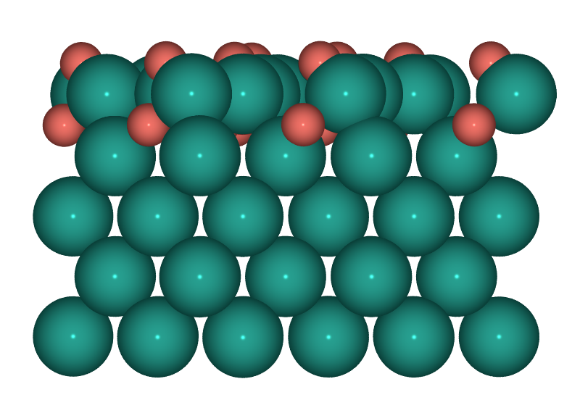  S2: PdO(101)/Pd(100)  Pd⁰/Pd²⁺ — surface oxide
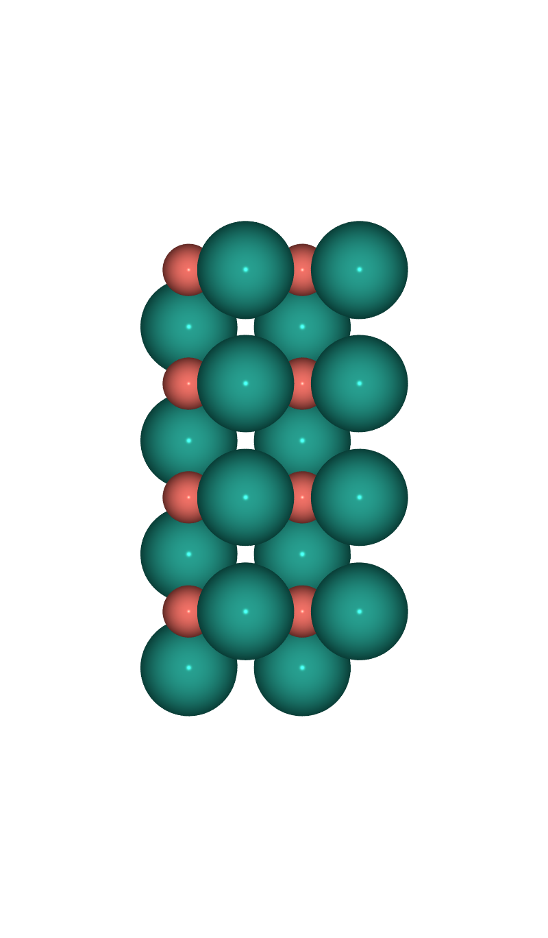  S3: PdO(100)  Pd²⁺ — bulk oxide | 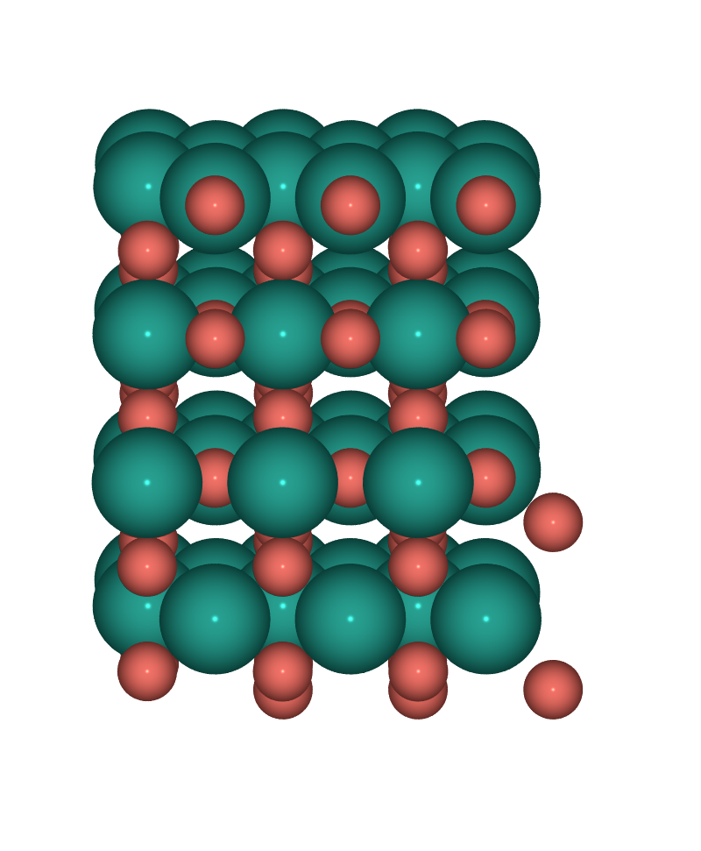  S4: PdO₂(110)  Pd⁴⁺ — high-valence oxide

