G2 Clean Slab Structures
Pd/PdO/PdO₂ DMC Formation | Side View | POV-Ray ase3 texture

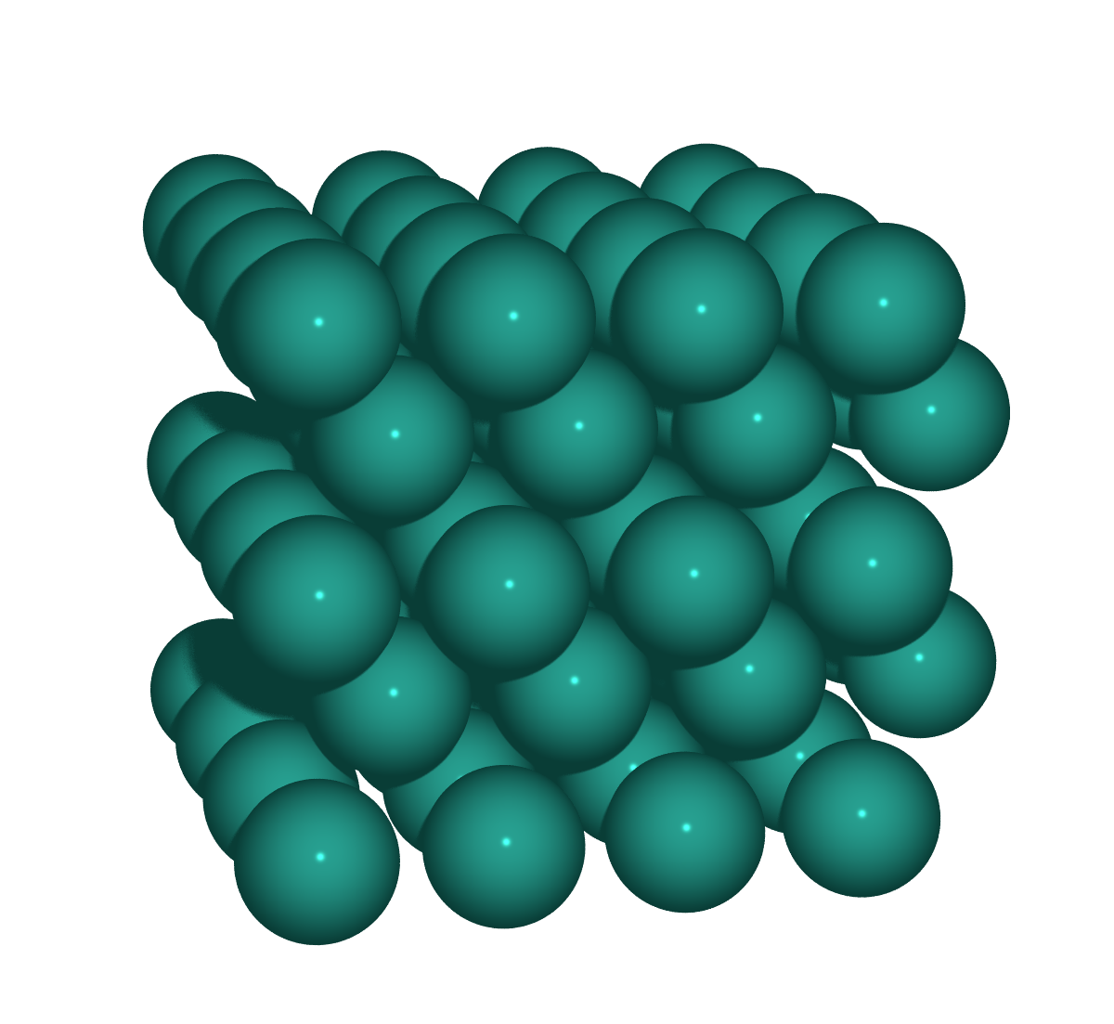  S1: Pd(100)  Metallic Pd, p(4×4), 4 layers  CONVERGED | 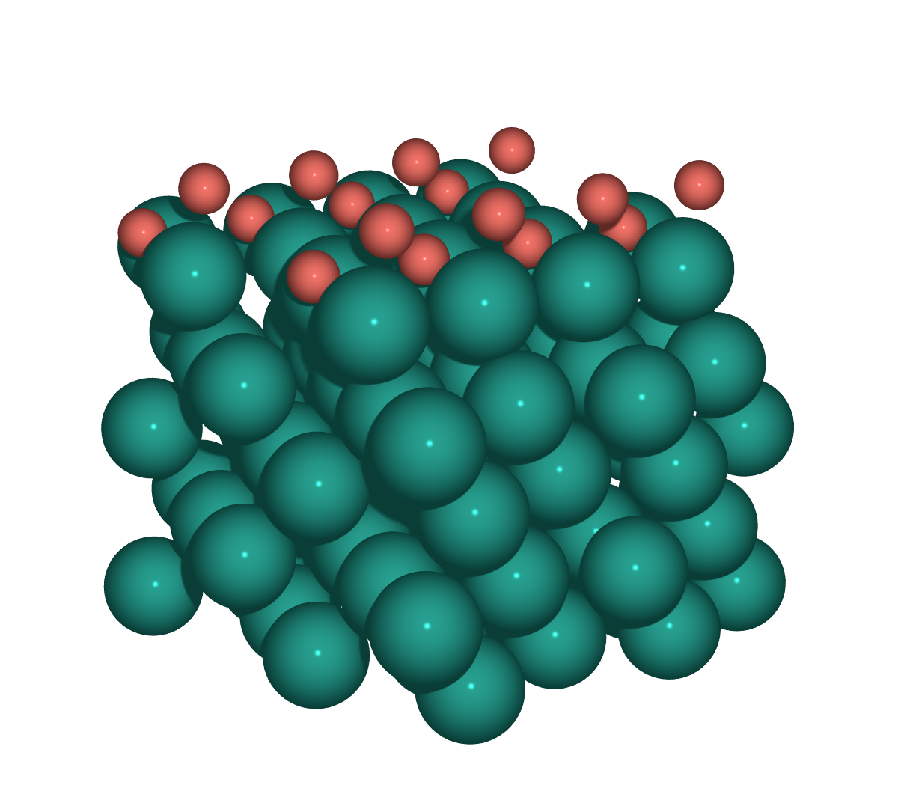  S2: PdO(101)/Pd(100)  (√5×√5)R27° surface oxide on Pd(100), 2×2  RUNNING
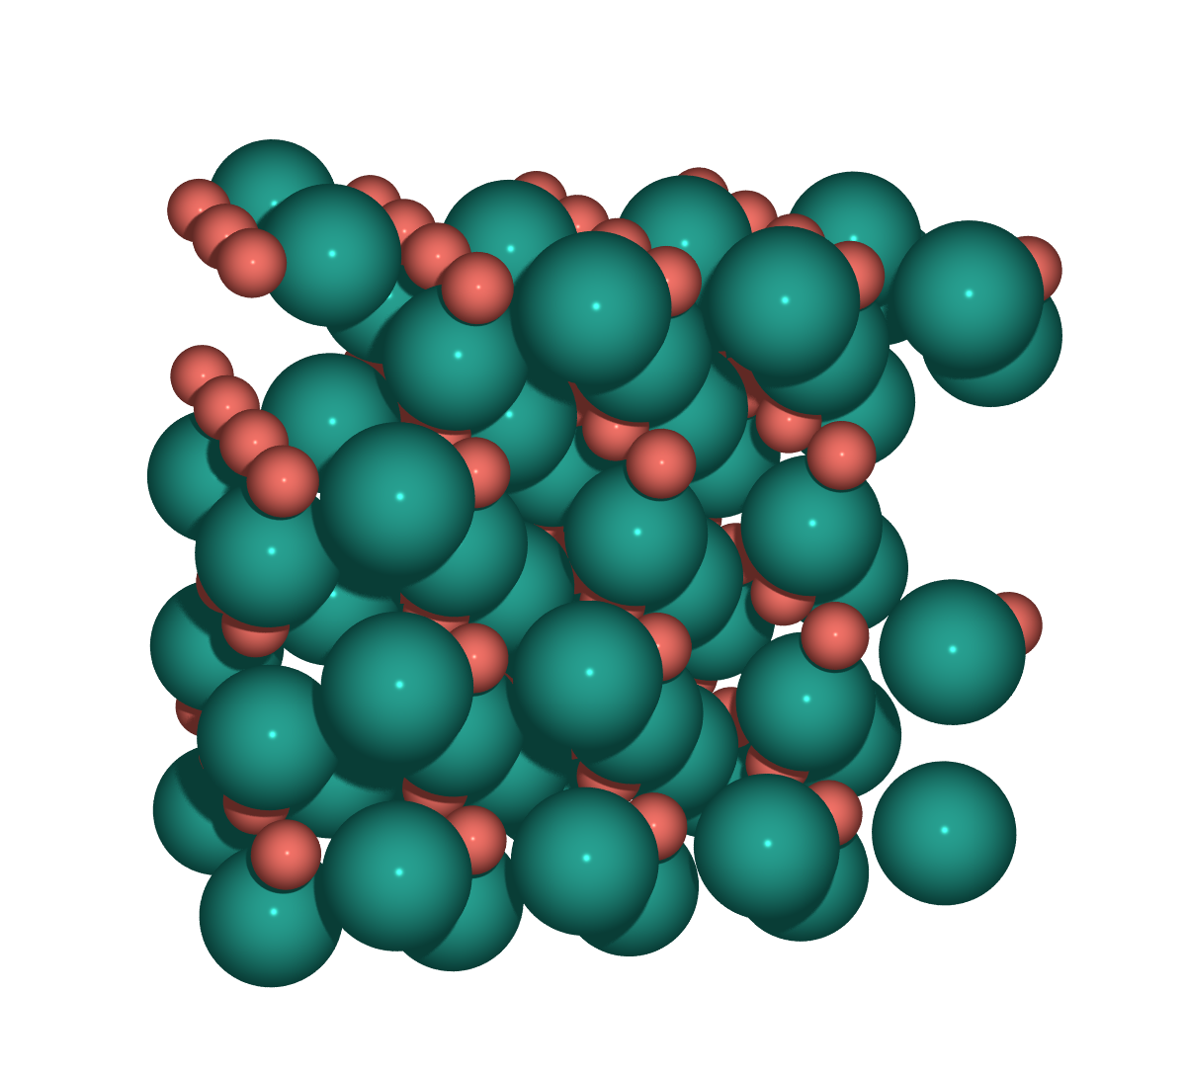  S3: PdO(100)  Bulk PdO, O-rich termination, 4×2  CONVERGED | 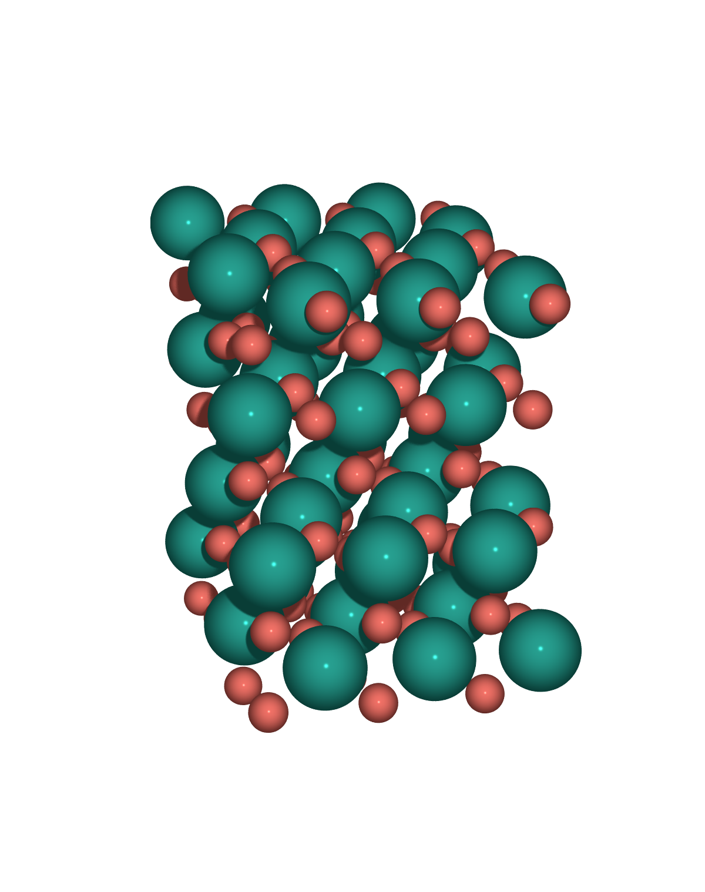  S4: PdO₂(110)  Rutile PdO₂, stoichiometric termination  RUNNING

Slab Properties
Surface | Oxidation | Atoms | Pd / O | Cell a × b (Å) | Layers | Fixed | Status
S1: Pd(100) | Pd⁰ | 80 | 80 / 0 | 11.0 × 11.0 | 5 | 32 | CONVERGED
S2: PdO(101)/Pd(100) | Pd⁰/Pd²⁺ | 112 | 96 / 16 | 12.3 × 12.3 | 7 | 40 | RUNNING
S3: PdO(100) | Pd²⁺ | 128 | 64 / 64 | 12.2 × 10.8 | 8 | 32 | CONVERGED
S4: PdO₂(110) | Pd⁴⁺ | 144 | 48 / 96 | 9.5 × 12.8 | 16 | 45 | RUNNING

Layer Structure Detail
S1: Pd(100)
Layer | z (Å) | Pd | O | Constraint
1 | 1.50 | 16 | - | FIXED
2 | 3.45 | 16 | - | FIXED
3 | 5.39 | 16 | - | free
4 | 7.34 | 16 | - | free
5 | 9.28 | 16 | - | free

S2: PdO(101)/Pd(100)
Layer | z (Å) | Pd | O | Constraint
1 | 1.50 | 20 | - | FIXED
2 | 3.45 | 20 | - | FIXED
3 | 5.39 | 20 | - | free
4 | 7.34 | 20 | - | free
5 | 9.54 | 16 | - | free
6 | 10.20 | - | 8 | free
7 | 11.53 | - | 8 | free

S3: PdO(100)
Layer | z (Å) | Pd | O | Constraint
1 | 1.50 | 8 | - | FIXED
2 | 3.03 | 8 | 16 | FIXED
3 | 4.57 | 8 | - | free
4 | 6.12 | 8 | 16 | free
5 | 7.65 | 8 | - | free
6 | 9.14 | 8 | 16 | free
7 | 10.75 | 8 | - | free
8 | 12.05 | 8 | 16 | free

S4: PdO₂(110)
Layer | z (Å) | Pd | O | Constraint
1 | 1.84 | - | 9 | FIXED
2 | 2.53 | - | 3 | FIXED
3 | 3.55 | 12 | 9 | FIXED
4 | 4.21 | 3 | 9 | FIXED
5 | 5.21 | - | 6 | FIXED
6 | 6.41 | 6 | 6 | free
7 | 7.22 | 6 | 9 | free
8 | 7.91 | - | 3 | free
9 | 8.69 | - | 6 | free
10 | 9.92 | 6 | 9 | free
11 | 10.60 | 6 | 6 | free
12 | 11.37 | - | 3 | free
13 | 11.93 | - | 6 | free
14 | 12.47 | - | 3 | free
15 | 13.40 | 9 | 9 | free
16 | 14.02 | 3 | 3 | free

Construction Notes
S1: Pd(100)
- ase.build.fcc100, a = 3.891 Å from G1 bulk Pd
- p(4×4), 4 layers, 20 Å asymmetric vacuum, bottom 2 fixed
- CONVERGED: max force (free) = 0.019 eV/Å, E = −434.408 eV
S2: PdO(101)/Pd(100)
- √5×√5 R27° surface oxide monolayer on Pd(100) substrate
- Oxide: pymatgen SlabGenerator(PdO, (1,0,1)) → 3D rotation to flat → 2×1 supercell
- Strain: PdO(101) 2×1 (6.11×6.21 Å) → √5×√5 Pd(100) (6.15×6.15 Å), < 1%
- Intra-oxide Pd–O: 2.02–2.75 Å (bulk PdO: 2.039 Å) — correct geometry
- Interface gap: 2.2 Å (bottom O → top substrate Pd)
- 2×2 final supercell → 112 atoms (80 sub + 16 Pdₒₓ + 16 O)
S3: PdO(100)
- pymatgen SlabGenerator(PdO, (1,0,0)), O-rich termination, 4×2 supercell
- CONVERGED: max force (free) = 0.023 eV/Å, E = −724.152 eV
S4: PdO₂(110)
- pymatgen SlabGenerator(PdO₂, (1,1,0)), stoichiometric termination
- Restarted from 20-step CONTCAR, NELM=500, GPU acceleration

VASP Settings
- ENCUT = 520 eV, PREC = Accurate, ISPIN = 2, IVDW = 12 (D3-BJ)
- EDIFF = 1e-6, EDIFFG = −0.03 eV/Å, IBRION = 2, NSW = 300, ISIF = 2
- KSPACING = 0.25, LDIPOL = T, IDIPOL = 3, ISYM = 0
- S1: ISMEAR=1, SIGMA=0.1 (metal) | S2–S4: ISMEAR=0, SIGMA=0.05 (oxide)
- NCORE = 1 (GPU), NELM = 500, VASP 6.4.3 GPU (CUDA/OpenACC)
- POTCAR: Pd_pv (28Jan2005) + O (08Apr2002)

2026-06-08 | Pd/PdO/PdO₂ DMC Study | JBNU | Pd=teal, O=coral

