G2 Slab Structure Report
Pd/PdO/PdO₂ DMC Formation Study — Clean Slab Structures

Slab Structures
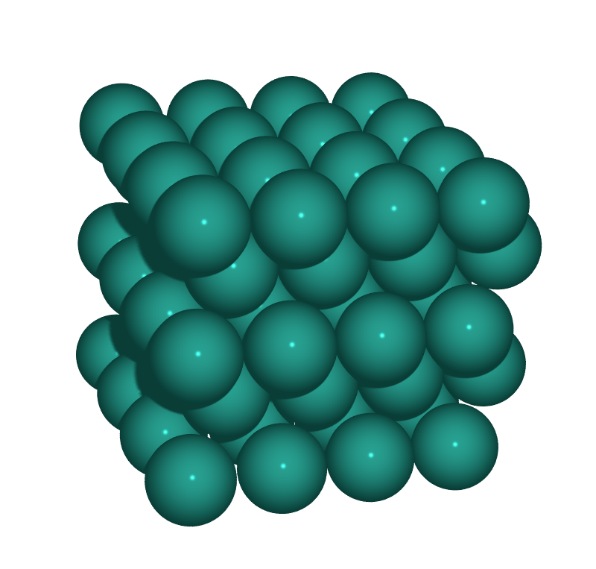  S1: Pd(100)  Metallic Pd, p(4×4), 4 layers | 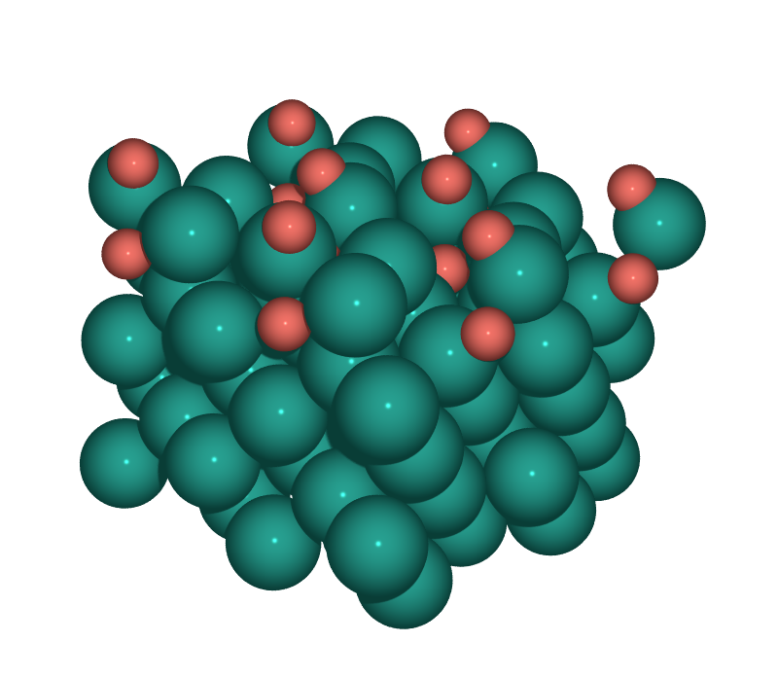  S2: PdO(101)/Pd(100)  (√5×√5)R27° surface oxide on Pd(100)
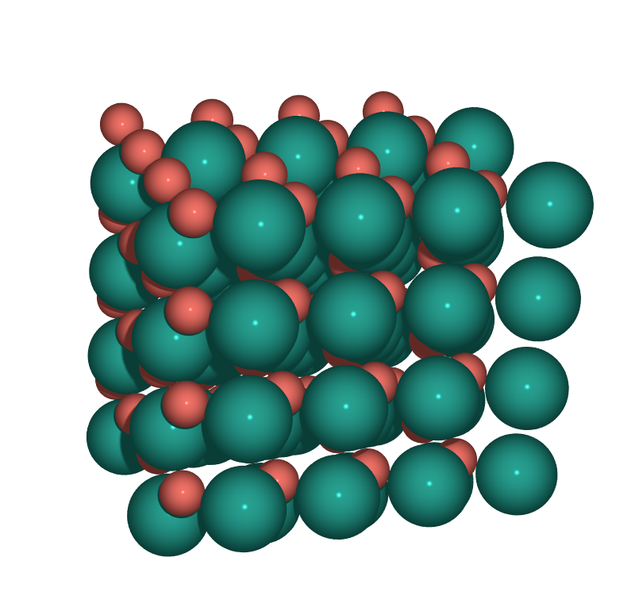  S3: PdO(100)  Bulk PdO, O-rich termination, 4×2 supercell | 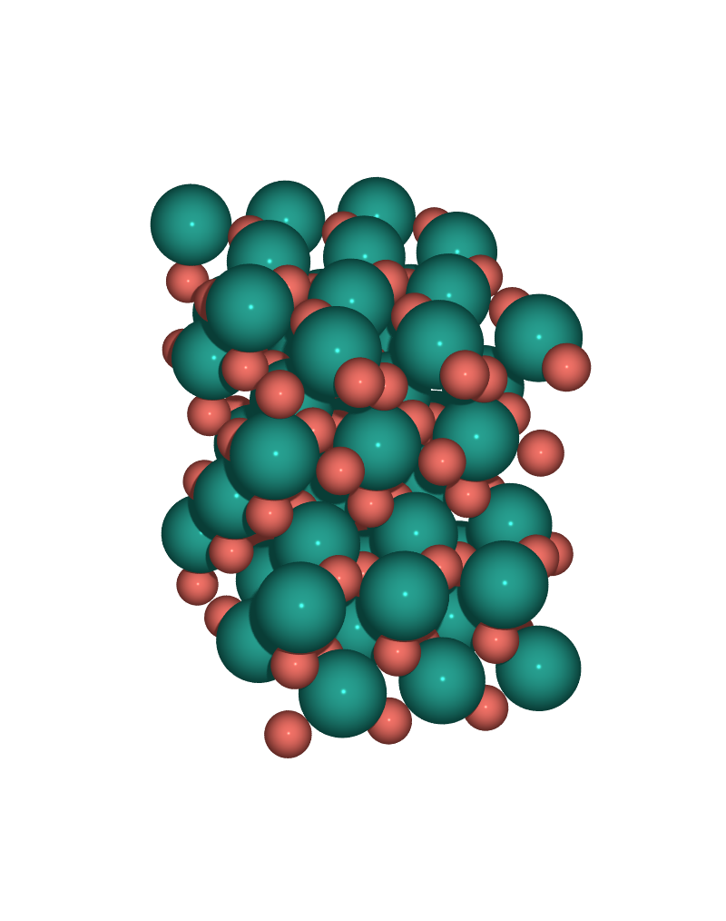  S4: PdO₂(110)  Rutile-type PdO₂, stoichiometric termination

Slab Properties
Surface | Oxidation | Atoms | Pd / O | Cell a×b (Å) | Layers | Fixed
S1: Pd(100) | Pd⁰ | 80 | 80 / 0 | 11.0 × 11.0 | 5 | 32
S2: PdO(101)/Pd(100) | Pd⁰/Pd²⁺ | 112 | 96 / 16 | 12.3 × 12.3 | 7 | 40
S3: PdO(100) | Pd²⁺ | 128 | 64 / 64 | 12.2 × 10.8 | 8 | 32
S4: PdO₂(110) | Pd⁴⁺ | 144 | 48 / 96 | 9.5 × 12.8 | 14 | 45

Generated: 2026-06-05 | Pd=teal, O=coral | POV-Ray + ase3 texture

