G2 Clean Slab Structures
Pd/PdO/PdO2 DMC Formation | Side View | ase3 texture

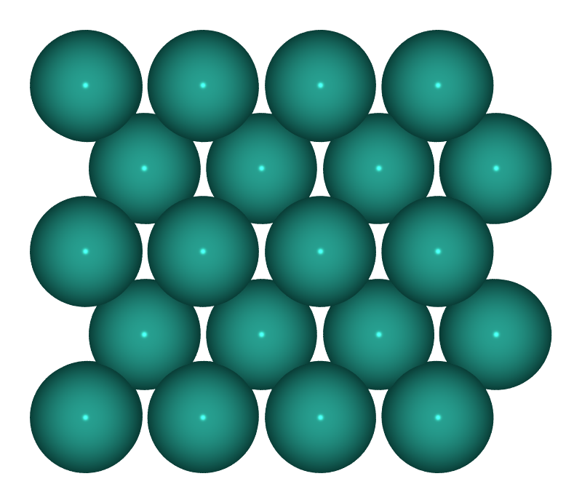  S1: Pd(100)  Metallic Pd, p(4x4), 4 layers | 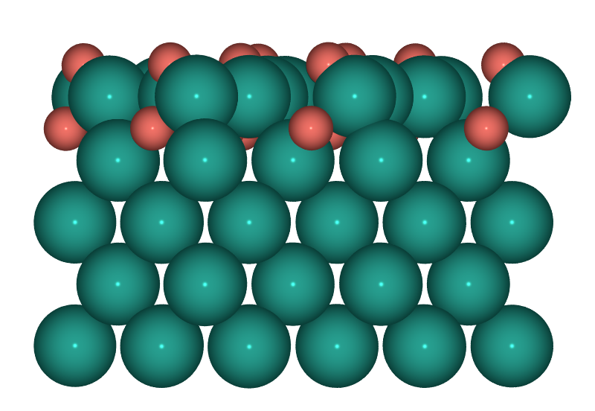  S2: PdO(101)/Pd(100)  Surface oxide on Pd(100)
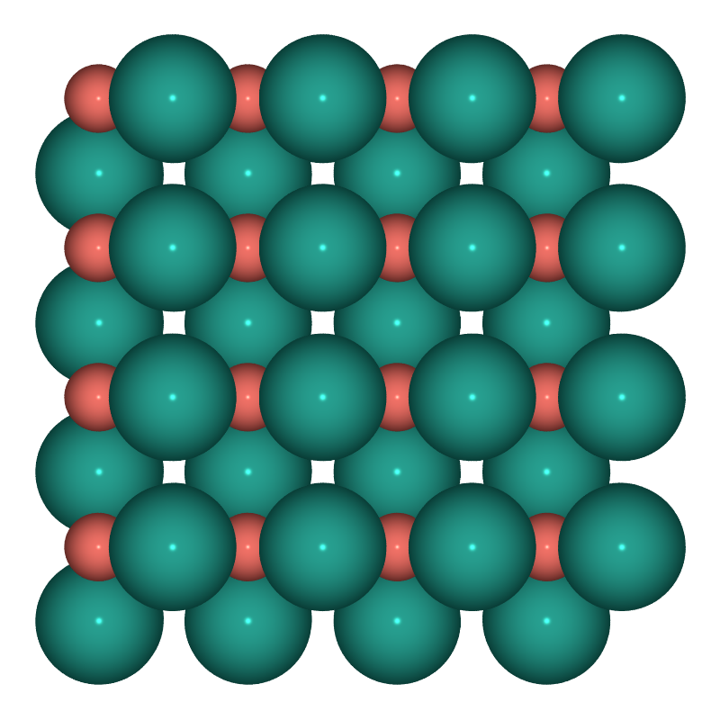  S3: PdO(100)  Bulk PdO, O-rich termination, 4x2 | 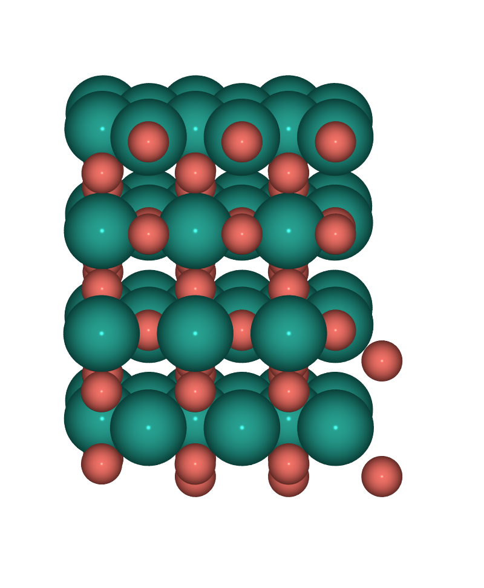  S4: PdO2(110)  Rutile PdO2, stoichiometric

Slab Properties
Surface | Oxidation | Atoms | Pd / O | Cell a x b | Layers | Fixed
S1: Pd(100) | Pd0 | 80 | 80 / 0 | 11.0 x 11.0 | 5 | 32
S2: PdO(101)/Pd(100) | Pd0/Pd2+ | 112 | 96 / 16 | 12.3 x 12.3 | 7 | 40
S3: PdO(100) | Pd2+ | 128 | 64 / 64 | 12.2 x 10.8 | 8 | 32
S4: PdO2(110) | Pd4+ | 144 | 48 / 96 | 9.5 x 12.8 | 14 | 45

2026-06-05 | Side view (-90x,0y,0z) | POV-Ray ase3 | Pd=teal, O=coral

