G2 Clean Slab Report — S1 / S2 / S3 / S4
Pd / PdO / PdO₂ DMC formation DFT study | 2026-06-09

Overview — oxidation hierarchy
Four clean-slab models span the oxidation axis used in the DMC mechanism study: S1 (metallic Pd⁰), S2 (Pd–PdO interface, surface oxide), S3 (bulk Pd²⁺ oxide), S4 (Pd⁴⁺ rutile reference). S2 and S4 were rebuilt in this revision: S2 is now the literature (√5×√5)R27° PdO(101)/Pd(100) model (Todorova 2003 / Kostelník 2007), and S4 is the clean orthogonal PdO₂(110) termination (Pd_5c cus + Pd_6c) instead of the previous tilted/wrong-termination build.

Summary table (cell / atoms / fixed / coordination)
Slab | Model | Atoms (Pd / O) | Cell a×b×c (Å) | Layers | Slab / Vacuum (Å) | Fixed / Free | Top Pd–O coord
S1 | Pd(100) | 80 (80 / 0) | 11.005 × 11.005 × 27.781 (α,β,γ = 90.0,90.0,90.0) | 5 | 7.78 / 20.00 | 32 / 48 | {0: 32}
S2 | 1 ML PdO(101)/Pd(100) | 112 (96 / 16) | 12.303 × 12.303 × 25.665 (α,β,γ = 90.0,90.0,90.0) | 7 | 9.17 / 16.50 | 60 / 52 | {2: 8, 4: 8}
S3 | PdO(100) | 128 (64 / 64) | 12.214 × 10.812 × 30.688 (α,β,γ = 90.0,90.0,90.0) | 8 | 10.62 / 20.07 | 32 / 96 | {4: 24}
S4 | PdO₂(110) | 144 (48 / 96) | 9.532 × 12.848 × 28.603 (α,β,γ = 90.0,90.0,90.0) | 12 | 12.10 / 16.50 | 72 / 72 | {5: 6, 6: 6}

Build notes & fixed-atom strategy
S1 — Pd(100) fcc Pd primitive a=3.8907 Å; p(4×4) surface, 4–5 layers; bottom 2 layers fixed. Status: CONVERGED (E_tot = −434.408 eV).
S2 — 1 ML PdO(101)/Pd(100) (REBUILT) (√5×√5)R27° supercell × (2×2), 5-layer Pd(100) substrate (80 Pd) + 1 single O–Pd–O sheet (16 Pd + 16 O) extracted from a validated standalone PdO(101) slab and strained ~1% to fit the √5 mesh. Lateral registration optimized by substrate shift; rigid +26.6° rotation in lab frame so substrate Pd-Pd nn directions align with lab x,y (literature framing). Bottom ~50% (60 / 112 atoms, bottom 2-3 substrate layers) fixed. R27° measured 26.6°. Per √5: 4 Pd_oxide + 4 O, 2-fold + 4-fold Pd mix, O-terminated — all literature identifiers. Previous wrong S2 (corrugated monolayer, 1-fold dangling O) → POSCAR_corrugated_bak. Status: job 324 queued.
S3 — PdO(100) PdO tetragonal a=3.0536, c=5.4058 Å; (100) surface, 5 layers; bottom half fixed. Status: CONVERGED (E_tot = −724.152 eV).
S4 — PdO₂(110) (REBUILT) Rutile PdO₂ a=4.5424, c=3.1772 Å; (110) surface via pymatgen SlabGenerator termination 1 (symmetric Pd_5c + Pd_6c + bridging O), then 3×2 supercell. Rigid rotation orthogonalizes the originally tilted primitive cell (preserves all interatomic distances; eliminates the staircase visual artifact). 144 atoms (48 Pd + 96 O). Bottom 50% (72 atoms) fixed. Top surface: 6× Pd_5c (cus, 5-fold) + 6× Pd_6c (full-coord), bridging O preserved. Previous tilted version → POSCAR_tilted_bak. Status: job 322 running.

Structures (lattice lines hidden)
S1 — Pd(100)
Pd⁰ metallic baseline (nanocube facet)
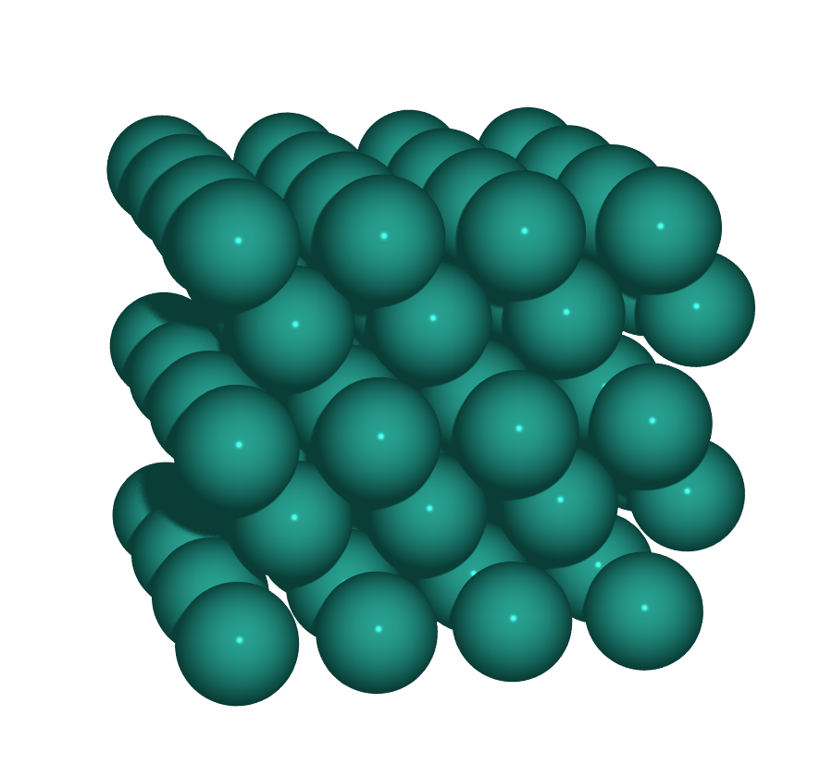  Perspective | 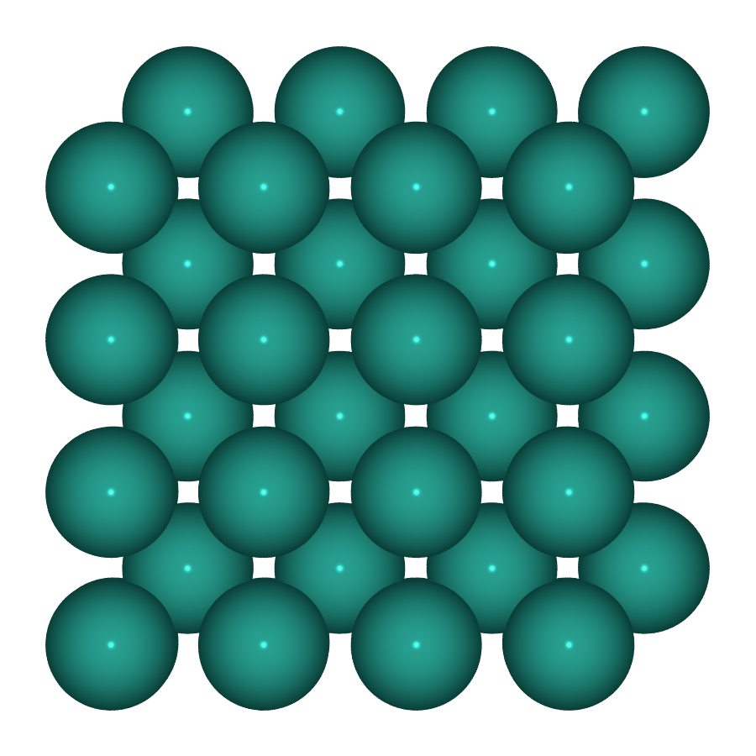  Top | 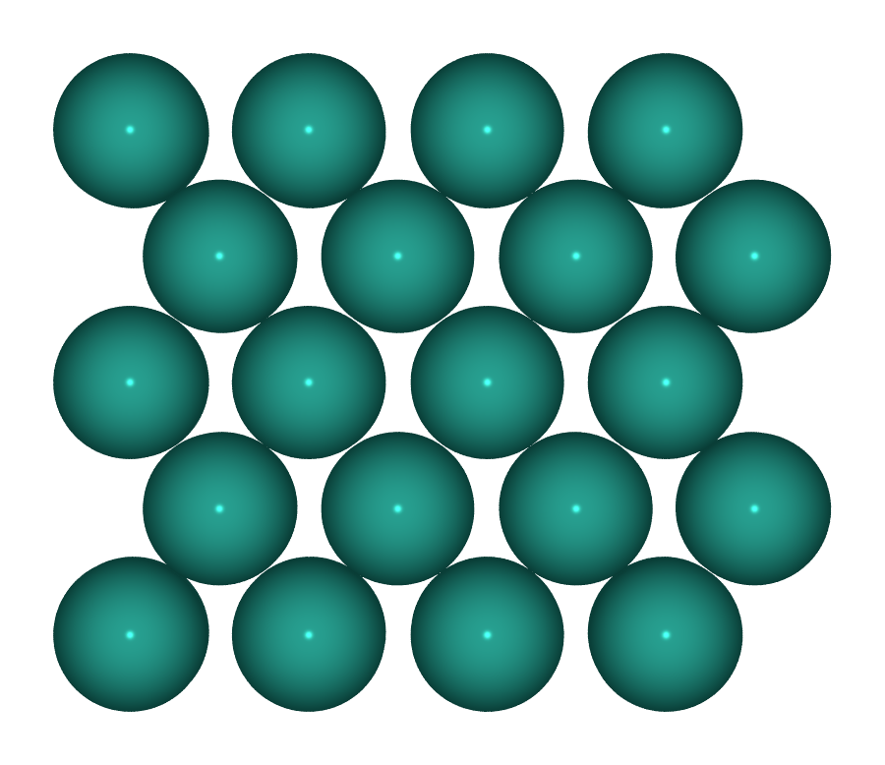  Side

S2 — 1 ML PdO(101)/Pd(100)
Pd²⁺ surface oxide / Pd–PdO interface — (√5×√5)R27°
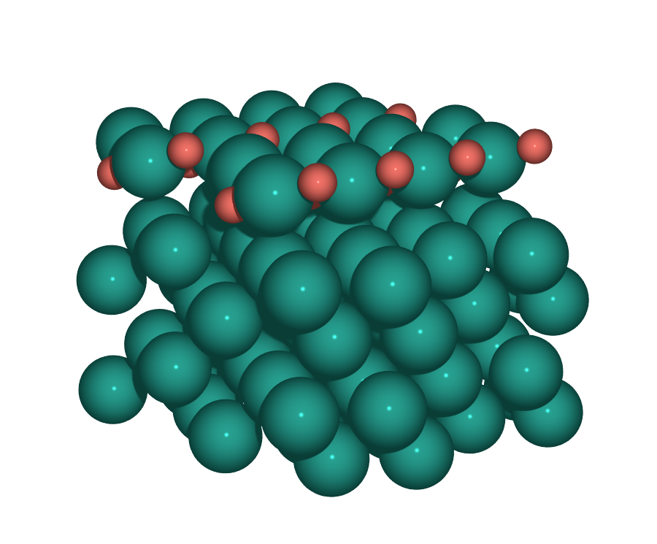  Perspective | 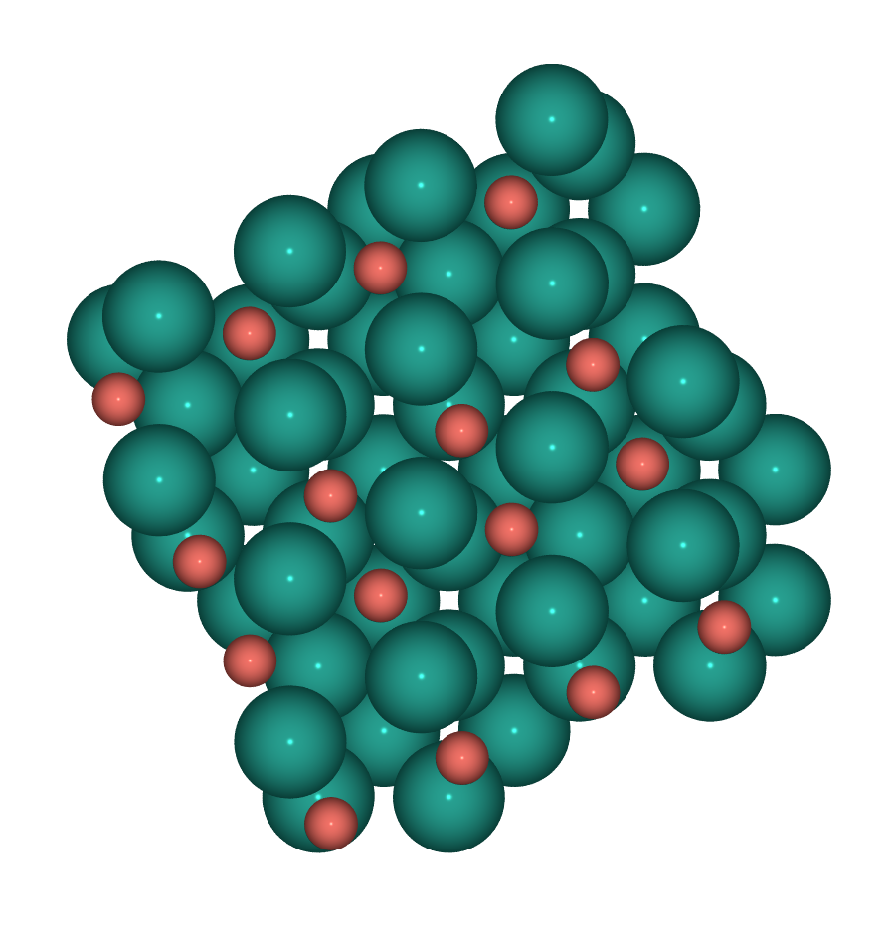  Top | 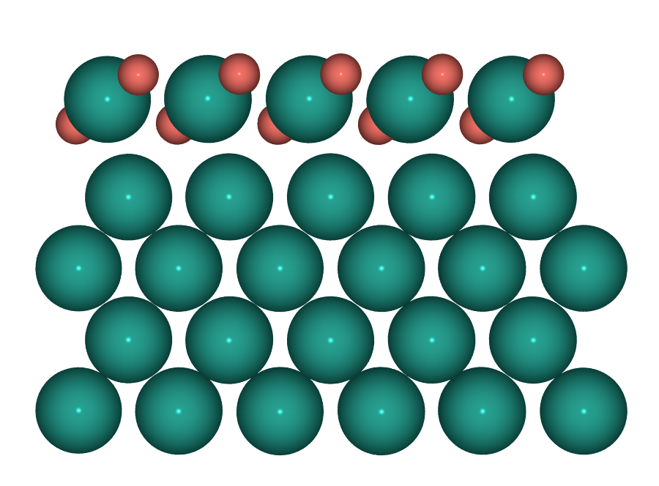  Side

S3 — PdO(100)
Bulk PdO Pd²⁺ termination (O-rich limit)
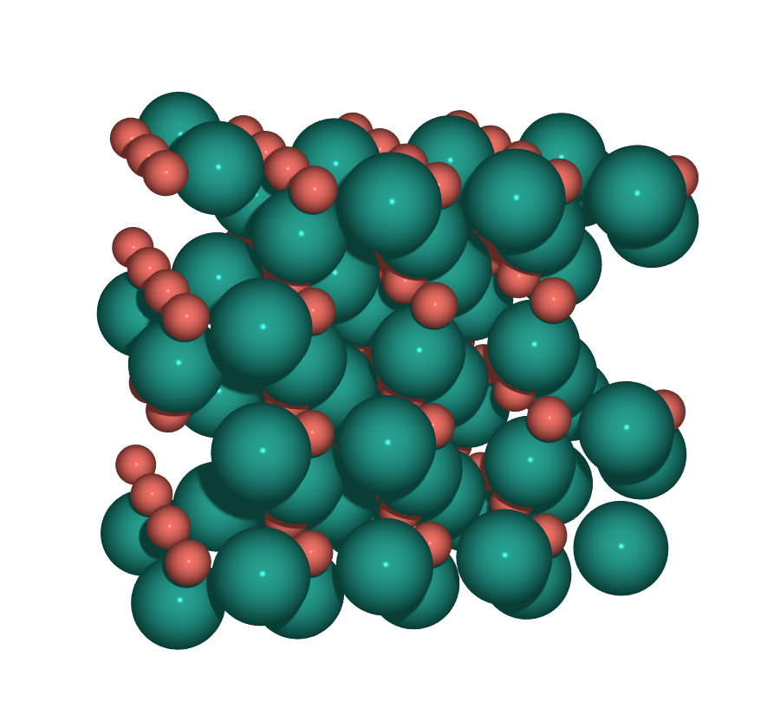  Perspective | 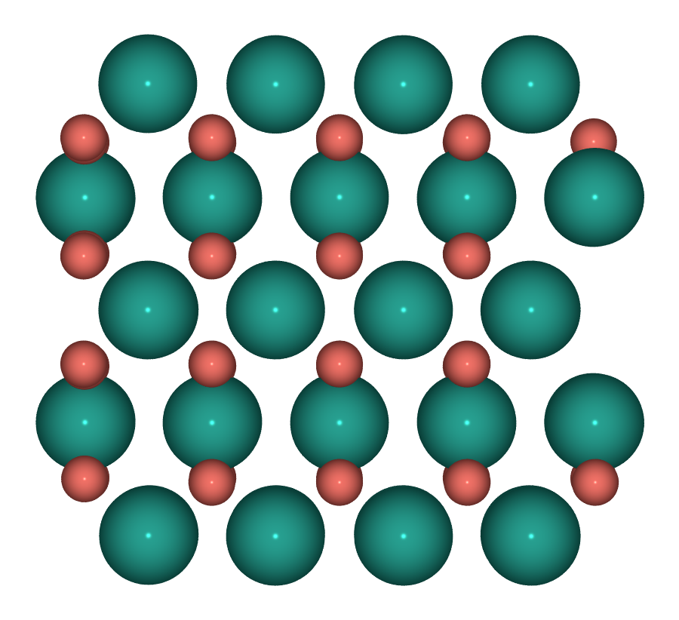  Top | 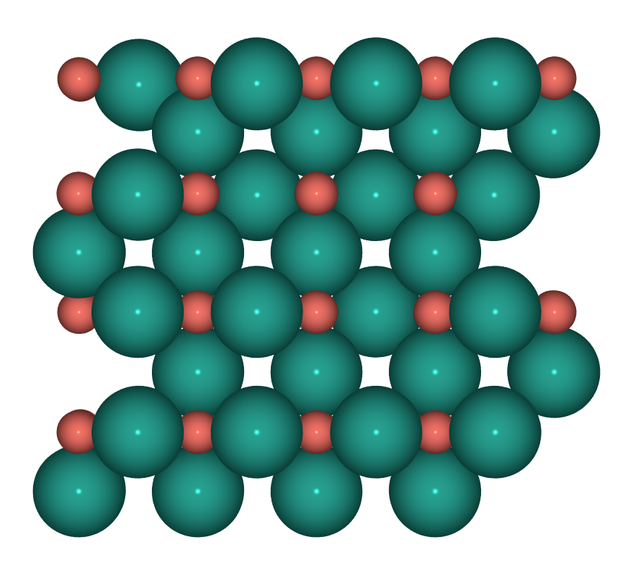  Side

S4 — PdO₂(110)
Pd⁴⁺ rutile high-valence reference
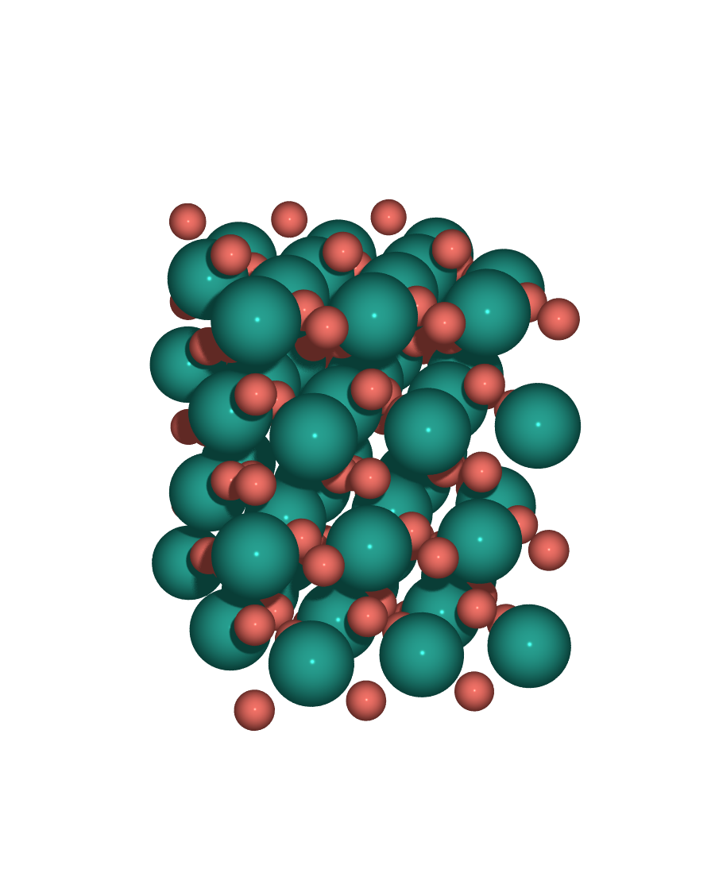  Perspective | 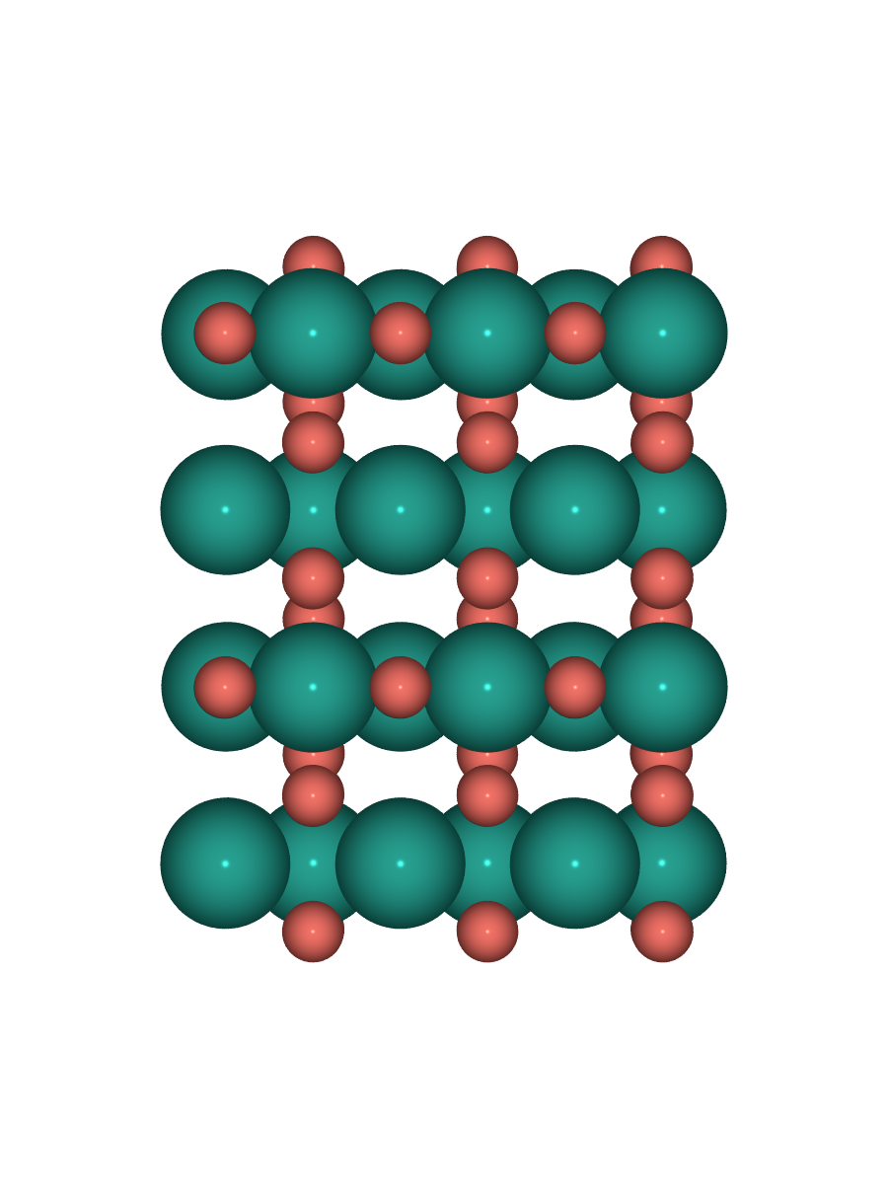  Top | 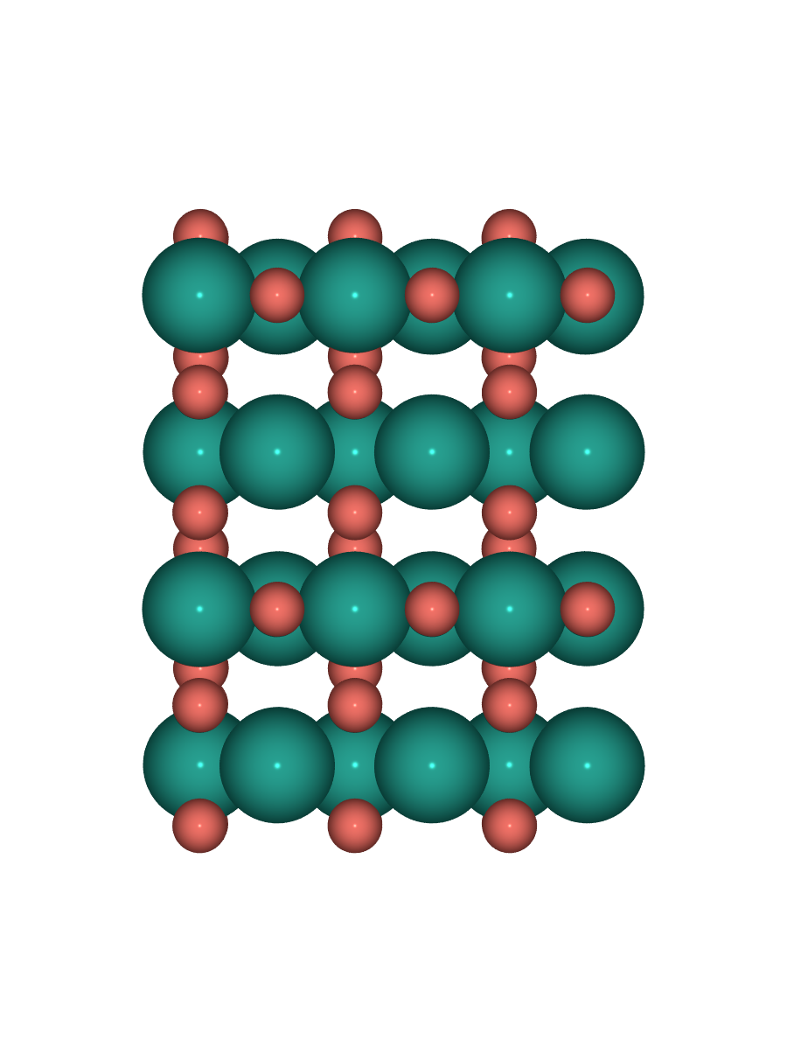  Side

DFT relaxation status
Slab | Job ID | Status | Notes
S1 | — | CONVERGED | E_tot = −434.408 eV
S2 | 324 | queued | new √5R27° PdO(101)/Pd(100); awaiting GPU resource
S3 | — | CONVERGED | E_tot = −724.152 eV
S4 | 322 | running | new orthogonal PdO₂(110); ~3 min into relaxation at report time

Common INCAR fingerprint (all 4 slabs)
ENCUT = 520 eV | PREC = Accurate | LASPH = T | ADDGRID = T
EDIFF = 1e-6 | EDIFFG = −0.03 | NELM = 500 | NSW = 300 | IBRION = 2 | ISIF = 2
ISPIN = 2 (spin-polarized) | IVDW = 12 (D3 BJ) | ISMEAR = 0, SIGMA = 0.05
LDIPOL = T, IDIPOL = 3 (asymmetric slab dipole correction)
KSPACING = 0.25 | ISYM = 0 | POTCAR = PAW_PBE O + PAW_PBE Pd_pv

Next step — G2 gate (T1.9 / checkpoint B)
Once S2 (job 324) and S4 (job 322) converge, run G2 validation per workplan T1.9: (i) rumpling pattern (esp. S2 oxide Pd_Br/Pd_H rumpling 0.03–0.17 Å vs literature), (ii) average Pd–O bond lengths (target ~2.02 Å bulk PdO), (iii) top-layer Pd coordination (verify 2f + 4f preserved on S2), (iv) slab dipole (IDIPOL = 3 correction), (v) termination stability (compare to alternative S4 terminations). Do NOT begin adsorption sampling before G2 passes.

