G2 Clean Slab Report — S1 / S2 / S3 / S4 (guideline-compliant)
Pd / PdO / PdO₂ DMC formation DFT study | 2026-06-09 (rev. guideline)

Guideline compliance (workplan line 28-29, T1.5)
Slab | Fix policy | Atoms fixed | Vacuum | Status
S1 | bottom 2 layers | 32/80 (40%) | 20.0 Å | ✓ guideline
S2 | bottom 2 layers | 40/112 (36%) | 20.0 Å | ✓ guideline (30–40%) [rebuilt]
S3 | bottom 2 layers | 32/128 (25%) | 20.1 Å | ✓ guideline (bottom 2 layers)
S4 | bottom 4 sublayers (≈ 2 PdO₂ layers) | 42/144 (29%) | 20.0 Å | ✓ guideline [rebuilt]
Guideline (workplan line 28-29): "Vacuum 20 Å, bottom 2 layers(또는 하단 30–40% 원자) 고정". All four slabs now satisfy this criterion. S2 and S4 were rebuilt for this revision (previous versions had vacuum 16.5 Å with ~50% fixed).

Summary table
Slab | Model | Atoms (Pd/O) | Cell a×b×c (Å) | Layers | Slab / Vac (Å) | Fixed / Free | Top Pd–O coord
S1 | Pd(100) | 80 (80/0) | 11.005 × 11.005 × 27.781 | 5 | 7.78 / 20.00 | 32/48 | {0: 32}
S2 | 1 ML PdO(101)/Pd(100) | 112 (96/16) | 12.303 × 12.303 × 29.165 | 7 | 9.17 / 20.00 | 40/72 | {2: 8, 4: 8}
S3 | PdO(100) | 128 (64/64) | 12.214 × 10.812 × 30.688 | 8 | 10.62 / 20.07 | 32/96 | {4: 24}
S4 | PdO₂(110) | 144 (48/96) | 9.532 × 12.848 × 32.103 | 12 | 12.10 / 20.00 | 42/102 | {5: 6, 6: 6}

Build & fix notes
S1 — Pd(100) fcc Pd (a=3.8907) p(4×4), 5 layers, bottom 2 layers fixed (32/80=40%). Vacuum 20 Å. CONVERGED (E=−434.408 eV).
S2 — 1 ML PdO(101)/Pd(100) [REBUILT] (√5×√5)R27°×2×2: 4 substrate Pd layers × 20 Pd + 1 O–Pd–O sheet (16 Pd + 16 O). Strain ~1%, registration optimized, axis-aligned (R27° preserved internally — measured 26.6°). Bottom 2 substrate layers fixed (40/112=36%). Vacuum 20 Å. Matches Todorova 2003 / Kostelník 2007 model. Job 325.
S3 — PdO(100) PdO tetragonal (a=3.0536, c=5.4058) (100), 8 sublayers, bottom 2 fixed (32/128=25%). Vacuum 20.1 Å. CONVERGED (E=−724.152 eV).
S4 — PdO₂(110) [REBUILT] Rutile PdO₂ (a=4.5424, c=3.1772) (110) via pymatgen term=1 + rigid orthogonalization, 3×2 supercell. 12 sublayers, bottom 4 fixed (42/144=29%, ≈ 2 PdO₂ formula layers). Vacuum 20 Å. Top: 6× Pd_5c (cus) + 6× Pd_6c. Job 326.

Fixed Atoms — color-coded side views
Grey = fixed (F F F in POSCAR Selective dynamics); colored = free (T T T): Pd green, O red. Side view (looking along y); layers stack vertically; oxide on top, substrate bottom.
S1 — Pd(100)
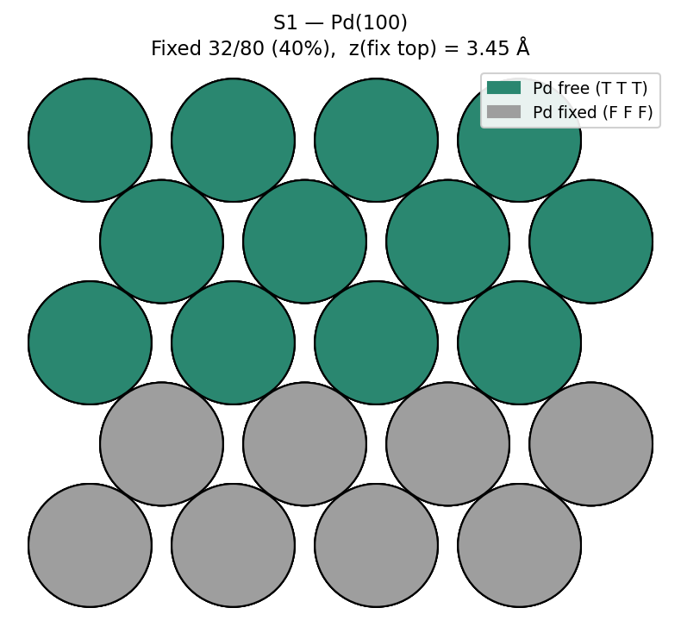

S2 — 1 ML PdO(101)/Pd(100)
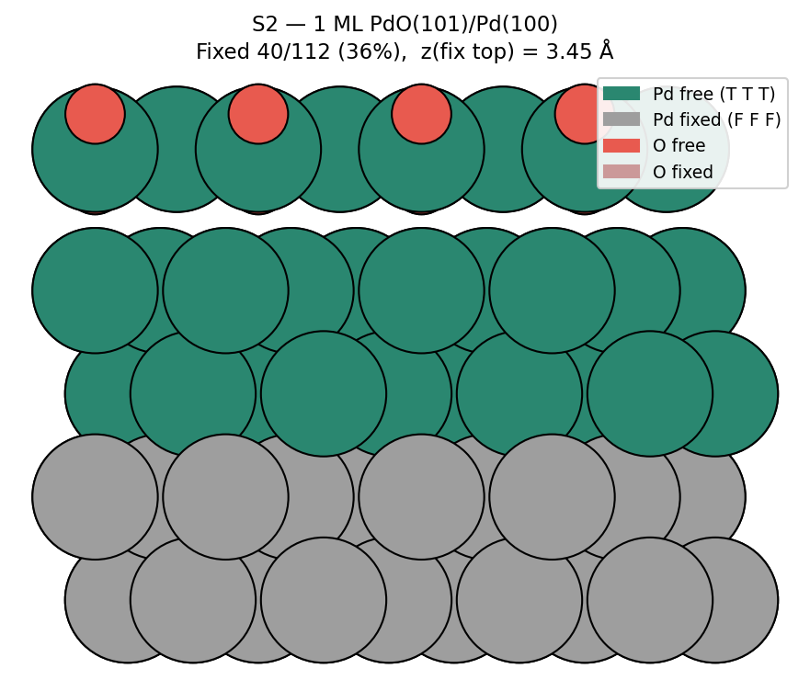

S3 — PdO(100)
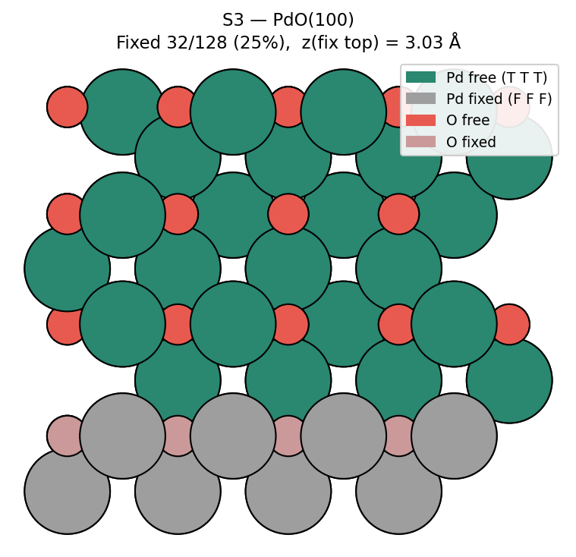

S4 — PdO₂(110)
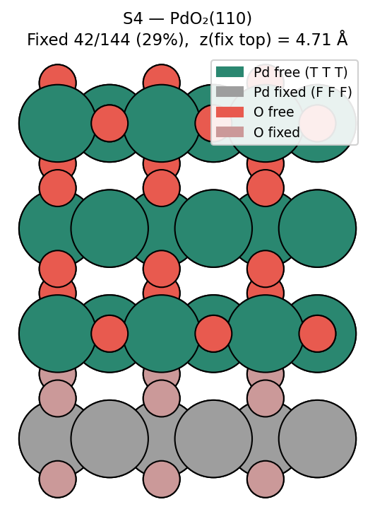

Structures (lattice lines hidden)
S1 — Pd(100)
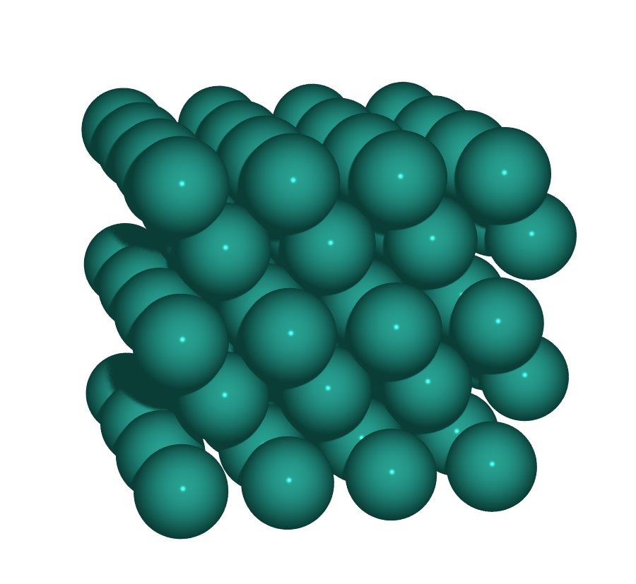  Perspective | 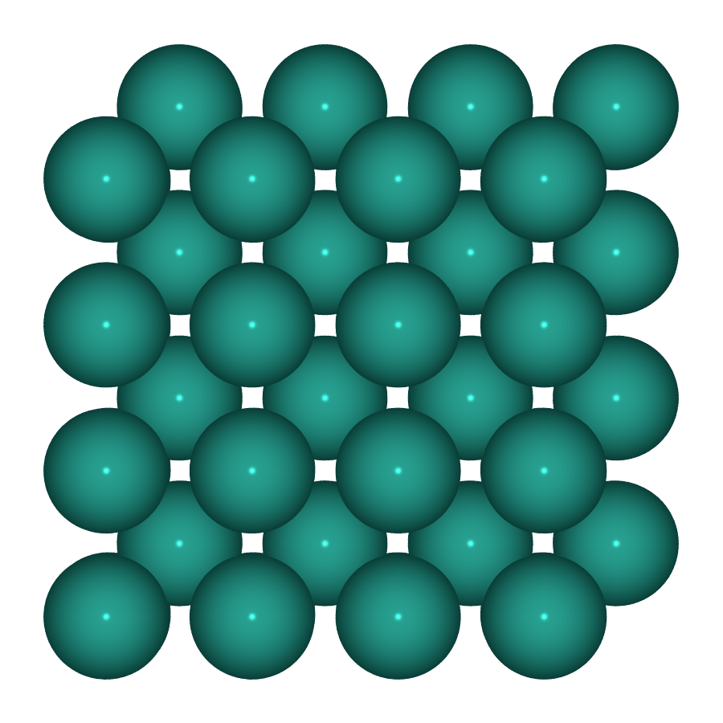  Top | 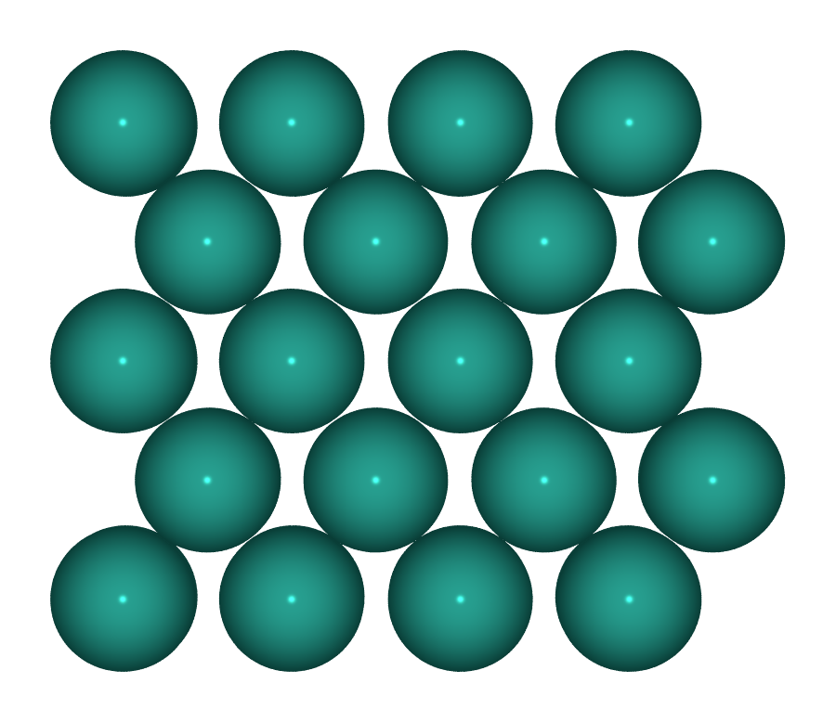  Side

S2 — 1 ML PdO(101)/Pd(100)
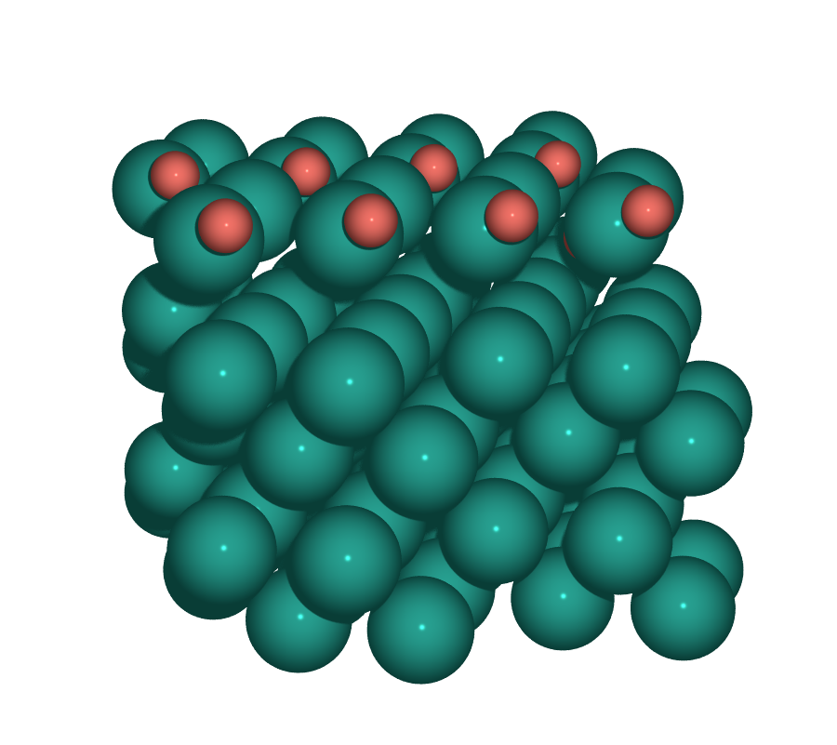  Perspective | 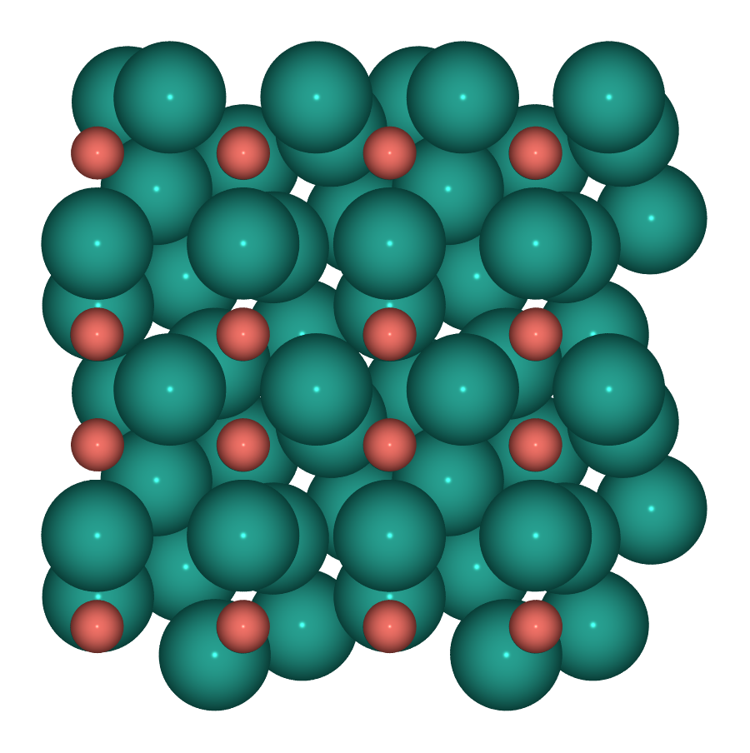  Top | 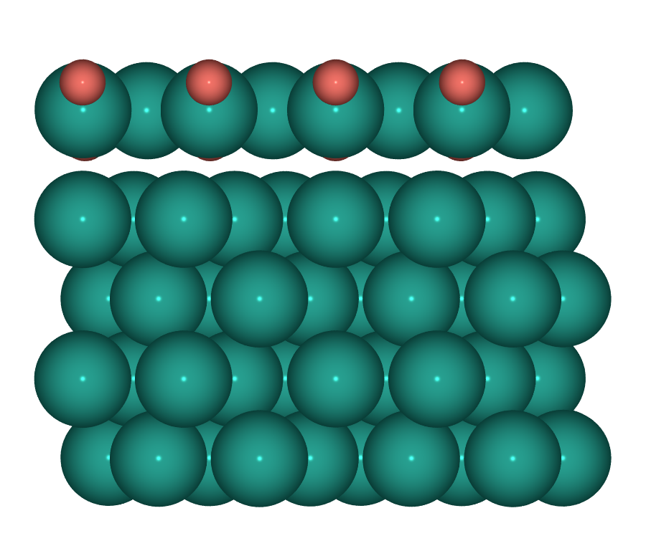  Side

S3 — PdO(100)
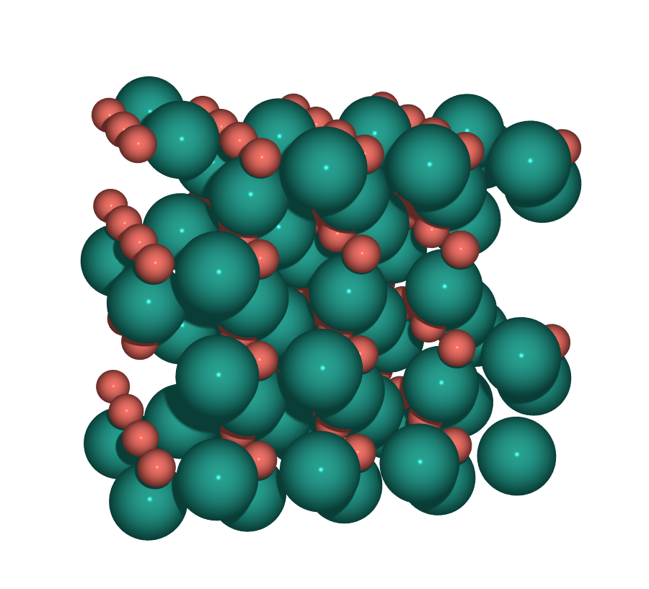  Perspective | 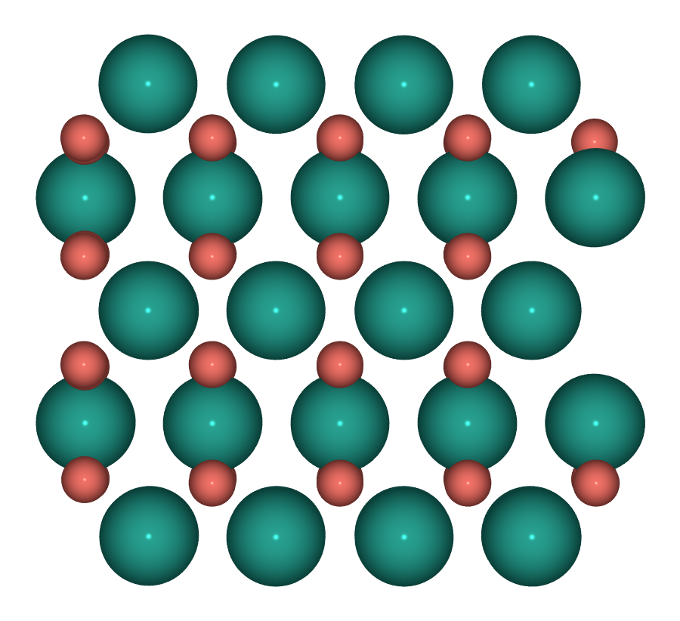  Top | 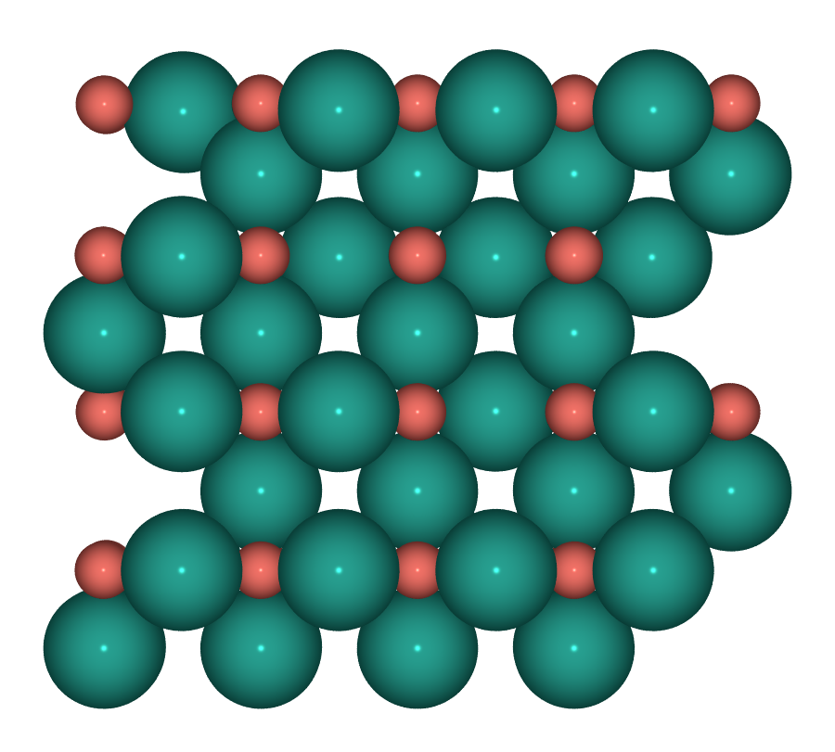  Side

S4 — PdO₂(110)
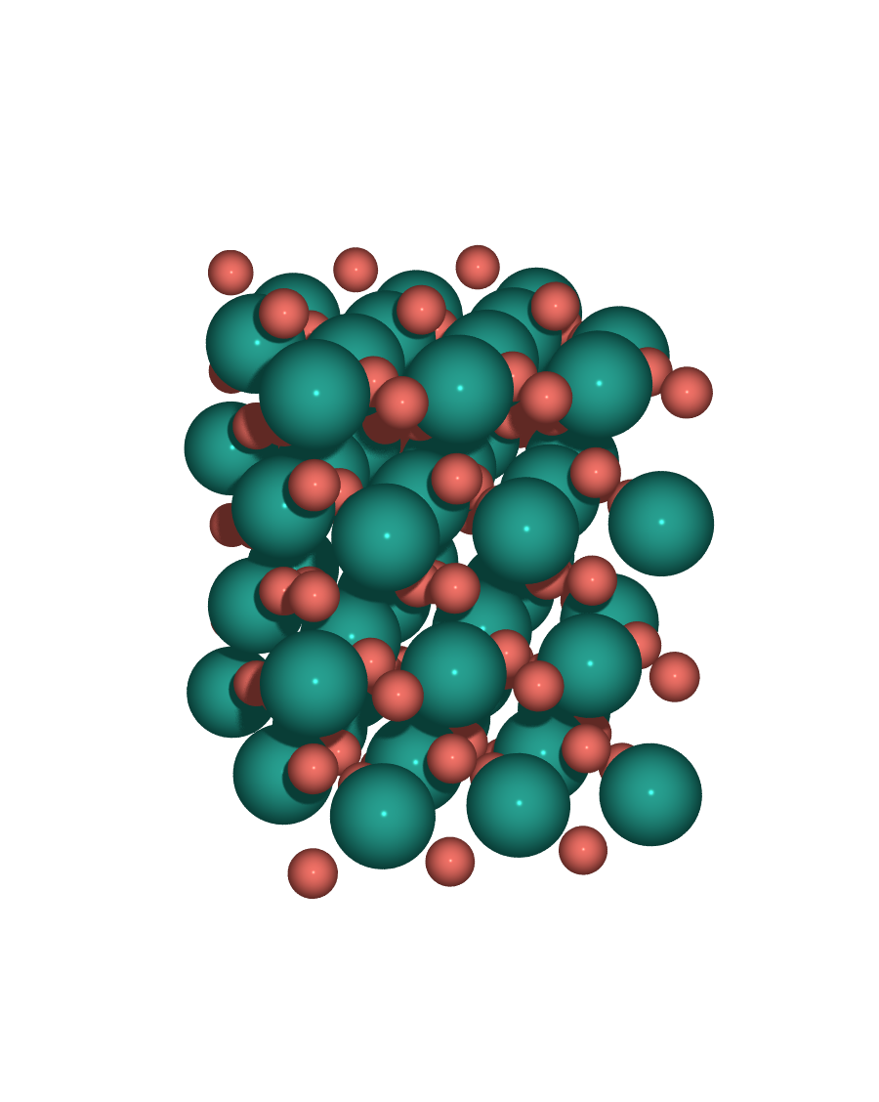  Perspective | 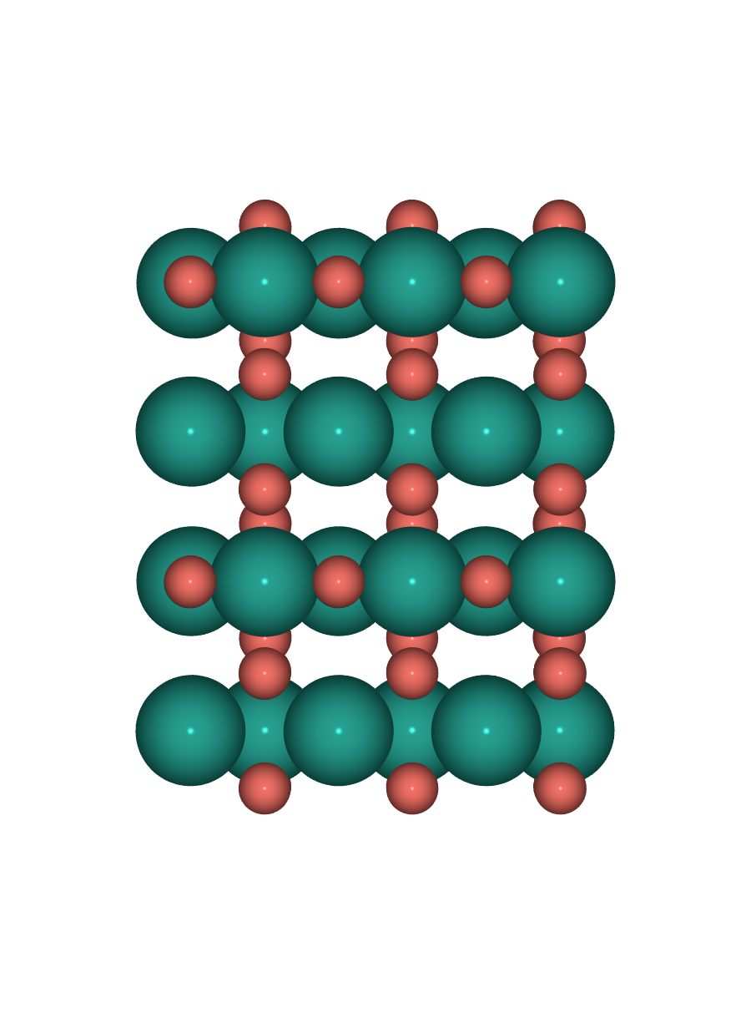  Top | 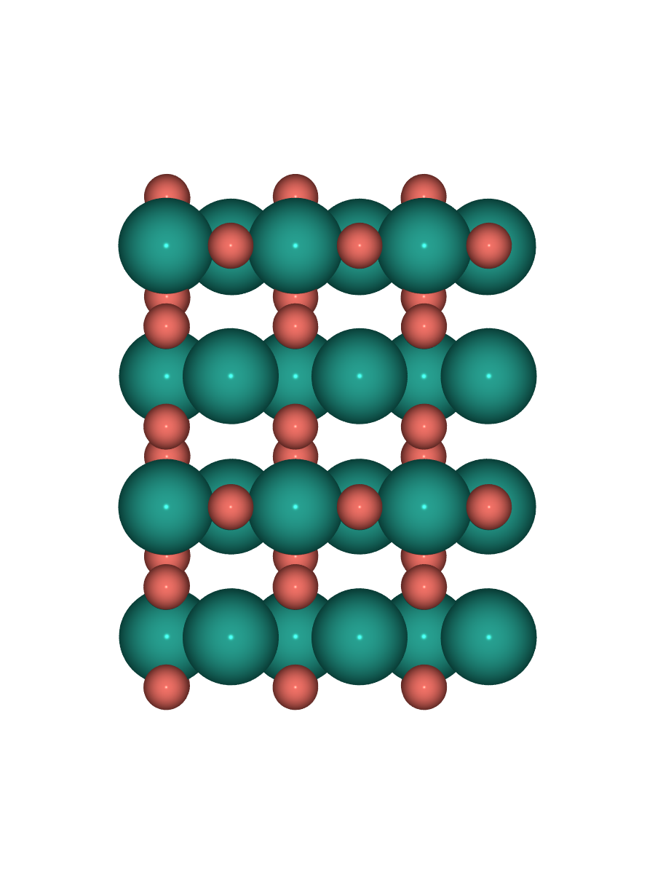  Side

DFT relaxation status
Slab | Job | Status | Notes
S1 | — | CONVERGED | E_tot = −434.408 eV
S2 | 325 | running | √5R27° PdO(101)/Pd(100); guideline (bottom 2 layers, vac 20 Å)
S3 | — | CONVERGED | E_tot = −724.152 eV
S4 | 326 | queued | orthogonal PdO₂(110); guideline (bottom 4 sublayers, vac 20 Å)

Common INCAR
ENCUT = 520 eV PREC = Accurate LASPH = T ADDGRID = T
EDIFF = 1e-6 EDIFFG = −0.03 NELM = 500 NSW = 300 IBRION = 2 ISIF = 2
ISPIN = 2 IVDW = 12 (D3 BJ) ISMEAR = 0, SIGMA = 0.05
LDIPOL = T, IDIPOL = 3 KSPACING = 0.25 ISYM = 0
POTCAR: PAW_PBE O + PAW_PBE Pd_pv

