G2 Clean Slab Report — S1 / S2 / S3 / S4
Pd / PdO / PdO₂ DMC formation DFT study | 2026-06-09
View conventions: Top = looking along −c (down z); Side = looking along +a (showing b–c plane, b right, c up); Perspective = left-tilt view (rotation −65x, −12y). PBC boundary atoms completed (buffer 0.3 Å).

Guideline compliance (workplan line 28-29, T1.5)
Slab | Fix policy | Atoms fixed | Vacuum | Status
S1 | bottom 2 layers | 32/80 (40%) | 20.0 Å | ✓
S2 | bottom 2 layers | 40/112 (36%) | 20.0 Å | ✓ [rebuilt]
S3 | bottom 2 layers | 32/128 (25%) | 20.1 Å | ✓
S4 | bottom 4 sublayers (≈ 2 PdO₂ layers) | 42/144 (29%) | 20.0 Å | ✓ [rebuilt]

Summary table
Slab | Model | Atoms (Pd/O) | Cell a×b×c (Å) | Layers | Slab/Vac (Å) | Fixed/Free | Top Pd–O coord
S1 | Pd(100) | 80 (80/0) | 11.005 × 11.005 × 27.781 | 5 | 7.78 / 20.00 | 32/48 | {0: 32}
S2 | 1 ML PdO(101)/Pd(100) | 112 (96/16) | 12.303 × 12.303 × 29.165 | 7 | 9.17 / 20.00 | 40/72 | {2: 8, 4: 8}
S3 | PdO(100) | 128 (64/64) | 12.214 × 10.812 × 30.688 | 8 | 10.62 / 20.07 | 32/96 | {4: 24}
S4 | PdO₂(110) | 144 (48/96) | 9.532 × 12.848 × 32.103 | 12 | 12.10 / 20.00 | 42/102 | {5: 6, 6: 6}

Build & fix notes
S1 — Pd(100) fcc Pd p(4×4), 5 layers, bottom 2 fixed. Vacuum 20 Å. CONVERGED (E=−434.408 eV).
S2 — 1 ML PdO(101)/Pd(100) [REBUILT] (√5×√5)R27°×2×2, 4 substrate Pd + 1 O–Pd–O sheet (16 Pd + 16 O). Strain ~1%, R27° preserved internally (measured 26.6°). Bottom 2 sub layers fixed (40/112=36%). Vacuum 20 Å. Matches Todorova 2003 / Kostelnik 2007. Job 325.
S3 — PdO(100) PdO tetragonal (100), 8 sublayers, bottom 2 fixed. Vacuum 20.1 Å. CONVERGED (E=−724.152 eV).
S4 — PdO₂(110) [REBUILT] Rutile PdO₂ (110) via pymatgen term=1 + rigid orthogonalization, 3×2 supercell. 12 sublayers, bottom 4 fixed (42/144=29%). Vacuum 20 Å. Top: 6× Pd_5c + 6× Pd_6c. Job 326.

Fixed Atoms — color-coded side views (b–c plane)
Grey = fixed; colored = free. Side view: looking along +a axis, b right, c up. PBC images shown.
S1 — Pd(100)
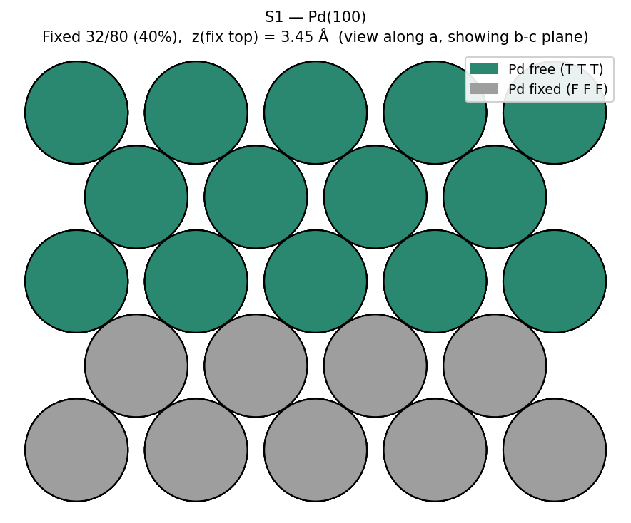

S2 — 1 ML PdO(101)/Pd(100)
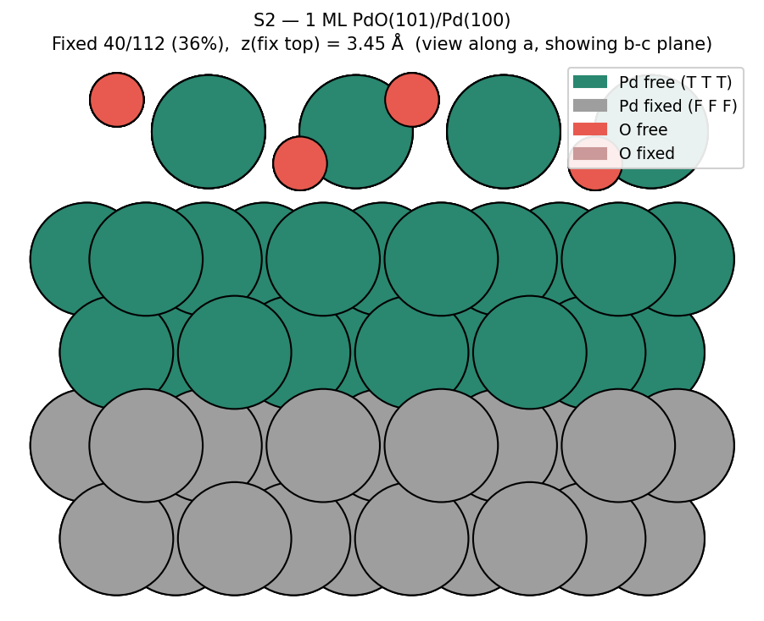

S3 — PdO(100)
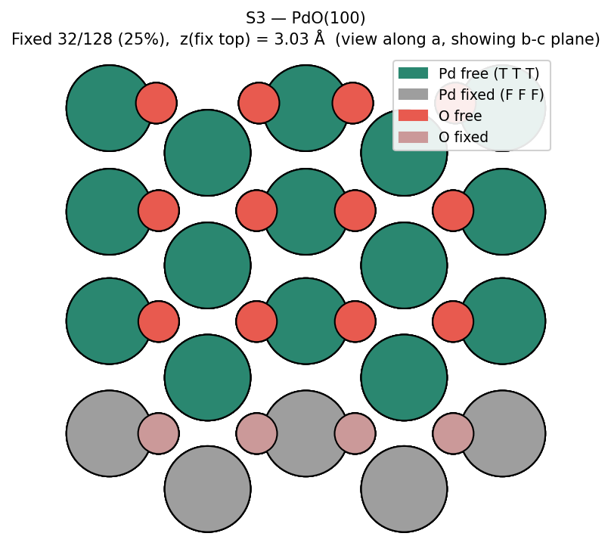

S4 — PdO₂(110)
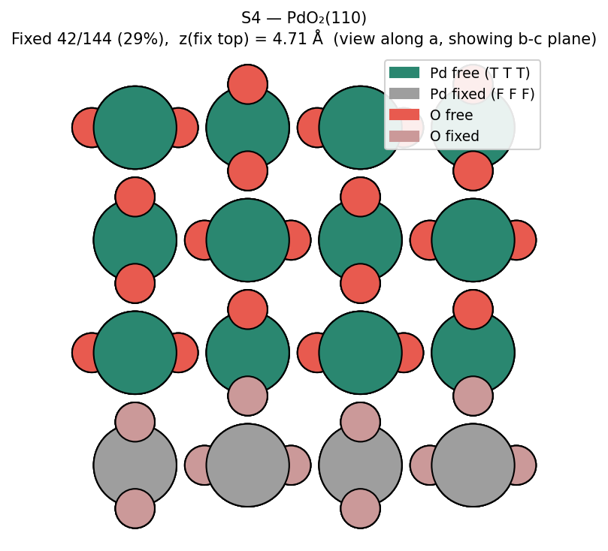

Structures (no lattice; b–c plane side view)
S1 — Pd(100)
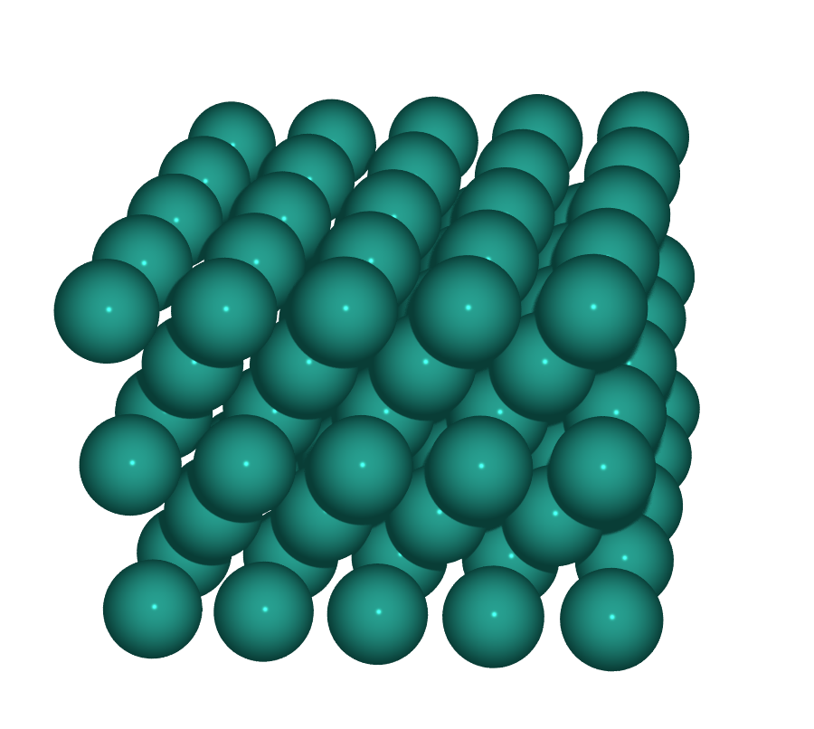  Perspective | 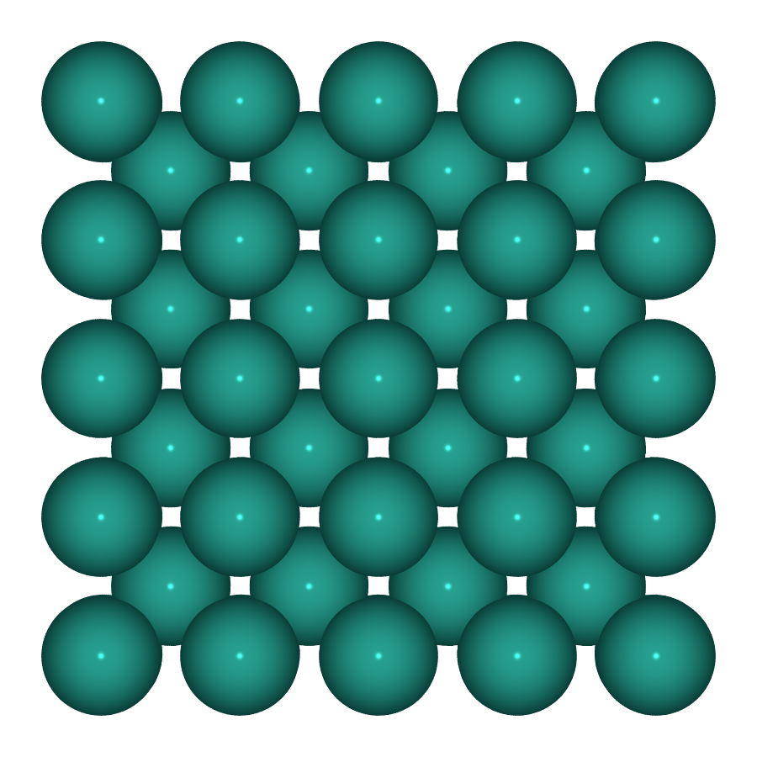  Top (down c) | 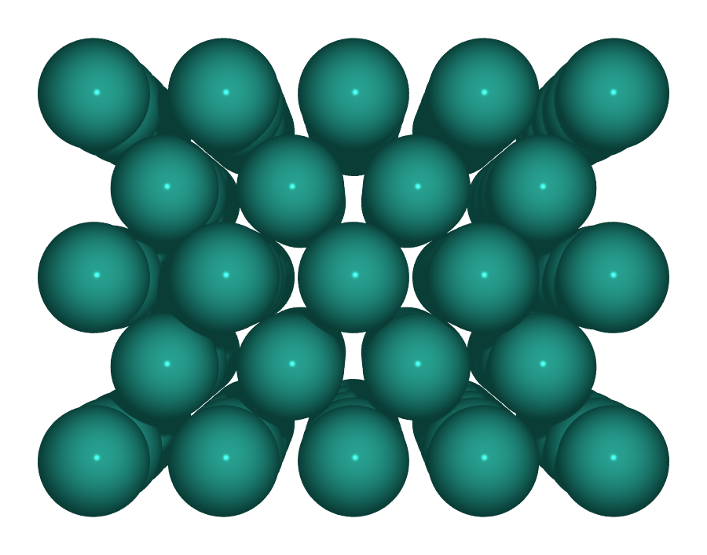  Side (along a, b–c plane)

S2 — 1 ML PdO(101)/Pd(100)
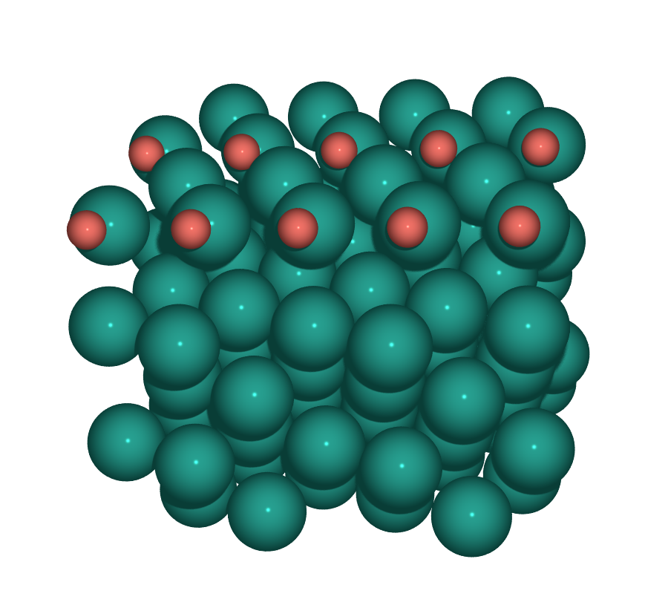  Perspective | 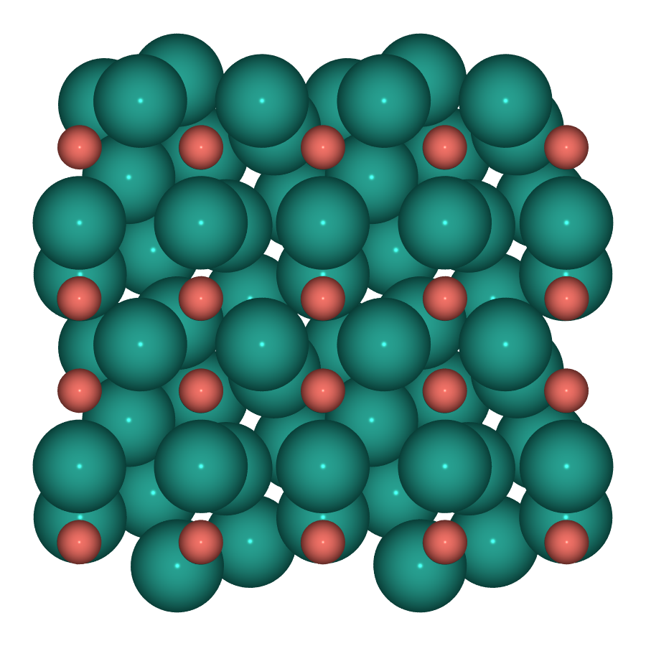  Top (down c) | 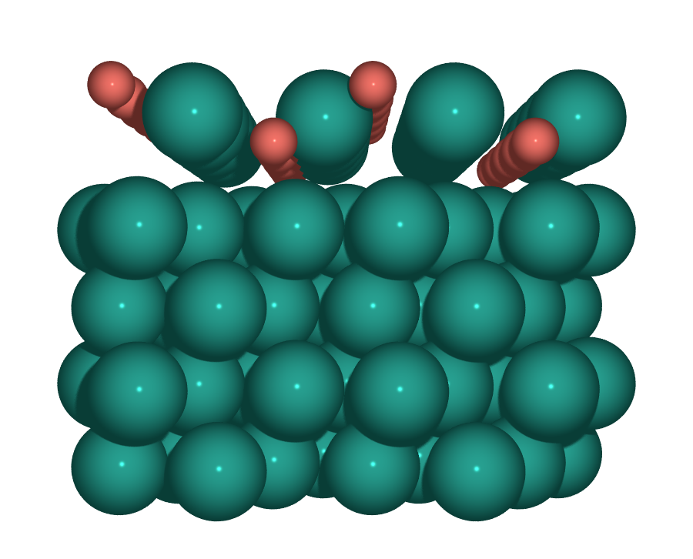  Side (along a, b–c plane)

S3 — PdO(100)
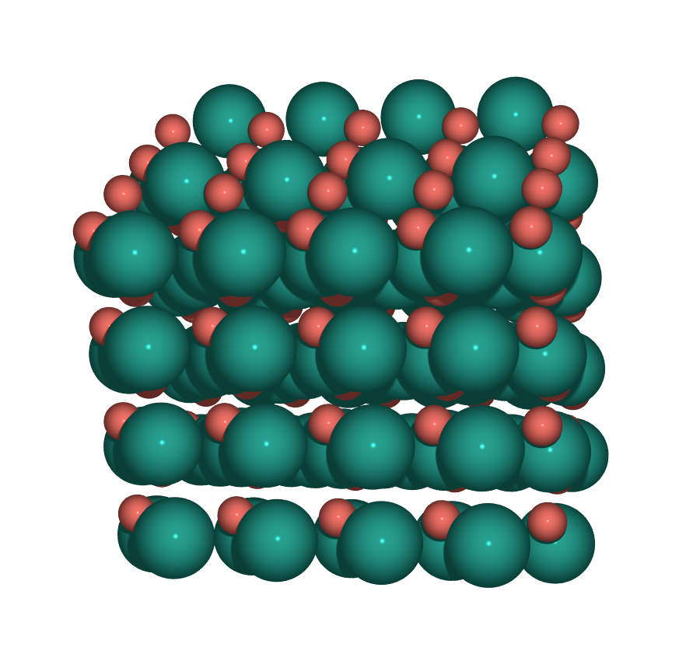  Perspective | 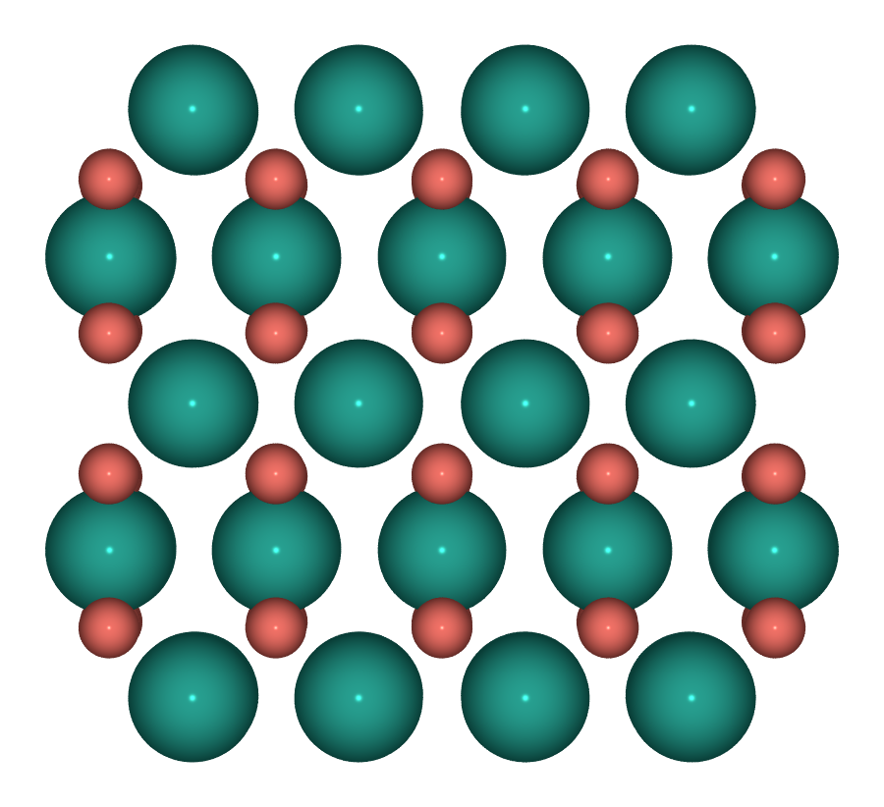  Top (down c) | 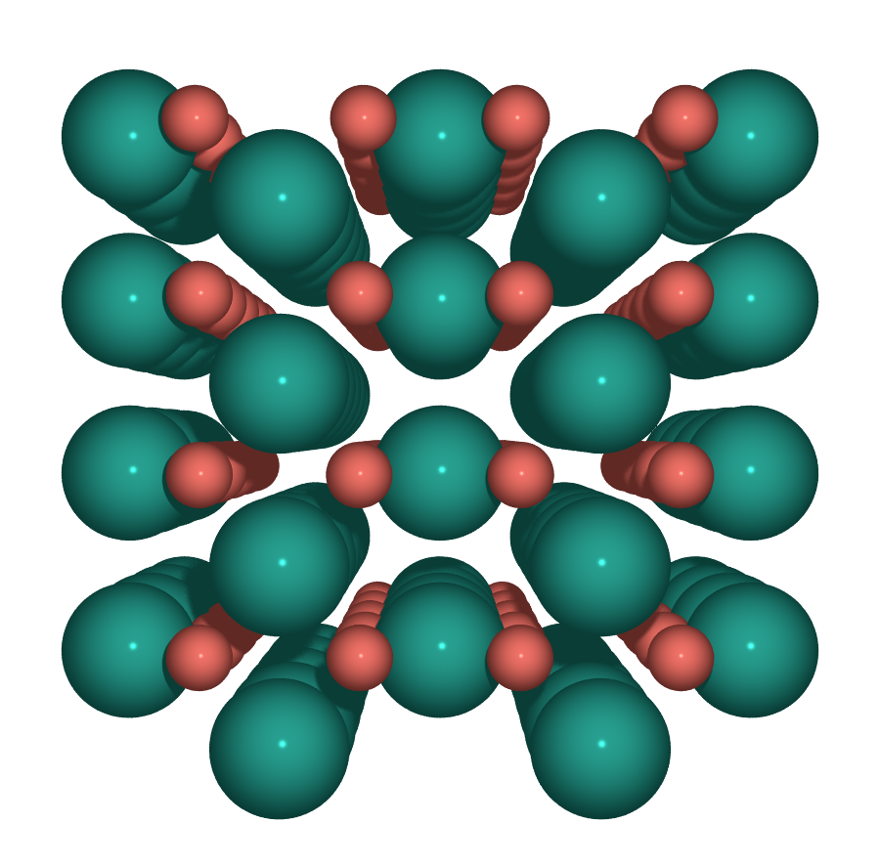  Side (along a, b–c plane)

S4 — PdO₂(110)
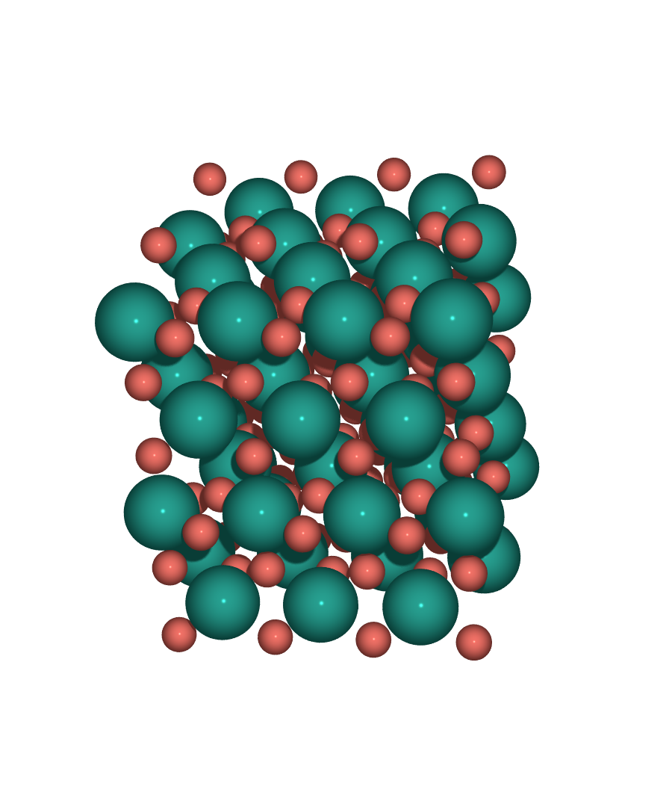  Perspective | 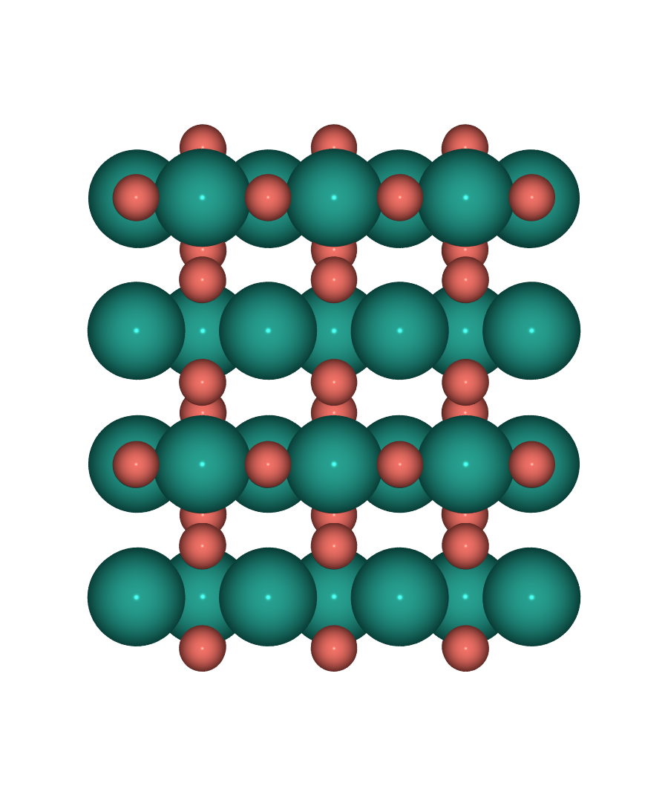  Top (down c) | 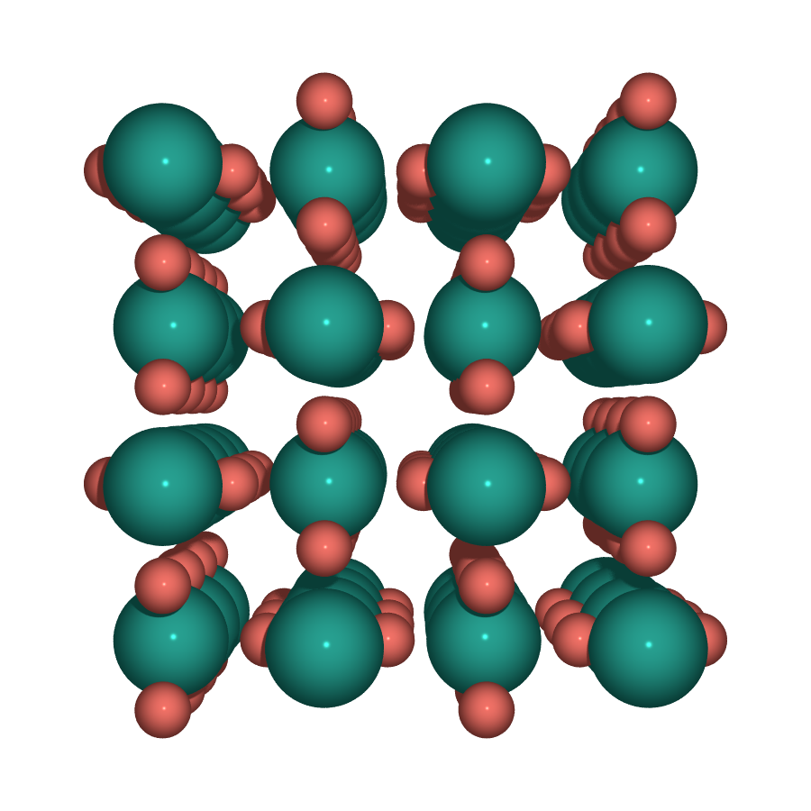  Side (along a, b–c plane)

DFT status
Slab | Job | Status | Notes
S1 | — | CONVERGED | E_tot = −434.408 eV
S2 | 325 | running | √5R27° guideline-compliant
S3 | — | CONVERGED | E_tot = −724.152 eV
S4 | 326 | queued | orthogonal PdO₂(110) guideline-compliant

Common INCAR
ENCUT = 520 eV PREC = Accurate LASPH = T ADDGRID = T
EDIFF = 1e-6 EDIFFG = −0.03 NELM = 500 NSW = 300 IBRION = 2 ISIF = 2
ISPIN = 2 IVDW = 12 (D3 BJ) ISMEAR = 0, SIGMA = 0.05
LDIPOL = T, IDIPOL = 3 KSPACING = 0.25 ISYM = 0
POTCAR: PAW_PBE O + PAW_PBE Pd_pv

